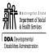

Washington State’s
RESIDENTIAL SERVICES CURRICULUM
4.1 EDITION

FACILITATOR GUIDE

Program Manager: Sarah Blanchette DDA Residential Training
Funding for the revisions made to the Residential Services Curriculum 4th Edition provided by Roads to Community Living. Public Access to this curriculum is permitted.

Training Objectives
As a result of participating in this segment of training, learners will be able to:
- List the basic food groups
- Find at least 1 benefit of each food group based on the guidelines of the USDA (ChooseMyPlate.gov)
- Construct what counts for serving sizes of common foods using visuals and/or manipulatives
- Take part in creating balanced & complete menu plans on the Weekly Menu Plan form
- Distinguish at least 3 important aspects of menu planning for someone with Diabetes
- Defend how menu planning for someone with Diabetes would be integrated into a sample Weekly Menu Plan
- Demonstrate how to read labels for nutrition value per portion size
- Identify 3 ways to involve supported individuals in the menu planning process
- Recommend at least 3 benefits of hydration
- List 2 symptoms each of poor nutrition and dehydration, when and whom to report symptoms of concern
- Distinguish different categories of fats
- Recognize ideal sodium intake levels
- Contrast empty and nutrient-rich calories
- Associate careless food handling with the potential for foodborne illness
- Illustrate 4 safe food handling practices
- Generalize the purpose of a grocery store layout
- Prepare a shopping list based on a created Menu Plan

Estimated Time
4 hours, depending on the number of participants

Supplies
Laptop or computer connected to a projector/monitor
External speakers for laptop or computer
Internet access
Paper and pens for participants
Residential Services Curriculum Toolkit (per participant)
Collection of at least 6 nutrition labels from a variety of foods for label reading activity (An
instant oatmeal box and packaged chips are a great example to compare.) Sodium poll answer signs copied and cut from end of this guide to post on wall

Preparation before training |  | Review Facilitator Guide for this chapter and ensure each participant has their Curriculum Toolkit available. Make sure to have a number of nutrition labels from a variety of foods for the label reading activity.
 | g | Opening and Engaging activity (10 minutes)
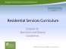  Say |  | “One cannot think well, love well, sleep well, if one has not dined well.”  ― Virginia Woolf, A Room of One's Own
Activity |  | Invite participants to write down on a piece of paper their favorite meals for breakfast, lunch, and dinner. After everyone has finished writing, direct them to pass their paper to the person next to, or across from them (depending on seating arrangements).
Ask |  | How do you feel about the meals you now have in front of you? If this was a menu written for you, would it be acceptable? Do you like this food? Are you allergic to anything listed? Are there any medical concerns this menu would create?  If someone were creating menus for you, what are some ways you would want to be involved?
Activity |  | In small groups, have participants come up with a list of ideas for involvement in all aspects of meal planning, purchasing, and preparation. After 2-3 minutes, ask a volunteer from each group to list their ideas on chart paper that can be taped to the wall for reference.
Immerse (15 | minutes)
Say |  | Let’s start by practicing inclusion when planning a menu for someone else.
Activity |  | Divide the group into pairs. Ask each pair to decide who will be a “1” and who will be a “2.” Once determined, share the communication limitations for each group.  Ones will only be able to say “yes” or “no.”  Twos will only be able to use facial expressions.

Curriculum |  |  |  | Invite participants to turn to the Curriculum Toolkit section of this chapter and view the page with the One Day Meal Plan Practice.
 | 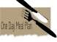
 | Toolkit
Activity |  |  |  | Working with their partners, ask them to complete the One Day Meal Plan for each other.  Remind them that the only person who can speak (other than the “yes” or “no”) is the person writing the menu.  When they have completed the one day meal plan, ask for some feedback about how individual choice was incorporated, particularly considering the communication challenges.
Teach and Train (20 minutes)
Say  Activity |  |  |  | Now let’s take a look at the meals you planned and assess the nutritional values.  On a blank piece of paper, draw a circle to represent your plate. Draw on the plate your lunch or dinner from the One Day Meal Plan.
Ask  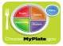 |  |  |  | Did you include the major food groups?  Can someone name the 5 food groups?  Do the portions and food choices match the recommended guidelines?  The USDA recommends food choices from Protein, Dairy, Fruits, Vegetables, and Grains, but how do you determine portion sizes for each of those?
Say |  |  |  | Let’s see what we know about portion sizes!
Curriculum  Toolkit |  |  |  | Refer participants to their CH 8 Curriculum Toolkit page for Portion Size Savvy.

Activity  Ask |  | Give 3-4 min before sharing correct answers  Comparison Object:  Deck of cards  Checkbook  4 dice  Computer mouse  Ping pong ball  Baseball  CD  CD case  Thimble or tip of the thumb  Shot glass  Tennis ball  Answers may include: being able to  guess a portion, knowing a portion  helps you know what you need for  shopping and what is necessary for  administering insulin  Instruct them to match the photos with the serving sizes of foods. using the correct answers | Instruct them to ma  Serving Size:  3 oz. poultry or red meat  3 oz. of fish  1 oz. of natural cheese  - medium potato  - tablespoons of peanut butter  1 cup of pasta  1 pancake  1 slice of bread  1 teaspoon butter, margarine, or oil  1/3 cup nuts  ½ cup cooked cereal or rice  Why would learning abou  Tion
Apply - Demonstrate Learning Application to Real Work (30 minutes)
Say |  | Now let’s take what we have learned about portion size comparisons and apply it to our One Day Meal Plan.
Activity |  | Instruct participants to label the portion sizes of their food choices on their Plan. Point out that if they have doubled the portion sizes for their food choices, it will equate to 2 servings; for example, a 6 oz. filet of fish would count as 2 servings of protein. They can work with a partner for
4
 |  | feedback. Remind them to use the visuals as their guide; this is an exercise in estimation.
Ask |  | How many servings of each of the food groups are recommended in a day?  The answer will depend on a person’s age, gender, and amount of physical activity.
Curriculum  Toolkit  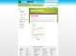 |  | In your Curriculum Toolkit, take a look at the food group options for daily 1600-2000 calorie recommendations.  [Link to this: http://www.choosemyplate.gov/myplate/index.aspx ]  In reflecting on your One Day Meal Plan, if there are food groups missing, or there are too many in one or more food groups, what changes would you make to that day? Could or would you choose to substitute low fat or fat free dairy options? What about fats and oils?  Did you incorporate nuts, seeds, or legumes?
Note |  | Note to Facilitator: Depending on the size of the class, you could suggest they compare and combine their menus to make a week’s worth. This can be done in pairs, small groups, or with the whole class to create a full week’s menu.
Ask |  | How could you adjust the combined meal plans over the week for better balance?  This menu you have created may work for you, but what if you are creating a menu for someone who has a health concern, like diabetes, or high blood pressure?  What would you need to know about the different food groups to make adjustments?
Teach and Train (45 minutes)
Say |  | Let’s take some time to review the benefits of the major food groups.
Curriculum  Toolkit |  | Provide time to read the information sheets in the Fundamentals section of the Curriculum Toolkit for this chapter about their assigned food group.
5
Activity |  |  |  | Divide the class to assign them to one of each of the 5 major food groups and fats & oils. Have them prepare to share with the rest of the class what they think is most important to know about the benefits of that food group. Ask them to have at least 3-4 points they will present (about 4 min. presentation time). Allow at least 5-10 min. preparation time (depending on how many groups will be presenting).
Curriculum  Toolkit |  |  |  | When all groups have presented, instruct everyone to capture that information on their own blank Curriculum Toolkit food plate.
Note  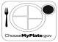 |  |  |  | Note to Facilitator: Onto a projected image of the empty food plate, have participants write on the whiteboard if able. If you are unable to write on the whiteboard, you may want to encourage participants to write on small sections of paper (or Post-it Notes) in large clear print to tape to the projected image on the screen.
Say |  |  |  | Now that we have covered the basics of the benefits of the major food groups, let’s talk about those potential health concerns.
Teach and Train (20 minutes)
 | Ask |  |  | What information did you hear that would help you plan meals for someone with Diabetes?  Answers may include: healthy portions, nutrient-rich food, adapting calories for activity.  What are empty calories?
 | 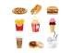
Show  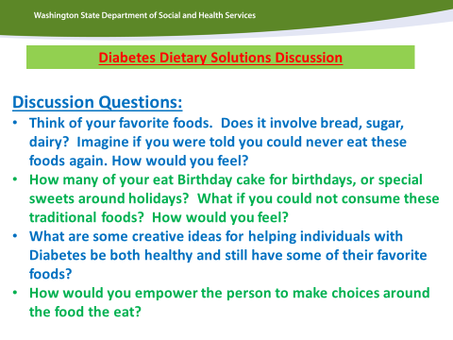 |  |  |  | Lead the class in a discussion about creative ways to make a Diabetes diet interesting, enjoyable and empowering.  See PPT slide for discussion questions
Curriculum  Toolkit |  |  |  | Look in the Curriculum Toolkit section of this chapter for information on empty calories. Once you have had a chance to review that information, go back to your One Day Meal Plan to see how many empty calories you may have included.
Apply- Demonstrate Learning Application to Real Work (20 minutes)
6
Activity |  | If you find empty calories, make some substitutions for more nutrient-rich choices, like suggesting unsweetened cereals instead of sugar-sweetened.  Participants can work together if they need ideas.
Say |  | One of the most common sources of added sugars (part of empty calories) are sodas, energy drinks, sports drinks, and fruit drinks. What can we drink instead?  Water! Suggest that they write in water as a beverage on their meal plan as a reminder to drink it throughout the day. Eight 8-ounce glasses of water are recommended per day.
Activity |  | Split the group in half and have them gather to quickly list:  What are the benefits of water? Ensure answers include: healthy skin, aids digestion, prevents dehydration, improves energy, and removes toxins and waste from the body.  What are the symptoms of dehydration? Ensure answers include: increased thirst, concentrated & darker urine, dry mouth, the eyes stop making tears, sweating may stop, muscle cramps, nausea and vomiting, heart palpitations, lightheadedness (especially when standing).
Note |  | Note to Facilitator: You may choose to have each group answer both questions, or assign one question to each group.
Teach and Train (5-7 minutes)
Say  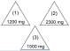 |  | Now let’s talk about high blood pressure and salt.  Let’s take a quick poll, and get up and move around at the same time!  Choose from the following options to make this more interactive. You may choose the same method of answering for the second question, or switch it up.
Note |  | Note to Facilitator:  There are a number of options to consider:  - Have 3 signs with the 3 possible answers posted around the room for participants to stand near.  - Have people stand and raise their hand with one, two, or three fingers to indicate their answer.  - Everyone can stand up and put their hand over their heart for answer  #1, put their hand over their kidneys for answer #2, or hands on their knees for answer #3.
7
Ask |  | How many milligrams of sodium are recommended per day?  - 1200 mg  - 2300 mg  - 1500 mg  The correct answer is 2) 2300 mg  What if you are a person who has diabetes, kidney disease, or high blood pressure? How much sodium should you have per day?  That answer is 3) 1500 mg
Curriculum  Toolkit |  | Invite participants to circle and label the correct answers in the picture of the salt and pepper shakers in the Curriculum Toolkit section of this chapter.
Say |  | While certain health conditions might require you to monitor your sodium intake, all of us can benefit from an awareness of sodium content in our food.
Apply- Demonstrate Learning Application to Real Work (45 minutes)
Ask |  | How do you know how much sodium is in packaged food? How can you tell if a packaged food is a good source of nutrition vs. empty calories of solid fat or added sugars?
Say |  | You have to read the labels!
8

Curriculum  Toolkit  Note |  |  | Distribute the food labels you have available (participants can share if necessary). Provide 1-2 minutes to review the nutrition label information in their Curriculum Toolkit, and assess their label for nutritional value.  Note to Facilitator: In the Curriculum Toolkit on the page with the Nutrition Facts Label and Descriptions, help participants find and highlight the sentence under #5 “Percent % Daily Value” where it says: Use the Quick Guide to Percent DV (%DV): 5%DV or less is low and 20%DV or more is high.
Activity  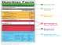 |  |  | Discussion prompts:  Who has a food high in protein?  If I am trying to cut back on sodium, which product should I avoid?  Which food could I have that is lower in sugar?  Are there any good choices for someone who has diabetes?  How many servings are shown?  What is the measurement of the serving size and the visual comparison?
Say |  |  | You might notice your food label includes ingredients, and this sample version does not. Ingredients are listed in the order of quantity, so the first ingredient is the highest percentage of the product.  A simple tip for choosing nutrient rich foods is to look for fewer ingredients i.e., a potato vs. boxed scalloped potatoes, or prepackaged instant oatmeal vs. old fashioned oats.
Ask |  |  | What is the value in interpreting labels?  Guide the discussion to be sure answers include: I will know how many calories I am eating  I will be more aware of serving sizes per container  I can help people make healthier choices when shopping  I will learn which foods are more nutritious vs. empty calories  What are symptoms of poor nutrition?  Answers may include:  Osteoporosis, high blood pressure, liver problems, obesity, weak immune system, fatigue, dizziness, muscle weakness, poor wound healing, weakness, type 2 diabetes  What do you do if you observe symptoms of concern related to poor nutrition or dehydration? Answers may include:  Contact the supervisor, contact the person’s doctor, document per agency policy, talk to the person about better food choices or a different food plan, consult professional nutritionist or dietician, look for community resources or groups for healthy eating, cooking, and shopping.

Say |  | Speaking of shopping…  Invite people to draw on a blank sheet of paper the layout of a grocery store. Typically the produce will be on one side of the perimeter. Where do you find the lean meat? Dairy?  In order to fill your plate with nutrient rich foods, you will want to focus on shopping the perimeter.
Ask |  | How do you know where to start? If you were going to buy groceries to prepare what is on your One Day Meal Plan, what would you need?
Activity |  | With a partner, chose one meal plan and one grocery store layout. Create a list of all the ingredients you will need, and then map your most efficient route on the store layout. Allow 5-7 min. of discussion and planning with their partners. Ask for several volunteers to share what was easy or difficult and why.  What would happen if you went to the store without a list?  Would you have what you need to prepare your menu plan?
Note |  | Note to Facilitator: Discuss any individuals that your agency supports who may have difficulty in the store and what the challenges are. For example: Do they grab candy in the checkout line? Do they open bread and eat it in the aisles? What about your people with Autism who like to go through the store in a particular pattern and routine?
Teach and Train (20 minutes)
Ask |  | Once shopping is completed and the bags are brought inside, which foods need to be put away first, and why?

Say |  |  |  | We, as Direct Support Professionals, are responsible for assisting with and teaching meal planning and shopping. We also must ensure safety in food handling. (Remember the Residential Service Guidelines, Health and Safety?)
Curriculum  Toolkit  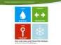 |  |  |  | Turn to the Fundamentals section of the Curriculum Toolkit for this chapter on food safety. As you can see, the food safety tips from foodsafety.gov are divided into Clean, Separate, Cook, and Chill.
Show  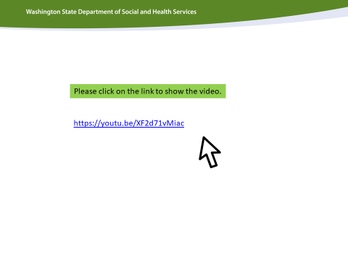 |  |  |  | Show Clean, Separate, Cook, and Chill video (3:44)
Activity |  |  |  | Have the staff work in groups, different than their previous work groups, to prepare to teach the whole group about one aspect of food safety:  Clean, Separate, Cook, and Chill.
Note |  |  |  | Note to Facilitator: Assign or allow groups to choose their topic from the four safety topics using the Curriculum Toolkit pages as a resource.  Offer creative options of drawing with markers & poster paper; create a rap or song, poem, skit, etc. to present/train their chosen topic. Instruct one person in each group to set their phone timer for 10 min. When that timer sounds, let everyone know they have 5 more minutes (if needed) to finish preparing their presentations.  Ask the groups who would be willing to present first. Then, remind everyone to give each group their full attention (no cheating to add to their own presentations).
Show  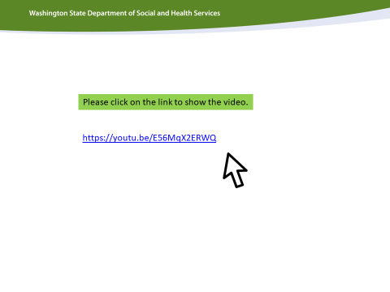 |  |  |  | After the presentations, show Bacteria Bar-b-que video, which is a humorous look at what happens when we don’t practice good food safety! (1:40)
Reflection & Celebration (5 minutes)

Say  Curriculum  Toolkit |  |  |  | Wow! Let’s take a step back, since we have covered a lot of information. I would like you to think about one practical tip you will use for yourself, someone you love, or with the people you support that will be beneficial, and write it down.  Refer to Choose MyPlate; 10 Tips To a Great Plate located in the Curriculum Toolkit section of this chapter.
 | Note |  |  | Note to Facilitator: To give them some parameters, you could write on the board the following categories:  - Food Groups  - Portion Sizes  - Label Reading  - Diabetes  - Successful Shopping  - Involving supported individuals
If you have enough people in the training, assign categories, to get a good variety of tips. Give staff a moment to think and write, then have them share their tip and defend why they feel it is valid.

For example, my tip might be “I will work to make half my grains whole, since whole grains have more fiber and health benefits.”

Encourage specific practical steps if staff share general tips (i.e., “make better choices”, could be rephrased into “choose leaner cuts of meat”). Reinforce their participation and the great ideas they are able to share from what they have learned.
 | Activity
Activity  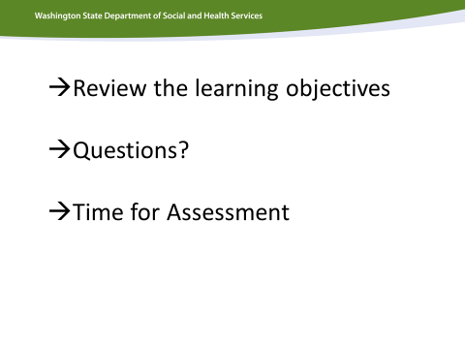 |  |  |  | Please administer the assessment at the end of this chapter.
Note |  |  |  | Note to Facilitator: Please review the objectives in the Curriculum Toolkit on the first page with participants. Ask participants to circle the objectives for this chapter in which they believe they need more clarity. Allow for question and answer dialogue to ensure that all of the objectives have been met.
Hand out the assessment for this chapter to each participant. End of chapter assessments should take approximately 10 minutes.

As a learning tool, it will be important for each participants to leave the training with the correct answers. Please review the answers and ensure that each participant has marked the correct answer. When you review the assessment with students, note where people are having difficulty and review that section again with the whole group or determine where you will address this in the next chapter. Ensure that you reteach/retrain topics where learning gaps were identified.

Due to the confidential nature of the assessments in this course, please collect and shred all completed assessments.

Graphics for Sodium poll

(1)

1200 mg

23
00
mg

(
2
)

This page left intentionally blank.

1
5
00
mg

(
3
)

