**Tacoma**

**Developmental disabilities administration**

**Continuing education Training**

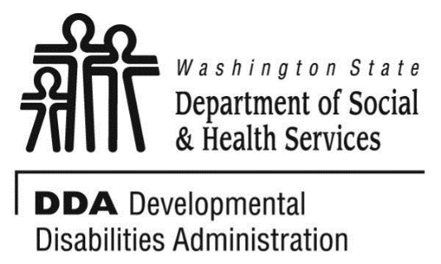

Figure 1 Developmental Disabilities Administration Logo

Figure 2 Developmental Disabilitiies Administration Logo

December 5th, 2019 9 AM to 4 PM 6 CEUs

**Supported Independence Model**

The Supported Independence Model (SIM) is a support staff strategy to avoid or prevent certain challenging behaviors. It is based on the notion that individuals with disabilities can be sensitive to their need for support. Their independence can be threatened when they do not have control over the supports. That threat can lead to challenging behaviors. By following three straight forward SIM principles support staff can:

* Maintain and increase an individual’s personal control and independence
* Preserve a person’s dignity and self-esteem
* Avoid unpleasant setting conditions that can lead to challenging behaviors
* Prevent setting events that can trigger challenging behaviors

[Click here to register](https://www.eventbrite.com/e/supported-independence-model-tacoma-12519-registration-65990893539)

*Photograph of Dr. Fischer
*

Presented by Edward Fischer

Dr. Edward Fischer has worked 17 years with individuals with developmental disabilities and Autism. He works for the Developmental Disabilities Administration in Region 3 with the Regional Clinical Team. He is also associate faculty at two universities where he teaches clinical and forensic psychology and serves as dissertation chair and committee member.

Tacoma DDA, 1305 Tacoma Ave S. Suite 300, Tacoma, WA 98402

**Parking is not available in the Garage at the Comprehensive Life Resources Building/DDA Office:**

• Metered parking is available on Tacoma Ave S in front of the office building. There are some free spots to the south, in front of the parking garage.

• More free street parking is available on S 14th St, S G St, S 15th St, S. 17th St and Court E and S. Fawcett Ave between S. 15th and S. 17th Streets. Parking is your responsibility.

Class Size: Limited to 50 Participants

**Additional classes are listed online at** [DDA Provider Training Opportunities](https://www.dshs.wa.gov/dda/dda-provider-training)