

**Developmental Disabilities Administration**

Region 1

Presents Trainings for

Continuing Education

2019

Presented by

Dr. Christen Kishel

&

Lee Ferguson

Christen Kishel, PhD, has wealth of knowledge from working in the Mental Health field, with experience in providing direct clinical services in the community, as well as providing supervision to clinical staff in community Mental Health programs.  Christen has experience and knowledge from running her own private practice, focusing on working with children diagnose with Autism Spectrum Disorder and their families.  Currently, Christen is the Lead DDA Region 1 Clinical Psychologist.

Lee Ferguson, MSW & LICSW, comes from a background of Supported Living in the community, where he provided positive behavior support programming, supervised a clinical Dialectical Behavior Therapy program, as well as mental health diversion program.  Currently, Lee provides mental health and positive behavior support services to agencies and DDA staff as part of his role as a Psychology Associate with DDA.

Who Should Attend?

AFH Providers/Resident Managers/Caregivers, Assisted Living Administrators/Caregivers, SL Staff, CH Providers, AL Providers, Supported Employment Staff. This is not for IP’s to earn their Continuing Education credits.

Training is approved for 6 hours of Continuing Education credits.

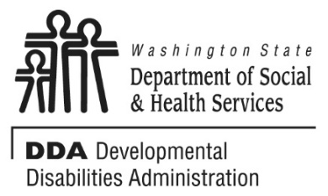

January 9, 2019, 9am-4pm Spokane

February 7, 2019, 9am-4pm Kennewick

March 7, 2019, 2018, 9am-4pm Yakima

Dual Diagnosis:

Mental Health Disorders in clients

with Developmental Disabilities

Attendees will better understand, treat, and support clients with some of the more common Mental Health Disorders: Depression, Bipolar Disorder, Psychosis, Anxiety/PTSD, and Personality Disorders.

Attendees will receive a brief overview of these diagnoses, which includes the symptomology associated with these diagnoses and the clarification on disorders frequently attributed incorrectly to the diagnosis of intellectual/developmental disability.  Participants will receive information on signs of possible undiagnosed mental health disorders they should be aware of as they provide services and supports to individuals diagnosed with intellectual/developmental disability.  They will also receive further instruction on supports and strategies used in supporting individuals who are receiving services in a community setting.

To Register:

* You must pre-register by contacting Gloria Martinez at [**MartinGA@dshs.wa.gov**](mailto:MartinGA@dshs.wa.gov)or **509-225-7991**
* This class is limited to 30 attendees, and you must be registered to attend.
* **Please include the name, phone number and email for each attendee wishing to register.**



Locations:

**Spokane -** [**8517 E. Trent Ave.,**](https://www.google.com/maps/place/8517+E+Trent+Ave,+Spokane+Valley,+WA+99212/@47.6809524,-117.2921332,17z/data=!3m1!4b1!4m5!3m4!1s0x549e1f8458d6595d:0xdc3b69daa9188eeb!8m2!3d47.6809488!4d-117.2899392) **Spokane Valley, WA 99212 (Region 1 Training Center)**

* **Kalispel Training Room**

**Kennewick -** [**4310 West 24th Ave,**](https://www.google.com/maps/place/4310+W+24th+Ave,+Kennewick,+WA+99338/@46.1880318,-119.1818502,17z/data=!3m1!4b1!4m5!3m4!1s0x5498784880a4edb9:0xc62ffb7a779c7c36!8m2!3d46.1880318!4d-119.1796562) **Kennewick, WA 99338 (L&I Building)**

* **Right side entrance, up the stairs to the large conference room**

**Yakima –** [**15 W Yakima Ave,**](https://www.google.com/maps/place/15+W+Yakima+Ave,+Yakima,+WA+98902/@46.6018145,-120.5115187,17z/data=!3m1!4b1!4m5!3m4!1s0x5499d7ec15567f3f:0x73a5a21b710ff16d!8m2!3d46.6018108!4d-120.5093354) **Yakima, WA 98902 (L&I Building)**

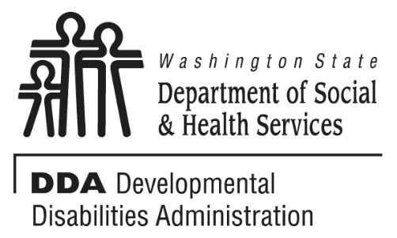

If you get lost or in the event of inclement weather, call 509-225-7991to get further direction or to find out if the training will be held as scheduled. Please don’t be late; doors will close at start time.

We ask that you follow safety and security rules of the venue. Please always wear the badge (when provided) and sign in/out if required by the venue. Thank you.

**Additional Classes are listed Online**

<http://www.dshs.wa.gov/dda/dda-provider-training>

**Purpose Statement**

**The Developmental Disabilities Administration (DDA) endeavors to make a positive difference in the lives of people eligible for services, through offering quality supports and services that are: individual/ family driven; stable and flexible; satisfying to the person and their family; and able to meet individual needs. Supports and services shall be offered in ways that ensure people have the necessary information to make decisions about their options and provide optimum opportunities for success.**

* INDIVIDUAL WORTH AND DEVELOPMENT
* CONTINUITY AND COORDINATION OF SERVICES
* COMMUNITY PARTICIPATION AND PARTNERSHIP
* RESPECT FOR EMPLOYEES
* SERVICES QUALITY AND PERFORMANCE ACCOUNTBAILITY
* NONDISCRIMINATION

Transforming Lives

**Developmental Disabilities Administration**

Region 1

Presents Workshops for

Continuing Education:

2019