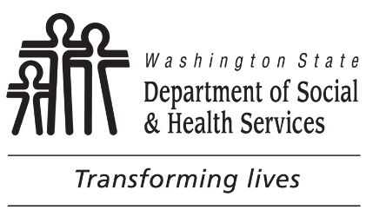
AWA ACCESS REQUEST FORM
INSTRUCTIONS: County workers who need access to or removal from ADSA AWA must complete section 1 of this form and then submit to the County coordinator for approval. The County coordinator completes section 2 and forwards to the DDA Employment and Day Program Manager. All requested information is required for ADSA DDA to process the request.

SECTION 1: TO BE COMPLETED BY REQUESTOR (county worker).
Name:
Title:
Phone Number:
County Email Address:

NOTE: Personal e-mail accounts (e.g. AOL, MSN, Gmail, Yahoo etc.) are not authorized for conducting business involving DSHS clients and information.

Justification for access:

Signature: __________________________________ Date:

SECTION 2: TO BE COMPLETED BY COUNTY COORDINATOR:
ADSA AWA: Removal from ☐ Access to ☐
Access Tabs: Data Transfer ☐ Billing ☐ Provider ☐
Worker Access Rights: View Modify Process Delete
Billing ID: ☐ ☐ ☐ ☐
Billing Maintenance: ☐ ☐ ☐ ☐
Client Referral Screen: ☐ ☐ ☐ ☐
Employment ID: ☐ ☐ ☐ ☐
Provider Maintenance: ☐ ☐ ☐ ☐

County Coordinator IT Contact Information:

Name: Phone Number: Email Address:
Remote connection type: State IGN ☐ or SSL VPN ☐

A static IP address is required on requestor’s computer.
Static IP Address:

County Coordinator‘s Signature: ______________________________ Date:

Distribution: County Coordinator retains original and a copy is to be emailed to DSHS DDA Employment and Day Program Manager: Megan.Burr@dshs.wa.gov.

SECTION 3: To be completed by DSHS DDA County Program Coordinator
Authorized: ___YES ___NO
If yes, send to ADSA HELPDESK for processing.
If no, return to county coordinator with explanation.

SECTION 4: To be completed by ADSAHelpdesk
IT staff processing request: ___________________________________ Date: _______________
When finished, IT staff will notify the requestor and county coordinator, filing completed form on ADSA Headquarter SharePoint site.

