*Photograph of Dr. Fischer
*

**R3 Online TRaining**

**Developmental disabilities administration**

**Continuing education Training**

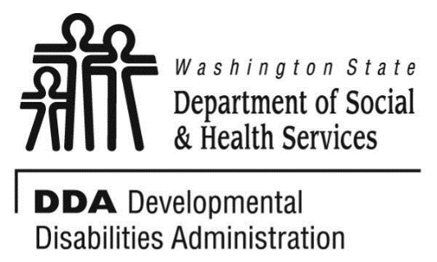

Figure 1 Developmental Disabilities Administration Logo

Figure 2 Developmental Disabilitiies Administration Logo

April 27, 2023 9 AM to 4 PM 6 CEUs

**Autism Spectrum Disorder 101**

Supporting individuals with Autism Spectrum Disorder can require unique and individualized supports. This course will provide an introduction to the diagnostic criteria based on the DSM-5 edition and explore how we can provide the best support possible for individuals living with Autism. It will look at specific strategies for supporting the individuals as well as the care providers with following training objects:

* Introduction to Autism Spectrum Disorder (ASD).
* Understanding the unique behavioral, social communication, and social relationship traits of persons with ASD.
* Identifying the skills and skill deficits of persons with ASD
* How to assist persons with ASD to develop appropriate skills to successfully function in the community.

Presented by Edward Fischer, PsyD

Dr. Fischer has worked 19 years with individuals with developmental disabilities and Autism. He works for the Developmental Disabilities Administration in Region 3 with the Regional Clinical Team. He is also associate faculty at two universities where he teaches clinical and forensic psychology and serves as dissertation chair and committee member.

*This training will be presented virtually and highly interactive. Participants should have the ability to access ZOOM platform.



**R3 Online TRaining**

**Developmental disabilities administration**

**Continuing education Training**

April 27, 2023 9 AM to 4 PM 6 CEUs

***Click the link to register for Autism Spectrum Disorder 101:***

## **April 27, 2023**

## 9:00 AM – 4:00 PM

[**Register Here**](https://www.eventbrite.com/e/autism-spectrum-disorder-101-dr-edward-fischer-tickets-418304067727)

**Class Size: Limited to 25 Participants**

**Additional classes are listed online at** [DDA Provider Training Opportunities](https://www.dshs.wa.gov/dda/dda-provider-training)

***Please Note:***

* **Class starts promptly at the stated times. If you are late, you may not receive credit.**
* **Please print any handouts, if provided, as they may be used in the class.**
* **Use of video is preferable.**
* **Please do not use a cellphone, a computer with screen is recommended to attend this course.**