Date: December 10th, 2025

Time: 9:00am – 12:00pm

Location: Online training
On-line Training
Developmental disabilities community services
region 3 clinical team

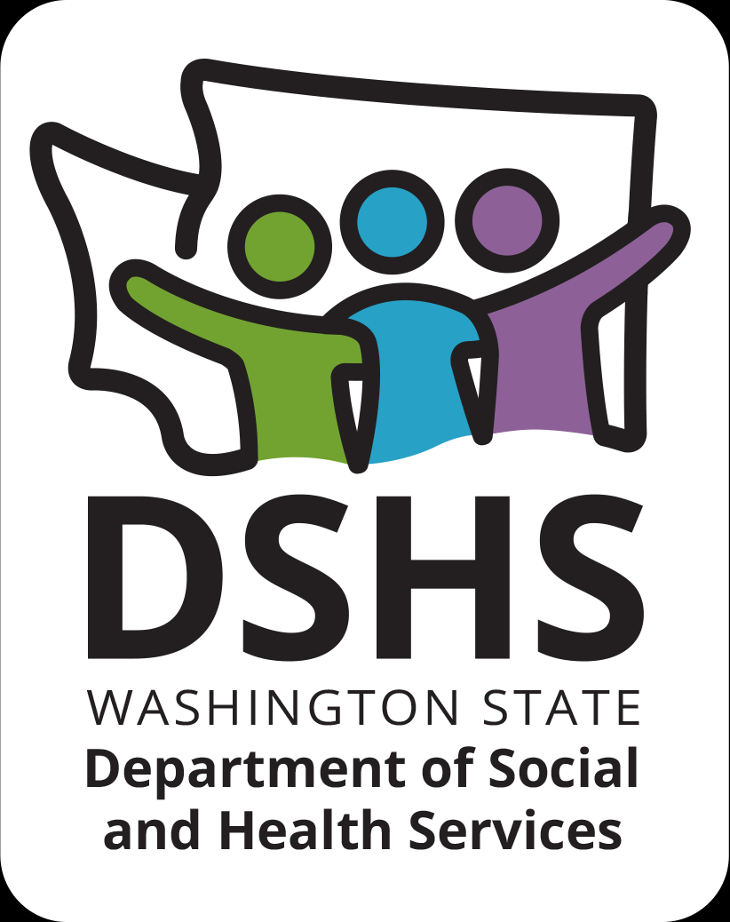
Figure 1 Developmental Disabilities Administr ation Logo

Figure 2 Developmental Disabilitiies Administration Logo

December 10th, 2025 9:00am to 12:00pm
Data Collection
Presented by:
Dr. Emily Branscum & Ryanne Smith, MSW

This course is designed to support direct service professionals in understanding the importance of data collection when working in community settings, recognizing the types of data collection and when to use them, as well as understanding how to summarize and display that information. A strong focus of this training is on the important role of direct support professionals in supporting people in community residential settings.
REGISTRATION LINK: https://events.humanitix.com/r3-data-collection-dec-10th-9am-12pm-ryanne-smith-emily-branscum
Additional classes are listed online at DDA Provider Training Opportunities
Please Note:
- Class starts promptly at the stated times. If you are late, you may not receive credit.
- Please print any handouts, if provided, as they may be used in the class.
- Use of video is preferable.
- Please do not use a cellphone, a computer with screen is recommended to attend this course.

Class Size: Limited to 25 Participants
3 CE Credits

