Date: October 8th, 2025
Time: 12:30pm – 3:30pm
Location: Online training
On-line Training
Developmental disabilities Community Services
Region 3 clincial team

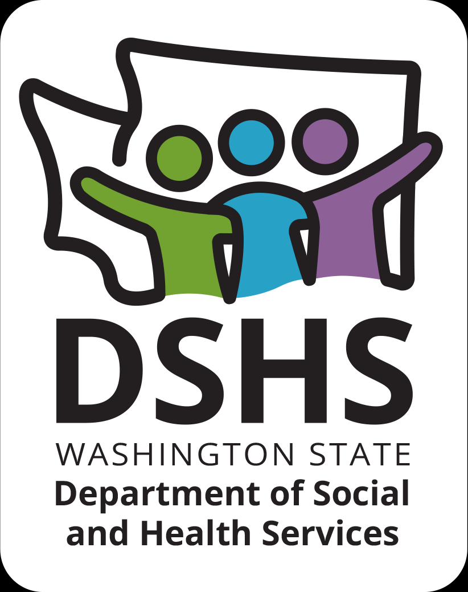
Figure 1 Developmental Disabilities Administr ation Logo

Figure 2 Developmental Disabilitiies Administration Logo

October 8th, 2025 12:30pm to 3:30pm

Dual Diagnosis
Presented by:
Dr. Emily Branscum & Ryanne Smith, MSW

Working with people who have been diagnosed with both mental health and developmental/intellectual disabilities can be challenging.

This course is an introduction to dual diagnosis and will explore how we can provide the best supports to individuals living with developmental disabilities and a co-occurring mental health disorder. It will also look at specific strategies for supporting individuals as well as care providers.
REGISTRATION LINK: https://events.humanitix.com/r3-dual-diagnosis-oct-8th-1pm-3pm-ryanne-smith-emily-branscum

Additional classes are listed online at DDA Provider Training Opportunities
Please Note:
- Class starts promptly at the stated times. If you are late, you may not receive credit.
- Please print any handouts, if provided, as they may be used in the class.
- Use of video is preferable.
- Please do not use a cellphone, a computer with screen is recommended to attend this course.

Class Size: Limited to 25 Participants
3 CE Credits

