*Photograph of Dr. Fischer
*

**R3 Online TRaining**

**Developmental disabilities administration**

**Continuing education Training**

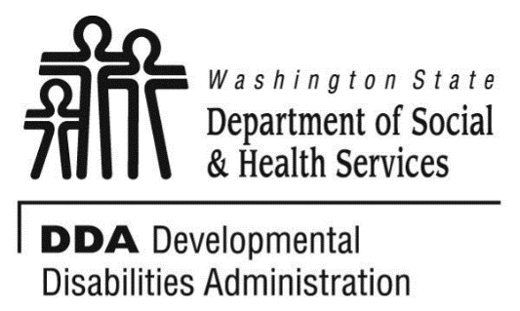

Figure 1 Developmental Disabilities Administration Logo

Figure 2 Developmental Disabilitiies Administration Logo

May 30, 2024 9 AM to 12 PM 3 CEUs

J

**Data Collection and Documentation**

Supporting individuals with Neurodevelopmental Disorders and/or mental health issues can require unique and individualized supports. This course will provide an introduction to what data collection and documentation means and looks like. Participants will understand that data collection and documentation is frequently based on:

* + Observing a behavior of another person
  + Identifying the trigger(s) for that observed behavior
  + Identifying the functionality of that behavior (what did the person want to communicate and achieve by using that behavior?)

Participants will be introduced to tangible tools for data collection methods and practice, as well as looking for patterns of behavior and skills utilized.

Presented by Edward Fischer, PsyD

Dr. Fischer has worked 21 years with individuals with developmental disabilities and Autism. He works for the Developmental Disabilities Administration in Region 3 with the Regional Clinical Team. He is also associate faculty at two universities where he teaches clinical and forensic psychology and serves as dissertation chair and committee member.

*This training will be presented virtually and highly interactive. Participants should have the ability to access the ZOOM platform.



**R3 Online TRaining**

**Developmental disabilities administration**

**Continuing education Training**

May 30, 2024 9 AM to 12 PM 3 CEUs

J

***Click the link to register for Data Collection and Documentation:***

## **Thursday, May 30, 2024**

## 9:00 AM – 12:00 PM

## **LINK:** [**https://www.eventbrite.com/e/data-collection-documentation-dr-edward-fischer-53024-9am-12pm-tickets-774029401777?aff=oddtdtcreator**](https://www.eventbrite.com/e/data-collection-documentation-dr-edward-fischer-53024-9am-12pm-tickets-774029401777?aff=oddtdtcreator)

**Class Size: Limited to 50 Participants**

**Additional classes are listed online at** [DDA Provider Training Opportunities](https://www.dshs.wa.gov/dda/dda-provider-training)

***Please Note:***

* **Class starts promptly at the stated times. If you are late, you may not receive credit.**
* **Please print any handouts, if provided, as they may be used in the class.**
* **Use of video is preferable.**
* **Please do not use a cellphone, a computer with screen is recommended to attend this course.**