1. **Identifying Information**

**Functional Assessment and**

**Positive Behavior Support Plan Instructions**

*\*Note that this is an open document which allows you to make changes in any area, including colors and fonts.*

**HISTORY**

1. **Description of the person**: Share information providing a snapshot of the person receiving services. Cite information from previous reports. The person should be a primary source as much as possible. Be sure to include preferred pronouns and gender identification information.

Information should include relevant history and recent changes (like moving, losses, accomplishments).

1. **Behaviors assessed:** List all behaviors being evaluated in the assessment. Include what type of data collection was used. State which behaviors you will focus on. Rank order the others and place them in the box at the end of the document.
2. **Likes and dislikes**: Be specific. Include the how, when and why. Providing context for the like and dislike helps staff anticipate and plan. Also consider any cultural or traditions the person celebrates or values.

|  |  |
| --- | --- |
| **What does the person like?** *Please be specific.* | **What does the person dislike?** *Please be specific.* |
| * Pizza. (*insufficient*) | * Being told “no” (*insufficient*) |
| * Pizza-Joe enjoys going to the Pizza Hut with his roommates on Thursday nights **(provides more context)** | * Being told “no” makes Joe feel like he is being treated like a child. **(provides more context)** |
|  |  |
|  |  |

1. **History of the formation and maintenance of behaviors of concern**:

Information in each section should be related to the behaviors of concern to help staff understand what behaviors they may see and why these behaviors may happen.

An example in the medical condition field: If an individual has diabetes and often refuses their medication, the behavioral implication may be that the individual presents as constantly thirsty or must use the restroom frequently. Someone who controls their diabetes through diet may not need to be listed here.

An example in the mental health field: If someone has anxiety and has not developed skills to regulate it, the behavior implication may be that the person has a hard time making choices. This can lead to an escalation of behavior. Someone who uses breathing techniques to regulate their anxiety may not need to be listed here.

An example in the significant life events field (negative impact): If a person recently experienced a loss of a loved one, the behavioral implication may be that the person is often found crying in their room. Whereas a person’s loss of a loved one several years ago may not need to be listed here.

A little bit about trauma-informed care:

What events are we aware of (bullying in school, multiple housing changes or similar)?

How may these events currently affect the person? What would be important for staff to know? What are direct triggers or links to trauma? How does their trauma experience change or impact their behavior? For example, they might react with outbursts when feeling they are not being listened to or they disregard or won’t interact with new staff.

Also consider events and behavior impacts that could support the person’s current goals.

An example in the significant life events field (positive impact): If someone has a skill or goal they are very proud of, such as following a recipe to bake a cake, presenting necessary factors and instructions in a stepwise way may be easier for them to follow.

1. **Medications and PRNs** (*Pro re nata*, or As Needed) **for behavior change:** This section should be limited only to those medications that are important for the behavior of concern and not an entire list of the individual’s medications.

Any psychoactive medications. What is the need, why is it prescribed?

Any PRN (“as needed”) medication tied to behavior. This should not include PRN medications used for occasional pain.

**BEHAVIOR ASSESSMENT**

1. **Behavior of concern:** Include a description that is based on observable measurable behavior that is easily recognized when it occurs. Avoid vague terms such as “rages.”

| **Prioritized behaviors of concern for the current plan year** |
| --- |
| **Behavior of Concern 1: Operationally define the behavior.** |
| **Linked to the following guiding values:** |

Consider how this behavior of concern impacts the person’s ability to live their valued life in each DDA value that applies. It would be easy to consider everything as linking to the health and safety value. Some behavior may be most appropriately linked to this value. However, we want you to think a bit deeper and broader about how this behavior may impact the person’s ability to be included in the community (inclusion), how it may impact how others look at and think about their abilities (competence), how it may restrict their ability to make choices (power and choice), how relationships may be damaged (responsibility) and the degree to which a person’s self-respect may be affected when this behavior occurs (status and contribution). Try to incorporate as many values as seems appropriate.

|  |  |  |
| --- | --- | --- |
| Antecedents and triggers | | Behavior |
| * *Noticeable signs of the behavior starting.* * *Known immediate or setting-based triggers.* | | * *Describe what the* ***start*** *looks like to intervene early?* * *What does this behavior look like?* * *Describe the frequency, severity and duration.* |
| Maintaining consequence | | Why this behavior works |
| * *What is currently working about this behavior?* * *What do staff do or what changes in the environment occur immediately following the behavior?* | | * *What is the primary function (can state it is unknown while the team gathers information)?* * *How does this behavior interfere with habilitative goals and how will we address that?* |
| **Skills related to behavior of concern**  **Check the box that best reflects the person’s skill level. Describe the impact that strength or suggested areas of improvement may have on the plan.** | | |
| **Skill area** | **Effect on plan** | |
| Cognitive skills | Strengths: *Joe can understand concepts when he is given an opportunity to ask questions and form his own summaries.*  Supports needed:*Provide a Q & A session when reviewing goals.* | |
| Communication | Strengths: *Joe has good receptive communication skills.*  Supports needed: *Joe has an articulation challenge which may lead to frustration. If he can write out or use pictures to communicate his frustrations remain low.* | |
| Coping skills | Strengths:  Supports needed: | |
| Social skills | Strengths:  Supports needed: | |

Consider what strengths and supports are needed **for this behavior**. Provide specific supports that will help staff provide the least amount of support needed in every area.

Follow the prompts for the Hypothesis Statement. This should be written is summary form.

1. **Replacement behavior:**

|  |
| --- |
| **Replacement behavior 1: Describe the behavior that will be taught. Include how this behavior matches the function of the behavior of concern.** |

|  |
| --- |
| **Instructions and modifications designed for the Positive Behavior Support Plan** |
| **Antecedent (prevention) strategies:** *Outline strategies to assist in preventing the behavior of concern from occurring and increase the occurrence of the replacement behavior. This may include a description of environmental (setting) adjustments, or adjustments to instruction presented to the individual.* |
| **Replacement behavior:** *Identify the behavior that will be taught to the person as a replacement to the behavior of concern. The replacement behavior should efficiently achieve the same function as the behavior of concern. Include the plan for instruction including prompts and systematic adjustment of behavior requirements over time and based on data trends.* |
| **Reinforcement for when the individual performs the replacement behavior:** *Describe specific procedures for providing reinforcement when the person performs the replacement behavior, so that the replacement behavior will be effective and efficient for the person in achieving the same function. Reinforcement should increase the likelihood that the individual will continue or increase the replacement behavior. Also include a plan for systematically thinning the reinforcement schedule over time and based on data trends.* |

Things to consider: The replacement behavior antecedents should differ from the behavior of concern antecedents. Disrupting the behavior chain as early as possible with teaching of the replacement behavior will allow the behavior of concern to not be needed.

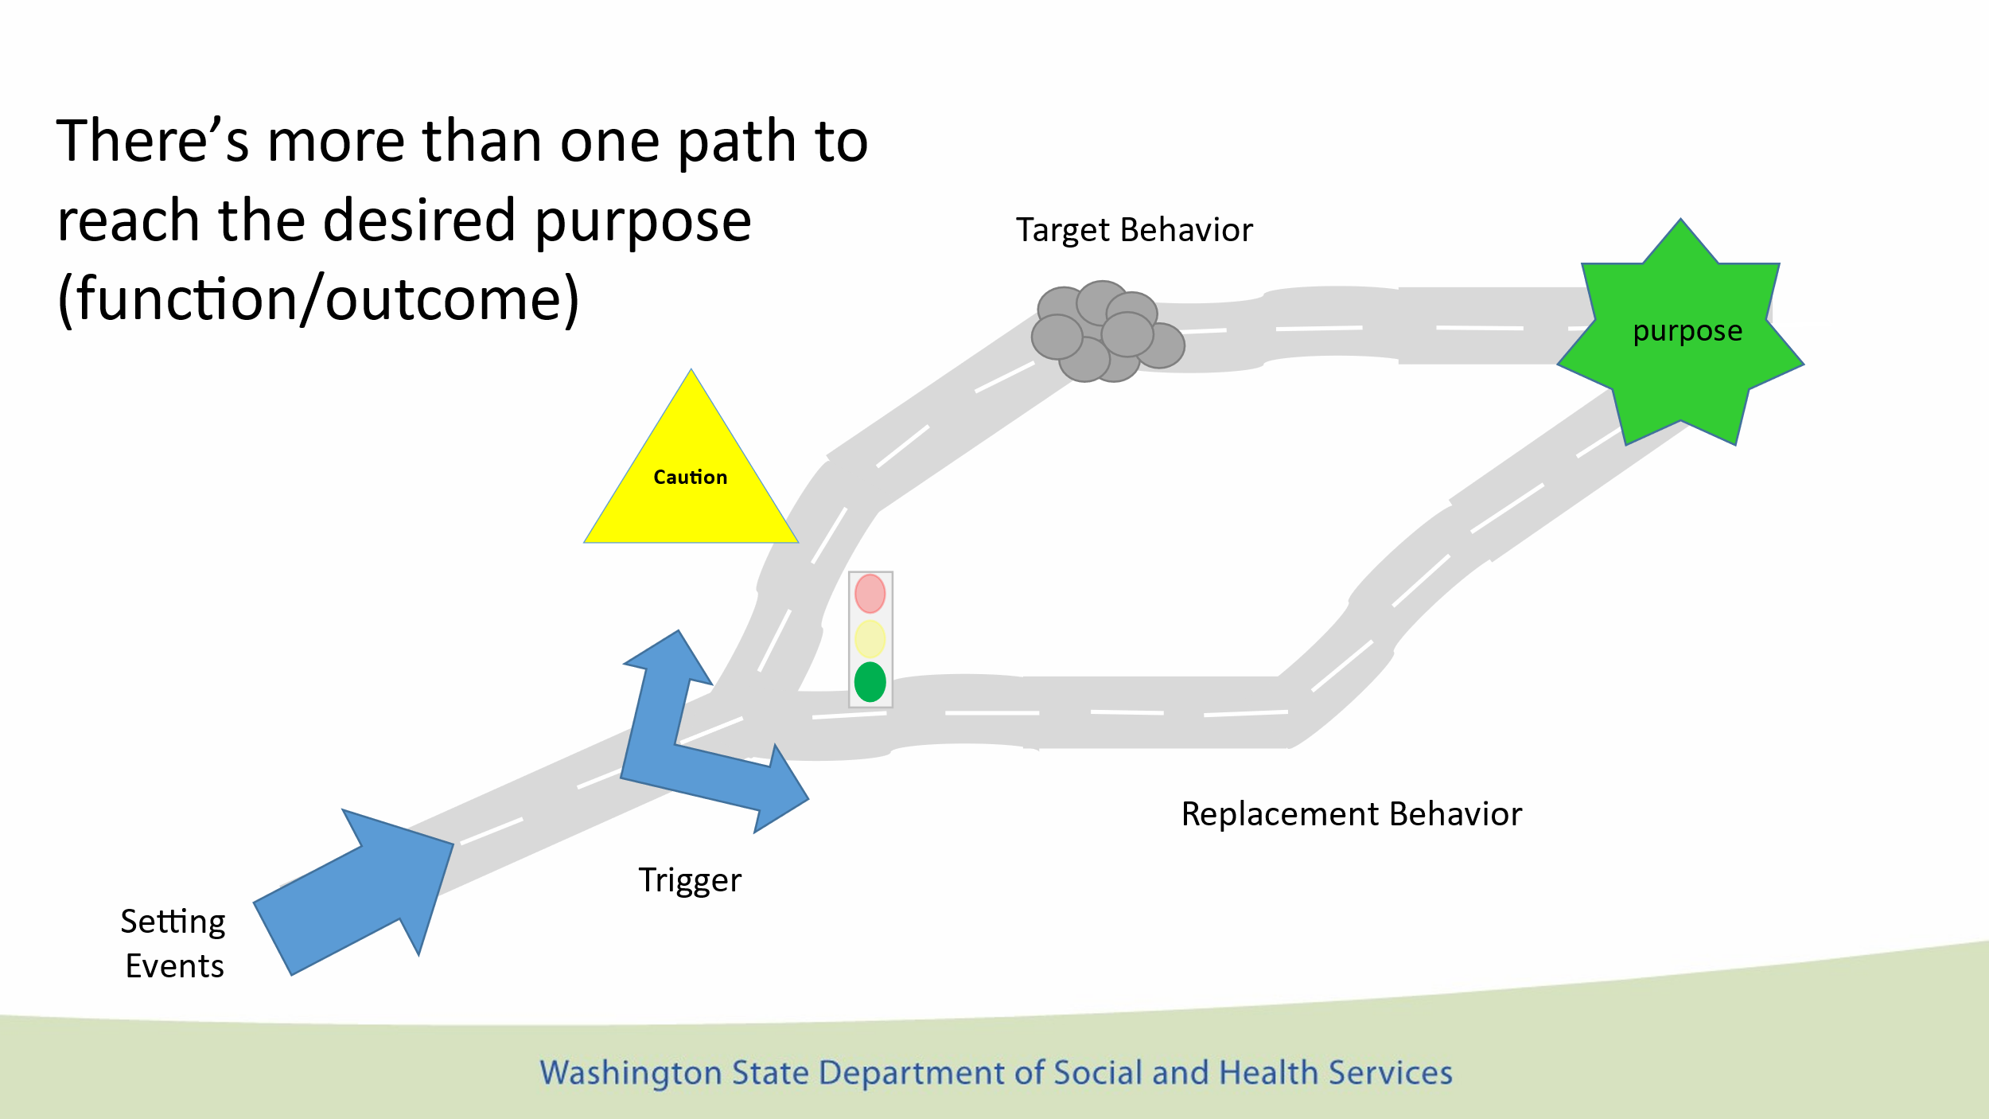

1. **Goals and data gathering and analysis:**

Identify reduction goals for this plan period including how they will be measured.

Identify replacement goals for this plan period including how they will be measured.

How and where will this be documented? What is the team’s general plan for analysis?

Clearly list data collection expectations - where, how often, etc.

1. Repeat for the Behavior of Concern 2 and its Replacement Behavior.
2. **Behaviors of concern prioritized for future plan:**

An PBSP should target only two behaviors even if other behaviors have been identified as “extensive support needed” in the CARE assessment. The behaviors required to be in the plan include injury to self or others, property destruction, sexual aggression, suicidality and intense emotional outbursts. When more than two behaviors are identified they will be assessed in the functional assessment and then ranked in order of importance with the next most important being ranked number one. While implementing the current plan, these behaviors should be monitored by periodic data collection. If any of these behaviors becomes more of a concern, the current plan should be modified to refocus on the primary two behaviors of concern. If data collection shows that ranking of the behaviors have changed, the list would be adjusted. When a new behavior is ready to be incorporated into the plan, a quick re-assessment will be required to ensure that the hypothesized functions remain current and skills and supports needed are updated.

As replacement behaviors become mastered, the behaviors of concern should decrease and eventually be able to be reduced to “some” or “no” support needed in the CARE assessment.

Also consider if it would be more appropriate for the person to include any of these behaviors as part of their Individualized Instruction and Support Plan As behaviors of concern are reduced and replacement behaviors are mastered also consider continuing to monitor progress and show how the replacement has generalized to other areas.

| **Behaviors of concern prioritized for future plan:** *Rank in priority order the behaviors that will become part of the next functional assessment and positive behavior support plan. Monitoring of the current plan and these behaviors will help guide revision of this plan and future plans as data is gathered and evaluated.* |
| --- |
|  |

1. Previously mastered replacement behaviors: In order to have the FA/PBSP be a living document as replacement behaviors are mastered, they will be put here with the date of the original FA, where it was assessed and the date it was mastered and removed from the plan.

|  |  |  |
| --- | --- | --- |
| **Previously mastered replacement behaviors** | **Original FA/PBSP dated** | **Date removed** |
|  |  |  |
|  |  |  |

**De-escalation and Crisis Intervention:**

1. **De-escalation procedures:**

Once the training opportunity for the replacement behavior has passed. The individual has chosen the path to the purpose in which the behavior of concern is likely to occur. Staff should switch from a teaching mode into one of de-escalation. For every potential escalation behavior listed in the behavior of concern, provide an action for staff to use to de-escalate the situation. The action may be taken from the agency’s de-escalation training (right response, therapeutic options, Ukeru).

Include what will be documented (this should relate back to the behavior of concern) and where the documentation will be sent (Complete data tracking sheet. IR sent to DDA CRM. GER sent to program manager).

1. **Crisis response procedures:**

If the behavior warrants a crisis response, this is where that information would go. Crisis responses address behaviors of concern that pose an immediate danger of significant harm to the individual, to others or to the house or property. These are often the highest severity identified for the behavior of concern. When the behavior of concern escalates to this level, staff stop de-escalation procedures until everyone involved is safe. For every crisis response behavior listed in the behavior of concern, provide a technique for staff to use to maintain the safety of the individual, others and property. The technique will be taken from the agency’s de-escalation training (right response, therapeutic options, Ukeru).

Include what will be documented. This should relate back to the behavior of concern. State where the documentation will be sent. Summarized data tracking sheets should be sent to DDA case resource manager. If manual holds or physical restraint are authorized in the plan, completion of restraint logs and observation forms are completed and filed in the client’s record. Incident report sent to DDA CRM. General Event Reports (GER) sent to program manager. For crisis level behaviors of concern, include any medical attention necessary and any involvement with outside agencies such as law enforcement. The Cross System Crisis Plan will be important to reference for this section. See Policy 5.18: Cross System Crisis Plans.

**Restrictive Procedures**

Follow the directions on the form and refer to Policy 5.15: Restrictive Procedures: Community and Policy 5.17: Physical Intervention Techniques. For restrictive procedures that require an exception to policy (RP-ETP), additional paperwork is required (forms 02-556 Request for ETP and 15-385 Consent for ETP).

Please consult with your CRM and Regional Clinical Team for any questions or concerns regarding RP-ETP submissions.

**SIGNATURE BOXES**

The author of the plan is required to sign the document.

Signature of the person receiving services indicates that they agree with the plan.

Signature of the guardian indicates that they agree with the plan, if applicable.