Date: October 8th, 2025

Time: 9:00am – 10:30am

Location: Online training
On-line Training
Developmental disabilities community services
region 3 clinical team

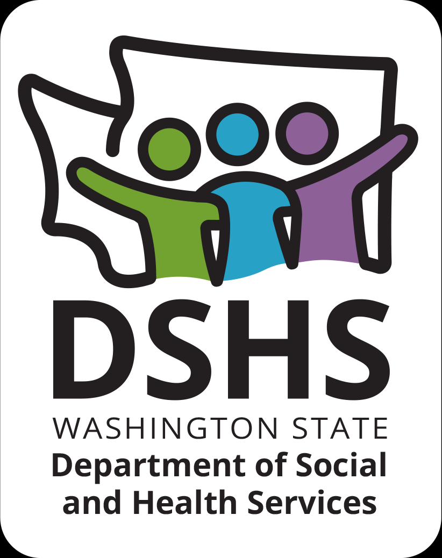
Figure 1 Developmental Disabilities Administr ation Logo

Figure 2 Developmental Disabilitiies Administration Logo

October 8th, 2025 9:00am to 10:30am
Listening to Understand
Presented by:
Dr. Emily Branscum & Ryanne Smith, MSW

Working with people who have been diagnosed with developmental/intellectual disabilities can be challenging.

This course will provide an overview of reflective listening and how it can decrease power struggles between direct support professionals and the people in their care. These skills will help reduce staff burnout, build good interactions between staff and people in their care, and provide the best quality of life options for people in residential care.

REGISTRATION LINK: https://events.humanitix.com/r3-listening-to-understand-oct-8th-9am-1030am-ryanne-smith-emily-branscum
Additional classes are listed online at DDA Provider Training Opportunities
Please Note:
- Class starts promptly at the stated times. If you are late, you may not receive credit.
- Please print any handouts, if provided, as they may be used in the class.
- Use of video is preferable.
- Please do not use a cellphone, a computer with screen is recommended to attend this course.
Class Size: Limited to 25 Participants
1.5 CE Credits

