

**Tacoma**

**Developmental disabilities administration**

**Continuing education**

**Training**

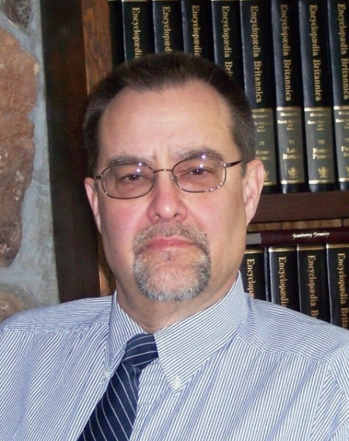

Mar 23 & Apr 20, 2018 25 CEUs On-line/In-person blended training 9 AM to 4 PM

**Creating Functional Assessments and Positive Behavior Support Plans**

Supporting Individuals with intellectual disabilities experiencing challenging behaviors requires unique and individualized supports. This blended on-line and in-person learning opportunity will provide an introduction to conduct a comprehensive Functional Assessment (FA) and design and implement a Positive Behavior Support Plan (PBSP) for people we support. The course will take two to three months to complete. It is required that attendees complete all on-line modules and take both the FA and PBSP workshops to complete the series.

First month-Functional Assessment:

[On-line courses](https://fortress.wa.gov/dshs/adsaapps/TPTesting/PBSP/module1a/story.html) Modules 1a, 1b, 1c, 2a, 2b & 3 must be completed and workbooks submitted by **March 16th 2017:** in order to enroll in this series.

Classroom training #1 **March 23rd, 2018**:

During class, students will have the opportunity to have questions, conduct a peer review of plans, receive feedback on the plan they drafted and receive additional instruction on concepts of Functional Assessment.

Each on-line class has DSHS approved CE credits. This classroom training is DSHS approved for 4 CE credits.

Second month-Positive Behavior Support Plan:

[On-line courses](https://fortress.wa.gov/dshs/adsaapps/TPTesting/PBSP/module4/story.html) Modules 4 and 5 must be completed by **April 6th, 2018**

Classroom training #2 **April 20th, 2018**

Each on-line class has DSHS approved CE credits. This classroom training is DSHS approved for 6 CE credits.

Class size limited to 26 participants

**Presenter: Dr. Edward Fischer**

**From North**:

Head South on I-5. Take Exit #101 Tumwater Blvd. Turn LEFT onto Tumwater Blvd. Travel approximately 1 mile. Turn LEFT onto Capitol Blvd. Go past Israel Road to the buildings with the fountain and clock. Just past the clock tower,

**From South:**

Head North on I-5. Take Exit #101 Tumwater Blvd. Turn RIGHT onto Tumwater Blvd. Travel Approximately 1 mile. Turn LEFT onto Capitol Blvd. Go past Israel Road to the buildings with the fountain and clock. Just past the clock tower,

**Directions from Yelm Hwy**

Head away from Lacey towards Tumwater on the Yelm Hwy. Take a LEFT on the light at Henderson Blvd. Follow it to Tumwater Blvd. Take a RIGHT at Tumwater Blvd. Turn RIGHT onto Capitol Blvd. Go one block past Israel Road to the buildings with the fountain and clock. Just past the clock tower,

**

[DDA Tacoma Office, 1305 Tacoma Ave S., Suite 300, Tacoma, WA 98402](https://binged.it/2efAX8C)

**Parking is not available in the Garage attached to our Tacoma DDA office/the Work Source Bldg. People park on the street or in pay to park lots. Advise that you come early and plan ahead.**

You must attend all of the trainings and submit plans meeting quality standards to receive a certificate in writing FA/PBSP. Class starts promptly if you are late you will be asked to sign up for a future training. For Questions: Call Sandi Miller at 360-407-1537. Do not call to register, use form attached.

Mar 23 & Apr 20, 2018 25 CEUs On-line/In-person blended training 9 AM to 4 PM

**Please register early as space is limited and the training sessions fill quickly. Registration ends two weeks prior to the date that the Online Courses need to be completed (see above).**

**If assistance for persons with disabilities is needed, please give us the information by March 2, 2018** by writing it in the space below. If you don’t receive a confirmation of this request please contact us. You can call Melody Erickson at 253-404-5560.

I need this special accommodation: ________________________________________

**Send this registration form and completed workbooks from on-line Modules via email:**

[**PBSPTraining@dshs.wa.gov**](mailto:PBSPTraining@dshs.wa.gov)

**Sandi Miller, Developmental Disabilities Administration**

**Additional classes are listed online at** <https://www.dshs.wa.gov/dda/dda-provider-training>

|  |  |  |  |  |  |
| --- | --- | --- | --- | --- | --- |
| |  |  | | --- | --- | | **Who Should Attend?**  This workshop is for DDA contracted providers who write & implement FA’s & PBSP’s to include; Supported Living, Group Homes, Group Training Homes, Alternative Living, Companion Homes,  State Operated Living Alternatives, Crisis Diversion/Supports, Community Intermediate Care, County Day Programs, Behavior Support Providers and Community Crisis Stabilization Services. | Please fill out, if you can, the below information:  Name of Company/Employer:  ______________________________________  Address of Company/Employer:  ______________________________________  ______________________________________    Phone Number:  ______________________________________ | | |  |  | | --- | --- | |  |  | |
|  | Please fill out, if you can, the below information:  Name of Company/Employer/AFH:  ______________________________________  Address of Company/Employer/AFH:  ______________________________________  ______________________________________    Phone Number:  ______________________________________   Individual Providers, can attend, but CEUs do not apply. IPs go through the Training Partnership for CEUs. |

Participants Name: ___________________________________________________________

Provide Email, Fax, or Address to send confirmation notice: (Email is preferred)

___________________________________________________________________________

___________________________________________________________________________

Phone number in case of last minute changes to training: _______________________________

**Tacoma**

**Developmental Disabilities Administration**

**Creating FA & PBSPs**

**Registration Form**