Date: November 18, 2025

Time: 12:30pm – 3:30pm

Location: Vancouver FSO,
800 NE 136th Ave #110, 150B All Staff Room,
Vancouver, WA 98684
In-Person Training
Developmental disabilities Community SErvices
REgion 3 Clinical Team

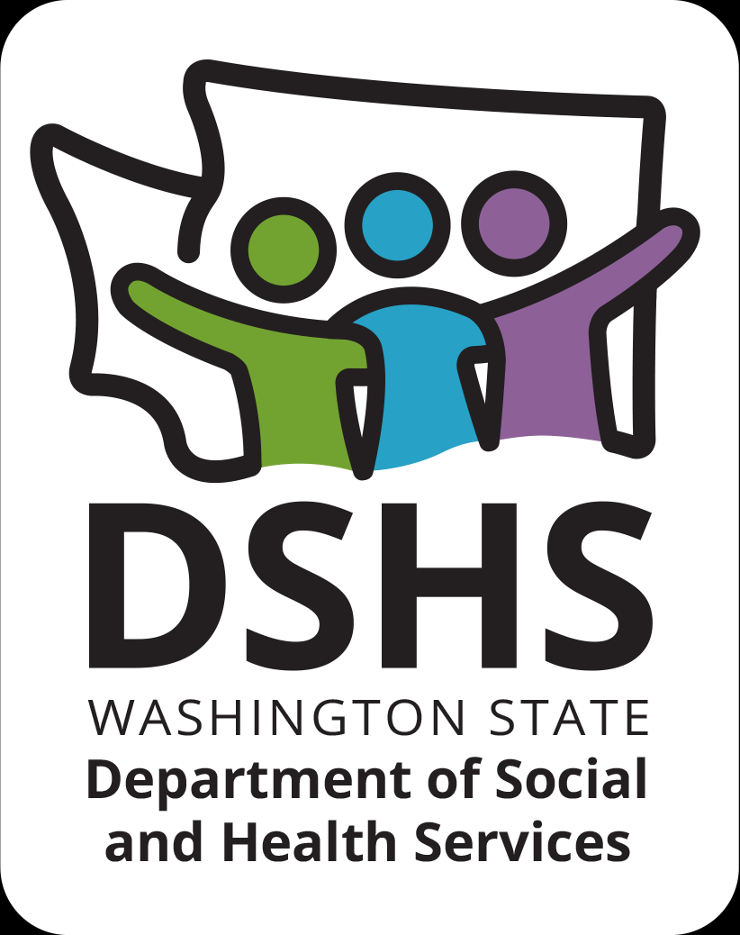
Figure 1 Developmental Disabilities Administr ation Logo

Figure 2 Developmental Disabilitiies Administration Logo

November 18th, 2025 12:30pm to 3:30pm
I Am Not Okay
Presented by:
Ryanne Smith, MSW

We all experience times of emotional difficulty. Treating people with care and respect during these times shows our humanity and compassion.

This course will provide you with an understanding of what happens in the brain during times of stress, why people are unable to “just stop”, and strategies to avoid the next big meltdown. Attendees will learn new tools and techniques to lessen the severity of emotional reactions and how to encourage regulation.
To Register: Please email Ryanne Smith at ryanne.smith@dshs.wa.gov and provide the following: -Name, email address, agency and job position of each participant

Additional classes are listed online at DDA Provider Training Opportunities
Please Note:
- Class starts promptly at the stated times. If you are late, you may not receive credit.
- Please print any handouts, if provided, as they may be used in the class.

Class Size: Limited to 25 Participants
3 CE Credits

