QUALITY ASSURANCE INDICATORS
FOR PERSONS WHO HAVE MOVED FROM RESIDENTIAL HABILITATION CENTERS (RHCs) TO THE COMMUNITY
1988 - 2009

What is the history of the RHCs?

- Lakeland Village in Medical Lake was established in 1908 and had a population of 1,650 residents at its peak.
- Rainier School in Buckley opened its doors in October 1939, and had about 1,900 residents at its peak.
- Fircrest School in Shoreline opened in 1950 and had about 1,000 residents at its peak.
- Yakima Valley School in Selah was established in 1958 to serve the needs of children and was later converted into a nursing home. At its peak it had 250 residents.
- Interlake School was established in Medical Lake to specifically address the needs of the medically fragile population. It was subsequently closed in 1994 and all residents moved to other RHCs or the community.
- Francis Haddon Morgan Center in Bremerton originally specialized in serving children with autism and opened with a capacity of 48; its current census is 56.

From 1970, the institutional population steadily declined from over 4,000 people to today’s census of 945 long term residents (or 975, including short term respite clients). Several factors contributed to this decline.

In 1972, Washington passed the first “Education for All Act” requiring school districts to provide education for all children, including children with severe disabilities. Federal legislation soon followed and States have been encouraged through major federal policy, funding decisions, and law suits to decrease reliance on institutional settings.

In the 1980s, states were encouraged to establish community-based living arrangements through the establishment of Home and Community Based Services waivers, which allowed the same federal reimbursement to community-based programs as was being received by institutions. As a result, Washington State financing has reversed from approximately 80% to institutional care and 20% to community services to the current approximately 80% to community supports and 20% to institutional care. The Centers for Medicare and Medicaid (CMS) have made several grant opportunities available over the years to help states rebalance their systems and provide increased opportunities to live in the community.

In June 1999, the Supreme Court decision regarding Olmstead vs. L.C found that individuals should be offered placement in the least restrictive environment possible.

The RHC population decline is shown in the chart below. The information was extracted from the Executive Management Information System (EMIS), October 22, 2009.

 | Residential Habilitation Center Population*
 | Fircrest | Rainier | Lakeland | Interlake | YVS | FHMC | Total
Jun-88 | 495 | 561 | 333 | 207 | 149 | 54 | 1799
Jun-89 | 494 | 562 | 329 | 204 | 149 | 56 | 1794
Jun-90 | 464 | 535 | 301 | 194 | 148 | 54 | 1696
Jun-91 | 432 | 495 | 319 | 141 | 134 | 54 | 1575
Jun-92 | 409 | 472 | 302 | 135 | 127 | 53 | 1498
Jun-93 | 389 | 467 | 306 | 122 | 125 | 55 | 1464
Jun-94 | 391 | 472 | 310 | 0 | 120 | 53 | 1346
Jun-95 | 377 | 459 | 298 | 0 | 119 | 54 | 1307
Jun-96 | 372 | 453 | 288 | 0 | 113 | 55 | 1281
Jun-97 | 340 | 446 | 290 | 0 | 113 | 57 | 1246
Jun-98 | 322 | 442 | 285 | 0 | 117 | 56 | 1222
Jun-99 | 293 | 433 | 263 | 0 | 110 | 54 | 1153
Jun-00 | 283 | 426 | 258 | 0 | 107 | 54 | 1128
Jun-01 | 279 | 424 | 254 | 0 | 99 | 49 | 1105
Jun-02 | 268 | 412 | 247 | 0 | 97 | 48 | 1072
Jun-03 | 262 | 381 | 251 | 0 | 105 | 55 | 1054
Jun 04 | 210 | 399 | 248 | 0 | 108 | 54 | 1019
Jun-05 | 190 | 396 | 250 | 0 | 102 | 54 | 992
Jun-06 | 191 | 392 | 245 | 0 | 105 | 55 | 988
Jun-07 | 209 | 392 | 249 | 0 | 107 | 54 | 1011
Jun-08 | 206 | 386 | 236 | 0 | 103 | 55 | 986
Jun-09 | 205 | 380 | 233 | 0 | 102 | 55 | 975
*Includes short term respite stays.

During this period, the RHC population declined by approximately 824 clients who moved into the community or through attrition.

What system has been used by DDD to assure the health, safety, and habilitation of those who have moved from the RHCs?

In 1986, there was a significant downsizing of Rainier School. In order to help ensure the quality of life for people who moved, the Developmental Disabilities Council (DDC) funded a project to survey the people who moved in an effort to understand how their lives were affected. This information was included in a report entitled “The Rainier Follow-Along Study.”

In 1990, when five of the DDD institutions were decertified, DDD was directed to do another significant downsizing, and more than 200 people were moved to community settings. The division hired a consultant to help revise a quality assurance follow-along tool, and to use it to evaluate the quality of life for those people who moved from the RHC to the community. The tool is used for quality assurance visits at various periods of time after the person leaves an RHC. The tool continues to be updated and used when individuals move.

Are there other quality assurance practices in place?

During the first year a person lives in the community, they receive quality assurance evaluations at thirty days, three to six months, and one year. After that, the state contracts with independent contractors to do residential agency evaluations of services. These contracts cover certified residential agencies, group homes and companion homes. If the person lives in an adult family home, boarding home, or nursing home, staff from the Aging and Disability Services Administration (ADSA) Residential Care Services Division performs that function.

For individuals who have moved to the community since 2007 under the “Roads to Community Living” federal grant, there is additional oversight through a federally required survey done by the Developmental Disabilities Council before the person leaves the RHC, and at one and two year intervals after the person has moved to the community.

Does the state have an overall quality assurance plan for people who live in the community?

In 2000, DDD established an Office of Quality Programs and Services, which includes provider and field services training, contract management, and incident reporting management. The six geographic regions have appointed Quality Assurance Managers to work with the Office of Quality Programs and Services. The focus of the office’s activities is consumer health, safety and satisfaction.
DDD also established a quality control program in the Office of Quality Control and Compliance. This seven member team is comprised of a Unit Manager and six Quality Control Compliance (QCC) Coordinators. The coordinators are headquarters employees assigned to each of the six regions. The team’s purpose is to facilitate the creation and consistent application of policy and procedures to help ensure a more reliable DDD service system. This team conducts annual audits of DDD’s five HCBS waivers. Team members are also responsible to provide on-site consultation and to train field services staff in each of these program areas.
In 2007, DDD implemented a new computer-based assessment tool called the “DDD Assessment.” The DDD Assessment contains several validated assessment tools that are designed to measure the unique support needs of people with developmental disabilities for a variety of tasks in many types of settings. In conjunction with the implementation of the DDD Assessment, the division instituted ongoing quality assurance measures to ensure that case resource managers continue to administer the DDD Assessment in accordance with established standards set forth in training. DDD hired an assessment program manager with staff in each region to provide case resource managers with ongoing training and monitoring to ensure that assessments are conducted in a consistent manner by qualified staff.

In addition, community providers have training requirements as part of their contracts to provide services. All new employees of certified providers have 32 hours of training that must be accomplished in the first six months of service. Adult family home, boarding home, and group home providers must take the “Fundamentals of Care Giving” training developed by ADSA’s Home and Community Services Division, plus DDD specialty training. Day program services delivered through county contracts must meet state standards as described in the contract, as well as any additional standards imposed by the county.

The division also contracts for technical assistance to providers when issues of concern for the person’s behavior, health or welfare arise. Technical assistance is also used to provide training required by statute (WAC 388-101-3260). Technical assistance helps providers make ongoing improvements in services, provide positive behavior support and restrictive practices training, and provide expert help in all matters of service delivery.

All individuals who are providers are mandatory reporters to the Adult Protective Services (APS), Child Protective Services (CPS), and Residential Care Services (RCS). In cases of abuse, abandonment, neglect and financial exploitation, reports must also be made to law enforcement. Each of these entities does investigations, which result in findings which either clear the provider or require action to be taken.

In addition, DDD also has an Incident Reporting (IR) system that providers are required to use to report the above plus other serious incidents to case resource managers, who monitor corrective actions that providers institute to prevent further incidents.

All community providers must have criminal history background checks every three years.

Do people leaving the RHCs have federal oversight under Home and Community Based Waiver Programs?

All people who move from the RHCs are enrolled in HCBS waivers. Currently, DDD operates five waivers: Basic, Basic Plus, Core, Community Protection and Children’s Intensive In-Home Behavioral Support. The waivers have stringent health and welfare rules for quality assurance. The Centers for Medicare and Medicaid (CMS) has accepted DDD’s Quality Management System and there have been no negative findings concerning the health and welfare of the people who are on the waivers. In fact, the last CMS report commended the state for its quality assurance plan and implementation.

What do reports show in relationship to the well being of those who have moved?

Status reports that are on file from 1991 forward indicate a positive result for the vast majority of people who have moved from an RHC to the community. When issues of concern are brought to the attention of DDD case resource managers, they are required to follow up and resolve the concern.

What is the death rate in RHCs in comparison to people receiving supported living services in the community?

Number of Deaths from January 2003 through December 2008
The data collected shows mortality rates in community-based settings are comparable to those in state facilities. The two charts below, compiled by DDD, are for the period January 2003 through December 2008. There were 129 deaths in the RHCs and 499 deaths in supported living, group homes, and adult family homes in the community. When averaging the percentage for that time period, it shows the percentage of deaths, were 2.17% of the total population in the RHCs and 1.52% of the total population living in supported living, group homes, and adult family homes in the community.

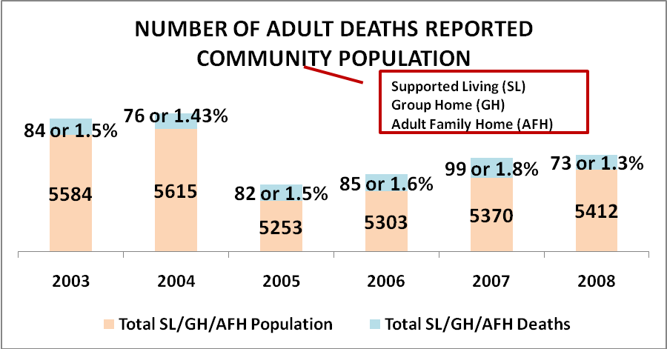

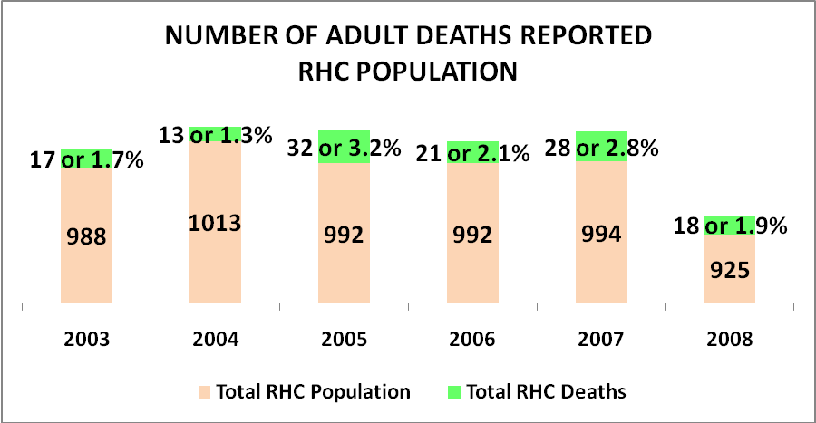

Have people been satisfied with their services in the community and if not, have they been able to move?

To use Fircrest RHC as an example: From 1990 to 1999, 173 people moved to the community. Of those who moved, 125 (or 72%) were supported by the same provider throughout this period; 28 people (16%) changed providers, 17 died (over the 10 year period), and 3 were discharged (moved to other states).

What happened to people and staff when Interlake School was closed in 1994?

All people who were moved from Interlake because of the legislated closure were able to move to the place they desired, whether it was the community or another RHC.

- 23 Interlake residents moved to the community
- 59 Interlake residents moved to Lakeland
- 18 Interlake residents moved to Fircrest
- 11 Interlake residents moved to Yakima Valley School
- 6 Interlake residents moved to Rainier

Residents in the other RHCs who wanted to move were able to do so this enabled Interlake residents to move to their preferred RHC.

None of the residents who moved died as a result of the move.

Of the 303 state employees who were laid off, only six employees did not receive other job options.

In a report to the Legislature on the Interlake closure dated August 18, 1994, the then director of DDD summarized the move by saying, “Interlake school closure was carried out within the context of a set of general guidelines which, in summary, called for:

- Phasing out Interlake on time and on budget;
- Reducing RHC census by 123 residents through community placements;
- Fully protecting the rights, interests, safety and welfare of RHC residents who would move between facilities and into the community as the result of these efforts; and
- Arranging all transfers on a voluntary basis and providing maximum opportunities for participation in planning for parents and guardians.”

For more information or copies of any of the materials referenced, please contact:

Janet Adams, Chief
DDD Office of Quality Programs and Services
adamsje@dshs.wa.gov
360/725-3408

