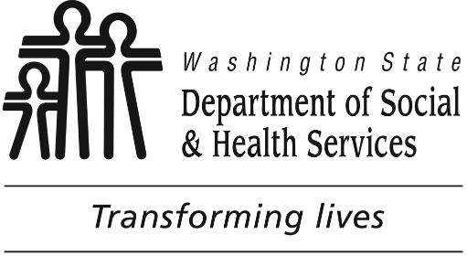

Aug 14 & Sept 27, 2018 25 CEUs On-line/In-person blended training 10 AM to 3 PM

**Developmental disabilities administration**

**Continuing education**

**Training**

**Creating Functional Assessments and Positive Behavior Support Plans**

Supporting Individuals with intellectual disabilities experiencing challenging behaviors requires unique and individualized supports. This blended on-line and in-person learning opportunity will provide an introduction to conduct a comprehensive Functional Assessment (FA) and design and implement a Positive Behavior Support Plan (PBSP) for people we support. The course will take two to three months to complete. It is required that attendees complete all on-line modules and take both the FA and PBSP workshops to complete the series.

First month-Functional Assessment:

[On-line courses](https://fortress.wa.gov/dshs/adsaapps/TPTesting/) to be completed by **July 30th:**

Modules 1a, 1b, 1c, 2a, 2b & 3 must be completed and workbooks submitted by due date in order to enroll in this series.

Classroom training #1 **August 14th**:

During class students will have the opportunity to have questions, conduct a peer review of plans, receive feedback on the plan they drafted and receive additional instruction on concepts of Functional Assessment.

Each on-line class has DSHS approved CE credits. This classroom training

is DSHS approved for 4 CE credits.

Second month-Positive Behavior Support Plan:

[On-line courses](https://fortress.wa.gov/dshs/adsaapps/TPTesting/) modules 4 & 5 to be completed by **September 10th**

Classroom training #2 **September 27th**

Each on-line class has DSHS approved CE credits. This classroom training

is DSHS approved for 6 CE credits. Class size limited to 26 participants

**Who Should Attend?**

This workshop is for DDA contracted providers who write & implement FA’s & PBSP’s to include; Supported Living, Group Homes, Group Training Homes, Alternative Living, Companion Homes,  State Operated Living Alternatives, Crisis Diversion/Supports, Community Intermediate Care, County Day Programs, Behavior Support Providers and Community Crisis Stabilization Services.

**Please tell us at least two weeks in advance if you need a special accommodations** by writing it in the space below. We need two weeks to process your request. **If you don’t receive a confirmation of this request please contact us**. For accommodations, you can call Sandi Miller at 360-407-1537

**Send this registration form and completed workbooks from on-line Modules via email:**

[**PBSPTraining@dshs.wa.gov**](mailto:PBSPTraining@dshs.wa.gov)

**Sandi Miller, Developmental Disabilities Administration**

**Additional classes are listed online at** <https://www.dshs.wa.gov/dda/dda-provider-training>

**Participant’s Name:**

**Email:**

**Employer Name:**

**I need this special accommodation:** _______________________________________ _

[DDA - Lunchrooms A & B](https://www.google.com/maps/place/1700+E+Cherry+St,+Seattle,+WA+98122/@47.6084909,-122.3118333,17z/data=!3m1!4b1!4m5!3m4!1s0x54906ac50c033497:0x465231a21e9a2f86!8m2!3d47.6084909!4d-122.3096446)

[1700 E Cherry St., Seattle, WA 98112](https://www.google.com/maps/place/1700+E+Cherry+St,+Seattle,+WA+98122/@47.6084909,-122.3118333,17z/data=!3m1!4b1!4m5!3m4!1s0x54906ac50c033497:0x465231a21e9a2f86!8m2!3d47.6084909!4d-122.3096446)