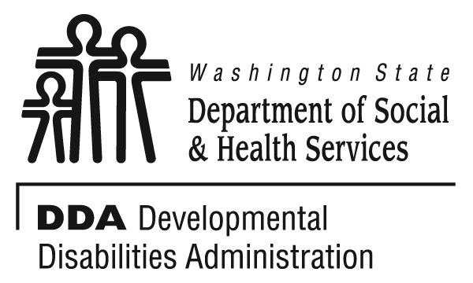

2000 -2009

Looking Back at Developmental Disabilities Services in Washington State during the First Decade of the 21st Century


February 21, 2014

This report relies heavily on data collected from the National Core Indicators (NCI) to explore changes in Washington State’s developmental disabilities service system over the first decade of the 21st century. One of the major goals of NCI is to collect and maintain valid and reliable data about the performance of public developmental disabilities service systems. The National Association of State Directors of Developmental Disabilities Services (NASDDDS) and the Human Services Research Institute (HSRI) provide the infrastructure for this effort by facilitating the Operations Committee (composed of participating state coordinators), providing technical expertise, data analyses and reports of data submitted by participating states. HSRI staff can provide special analyses of NCI data for participating states as needed. Washington State entered into a special contract with HSRI to analyze Washington State’s NCI data over time and to perform a literature review of national trends in developmental disability services during the first decade of the twenty-first century.
The Washington State Developmental Disabilities Administration wishes to thank Dorothy Hiersteiner, Julie Bershadsky, Josh Engler, Human Services Research Institute and the National Association of State Directors of Developmental Disabilities Services for their contributions to this report and to the National Core Indicators effort in general.
NCI relies on the individual participating states to make connections, observations, interpretations and recommendations based on NCI results as they pertain to their local state. This requires extensive, in-depth, historical, local program knowledge and familiarity with local nuances in how data were collected. As such, this report would not be possible without the collaborative efforts of NASDDDS and HSRI, as well as Washington State Developmental Disabilities Administration staff.
HSRI staff analyzed specific question wording over the years to determine compatibility, then combined data sets submitted by Washington State over the years to determine whether statistically significant changes had occurred for each question over time. Data analytic rules have varied somewhat over the years, so HSRI applied the current rules to each historical data set. HSRI also performed a literature review of national changes to developmental disabilities service systems over time and wrote the sections of this report pertaining to national trends.
DDA staff compiled a list of historical events within Washington State as well as national trends on NCI indicators as published in annual reports over time, and then correlated those events with statistically significant findings identified by the HSRI team to interpret the meaning of these findings. In some instances, HSRI was unable to locate certain historical data, or their analyses of the historical data set was too divergent from the trend of results over time to deem the data to be consistent with future data points. Where possible, DDA staff was able to locate reports from the early years of the NCI effort and insert these values into the charts and graphs. DDA staff also performed analyses of local data sets to supplement the findings in this report, and wrote the sections of the report addressing Washington State specific trends and events.

“The whole is greater than the sum of its parts” – Max Wertheimer
Looking Back at Developmental Disabilities Services in Washington State during
the First Decade of the 21st Century

trends In developmental disability services

Approaching the Turn of the Century
Just prior to the turn of the century, the Division of Developmental Disabilities (DDD) was facing what appeared to be an oncoming super storm. Where it was once quite common for program managers to personally know everyone supported by their Region, the Division’s caseload and their support needs had now grown well beyond its existing infrastructure:
- Caseload ratios were two-and-one-half times higher than the national average;
- The effectiveness of its highly regionalized management approach was being questioned;
- The division’s caseload was growing by 7% per year, with a total growth of 65% since 1992, yet the division’s funding had only grown by 24% over the same period;
- Increasing demands for data-based decision making and accountability were difficult to impossible to meet given the limited amount of data and information available in a centralized location;
- The division was being criticized for inconsistency and lack of responsiveness; and
- Various stakeholder groups for persons with developmental disabilities were at odds with one another, making it difficult to implement any changes to the division’s operations.
In February 1997, aware of the impending storm, the Secretary of the Department of Social & Health Services (DSHS) and the Chair of the Senate Health and Long-Term Care Committee challenged the Division’s stakeholders to construct a unified approach to the Division’s major funding and policy issues. In June 1997, the Secretary formed the DDD Strategies for the Future Stakeholder Workgroup. The Stakeholder Workgroup, assisted by a professional mediator, achieved an “Agreement in Principle” in December 1997, which laid the foundation for addressing funding for unmet service needs and provided a compromise for the historical conflict between those who advocated for institutional and those who advocated for community-based policies and procedures.
The “Agreement in Principle” helped guide legislation proposed by the Senate Health and Long-Term Care Committee during the 1998 legislative session. Key legislative actions during the 1998 session included the following:
- Passing a significant supplemental budget appropriation, allowing the Division to begin addressing the needs of those in deepest crises; and
- SSB-6751 directing the Division to develop a long-term strategic plan in conjunction with a stakeholder workgroup, to make recommendations to the Legislature on how to best meet the needs of people with developmental disabilities and their families, today and in the future.
Dr. Timothy Brown, then director for the Division, re-convened the Strategies for the Future stakeholder advisory group to work toward a consensus on the direction for the division. The first report by this group to the Washington State Legislature, Strategies for the Future, Long-Range Plan Report Phase 1: 1999-2001, (Division of Developmental Disabilities, 1998) was published in December of 1998 and focused on a proposal to stabilize the current system as well as ideas to create a plan for restructuring the service delivery system for the future. The Division also contracted with the Research and Data Analysis within the Department of Social and Health Services to conduct two studies. The first of these two studies, Workload Standards Study: Case/Resource Management in the Division of Developmental Disabilities, (Administrative Services Division, 1999) Report #5.30, was published in March of 1999. The second study, An Analysis of Unmet Service Needs for Washington State’s Division of Developmental Disabilities, (Administrative Services Division, 1999) Report #5.29, was published in September of 1999.
The Supplemental Appropriations Act of 1998 (ESSB-6108) also directed the Joint Legislative Audit and Review Committee (JLARC) to complete a management audit of the Division of Developmental Disabilities (Joint Legislative Audit and Review Committee, 1999). In this review, JLARC made the following observations and recommendations:
- The Division has implemented recent budget provisos according to legislative intent.
- The Division has a plan for closing the gap between the number of clients currently served, and current and future needs of those underserved or unserved; however, the Division had not yet linked its estimates of needed resources to performance indicators.
- JLARC concurs with the Division’s contention that it cannot adequately serve its existing clientele with the current number of case managers.
- The Division should improve its management practices relating to quality assurance.
- The Division’s coordination efforts with other agencies, state and county entities need improvement.
- Communication with legislators, legislative staff and program stakeholders has improved, but the Division is still challenged by meeting the needs and demands of several opposing stakeholders.
Some system change efforts were already underway in the late 1990s. The Legislature had provided funding, beginning in 1996, to develop and operate secure residential and day program placements for persons who are a risk to public safety (a program that would later be established by rule and become known as the Community Protection Program). Concerns were also raised over the population of individuals with developmental disabilities who were residing in state psychiatric hospitals due to severe behavior problems and the lack of available
resources to support them in either community-based settings or in the state’s Residential Habilitation Centers. The Legislature also provided funding to create appropriate community-based placement options to begin reducing the census of persons with developmental disabilities in the state hospitals.
Additionally, DSHS was in the process of drafting their “Olmstead Plan” to be in compliance with the landmark Supreme Court‘s Olmstead Decision of June 1999, that unnecessary segregation of individuals with disabilities is a violation of the provisions of the Americans with Disabilities Act (ADA). The decision requires that persons with disabilities be placed in the community instead of an institution when (1) treatment professionals determine that a community placement is appropriate; (2) the individual wants to move to the community; and (3) the placement can be accomplished taking into consideration the resources of the state and without fundamentally altering the state’s programs.
Guidance was issued by the Centers for Medicaid and Medicare Services (CMS) and the U.S. Department of Health and Human Services’ Office of Civil Rights (OCR) on how to comply with the Olmstead decision. States may meet their obligation under the ADA by demonstrating that they have a comprehensive, effective work plan for placing persons with disabilities in the most integrated setting appropriate and waiting lists are reduced at a reasonable pace.
However, these efforts were not sufficient to avoid legal action against the division.
- In January 1999, the Allen vs. DSHS lawsuit was filed, alleging that persons with developmental disabilities were being abused and neglected at Western State Hospital (WSH), that they were being denied opportunities for discharge and support, and that they were at risk for unnecessary involuntary commitment.
- In November 1999, the Arc of Washington filed a lawsuit over the long waitlist of people needing supports. The Arc of Washington alleged that Washington State was in violation of federal Medicaid law and the Americans with Disabilities Act (ADA) by failing to provide Medicaid long-term services with reasonable promptness to otherwise eligible individuals with developmental disabilities.
- One month later, a mediated settlement agreement to the Allen lawsuit was reached that, among other terms of the agreement, the Division would request funding from the Legislature to implement a 3-phase remedy, titled the Division of Developmental Disabilities/Mental Health Division Collaborative Work Plan. The Division would spend most of the next decade carrying out the terms of the settlement agreement, and the suit was dismissed in July 2008.

The new millennium
The first decade of the new millennium was indeed the ‘perfect storm’. This ten year timespan was littered by additional lawsuits, numerous audits, and media attention. The national economy went into a recession and new funding came to the Division almost exclusively in the form of lawsuit settlements or mitigation responses to audit findings. These funds were usually tied to specific proviso populations, and often just for those with the most significant support needs. Despite these limitations, transformation did occur.

Lawsuits
Lawsuits were being filed in states all across the country regarding waiting lists and failure to comply with the provisions of the Olmstead ruling. Washington State, having already become involved in these suits just prior to the turn of the century, was no exception. Washington State prevailed in court rulings regarding the Arc of Washington State lawsuit when the Court ruled in December 2000 that the ADA does not require a state to increase its number of HCBS waiver slots as this would be a “fundamental alteration” in the state’s services. The plaintiffs responded by raising two additional issues; that current HCBS waiver participants are not receiving all the services that they are entitled to receive, and ICF/MR services have not been provided with reasonable promptness. A settlement agreement was reached with the Arc of Washington in April of 2001, whereby $14 million in additional funding would be provided in July 2002 and additional funding in cumulative increments of $25 million would be provided in each of the next two years to reduce the waitlist.
The Boyle lawsuit was filed in December 2001 and closely paralleled the Arc of Washington State lawsuit. This complaint alleged that Washington State had failed to provide the full range of services offered through its HCBS waiver, the Community Alternative Program (CAP), to waiver participants either through individuals’ not receiving necessary services or not informing them about the array of services offered under the waiver. This lawsuit was stayed pending a ruling on the Arc of Washington lawsuit settlement.
In December 2001, the Marr lawsuit was filed on behalf of persons with developmental disabilities residing in Eastern State Hospital (ESH). A settlement agreement was reached in the Marr lawsuit in November 2002, but like the Allen lawsuit over persons with developmental disabilities being detained in Western State Hospital (WSH), the Division would spend most of the next decade fulfilling the terms of the agreement. This lawsuit was not dismissed till May 2012.
In December 2002 the federal court rejected the Arc of Washington settlement agreement over concerns that the agreement did not ensure that individuals would receive the services that they require. In April 2003, the State also prevailed in the Boyle lawsuit. The class certification was denied and the case dismissed based on the State’s argument that the issues were administrative in nature and should best be addressed individually via the state’s administrative procedures. The plaintiffs appealed the dismissal to the 9th Circuit Court. The Arc of Washington lawsuit was dismissed entirely in June 2003 based on the State’s argument that the issue was no longer relevant because the state was in the process of changing its waiver program. The Arc of Washington also appealed the dismissal to the 9th Circuit, and the case was consolidated with the Boyle case for purposes of oral argument.
In March 2005, the court upheld the decision of the lower court that the ADA is not in conflict with a state’s decision to limit the number of HCBS waiver participants. However, the case was remanded back to the district court to reconsider other aspects of the dismissal. The case was reassigned to a different district court judge, and a new trial was proposed over whether current HCBS waiver participants were receiving all the services to which they are entitled. A settlement agreement was reached in May 2007, and the 2007 Legislature provided an increase in DDD funding in accordance with the settlement, but this still left a large number of individuals without any service funds from the division.
An amended complaint was filed in the Boyle lawsuit in September 2005, alleging that the state was still not providing necessary waiver services with reasonable promptness and the assignment of individuals to the state’s four new waivers resulted in some individuals receiving fewer services than they require and without the right to appeal their waiver assignment. In September 2006, a settlement agreement was reached that required the state to implement a new comprehensive annual assessment process to evaluate each waiver participant’s needs; to allow individuals the right to request a transfer to a different waiver; that waiver services would be documented in the service plan and provided within 90-days; prompt response to requests for new services by waiver participants; individuals would receive clarification of their appeal rights; and the plaintiffs could evaluate randomly selected waiver participant files to determine whether the agreement was being followed. The court approved the settlement agreement in December 2006, and the case was finally dismissed in May 2013.

Audits
Numerous audits also occurred in the early part of the 21st century. The results of each of these audits further eroded the confidence of the Legislature and the public over the operations of the Division of Developmental Disabilities.
In December 2000, the chair of the Senate Ways and Means Committee provided a memo to the chair of the Joint Legislative Audit and Review Committee (JLARC) with concerns over soaring costs in the Voluntary Placement Program (VPP). JLARC was charged with reviewing this program, and they published a briefing report (Joint Legislative Audit and Review Committee, 2001) on their findings in February 2001. The following conclusions were made:
- The Voluntary Placement Program is significantly different in terms of both eligibility requirements and levels of service authorized and provided, as compared to when the process was administered by the Children’s Administration (CA) prior to July 1998.
- Young adults, ages 18-21, make up one-third of the program’s caseload and comprise half of the total expenditure, yet the statute (RCW 74.13.020) define a “child” as being under 18 years of age.
- There are no written uniform criteria used consistently to determine eligibility, levels of service, or levels of reimbursement for services. Therefore, effective cost control measures cannot be assured.
The Legislature responded by capping the Voluntary Placement Program in July of 2001 due to cost concerns, partially funding the Division’s request for additional case managers, and directing JLARC to review the reliability of the caseload and staffing numbers that generated the request.
Simultaneously, the Division was preparing a request for a substantial increase in field staff to lower case management staff-to-caseload ratios based on findings from the report, Workload Standards Study: Case/Resource Management in the Division of Developmental Disabilities, and recommendations by the Strategies for the Future stakeholder advisory group.
In May 2002, JLARC published a scathing interim report from their investigation (JLARC, 2002), claiming the Division lacked effective management controls resulting in an absence of credible caseload and staffing information, clients receiving services who were ineligible, inaccurate caseload counts, and poor linkage between client data and payments for services provided. Therefore, accurate estimates of caseload growth and staffing requirements could not be determined.
Aware of the impending report and growing concerns regarding credibility, the Department of Social & Health Services (DSHS) contracted with Sterling Associates, LLP to conduct an independent review of the Division and provide recommendations. Sterling Associates made the following recommendations in their May 2002 report (Sterling Associates, 2002):
- Realign the Division with stronger, more credible, organizations to avoid further erosion of the service delivery system.
- Clarify, strengthen, and fulfill policy direction based on a new business and service culture.
- Develop operational procedures and practices to support the policy guidance available to the program.
- Develop and implement a policy and supporting plan to communicate in a coordinated way with clients and families, employees, stakeholders, decision makers and elected officials regarding the programs, clients, achievements and challenges facing the division.
- Develop and implement an information technology plan to support policy, address case management and program management needs and to help mitigate program risks.
- Appoint a Deputy to oversee program operations and a Communications Specialist, develop and implement a new client eligibility determination procedure, and improve data accuracy.
DSHS moved the Division into a new administration, combining it with the department’s aging and long-term care service system. The Legislature directed JLARC to continue monitoring the Division of Developmental Disabilities, requesting a performance audit of community services, management of the federal Medicaid program, and case management. The Interim Report (JLARC, 2002) focused on describing DDD services and was published in December 2002. In this study, JLARC acknowledged the strong rise in community-based clients, with about one-third receiving no Division paid services. Of those who did receive paid community-based services, most received more than one, and eighty-one percent of clients received services (such as Medical Assistance) through other parts of DSHS. JLARC raised a concern over the methods for determining level of need for services: “… current assessment procedures cannot ensure that clients with similar needs receive similar services.” The Final Report (JLARC, 2003) was published in June 2003 and made three recommendations, requiring the Division to submit reports to the Legislature at each stage of implementation:

- Develop an assessment process that can be consistently applied to all clients, in all parts of the state. Clients need to be assessed before a determination of services is made.
- Seek outside technical assistance to develop a plan for implementing a case management system in DDD.
- Provide detailed reports on the impacts of the reorganization of DSHS to bring together DDD and the aging and long-term care service system.
Washington State’s HCBS Waiver was audited by the Centers for Medicare and Medicaid Services (CMS) in 2002. Their report, published July of 2002, Washington Medicaid Assessment Report: Community Alternatives Program Waiver (CMS, 2002), raised a variety of issues concerning the management and operation of the waiver. A few of CMS's concerns were:
- Waiver recipients are being denied access to needed services based on funding limitations;
- People are being placed on the waiver for the sole purpose of obtaining Medicaid coverage for state plan services. These waiver enrollees are at 300 percent of the Federal Poverty Level (FPL) and require state plan Medicaid Personal Care services but use no waiver service;
- Data available to monitor the waiver system is insufficient and unreliable; and
- Waiver participants are not being given a choice between waiver and institutional services.

A Corrective Workplan
The Division drafted a corrective work plan, referred to as the Comprehensive Work Plan and released in June 2002, to address the findings and recommendations that arose in the JLARC, Sterling, and CMS audits. The plan was published in Appendix E of the Strategies for the Future, Long-Range Plan Report Phase 3: Final Report (December 2002).
- Strengthen the Management Capacity of the Division
  - Appoint an Assistant Director
    - Establish a new position with responsibility for follow-up on all corrective actions including CMS Waiver, management information systems, policy/procedure development for core data and core systems, including consistent regional application.
  - Establish a Waiver Implementation Team
    - Create a team to manage and implement a new Home and Community-Based Services (HCBS) Waiver program to better meet the needs of the Division and its caseload members, and to remain in compliance with federal HCBS waiver operating requirements.

  - Establish a Compliance Team
    - Create a headquarters unit responsible for establishing business process improvements, designing policies, and creating monitoring reports. The team will define best practices, establish procedural requirements, draft training curricula and create management information reports that will monitor the consistency of system practices.
  - Appoint a Division Communications Specialist
    - The Communications Specialist will focus on the development and delivery of consistent program and management information, both internally and externally.
  - Develop the Comprehensive Work Plan
    - The Division will contract with Rhodes Consulting Services, Inc. to assist with the development and monitoring of a comprehensive work plan that identifies tasks, activities, timeframes, resource needs and expected outcomes for the overall corrective work plan.
  - Create a Division Realignment Plan
    - The Department will review options to meet infrastructure needs, share available resources, expertise or systems and adopt business practices that support policy requirements and program direction.
- Information Technology Systems
  - Data Quality Improvement Plan
    - The Division will identify critical decision data, develop clear and consistent data definitions, and document the data source; develop appropriate business rules to edit the data and develop and implement a quality improvement plan; verify and correct data not meeting business rules; and develop internal policies and procedures related to the management of data.
  - Long-Range Strategic Technology Plan
    - The Division will perform a current systems assessment and inventory, develop a strategic plan for technology, then deploy and implement the technical solution.
- Standardize Business Practices
  - Eligibility Process
    - Using the core principles of the Quality Improvement process, the Division will assign the Compliance/Monitoring team responsibility to develop clear policies and procedures for eligibility that are implemented consistently across regions. In addition the team will formulate monitoring reports that are reflective of each region’s compliance with consistent application of the eligibility rules.
  - Service Assessment Process
    - Using the core principles of the Quality Improvement process, the Compliance/Monitoring team will be assigned responsibility to develop clear policies and procedures for service assessments that are implemented consistently across regions, and for developing curriculum and training field staff.
  - Service Authorization
    - Under the aegis of the Compliance team, perform Quality Improvement process work on the service authorization process that leads to the development of clear policies and uniform procedures, developing curriculum and training field staff.
  - Case Management
    - Under the aegis of the Compliance team, perform Quality Improvement process work on case management processes that leads to the development of clear policies and uniform procedures, developing curriculum and training field staff.
  - Service Termination
    - Under the aegis of the Compliance team, perform Quality Improvement process work on service termination procedures that leads to the development of clear policies and uniform procedures, developing curriculum and training field staff.

Media

News media publicized the audit findings and lawsuits as well as several other incidents. In November 2005, a Seattle television news station aired a special report on unexpected deaths and other incidents at one of the state’s Residential Habilitation Centers. Shortly thereafter, a Seattle-based newspaper published a story alleging lack of oversight by Community Protection Program providers. This story was picked up by the Associated Press and distributed nationally. In another television news expose’ that aired in October 2007, two employees of another Residential Habilitation Center were filmed while physically abusing clients and were later arrested.

CMS Requirements
In addition to local factors and media attention, national factors were also an impetus for the Division’s transformation. In the early years of the new century, there were significant changes in the way that the Centers for Medicare and Medicaid Services (CMS) monitored state performance of Home and Community Based Service Waivers (HCBS). The changes were in part stimulated by the findings of a Government Accountability Office (GAO) report in June 2003, Long-Term Care: Federal Oversight of Growing Medicaid Home and Community-Based Waivers Should Be Strengthened (GAO, 2003). In that report, the GAO found that there were few specific requirements regarding the submission of performance data regarding the provision of HCBS services and that the onsite reviews conducted by CMS were infrequent and sometimes skipped all together. The conclusion was that the magnitude of waiver services nationally had surpassed the ability of CMS to monitor performance given the methods that were being used.
The first step that CMS took to re-conceptualize the way that the agency oversaw quality in Home and Community Based Services was to design the Quality Framework (CMS, n.d.). The framework articulated the components of a quality management system and introduced the importance of design, discovery and remediation (Larson, 2008). Subsequently, CMS directed the states to provide specific evidence on their compliance with waiver assurances including the extent to which any non-compliance had been remediated. CMS also required the states to institute quality improvement policies to solve problems in performance that rose to systems level issues. In order to structure the submission of evidence, CMS required states to develop performance metrics or indicators.
These changes had a profound impact on the quality assurance and quality improvement systems across states. It required states to examine the data they collected, assess how it could be analyzed in the aggregate, identify where new data was required, and to develop methods to capture remediation. In many states like Washington, this required aggregating data that had previously been kept at the county or local level. An infrastructure for gathering information, analyzing it, and then planning and implementing remediation efforts based upon findings also needed to be created. It also meant securing information from other agencies, such as Adult Protective and Child Protective Services, in order to submit evidence on health and welfare. In sum, the new CMS requirement ushered in a more “data driven” management system in states around the country than had existed previously.

Washington State’s Developmental Disabilities service system today
The service system for persons with developmental disabilities residing in Washington State today is very different than it was at the turn of the century. The changes have focused on improved statewide consistency, accountability, transparency, and quality assurance. As compared to the highly regionalized and primarily “clinically-based” management system that existed in the 20th century, the service system in the 21st century is more accurately described as “data-driven” management. The implementation of assessment-based services as well as standardized rate setting mechanisms have not only provided the agency with a wealth of information for decision making and reporting, but have also provided documentation to show that persons with similar needs receive similar amounts of service regardless of where they live in the state. Most agency policies and procedures are now carefully documented and openly available to the general public.
Eligibility rules, service options, and the case management system have gone through substantial redesign. These changes have occurred in collaboration with families, individuals, other agencies and stakeholders as our partners.
Transformations that began prior to the turn of the century continued to blossom in the following decade. Continued state psychiatric hospital downsizing occurred as well as substantial downsizing of the Residential Habilitation Centers. Community crisis and intensive support programs were expanded to begin allowing even those with the most significant support needs to avoid institutionalization and be supported successfully in community-based settings. The state’s long history as a leader in employment for persons with developmental disabilities was strengthened when Washington became the first state in the nation to issue a “Working Age Adult Policy,” for which Linda Rolfe, Director of the Division of Developmental Disabilities from June 2000 to February 2013, was nationally recognized by receiving the Ben Censoni Award for Excellence in Public Services from the National Association of State Directors of Developmental Disabilities Services (NASDDDS) in November 2010.
Despite enormous change, the agency’s values, as documented in the Residential Service Guidelines (Division of Developmental Disabilities, 1998) and the County Service Guidelines (Division of Developmental Disabilities, 1992), are still the foundation for the service delivery system. Today, persons with developmental disabilities in Washington State experience greater power and choice, better relationships, improved status and ability to contribute back to their community, integration, competence, and enhanced health and safety. Participation in the National Core Indicators (NCI) has provided an opportunity to view the impact of Washington State’s developmental disabilities service system revolution through the eyes of our consumers and their families or advocates.

Data sources and methods

Overview of NCI
National Core Indicators (NCI) began in 1997 as a collaborative effort between the National Association of State Directors of Developmental Disabilities Services (NASDDDS) and the Human Services Research Institute (HSRI). The goal of the program was to encourage and support NASDDDS member agencies to develop a standard set of performance measures that could be used by states to manage quality and to compare themselves to other participating states and set benchmarks. Thirteen states initially stepped forward to work on the Core Indicators Project, as it was originally known, and pooled their resources to develop valid and reliable data collection protocols. Washington State joined NCI for the first round of data collection utilizing the new tools in 1999/2000. NCI tools align with basic requirements for assuring quality in HCBS Waivers and over time have become an integral component of many states’ quality management systems. NCI states and project partners continue to work toward the vision of utilizing NCI data not only to improve practice at the state level but also to add knowledge to the field, to influence state and national policy, and to inform strategic planning initiatives for NASDDDS and within the individual states.
The NCI framework includes approximately 100 performance and outcome indicators organized across five broad domains: Individual Outcomes, Health Welfare & Rights, Staff Stability & Competency, Family Outcomes, and System Performance. Each domain is broken down into sub-domains representing specific expectations. For example, “Work” is a sub-domain of Individual Outcomes. The sub-domains are measured by one or more performance indicators developed by the steering committee of participating states. These performance indicators were developed based upon a number of criteria including face validity, usefulness as a benchmark, and feasibility to collect. Indicators have remained largely consistent over the years, although some recent revisions have been made to include enhanced information about health, wellness and employment.
Some indicators are measured using survey data gathered on a sample of individuals with intellectual or developmental disabilities (ID/DD), while others are computed using population data available through state data systems (e.g., mortality reports). The full list of core indicators may be viewed and downloaded on the NCI website at http://www.nationalcoreindicators.org.
Four primary data sources are referenced in this report. The Adult Consumer Survey (ACS) gathers information in a face-to-face interview from service recipients with ID/DD and their proxies. States are expected to interview a random sample of at least 400 individuals. Three family surveys - the Adult Family Survey (AFS), the Family/Guardian Survey (FGS) and the Child Family Survey (CFS) - are administered by mail. The family surveys collect data on family and guardian perspectives of the quality of services and supports received by adults with ID/DD living at home, adults with ID/DD living outside the home, and children with ID/DD living at home. For each Family Survey, states typically send out 1,000 to 1,200 surveys in order to obtain a target return of 400 responses per survey. Figure 1, below, provides a brief description of the target population for each of the four surveys and the method of administration.

FIGURE 1. SUMMARY OF NCI SURVEYS
NCI Survey | Target Population | Method of Administration
Adult Consumer Survey (ACS) | Adults age 18 and older receiving at least one service besides case management | In-person interview
Adult Family Survey (AFS) | Families of adults age 18 and older living at home with parents or relatives and receiving at least one service besides case management | Mail
Family/Guardian Survey (FGS) | Families or guardians of adults age 18 and older living outside the family home and receiving at least one service besides case management | Mail
Child Family Survey (CFS) | Families of children under age 18 living at home with parents or relatives and receiving at least one service besides case management | Mail

Washington State’s Participation in NCI
Figure 2 shows the years included in this report for each survey. Information was gathered from Paid-Services clients only. No-Paid Services clients are not included in the national NCI survey processes.
Washington State participates in each NCI survey process on a bi-annual basis. There was a gap towards the middle of the decade in administering the Adult Consumer Survey due to resource limitations. This process was re-instituted in the spring of 2005 using the Division’s new quality assurance staff as interviewers and collecting data over a 24 month cycle. When the Adult Consumer Survey was reinstated, respondents were restricted to HCBS waiver participants rather than the entire caseload because the process was linked with Washington State’s quality assurance reporting to meet the new guidelines required by CMS and the Quality Framework. The 2006-2007 Adult Consumer Survey results represent interviews conducted in calendar year 2005 and 2006. The 2007-2008 Adult Consumer Survey results represent interviews conducted in calendar year 2007 and 2008.

FIGURE 2: WASHINGTON STATE NCI PARTICIPATION 2000-2009
NCI Survey | 1999-2000 | 2000-2001 | 2001-2002 | 2002-2003 | 2003-2004 | 2004-2005 | 2005-2006 | 2006-2007 | 2007-2008 | 2008-2009
Adult Consumer Survey | X |  | X |  |  |  |  | X | X
Adult Family Survey | X |  | X |  | X |  | X |  | X
Child Family Survey |  | X |  | X |  | X |  | X |  | X
Family/Guardian survey | X |  | X |  | X |  | X |  | X

Longitudinal Data Analysis of independent samples
The NCI surveys are designed to be dynamic instruments that can be adapted and modified based on factors such as the identification of confusing or misleading wording, feedback from stakeholders, or changing priorities in the field of developmental disabilities. As such, the surveys have seen some changes in the past decade covered in this report. Comparisons of results from year to year for NCI surveys should be made with caution: even slight changes in wording or response options of certain questions may affect comparability of results from one year to the next; the mix of participating states differs slightly each year and may affect the NCI Averages; and states draw new samples each year rather than following the same group of individuals. Extra caution was taken when selecting results to present in this report so that only results that likely reflect service system changes, rather than extraneous factors, are presented.
In order to create an aggregate dataset compiling the results from Washington State, NCI staff conducted an analysis of each of the four surveys to ascertain which questions remained comparable for at least 3 data cycles (to allow for meaningful trend analysis) throughout that time period. NCI staff created a merged dataset for each survey. Using these merged datasets, Washington’s data was reviewed to determine how NCI indicators had changed from year to year, noting trends that warranted a further examination and statistical significance testing.
Before significance testing was performed, the variables were recoded by collapsing the responses and creating binary variables. For example, a question that had the categorical response options of “Always or usually,” “Sometimes” and “Seldom or never” was collapsed into a binary variable with response options: “Always/usually” and “Not always/usually”.
Two types of analysis and significance testing were then performed for each variable under consideration. First, was a binary logistic regression with the data cycle year as a fixed-factor predictor and recoded binary item as the dependent variable. This type of modeling provides evidence whether there are ANY significant differences between years, but does not indicate where the difference is (for example, which years have significantly different responses) or whether the significance indicates a potential linear trend (meaning uniformly increasing or decreasing). Second, if the first type of modeling showed significance, a binary logistic regression with year as a linear predictor was performed – i.e. to test whether there is a significant linear trend in the logistic regression of the response variable. In this type of modeling, each one year increment is modeled as if it has an equal impact on the dependent variable. If this second type of modeling shows statistical significance, there may be a linear trend in the responses to the question (i.e. percentages on average are uniformly increasing or decreasing). Because of the large number of comparisons performed, a more conservative level for statistical significance was used in this study (p=0.01, rather than p=0.05).

Other Data Sources
The majority of data presented in this report came from the four NCI survey processes mentioned above. However, other data sources were sometimes utilized in this report as appropriate to describe population or service system changes.
Data on Washington State’s general population was obtained from the Office of Financial Management’s (OFM) website at www.ofm.wa.gov/population. The Population unit within OFM is responsible for developing official state and local population estimates and projections for use in the allocation of certain state revenues, growth management, and other planning functions. The Population unit is the official partner of the U.S. Census Bureau for Washington State and provides estimates of demographic characteristics for the overall Washington State population based on the most recent Decennial Census administered by the United State Census Bureau. Washington State general population data in this report are based on the 2000 and 2010 Decennial Census, with estimates for each year in between calculated by OFM’s Population unit.
Data on client residence, employment, and Paid Services versus No-Paid Services caseload size over time was obtained from the division’s Case Management Information System (CMIS) and service authorization records. Type of residence is entered into CMIS by the client’s case manager and is updated as necessary when the client’s address is changed. Employment information is entered into CMIS by the individual counties via the Aging & Disability Services Administration Web Access tool (AWA), formerly known as the County Human Resource Information System (CHRIS). Counties are funded by the Division to either provide employment and day program services themselves or to sub-contract with private provider agencies. Service authorization information came from AWA and the Social Services Payment System (SSPS).

Trends versus Statistical Significance
Statistically significant differences are results that more than likely are due to true differences rather than random variation. Substantially large sample sizes are often necessary to detect statistical significance, particular when changes are in the mild to moderate range rather than the large range. Therefore, this report discusses patterns in the data that seem to indicate a trend that potentially might have been statistically significant if the sample size was large enough, as well as data patterns that reached statistical significance. Those trends that did reach statistical significance are noted. Trends that did not reach statistical significance are included if they are consistent with a known service system change, but the reader should note that there is a greater chance that these results are due to random variation and may not truly be indicative of what is happening across the entire population under consideration.
The reader should also note that the present study is a correlational study design rather than an experimental study design. Because strict experimental controls were not possible in the data collection and the factors that influence the data, changes over time in the Division’s procedures and processes should be considered “consistent” or “inconsistent” with changes in NCI survey responses. This study design cannot affirmatively state that changes in procedures and processes “caused” the changes in NCI survey responses. The observed changes potentially may be due to other unidentified factors or could be merely coincidental.

Comparison to National Averages
For some analyses in this report, Developmental Disabilities Administration staff compared Washington State’s results to the national averages for the same NCI question. Statistical significance testing was not performed on the national averages. The purpose of this analysis was to gain insight into what changes were likely due to a national trend versus changes that were likely due to changes that happened locally within Washington State. The national averages were obtained from published reports of the NCI surveys, available on the NCI website at www.nationalcoreindicators.org/resources/reports for the most recent years. National averages for earlier years were obtained from paper reports archived in DDA’s Research Unit’s files. NCI reports from earlier years can also be obtained by request through HSRI.
The NCI Average is the average of all individual state percentages for states that participated in a particular survey process in a particular year. The NCI Average is not a true national average, but rather a rough approximation. Only a handful of states participate in a particular survey process in a given year and the mix of states that participate varies from year to year. A large difference between one state and all others can substantially impact the overall average.

Major Trends/Events

Changing Face of the Caseload
Nationally, the demographic characteristics of individuals with intellectual and developmental disabilities (ID/DD) receiving services are changing. Two major trends have influenced the demographic composition of state caseloads; the longevity of individuals receiving services as well as the mix of individuals seeking services. First, partly because of improved health care and supports, the life expectancy of adults with ID/DD has increased over the past few decades (Janicki, et al., 1999; Perkins & Moran, 2010). As a result, state DD agencies have seen an increase in the average age of individuals using services. Second, the nation has also seen an increase in Autism Spectrum Disorder (ASD) diagnoses (Matson & Kozlowski, 2011; Mandell, et al., 2005; Nassar, et al., 2009; Boyle, et al., 2011). Current estimates propose that the prevalence rate for ASD is 110 out of 10,000 people (Kogan, et al., 2009), when early estimates suggested a rate of 10 out of 10,000 (Chakrabarti & Fombonne, 2001). These increased numbers are reflected in state caseloads.

Major WA State events:

Racial Composition
Similar to the population of United States in general, Washington State’s population is becoming more diverse. Between 2000 and 2009, WA State’s overall population of Whites (including Hispanic or Latino) declined from 86% to 83%, while the portion of Non-Whites increased from 14% to 17%. Comparable statistics for a similar ten year span for persons receiving paid services through the Division of Developmental Disabilities, per results from the National Core Indicators, are as follows (see figure 3). Statistically significant changes are shaded.

FIGURE 3: RACE OF CONSUMER
Survey | Time Frame | Whites | Non-Whites
Child Family Survey | Beginning of Decade  (Spring 2001) | 76% | 24%
Child Family Survey | End of Decade  (Spring 2009) | 72% | 28%
Adult Family Survey | Beginning of Decade  (Spring 2000) | 87% | 13%
Adult Family Survey | End of Decade  (Spring 2008) | 78% | 22%
Family/Guardian Survey | Beginning of Decade  (Spring 2000) | 92% | 8%
Family/Guardian Survey | End of Decade  (Spring 2008) | 93% | 7%
The in-home surveys (Child Family Survey, Adult Family survey) show a more diverse population over time, just as in the overall Washington State population. However, change in the racial composition of adults with ID/DD living in the family home has been the largest. This may be due to the more diverse population of children who are aging and entering our adult service system over time. Out of home placements are limited due to budgetary constraints and reduced turnover due to individuals living longer, so more and more children are aging in place with their parents. Thus, the out-of-home survey (Family/Guardian Survey) population is more static.

Non-English Speakers
Supporting a more diverse population also means a greater need for translators. As NCI results show (see figures 4 & 5), Washington State has kept pace with this need, even improving slightly on its performance as compared to the early part of the decade. Over time, the portion of respondents who said “always or usually” to whether there were enough support workers that speak their language and who can communicate with their family member in their preferred language, has maintained or improved, particularly amongst respondents for children who live at home, but the results for the adult surveys did not reach statistical significance . A similar pattern occurred for other states participating in NCI.
FIGURE 4: AVAILABILITY OF TRANSLATORS FOR RESPONDENTS
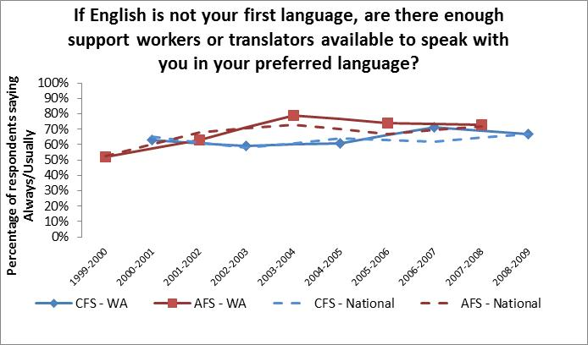
FIGURE 5: AVAILABILITY OF TRANSLATORS FOR CONSUMERS
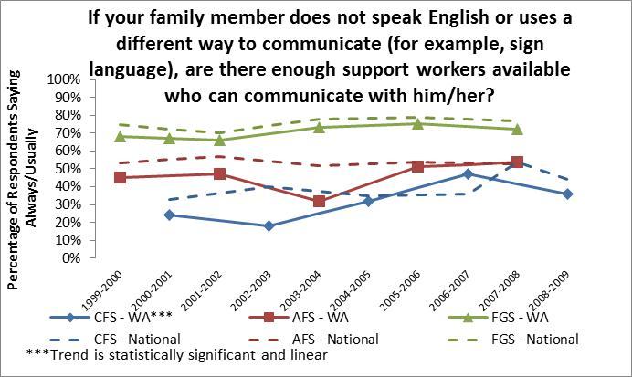

Aging Caseload
Washington State is also experiencing a sharply aging Paid Services caseload, particularly amongst children and those being supported out of the family home (see figure 6, statistically significant changes are highlighted). Due to limited service slots, children entering the Paid Services caseload tend to be older, having aged several years while waiting on the No-Paid Services caseload. Similarly, those with residential services continue to receive them and live longer, resulting in an aging out-of-home caseload as well. The target population for the Adult Family Survey is influenced by two competing factors: 1) those currently in service who are aging; and 2) children receiving paid services who are aging into the Adult Family Survey target population. Thus, changes in average age for this target population are more subtle.
The overall trend for other states participating in NCI during the first decade remained stable for children and adults being supported in the family home, but showed a similar aging trend for out of home placements. This may indicate that while other states are also struggling to provide additional residential placements due to funding limitations resulting from the national economy and individuals surviving longer, they have been more successful than Washington State at funding services for youth and their families.
FIGURE 6: AVERAGE AGE OF CONSUMER
Survey | Time Frame | Average Age of Family Member - WA | Average Age of Family Member – NCI Avg.
Child Family Survey | Beginning of Decade  (Spring 2001) | 9.2 | 10.0
Child Family Survey | End of Decade  (Spring 2009) | 12.0 | 9.7
Adult Family Survey | Beginning of Decade  (Spring 2000) | 31.2 | 33.3
Adult Family Survey | End of Decade  (Spring 2008) | 31.7 | 34.0
Family/Guardian Survey | Beginning of Decade  (Spring 2000) | 30.9 | 42.9
Family/Guardian Survey | End of Decade  (Spring 2008) | 46.3 | 45.1

Aging Caregivers
As the Paid Services caseload ages, so do the parents/relatives who care for them. In Washington State’s general population, the proportion of 55-74 year olds is growing, while other age groups are declining. Comparisons of age of the primary caregiver supporting someone with ID/DD in the family home are not directly comparable to the overall state population because parents of children are likely to be younger and parents of adults are likely to be older. Nevertheless, when the age of NCI Family Survey respondents are compared to the general population and across NCI target populations, there are a few notable trends (see figure 7).
In both the Child Family Survey and the Adult Family Survey there were statistically significant increases in middle age (55 – 74 years) respondents. A similar trend was observed for the Family/Guardian survey, but the trend did not reach statistical significance. Parents/Relatives supporting children with developmental disabilities in the family home are primarily 35-54 years of age, with respondents under age 35 decreasing and those between ages 55-74 increasing. For adults with ID/DD being supported in the family home, the age of the parent/relative they live with has shifted markedly across the decade. Respondents of ages 35-54 declined sharply, while respondents in the 55-74 age range increased sharply, well exceeding changes in these age groups amongst the general population in Washington State.
Another interesting trend is the increasing portion of respondents under the age of 35 for the Adult Family Survey, particularly since this age group is declining in the Washington State general population and persons of this age are likely not parents of adults. Perhaps parents are getting burned out, leaving siblings or other younger family members to shoulder the burden of caring for their family member with ID/DD. The NCI family surveys do have a question asking for the relationship of the respondent to the individual with a disability, but no statistically significant trends were identifiable due to the small percentages of non-parent respondents. A query of the Division’s client residence information via its Case Management Information System (CMIS) did confirm, however, that the portion of adults living in the home of their sibling has slowly, but steadily, increased over the decade; while the portion of adults being supported in the family home by a parent has slowly, but steadily, declined. Also, though the sample sizes were too small to detect statistically significant differences, more and more respondents to the Adult Family Survey are saying that their family member would not be living at home if supports were not available (see figure 8).
FIGURE 7: AGE OF RESPONDENTS TO NCI FAMILY SURVEYS IN COMPARISION TO WA ADULT GENERAL POPULATION
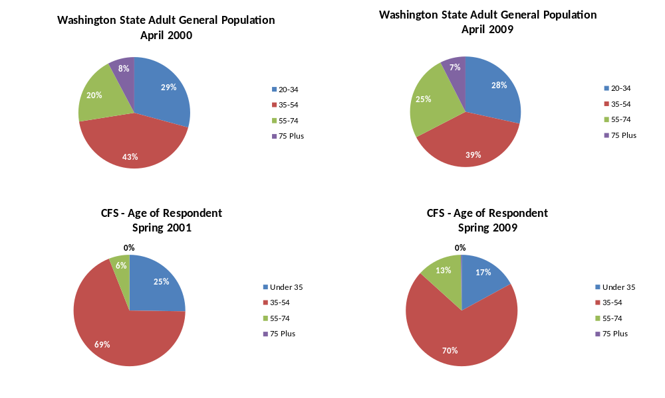

FIGURE 7 (cont.): AGE OF RESPONDENTS TO NCI FAMILY SURVEYS IN COMPARISION TO WA ADULT GENERAL POPULATION
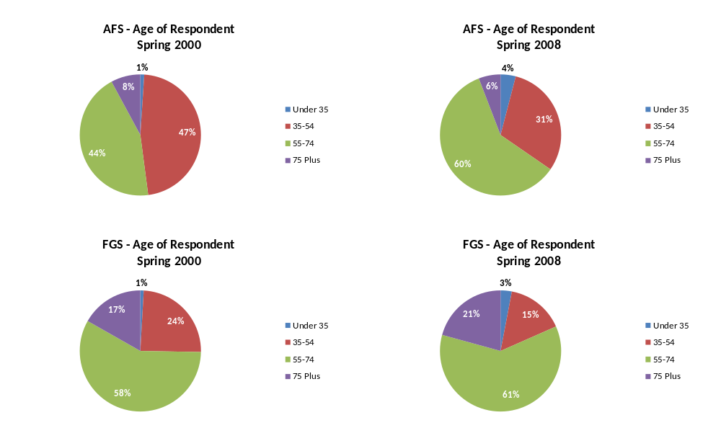
FIGURE 8: PROPORTION OF RESPONDENTS SAYING THEIR FAMILY MEMBER WOULD STILL LIVE AT HOME WITHOUT SERVICES

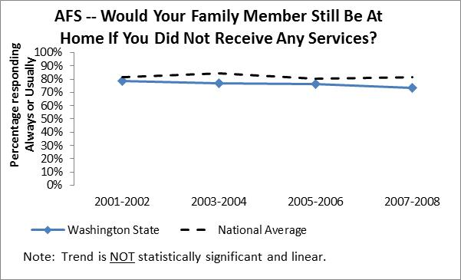

Type of Disability
Changes have also occurred in the types of disabilities for the service population. In comparison to the beginning of the decade, children receiving paid services through the Division are more likely to have a diagnosis of autism, require more complete help with daily activities, and be more likely to have an intellectual disability diagnosis (see figures 9-11).
FIGURE 9: LEVEL OF HELP WITH DAILY ACTIVITIES FOR CHILDREN LIVING IN THE FAMILY HOME
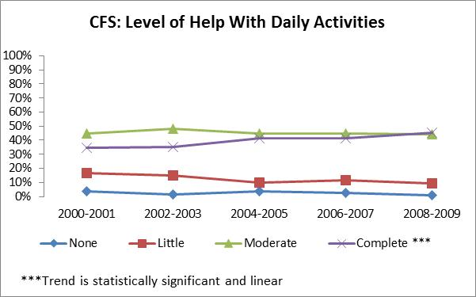
FIGURE 10: INTELLECTUAL DISABILITY DIAGNOSIS FOR CHILDREN LIVING IN THE FAMILY HOME
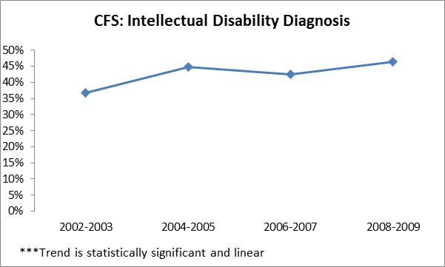
FIGURE 11: OTHER DISABILITIES FOR CHILDREN LIVING IN THE FAMILY HOME
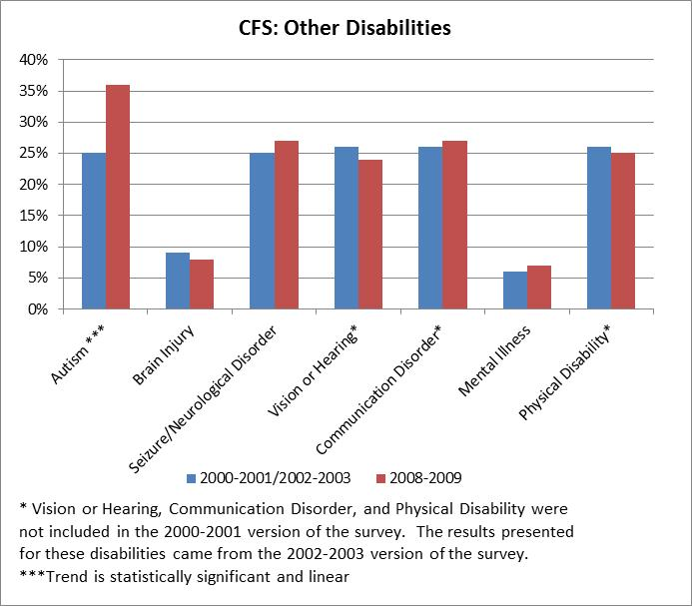
Amongst adults receiving paid services in the family home, there were no statistically significant changes in composition of the caseload (see figures 12 & 13); persons diagnosed with autism did increase, but this trend did not reach statistical significance.
FIGURE 12: LEVEL OF INTELLECTUAL DISABILITY FOR ADULTS LIVING IN THE FAMILY HOME
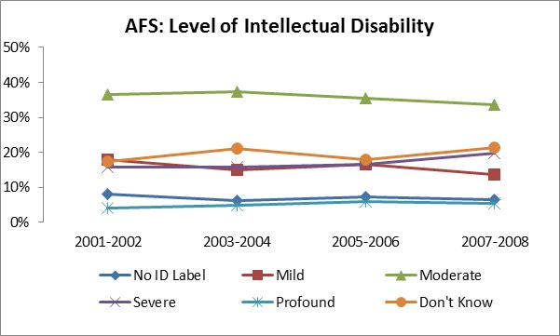
FIGURE 13: OTHER DISABILITIES FOR ADULTS LIVING IN THE FAMILY HOME
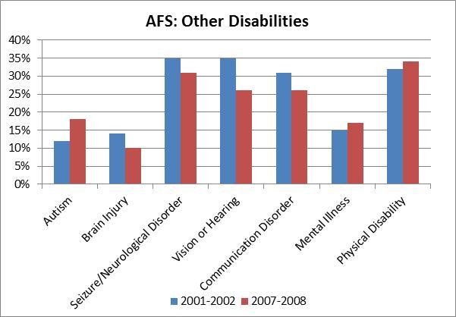
Persons being supported outside the family home became less likely to have a diagnosis of profound intellectual disability (after 2003-2004, see figure 14), and less likely to have a seizure/neurological disorder, vision or hearing impairment, or communication disorder (see figure 15). Individuals being supported outside the family home were slightly more likely to have a mental illness diagnosis and slightly less likely to have a brain injury or physical disability, but these trends fell just short of reaching statistical significance.
FIGURE 14: LEVEL OF INTELLECTUAL DISABILITY FOR ADULTS LIVING OUTSIDE THE FAMILY HOME
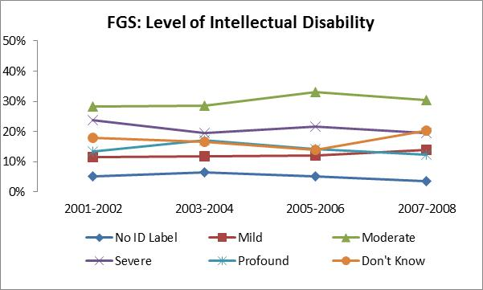

FIGURE 15: OTHER DISABILITIES FOR ADULTS LIVING OUTSIDE THE FAMILY HOME
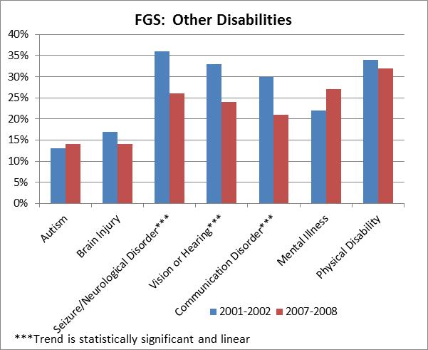
The national trend toward an increase in Autism Spectrum Disorder (ASD) diagnoses is one clear explanation for these trends, but limitations in the Division’s funding and changes to its eligibility rules have also played a role.
Historically, the Division’s budget has not kept pace with caseload growth; however, the Division did receive a 12.1% budget increase for fiscal year 2002 and $14 million from the Arc of Washington lawsuit for fiscal year 2003. Shortly thereafter, the nation’s economy went into a recession and budget cuts were far more likely than budget increases. The national economy emerged from the recession by fiscal year 2007 but found itself back into an even deeper recession by 2009. Because of limited funding, new service slots were typically given to those with the most critical support needs. When the legislature did provide funding, particularly for residential placements, it was usually ear-marked for specific proviso populations such as those being released from institutions and those in crisis. Persons with profound intellectual disabilities, physical impairments, or communication disorders are less likely to be noticed as a crisis circumstance in immediate need for out of home placement.
A major change in the Division’s eligibility rules, that took effect in July 2005, also impacted the caseload composition. The new rules were substantially more extensive than their predecessor. The new rules only impacted those who were children, new eligibility determinations, and the No-Paid Services caseload. Adult Paid Services clients were exempt from the new rules. Major changes to the eligibility rules included:
- Documentation of adaptive functioning limitations of more than two standard deviations below the mean in addition to a qualifying diagnosis.
- Eligibility conditions are specific to age.
- Eligibility determinations are subject to expiration and review on the 4th, 10th, and 18th birthday, or before authorization of a paid service for adults not currently receiving a paid service.
These new rules meant that those with an eligible diagnosis, but little impact on adaptive functioning, were no longer eligible; substantial impact across a variety of tasks would be needed rather than in just one or two specific tasks, and adaptive functioning needed to be documented. Children and individuals receiving paid services for the first time needed to demonstrate ongoing eligibility in order to continue on the caseload. Eligibility criteria became stricter with each age review, thus those just needing early intervention or who similarly had delayed maturation were not being maintained on the roles as they became older. The changes in level of help with daily activities that were observed in the Child Family Survey over time align with the changes to eligibility criteria, considering that it would take several years after implementation of the new rules before eligibility reviews occurred for most clients. Given that those who receive services continue to receive services over time due to the chronic nature of developmental disabilities and the exemption to the new eligibility rules for adults already receiving services, changes in the adult in-home served population by condition are more subtle.

Disability Rights Movement
Within the past decade, the national disability rights movement has continued to emphasize the importance of choice, self-determination and self-advocacy. These principles rest on the premise that people living with disabilities should direct, to the extent possible, how and by whom services are delivered, and make choices about what is important to them. These life choices include how and where they live, what their goals and preferences are, and what supports they need or want to reach those goals. These priorities have influenced service design, delivery and quality measurement within the past decade.
Across the nation, large institutional settings for persons with ID/DD were downsizing or closing. Some states have closed all of their large ID/DD institutions. In addition to changes in housing, disability advocates have also brought pressure on public systems to support the employment of people with ID/DD, to foster community inclusion, to support personal relationships, and enhance self-advocacy. A culture of respect for individuals with intellectual and/or developmental disabilities was growing as these persons became more and more integrated into our communities.
In February, 2001, President George Bush announced the New Freedom Initiative which promoted the full participation of people with disabilities in all areas of society and community. This initiative represented a federal effort to implement the Olmstead Decision, and facilitated the inclusion of individuals with disabilities in community life. Similarly, in 2001, Congress created the Office of Disability Employment Policy within the Department of Labor. This office was given the task of improving workforce development system services for people with disabilities. The No Child Left Behind Act (NCLB) was signed into law by President Bush in January 2002, which included incentives to reward schools for showing progress for students with disabilities and required that most students with mild disabilities or physical disabilities take the same assessment tests as non-disabled students. The NCLB Act changed the general public’s attitudes and expectations for students with disabilities.
The term “mental retardation” came to be seen as offensive and was more and more often being replaced by the term “intellectual disabilities” or subsumed under the broader label of “developmental disabilities”. In July 2003, the President’s Committee on Mental Retardation changed its name to the “President’s Committee for People with Intellectual Disabilities.” Several years later, in June 2006, the American Association on Mental Retardation (AAMR) changed its name to the “American Association on Intellectual and Developmental Disabilities” (AAIDD). By the end of the decade, there was awareness that something should be done about the references to “mental retardation” in long-standing laws and statutes; however, these terms were still commonplace. This would change in calendar year 2010 both in Washington State as well as federally. Governor Gregoire signed HB-2490 in June 2010 to eliminate disrespectful language in all state laws and replace it with “people first” language and the use of the term “intellectual disability” in place of “mental retardation”. Similarly, President Obama signed “Rosa’s Law” in October 2010, changing “mental retardation” references in federal statute to “intellectual disability”.
Several highly publicized events drew public attention to individuals with developmental disabilities and the need to protect their rights and ensure their safety.
- In the late 1990s, several states, including Washington, had already banned the death penalty for individuals with developmental disabilities, but persons with intellectual disabilities were still on death row for crimes committed in other states. In June 2002 the Supreme Court banned the death penalty for convicts with intellectual disabilities in the landmark Atkins v. Virginia case.
- Later that year, in November 2002, the Election Reform bill (a.k.a. the Martin Luther King Jr. Equal Protection of Voting Rights Act) was signed by President Bush, requiring at least one accessible voting machine at all polling places.
- In September 2005, Hurricane Katrina struck the Gulf States and numerous individuals with ID/DD were without supervision or personal care attendants. The plight of these individuals raised states’ awareness of the need for disaster planning for persons with intellectual and/or developmental disabilities.
- In October 2006, a medical journal, the Archives of Pediatrics & Adolescent Medicine (Gunther & Diekema, 2006), reported on a controversial intervention to permanently halt the growth of a six year old Washington State girl so she would remain small and be easier for her parents to care for. Public outcry ensued over whether eugenics was resurfacing. People debated whether the needs of a parent should outweigh the rights of the child, and whether such an event would be allowed to occur in their state.
- In December 2006, the American College of Obstetricians and Gynecologists recommended screening for Down syndrome of all pregnant women, regardless of age.
- In February 2009, the Sunday Times of London (Deer, 2009) reported that the researcher behind a well-known 1998 publication in the medical journal, The Lancet, linking autism with the measles, mumps and rubella (MMR) vaccine had manipulated patient data and falsified results.

Major WA State events:

Policy & Practice
Washington State’s support system for individuals with developmental disabilities has also changed to stay in alignment with these trends. New policies and practices have been put in place to ensure the protection of rights and safety for individuals with intellectual and/or developmental disabilities.
- In February 2002, background checks became mandatory for all DDD positions.
- A Director’s memo to staff was issued in September 2003 regarding possible conflicts of interest when a staff member is serving as the guardian to one of our clients.
- In March 2004, an Admissions Review Team was established, creating a formal process for review and assessment of requests for Intermediate Care Facilities for Persons with Intellectual Disabilities (ICF/ID) admissions to ensure that persons are being served in an appropriate, least restrictive setting.
- An electronic Incident Reporting System was implemented in May 2004 to allow the division to monitor major incidents involving our clients and to take swift action when necessary.
- Through several policy as well as legislative mandates throughout the decade, providers were required to receive more and more specialty training on supporting individuals with developmental disabilities.

Legislation
Advocacy organizations in Washington State have a strong voice with our legislature. Several major bills were passed through the Legislature and signed into law during the first decade of the 21st century that help protect the rights and foster respect for individuals with developmental disabilities. Self-advocates played a major role in initiating and lobbying for these bills to become laws.
- 2004 Legislature: HB-2663 requires all agencies to use person-first terminology in new and revised statutes and agency rules.
- 2005 Legislature: SHB-1711, initiated by Self-Advocates in Leadership (SAIL), removes the term “disabled” from signs marking parking places for persons with disabilities.
- 2006 Legislature:
  - HB-2479 requires all counties to provide accessible voting for individuals with developmental disabilities prior to an election, and county elections advisory councils are required to include people with disabilities.
  - HB-1107 mandates every school district to provide or contract for early intervention services by the year 2009.
- 2007 Legislature: HB-1050 (a.k.a. “Kevin’s Law) allows students receiving special education services to participate in graduation ceremonies with their same age peers, even if they will remain in school until age twenty-two.
- 2008 Legislature: SB-6313 establishes October as Disability History Month in Washington State for all public schools, colleges, and universities.
As more and more individuals with intensive support needs were becoming part of our everyday communities, laws were also passed to make sure that these individuals were identified and to ensure that appropriate accommodations were being provided.
- 2003 Legislature: SB-5473 requires the Criminal Justice Training Commission to develop training for law enforcement on interacting with persons with mental illness or developmental disabilities. However, the bill does not make the training a requirement for city and county jail personnel.
- 2005 Legislature: ESHB-2126 provides accommodations for dependent persons who are the victims or witnesses of a crime.
- 2007 Legislature: SHB-1694 directs the Washington State Joint Transportation Committee (JTC) to complete a Special Needs Transportation Coordination Study (Nelson/Nygaard Consulting Associates, 2009) to examine and evaluate the effectiveness of special needs transportation and make recommendations for improving and enhancing the effectiveness of these services. The results of this study were published in January 2009.
- 2008 Legislature: SHB-2903 creates an access coordinator within the Administrative Office of the Courts to provide equal access to courts for persons with disabilities.
- 2009 Legislature: E2SHB-2078 requires the development of a screening tool by July 1, 2010 for use by corrections staff to identify persons with developmental disabilities during a jail’s intake process so that any necessary accommodations can be provided as soon as possible.
At the same time, individuals with developmental disabilities were fighting for their right to make their own decisions and to be in charge of their own lives. In November 2009, the American Association on Intellectual and Developmental Disabilities and The Arc issued a Joint Position Statement on guardianship (American Association on Intellectual and Developmental Disabilities, 2009):
“Most people with intellectual and/or developmental disabilities (1) can manage their own affairs with assistance and guidance from others, such as family and friends. If guardianship (2) is necessary, it should be tailored to the person’s needs. Strict monitoring must be in place to protect the best interests and preferences of each person.”
Some states, such as Washington State, offer limited guardianships that only allow the guardian to have control over specific aspects of the individual’s life, such as medical or financial decisions, while the individual retains their rights in all other areas. Circles of Support and other informal support networks, were gaining in popularity across the nation. These alternatives to guardianship provide for the needs of the individual without resorting to the removal of his or her legal rights. The national trend toward utilization of other less restrictive alternatives to guardianship is evident in the National Core Indicators surveys over the past decade (see figure 16). Over time, fewer and fewer respondents were identifying themselves as being a legal guardian for their family member.
FIGURE 16: RESPONDENT IS LEGAL GUARDIAN
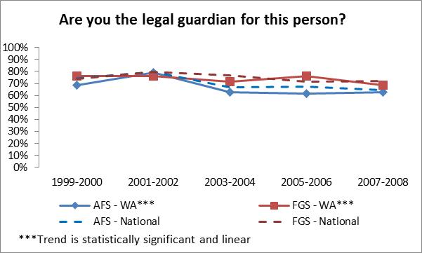

Partnership with Stakeholders
The thoughts and opinions of individuals with developmental disabilities and their families have played a major role in shaping the changes to Washington State’s service system over the past decade. Following the success of the Strategies for the Future stakeholder workgroup, advocates and self-advocates became regular advisors to the Division and to the Governor.
The 2005 Legislature created an Autism Task Force to study and make recommendations to the legislature regarding the growing incidence of autism and how to improve the delivery and coordination of services to persons with autism in Washington State; at least two members were required to be parents of children with autism. The Division created its own advisory boards as well. There was a statewide Developmental Disabilities Advisory Committee and a State Quality Assurance Advisory Committee, as well as an advisory board in each region. These groups continued until February 2009 when Governor Gregoire eliminated 50 volunteer boards, including the DDD Regional and Statewide Advisory Committees and the State Quality Assurance Advisory Committee in an effort to save funds and streamline government. Specifically targeted short-term stakeholder workgroups continued to be formed, however, and convened whenever possible to advise the Division on major service system changes.
In addition to administering the National Core Indicators tools and its own advisory groups, the Division implemented other methods to obtain direct feedback from its consumers. Beginning in August 2003, field staff were given comment cards to give to individuals and families after each interaction with them. This allowed our consumers and families to give direct and anonymous feedback on their day-to-day interactions with the division. Beginning in July 2005, the Division started sending anonymous surveys to individuals following their annual Plan of Care meeting, requesting input on their experiences with the planning process.

Individuals/Families as Partners
The growing role and voice of individuals and their families or other advocates is evident in National Core Indicators data gathered across the decade. Individuals and their families were more involved with planning and had more choice over their providers at the end of the first decade, as compared to the start of the new century (see figures 17-23). Respect for individuals and their choices grew over time as well. Improvements were evident not only in Washington State’s performance on these indicators, but nationally as well.

FIGURE 17: RESPONDENT HELPED DEVELOP CONSUMER’S SERVICE PLAN

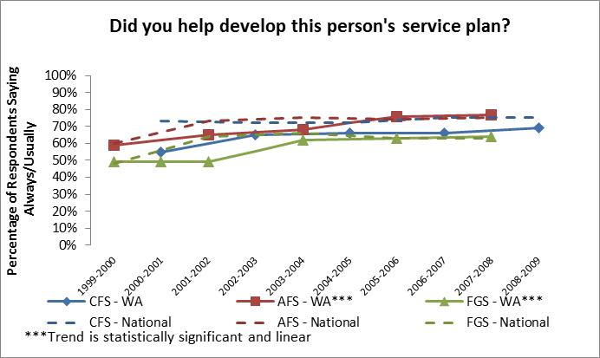
FIGURE 18: PLANNING STAFF RESPECT RESPONDENT’S CHOICES AND OPINIONS
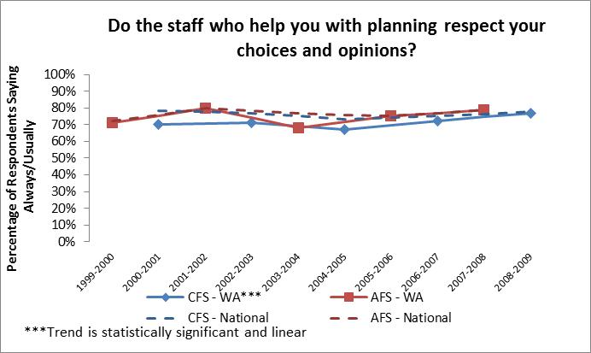

FIGURE 19: CHOOSE AGENCIES/PROVIDERS
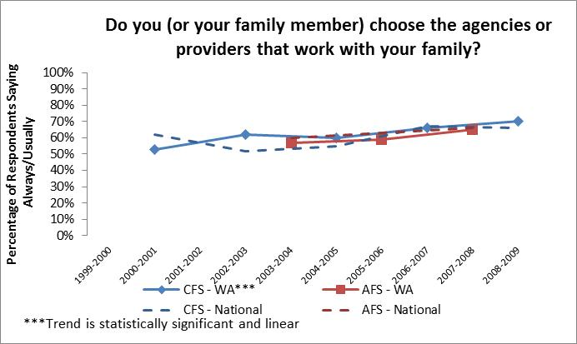

FIGURE 20: CHOOSE SUPPORT WORKERS
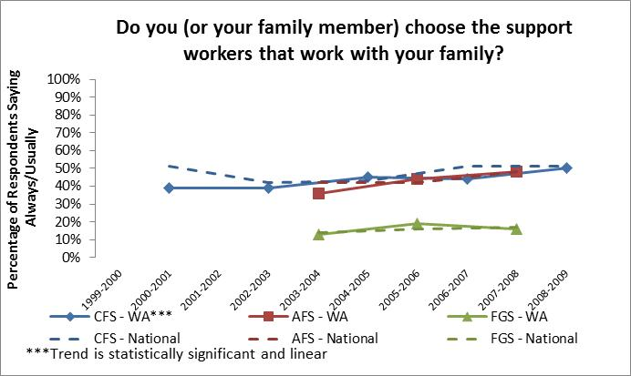

FIGURE 21: HAS CONTROL OVER HIRING/MANAGEMENT OF WORKERS
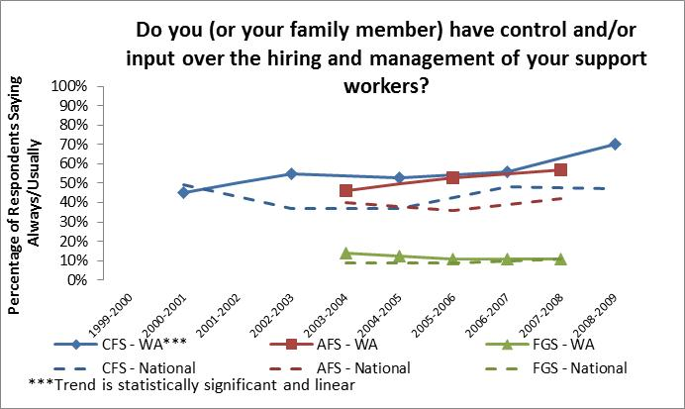

FIGURE 22: WANTS CONTROL OVER HIRING/MANAGEMENT OF WORKERS
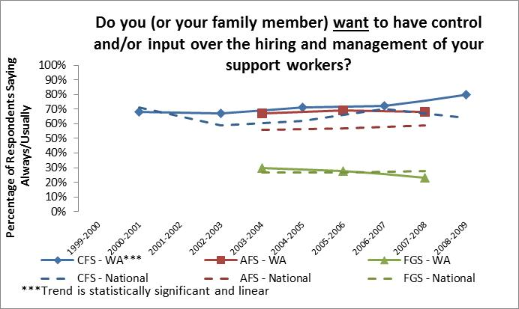

FIGURE 23: PERSON PARTICIPATES IN CHOICE MAKING
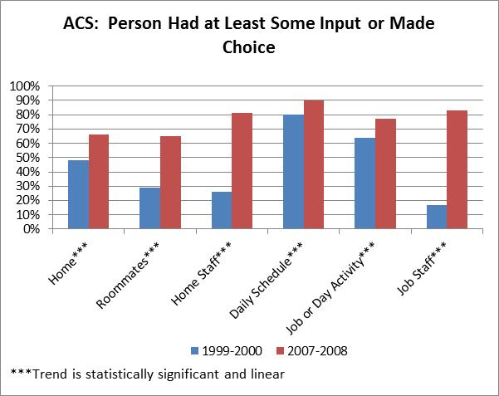

The “Information Explosion”
Along with the emphasis placed on self-determination, the past decade has seen a heightened demand for information regarding services and supports to assist consumers in making informed decisions. The dissemination of information has been facilitated by the increasing popularity and utility of the internet. Disability rights advocates today can connect electronically to share information, air grievances and communicate with other advocates locally and throughout the world. Both national and local self-advocacy organizations exist. The primary self-advocacy organizations in Washington State include People First of Washington, Self-Advocates in Leadership (SAIL), and Self-Advocates of Washington (SAW).
There are a number of sites to help self-advocates. Here are some examples of self-advocacy resources online:
- The Autistic Self Advocacy Network (ASAN) at autisticadvocacy.org is a nonprofit organization run by and for persons with autism. ASAN provides support, services, educational tools and resources to individuals on the autism spectrum and the general public.
- Self-advocacy Online (selfadvocacyonline.org) is an interactive site that provides instructional videos, accessible research papers, stories from self-advocates and other resources to empower and encourage people to become self-advocates. Self-advocacy Online also has links to self-advocacy organizations across the country.
- Autism Now (autismnow.org) aims to be a dynamic, interactive, visible and accessible provider of resources and information for people with Autism Spectrum Disorder (ASD) or other developmental disabilities and their families.
- Several local self-advocacy organizations have developed their own websites: People First of Washington (people-first.ning.com); Self-Advocates in Leadership (sailcoalition.org); and Self-Advocates of Washington (wearesaw.org).
Many of the above sites also have blogs or Facebook pages which provide personal stories and profiles of individuals who are self-advocates. In addition, there are several conferences each year at which advocates can meet face to face, share stories and ideas, and work to empower each other and the self-advocacy movement.

Major WA State events:
During the first decade of the 21st century, Washington State’s developmental disabilities service system became more transparent to the state’s general citizenry. This made it easier for individuals and families to understand the service system and become more active participants in service planning and delivery. Washington Administrative Code and the DDD Policy Manual were greatly expanded over the decade. Almost all processes of the Division are now documented and readily available to the general public via the internet. WAC Chapters 388-823 through 388-850 include detailed information on how eligibility is determined, the types of services and programs offered, the assessment process, and how service rates are determined. The division’s Policy Manual, Management Bulletins, and a variety of other information can be accessed by anyone from the division’s website (http://www.dshs.wa.gov/ddd).
Numerous efforts by the Department of Social and Health Services (DSHS) as well as the Division have made information more readily available, and easier to understand and apply consistently across the state.
- February 2001 – The DSHS Secretary sent a staff memo requesting that staff update voice mail messages at least weekly and use out of office email replies when unavailable.
- October 2001 – The DSHS Secretary established the “No Wrong Door” initiative to make access to department services easier for consumers and to provide better coordination between individual DSHS offices.
- November 2001 – DDD launched a redesigned website to make information access simpler for the general public.
- September 2002 – Washington State received a “Real Choices” grant for information/education in local areas. The grant was used to provide seed funding for local councils of counties, regions, parents, and self-advocates, assisting them with gathering and disseminating information.
- August 2003 – DDD implemented the Necessary Supplemental Accommodation (NSA) policy requiring caseload members to identify someone to receive copies of all DDD notices and other correspondence sent to the client, and to assist the eligible person to understand the documents and exercise their rights.
- March 2004 – DDD began using Management Bulletins to improve consistency in the division’s operations and to electronically communicate changes in process and policy to all staff rapidly and efficiently.
- March 2005 – Governor Gregoire issued an Executive Order directing all state agencies to adopt the principles of “Plain Talk” to make sure all communications are clear and understandable to our citizens.
- February 2006 – DDD began using Planned Action Notices (PANs) to provide a consistent method of communication to consumers on actions taken by the division such as initiation, changes, or denial of services, and to inform the consumer of their right to contest these actions.
- September 2006 – DDD published the “Road Map to Services” brochure for the general public, providing a succinct and easy-to-follow illustration of the division’s service offerings.
- May 2008 – DSHS issued its own Plain Talk Policy, setting the expectation that all Department communications are written clearly and are easy to understand, and appointed a Plain Talk Lead and Coordinators to provide expertise and technical assistance to employees and to ensure that all new administrative policies use Plain Talk principles.
- May 2008 – The Division partnered with the Washington State Developmental Disabilities Council (DDC) to launch, “Informing Families, Building Trust” (IFBT). IFBT has a website and regularly publishes bulletins, videos and podcasts for distribution to the general public about developmental disabilities issues in Washington State (https://fortress.wa.gov/com/csddcifbt/). Interested persons can E-subscribe to their list-serve or ‘like’ their Facebook page.
The results of these efforts are clearly demonstrated in National Core Indicators Survey responses across the decade (see figures 24-26). Washington State showed improvements on indicators for information, but the national average for other participating NCI states has remained flat or slightly declined for these indicators, indicating that the changes likely occurred as a result of local influences. Washington State still has room to grow, however. Once a poorly performing state on these indicators, Washington State’s current performance is currently about average.
While more people say they are receiving information about services, families supporting children report that this information is becoming easier to understand, but families supporting adults are finding information is becoming more difficult to understand (see figure 25). This may be due to differences in the ages of these respondents and their comfort level with modern media rather than something specific to Washington State’s informational materials. The same trend occurred over time in the NCI national averages for these indicators, suggesting that the differences result from factors that extend beyond Washington State’s borders.
FIGURE 24: RECEIVES INFORMATION
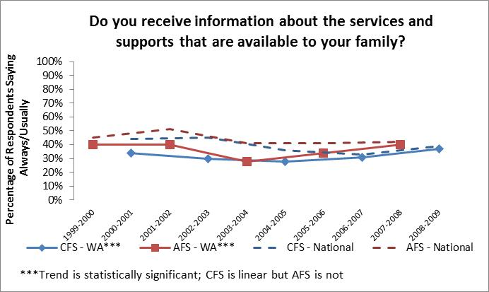

FIGURE 25: INFORMATION IS EASY TO UNDERSTAND
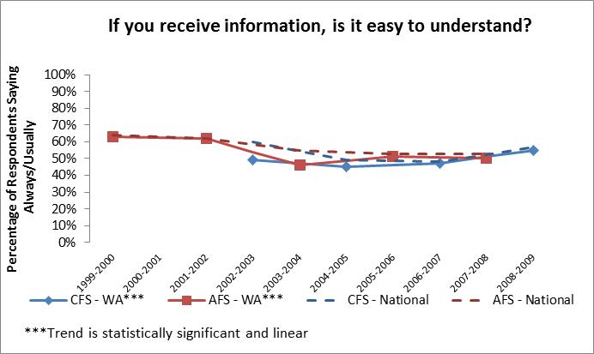

FIGURE 25: GET ENOUGH INFORMATION FOR PLANNING
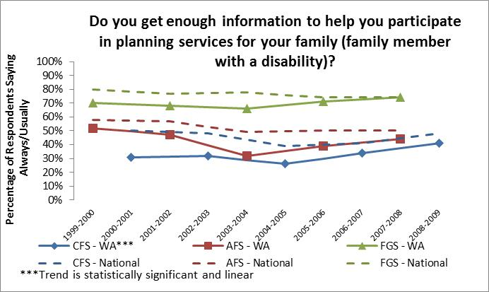
As indicated by changes in scores on NCI indicators, there have been information campaigns in Washington State, targeted toward the general population, which individuals with ID/DD and their families seem to have benefited from as well (see figures 26 and 27).
- Child Profile Health Promotion – in January 2002, the Department of Health assumed responsibility for administering this system and expanding it statewide. The statewide expansion efforts were completed in May 2004 when the promotion began sending well-child checkup and immunization reminders to parents of all children in Washington State as they turn six years old. Today, families with a child under the age of six who live in Washington State receive Child Profile mailings every three to six months free of charge with updated immunization, health, and safety information relevant to their child’s current age.
FIGURE 26: RECEIVE INFORMATION ABOUT CHILD DEVELOPMENT
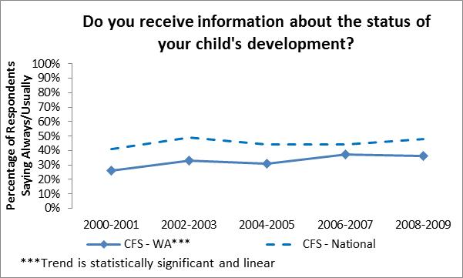
FIGURE 27: INFORMATION ABOUT CHILD DEVELOPMENT IS EASY TO UNDERSTAND
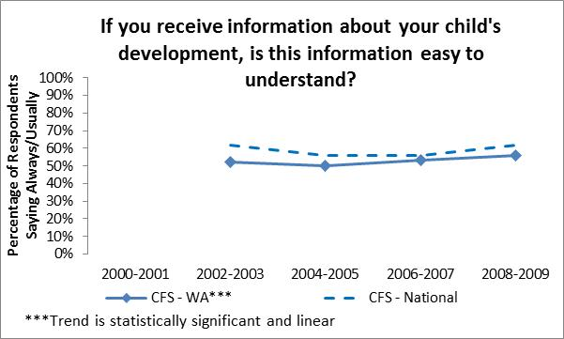

Developmental Disabilities Service Changes
Throughout the past decade, the number of small, less restrictive settings has continued to increase nationally as the number of institutional settings for individuals with ID/DD decreased. By 2004, of the 160 institutions across the nation that had been open in 1991, nearly half of those facilities had closed (Minnesota Governor's Council on Developmental Disabilities, 2006). More recently, even smaller congregate settings such as group homes that provide 24-hour support, are increasingly being considered an outdated model for community living. The shared-living model, in which an individual, couple or family in the community provide accommodation and support to an individual with a disability, is increasing in popularity. The term “shared living” carries the expectation that people with and without disabilities will live together and share experiences, epitomizing the idea of community integration as opposed to community exposure. These changes in housing trends further demonstrate a move towards community integration for individuals with ID/DD.
As states close institutions and shift supports to community settings, the key role played by families in the provision of services and supports has been increasingly recognized. As a result, states have begun to design services and supports for families to ensure that families continue to have the capacity to provide assistance for as long as possible (Hecht & Reynolds, 2011). Furthermore, recently there has been increasing recognition of the fact that services should be designed to support the entire family (when an individual with ID/DD lives with the family) and not just the individual with ID/DD. For example, the provision of respite care can be helpful to families providing care.
Federal programmatic, policy, and financial initiatives have also had a significant impact on the provision of services and supports at the state level. These factors include new HCBS waiver opportunities including “Independence Plus” waivers, financial incentives such as Systems Change and Money Follows the Person grants, and clarifications of policy, such as what constitutes a community residence. In addition, CMS has developed projects and initiatives to encourage and support people with disabilities in re-engaging in the workforce (e.g., Ticket to Work, Work Incentives Improvement Act). The Social Security Administration began sending “Tickets to Work” in Washington State in November 2003. CMS has also proposed grants that are aimed to help increase the pool of direct care workers working in the community (e.g., The Demonstration to Improve the Direct Service Community Workforce) (Kitchener, et al., 2007).

Major WA State events:

Residential Services
Throughout the first decade of the 21st century, Washington State continued its downsizing of the number of persons with ID/DD who were residing in the two state hospitals for individuals with mental illness. Persons residing in Residential Habilitation Centers or Nursing Homes were also given opportunities to move to community-based homes in accordance with Washington State’s Olmstead Plan (see figure 28). Whenever possible, these individuals tended to move closer to their family members. Anecdotally, care providers report a substantial increase in family visits for individuals who move to community settings as compared to when these individuals lived in the institutional setting.
The fiscal year 2000, 2001, and 2002 budgets for the Division included funding specifically for reductions in the population of individuals with developmental disabilities in the state’s two psychiatric hospitals. Washington State’s Division of Developmental Disabilities also proposed eight cottage closures at Fircrest School as a result of Olmstead plan implementation. Funding was provided in the fiscal year 2002 budget specifically for RHC outplacements. Funding was also provided in the fiscal year 2004 budget to facilitate community placements in order to downsize Fircrest School by 60 residents. The Division’s budgets for future years also included funding for the development of community residential service slots. However, the limited amount of funding that the Division did receive for community residential placements, coupled with the freezing of the Voluntary Placement Program, resulted in increasing RHC admissions toward the end of the decade, particularly for children (see figure 29).
In May 2007, Governor Gregoire issued a directive restricting RHC placements for children and directed the Division to identify alternative service models to support families caring for children with significant needs at home or in less restrictive out-of-home community placements rather than in institutional settings. The Children’s Intensive In-Home Behavior Support (CIIBS) program was funded, in part, as an early intervention strategy to help reduce demand for expensive out of home placements, particularly for children. Additional funding for expanding intensive in-home services and for community placements would need to come from elsewhere, as the Washington State and national economy was beginning to plummet. In March 2008, CMS approved the Roads to Community Living (RCL) program, Washington State’s Money Follows the Person Demonstration Project, which allows states to obtain enhanced federal matching funds to support individuals desiring to move from institutional settings into the community.
Similar to the national trend, group homes were also downsizing or closing in Washington State. The development of new community-based residential service slots were primarily in the Supported Living program. Supported Living services offer instruction and support to persons who live in their own homes in the community. Supports may vary from a few hours per month up to 24 hours per day of one-to-one support. Clients pay for their own rent, food, and other personal expenses. DDD contracts with private agencies to provide Supported Living Services. The Companion Home program also expanded. Companion Homes provide residential services and supports in an adult foster care model to no more than one adult client. The services are offered in a regular family residence approved by DDD to assure client health, safety, and well-being. DDD reimburses the provider for the instruction and support service. Companion homes provide 24-hour available supervision.
FIGURE 28: RESIDENCE TYPES OVER TIME

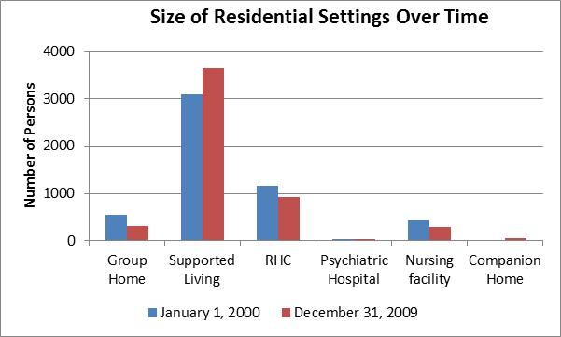

FIGURE 29: CHILD AND YOUTH POPULATION IN RHCs OVER TIME
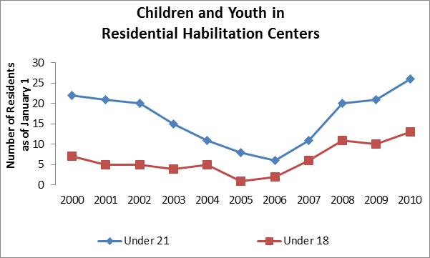

Employment SupportS
Similar to the shift from large residential settings to smaller, more individualized residences, the places where individuals with developmental disabilities work were downsizing and becoming more individualized (see figure 30). Large sheltered workshops were closing, while more and more people were working in community-based settings alongside the general citizenry with the assistance of Supported Employment. Washington State has been a national leader in employment for individuals with intellectual and/or developmental disabilities, and received national recognition from the EEOC in November 2005.
However, the Strategies for the Future stakeholder workgroup felt that the State could do more. In the December 2000, Strategies for the Future Long-Range Plan Phase II Report to the Washington State Legislature, the Stakeholder Workgroup recommended that: “Each individual will be supported to pursue his or her own unique path to work, a career, or his or her contribution to/participation in community life. All individuals, regardless of the challenge of their disability, will be afforded an opportunity to pursue competitive employment.”
Division Director, Linda Rolfe, recognized that more could be done to encourage individuals with developmental disabilities, their families, and society in general to have the expectation that persons with developmental disabilities should pursue employment in their young through middle-aged adulthood, just like all other citizens do. Employment provides the rest of the community with the opportunity to experience the capabilities and contributions made by individuals with developmental disabilities and allows individuals to become less dependent on service systems. This would be particularly important for the future welfare of individuals with developmental disabilities, as it was clear that the state’s financial resources were insufficient to provide all the supports that its citizens with developmental disabilities require.
Washington State issued the landmark Working Age Adult Policy and became the first state in the nation to declare that employment in integrated settings shall be the first service option for all clients of working age (defined as ages 21 through 61 in Washington State) regardless of their level of disability. The Working Age Adult policy was first issued in July 2004 and counties were given a timeline of July 2006 for full implementation. Between 2007 and 2009 the number of DDD clients in integrated employment increased by 54 percent, representing an additional 2,555 clients and a total of 7,277 clients in integrated employment.
Further support for individuals with developmental disabilities in the workforce came in the fiscal year 2008 budget when the Legislature authorized funding to the Division to create partnerships with school districts and other state and local offices to increase employment of persons with developmental disabilities after high school graduation.
These efforts have resulted in a dramatic increase in the number of persons of working age with a developmental disability who are receiving Individual Employment support services. By the end of the decade there were approximately 460 more individuals with developmental disabilities working in Washington State and contributing to our economy, as a result of consumer advocacy and the Working Age Adult policy. However, the overall percentage of persons on the DDA caseload who are of working age and earning a wage while participating in an employment support program has remained relatively the same (see figure 31), declining only slightly.
FIGURE 30: TYPE OF EMPLOYMENT SUPPORT OVER TIME
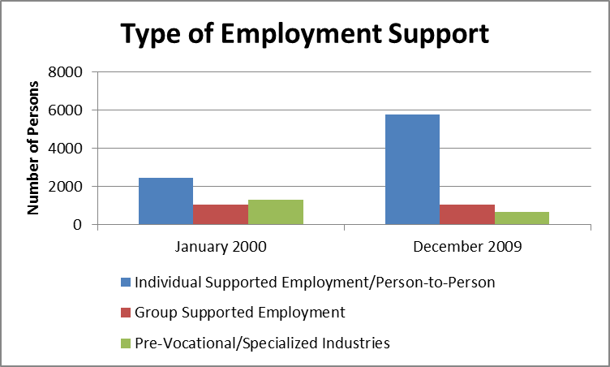

FIGURE 31: WAGE STATUS OVER TIME

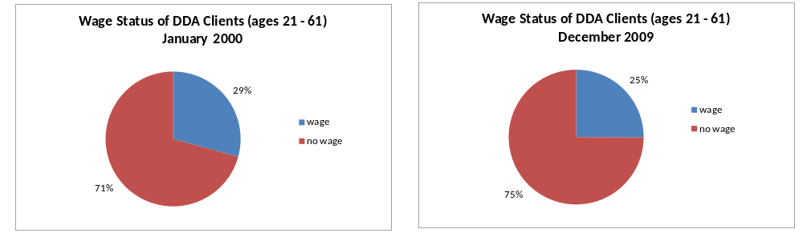

Supports for Families
While large residential and employment settings were downsizing or closing, services to families supporting individuals with ID/DD at home were increasing (see figure 32). Every few years, the division received funding to support additional families. The Division received $660,000 funding in its fiscal year (FY) 2001 budget and another $14 million in FY 2003 in accordance with the settlement agreement with the Arc of WA State over their waiting list lawsuit. The FY 2006 budget included funding to start a Family Support Pilot program to service 1,500 low income families, and the FY 2008 budget provided funding to support an additional 1,300 families.
FIGURE 32: PROPORTION OF CASELOAD IN PAID SERVICES OVER TIME

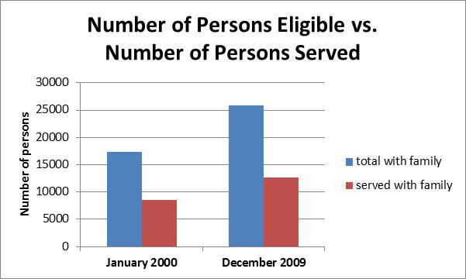

Even with substantial expansion, service programs were unable to keep up with the growth in the number of enrolled clients; the gap between families receiving services and those without services continued to grow (see figure 32). The proportion of paid services clients to total enrolled clients living with family has remained fairly constant at 49% (if expansion to employment support programs is also taken into account). However, the proportion of individuals receiving in-home services to total enrolled clients living with family has declined from 38% to 34% despite substantial expansion of in-home service programs, including the Medicaid Personal Care program which is an entitlement. As compared to the beginning of the decade, by the end of the decade there were an additional 6,200 individuals enrolled with DDA and not authorized to receive in-home supports.
With a freeze on the Voluntary Placement Program and concern over the increasing number of children being placed in Residential Habilitation Centers due to the lack of alternative placements, new approaches were needed to support families with children who have intensive behavioral support needs. In response to Governor Gregoire’s May 2007 directive, the Children’s Intensive In-home Behavioral Supports (CIIBS) program was developed to support children with intensive support needs in the least restrictive setting possible. Through this program, families of children ages 8 through 20 receive intensive Positive Behavior Support and other necessary supports coupled with an intensive case management model utilizing Wrap-Around service delivery. In a Wrap-Around service model the family and case manager, behavior support providers, the school, and other involved agencies work as a team to support the individual and family with the goal of preserving the child’s continued placement with family in lieu of the need for out-of-home placement. With the assistance of stakeholders, families, division staff and partner agencies, this program was approved for a federal HCBS waiver and was implemented in May 2009 with a capacity to serve up to 100 individuals and their families.

Indicators of Consumer and Family Satisfaction with Service Delivery
Results from National Core Indicators surveys over the decade illustrate that individuals and families who received paid services were responding positively to the service system changes. Overall, people were very satisfied with the services and supports they received (see figure 33). Individuals and families were more likely to say that they get the supports they need (see figures 34 and 35), the supports offered meet their needs (see figure 36), and that supports are available when they need them (see figure 37). Families were increasingly reporting that supports were making a difference in keeping their family member at home (see figure 38) and improving their ability to care for their child (see figure 39).
FIGURE 33: OVERALL SATISFACTION WITH SUPPORTS/SERVICES
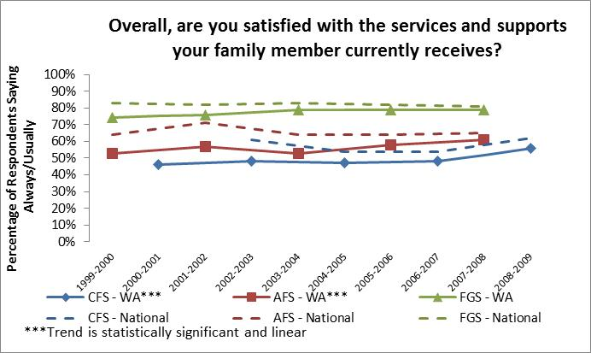
FIGURE 34: FAMILY GETS NEEDED SERVICES
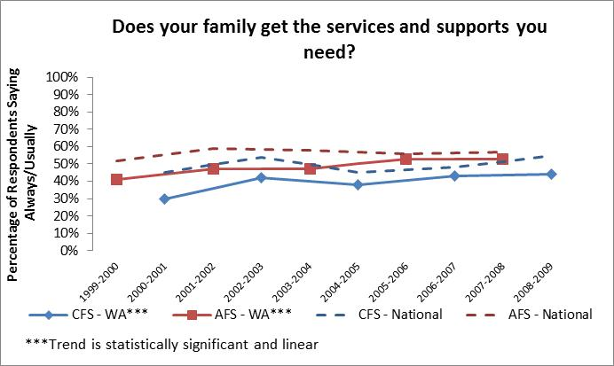

FIGURE 35: FAMILY MEMBER GETS NEEDED SERVICES
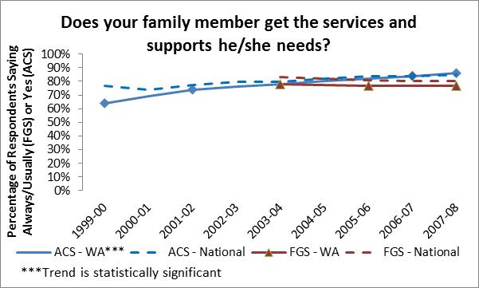
FIGURE 36: SUPPORTS OFFERED MEET NEEDS
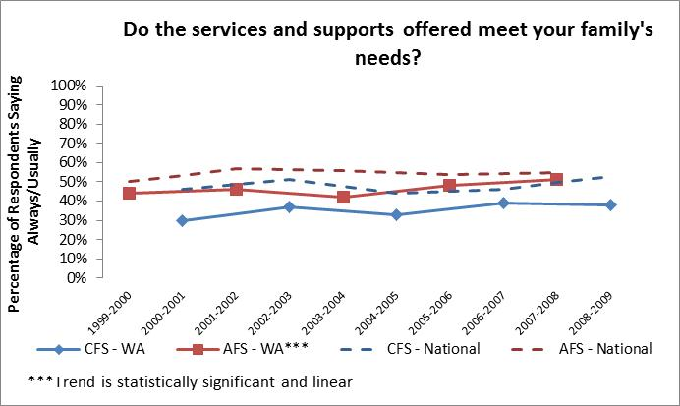

FIGURE 37: SUPPORTS AVAILABLE WHEN NEEDED
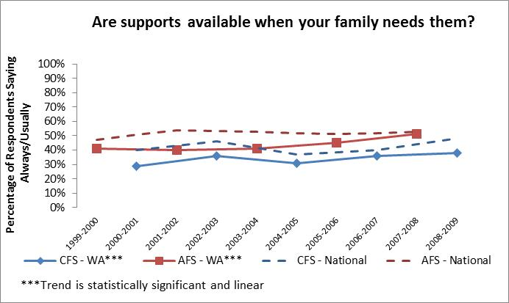

FIGURE 38: SUPPORTS HAVE MADE A POSITIVE DIFFERENCE IN KEEPING FAMILY MEMBER AT HOME
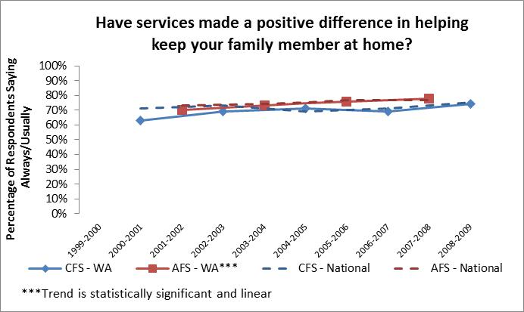

FIGURE 39: SUPPORTS IMPROVED ABILITY TO CARE FOR CHILD
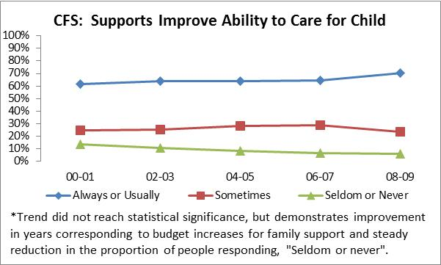

Developmental Disabilities System Changes
The increase in use of waiver programs has changed the way state agencies for persons with intellectual and/or developmental disabilities operate. In 1991, HCBS (including waiver programs, personal care, and home health benefits) represented only about 14 percent of Medicaid long-term care expenditures (Kaiser, 2005). By 2004, community-based services represented 36 percent ($31.7 billion) of total long-term care spending, and $21.2 billion went specifically to HCBS waiver programs (Burwell, et al., 2005). Similarly, the Real Choice Systems Change Grants program of 2000 helped shift the service paradigm towards integrated and community-based care. These systems change grants helped build the infrastructure necessary for individuals to live in integrated community settings, supported efforts to facilitate access to existing services and supports, created new services and supports, improved data collection and quality assurance processes, and enhanced the recruitment, training and retention of direct care workers (Shirk, 2006).

Major WA State events:

Organization & Structure
The service system for individuals with developmental disabilities in Washington State underwent substantial modification during the first decade of the 21st century with the intent to improve accuracy, consistency, and documentation. In October 2002, DDD was merged with the Aging and Adult Services Administration to become the Aging and Disability Services Administration (ADSA). This merger allowed the two entities to pool and streamline administrative resources. Over time, policies were formally documented, and expectations were formally communicated to all staff utilizing Management Bulletins beginning in March 2004. Many of the decisions typically made locally at the level of individual field offices or institutions were moved to a Central Office level to improve statewide consistency in how services were authorized and delivered. These changes were motivated, in part, as remediation efforts for audit findings. The need to become more cost efficient in the use of state dollars in response to the economic recession also stimulated change and efficiency improvements.

Funding
Recognizing that state service funding was not a viable long-term solution for supporting every individual with a developmental disability, the Developmental Disabilities Endowment Fund was created by the Washington State Legislature in the 1999 session. The current title for this program is the Developmental Disabilities Life Opportunities Trust (DDLOT). This program allows individuals with developmental disabilities or their families to save for their future without affecting their eligibility for government programs or benefits. The funds can also be used for services not covered by other benefits, such as recreation, therapy, clothing, and transportation. Funds are invested and managed by the Washington State Investment Board, and the State provides matching funds on fees for individual trust accounts. The fund opened for enrollment in July 2002 and as of December 2011, the cumulative value of the trust exceeded $27 million.
Private corporations also began expanding their health care coverage for the treatment of autism. In January 2001, Microsoft became the first major corporation in the nation to provide health care coverage to their employees and families for Applied Behavioral Analysis (ABA). It would not be until January 2013, however, that coverage of ABA treatment of autism would be mandated in Washington State for all private medical insurance carriers and Medicaid.
Changes also occurred in how services within the Division of Developmental Disabilities were funded. In September 2002, the Division implemented a new State Supplementary Payment (SSP) program for developmental disabilities services. Prior to July 2002, aged, blind and disabled persons in Washington State who received monthly SSI payments from the Social Security Administration received a state funded supplemental payment (SSP). The State was facing a financial shortage, but under federal law they were required to continue spending the same amount of funds on SSP as they had expended in the previous year or risk losing $3 billion in Federal matching funds. The Legislature decided to reduce funding for the Division of Developmental Disabilities overall and then award the division $21.3 million in funds to support their clients receiving SSI who were receiving state-funded services for their developmental disability. In lieu of traditionally funded services, some clients receiving SSI began receiving a cash payment in the amount of their previously funded DDD services to pay for their supports directly. An advantage to these individuals was that the cash grant, contrary to traditionally funded supports, had no restrictions on how the money was spent, thus allowing individuals and families more freedom of choice on the type of supports that best suit their needs.
In December 2002, DDD and the Medical Assistance Administration initiated a joint project to identify clients with ID/DD who were eligible for Disabled Adult Child (DAC) Social Security benefits and Medicaid to ensure that these individuals receive all of the Federal benefits to which they are entitled. DAC benefits are for the natural, step, or adoptive child meeting the Social Security definition of disability prior to the age of 22 who have a parent that is entitled to Social Security benefits based on retirement, death, or disability. Accessing these Federal benefits often reduced or eliminated the individual’s need for state-funded assistance.

HCBS Waivers
In response to the concerns voiced by CMS, as well as the Legislature through several audits of the division, plans were made to replace the Community Alternatives HCBS Waiver program (CAP Waiver) with four waivers that more clearly defined the services and supports that a person could expect to receive. The Basic Waiver would support individuals and families who required just a small dollar amount of assistance to support an individual with ID/DD in the family home or to live independently. The Basic Plus Waiver would support individuals and families who required a little more support to live in the family home or independently, or who received residential supports in Adult Family Homes or Adult Residential Centers. The Core Waiver would support individuals and families who required substantial support, or who received residential services through one of the Division’s contracted residential support agencies. A Community Protection Waiver was also established specifically for those participating in the division’s Community Protection Program. These new HCBS waivers were approved by CMS and implemented in April 2004. The Division would later obtain approval from CMS and implement the Children’s In-Home Intensive Behavioral Support HCBS Waiver program in May 2009.
Similar to other states, Washington State expanded its use of HCBS waiver programs. Most new service slots for residential services were partially funded through federal matching funds via an HCBS waiver. Also, when severe budget reductions were being implemented due to fiscal shortages in the later part of the decade, DDD mitigated these reductions by transferring as many people as possible from state-only funded programs to programs that offered federal matching funds. The additional service slots are relatively small in number as compared to the total HCBS waiver population and are not noticeable amongst the trend for the total number of persons on HCBS waivers. However, new slots tended to be for the persons with the most significant support needs and the supports required by the existing aging caseload were increasing over time. Thus, overall HCBS waiver expenditures rose substantially across the decade. Budget reduction targets and overall increases in need amongst the service population were managed via attrition of current HCBS recipients. The overall trend (see figure 40) has been a rise in HCBS expenditures and a reduction in the number of persons enrolled on a waiver (with the exception of the early part of the decade and the end of the decade when the addition of HCBS waiver slots exceeded attrition).
FIGURE 40: NUMBER OF HCBS WAIVER PARTICIPANTS AND EXPENDITURES OVER TIME
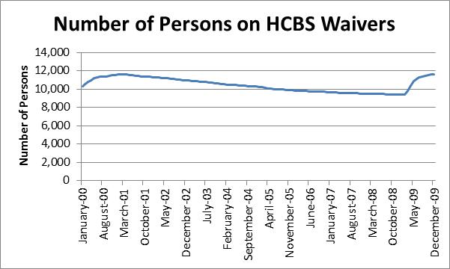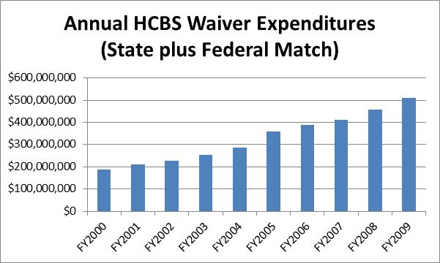

In fiscal year 2008 the Division received authorization from the legislature to begin transferring 1,000 people receiving state-only employment/day or residential services to an HCBS waiver. An additional 3,000 people receiving state-only employment/day services were authorized to be transferred to a waiver beginning in February 2009. A similar approach was used to mitigate the impact of a large reduction in personal care hours and in the Individual and Family Services (IFS) program that took effect in July 2008, and when further reductions to personal care hours took effect in July 2009. An advantage to the move from state-only to waiver funded services for individuals was that they became eligible for the full array of services offered under that waiver. This preserved transportation services for persons receiving employment supports when community transportation resources were being drastically cut due to the national recession.

Consolidation of Service Options
The structure and processes of the Division of Developmental Disabilities service system were streamlined, centralized, and standardized to become more efficient in response to the economic times and as corrective actions to audit findings. In July 2001, the Intensive Tenant Support, Regular Tenant Support, and Supportive Living programs were combined into a single program called Supported Living.
Service programs to support families were also streamlined. By 2006, the Division found itself operating three separate family support programs: Traditional Family Support, for families who began receiving family support services prior to 1996; Family Support Opportunities, a program initiated in 1996 and designed to bring supports to a larger number of families by utilizing a smaller award amount per family; and Family Support Pilot, a program initiated by the Legislature in July 2005 to serve 1,500 low income families. In November 2006, DDD and its stakeholder representatives submitted a report to the Legislature requesting a new family support program that combined these three programs into one. The Legislature passed SSB-5467 in April 2007, creating the Individual & Family Services (IFS) program. The IFS program began in July 2007. An advantage to the new program is that it includes one-time exceptional needs and emergency supports for families who are not receiving IFS grants to assist them in the event of a short-term crisis situation. This allowed the division to be able to respond to the most emergent needs of the many thousands of people waiting for service slots without having to resort to expensive institutional placements as the only service option for individuals and families in crisis.
Over the past decade, Washington State has made progress toward meeting the needs of individuals and families in crisis (see figure 41). This is partly due to improvements in crisis stabilization services. However, increased oversight and demands from CMS for states to meet all needs for HCBS waiver participants within 90 days, and proviso funding from the legislature that has tended to be restricted only to those with the greatest need, have also influenced this trend. The Developmental Disabilities Administration operates as a crisis-driven service system, so the needs of persons in crisis are being met first, while those with less emergent needs continue to wait on the No-Paid Services caseload.
FIGURE 41: AVAILABILITY OF CRISIS SERVICES

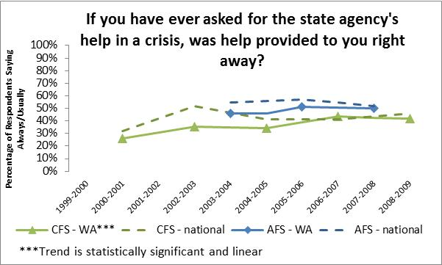

Infrastructure
The division’s infrastructure was enhanced to improve accuracy, consistency, and documentation. These new computer-based tools also provided the Division with a wealth of centrally located information about caseload members and the services they receive.
- The Client Authorization Service Input System (CASIS) was implemented in October 2002 to simplify and improve accuracy of service authorizations by connecting the Division’s case management system with the Department of Social and Health Services’ Social Services Payment System (SSPS).
- In July 2003, the Division began using the Client Assessment, Reporting and Evaluation (CARE) tool to determine service level need for personal care amongst adults. A children’s version of the CARE assessment was launched in September 2004. This standardized the method of determining authorizations for Medicaid Personal Care within the Division of Developmental Disabilities and aligned with the method currently in use for other aging and long-term care programs.
- An electronic Incident Reporting System was implemented in May 2004 to facilitate standardization of documentation and review of major incidents involving Division clients.
- An assessment and standardized algorithm for determining service need and authorization levels for respite under the division’s new HCBS waivers was launched in September 2004.
- An intake and eligibility module to the CARE tool was launched in July 2005, providing, for the first time, an electronic accounting of eligibility determinations for DDD services.
- In June 2007, a new DDD assessment was launched to provide a consistent method of determining level of care and need for division services. The new assessment included algorithms to determine HCBS Waiver eligibility and ensure consistent and accurate service allocations for respite, family support, and most residential programs across the state.
- A Case Management Information System (CMIS) was added to the CARE tool in April 2008 to streamline data tracking and improve the coordination and operation of many case management functions.
- Further enhancements to the CMIS module were released in May 2009, and
- Standardized algorithms for determining respite allocations for Voluntary Placement and Companion Home providers were implemented in September 2009.
While the implementation of standardized rate structures may have improved fairness, accuracy and consistency, it is also associated with a reduction in the proportion of respondents who say that they “always or usually” know how much money is spent by the Division on their family member’s behalf (see figure 42). This may be because most of the Division’s assessment-based service algorithms result in an allocation of service hours rather than a specified dollar amount. Another impact of standardized assessment-based service rates, greater monitoring and quality assurance efforts was that there is now less room for negotiation between families and case managers on how and where service funds are used. Though not statistically significant, NCI results do show a slight decline in the number of people who say that they “always or usually” decide how service dollars are spent (see figure 43). These two trends continued until the spring of 2007, when families of children started to say that they had more knowledge and control over funding for their family member. However, the most recent data collected for the Adult Family and Family/Guardian Surveys does not yet show a rebound. Perhaps this is due to differences between younger and older adults regarding electronic methods, as mentioned earlier in the “Information Explosion” section.
FIGURE 42: KNOW HOW MUCH MONEY IS SPENT ON BEHALF OF FAMILY MEMBER
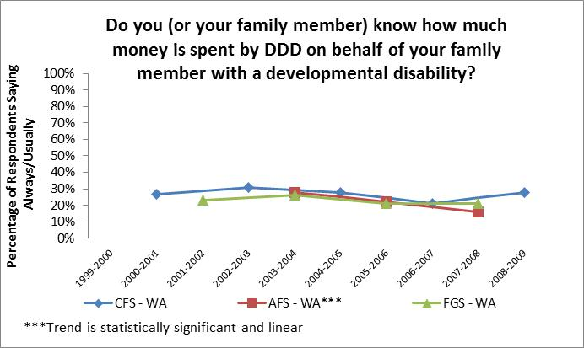

FIGURE 43: DECIDE HOW MONEY IS SPENT ON BEHALF OF FAMILY MEMBER
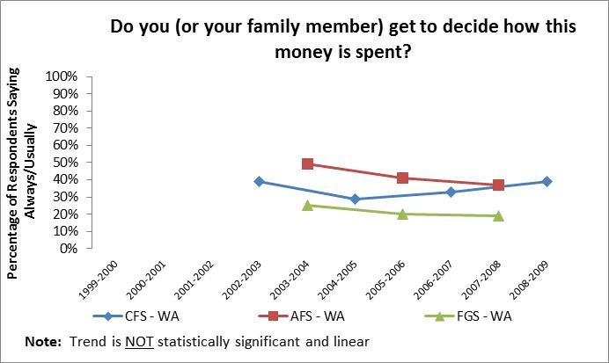

Quality Assurance
The Division of Developmental Disabilities created several units during the first decade of the 21st century in order to provide better oversight of Division programs and to meet increasing demands from the Washington State Department of Social & Health Services, Governor’s Office, and CMS for initiating quality assurance and improvement activities. These units were instrumental in designing and overseeing the implementation for many of the service system changes and improvements discussed above.
The Division created a state Office of Quality Assurance in November 2001. An office chief was appointed to oversee the new unit at the central office level and six regional quality assurance coordinators were assigned to carry out quality assurance activities from field offices across the state. A Quality Assurance Steering Committee was also appointed in November 2001 to help identify the roles and responsibilities of each part of the enhanced quality assurance system. One of the first tasks for the regional quality assurance staff was to conduct quality assurance visits for individuals moving from the RHCs into community placements. These regular follow–up visits are still occurring today and have been expanded to include moves from any institutional setting. Quality Assurance staffing would later increase to include a Quality Assurance Manager in each region to oversee the work of several Performance and Quality Improvement specialists within their region.
Other roles of the Office of Quality Assurance are to seek input for consumers and families about the quality of the services they receive, to handle constituent complaints and to ensure that they are appropriately addressed by the division. The Office of Quality Assurance worked to increase consumers’ awareness of their rights and designed a formal process for handling constituent complaints.
- In June 2004, DDD began requiring the client or representative to sign “Your Rights and Responsibilities When You Receive Services Offered by Aging and Disability Administration” upon initial authorization of services and at annual review.
- In March 2005, the Aging & Disability Services Administration (ADSA) issued a new grievance policy to be used by Area Agencies on Aging, Home and Community Services Division, and the Division of Developmental Disabilities.
A central office Compliance/Monitoring Team was also established to conduct regular audits on regional offices to ensure that important policies and procedures for eligibility determination, service assessment, and service authorization were being followed at the local level. This unit was created in July 2002, and was responsible for establishing business process improvements, designing policies, and creating monitoring reports. The Compliance Unit Program Manager oversaw the work of six team members who were located in field offices across the state. The team members were assigned to help develop clear policies and procedures and to ensure that they were implemented consistently across the state. The team was also responsible for generating regular monitoring reports to document regional compliance with Division policies and procedures. One of the first tasks for the Compliance/Monitoring Team was to monitor compliance with the division’s rules for eligibility determination. The Team is also responsible for gathering data and preparing the quality assurance report that is required by CMS under its new HCBS Waiver rules.
In April 2008, a Central Office Statewide Investigation Unit (SIU) was established. Federal regulations require that ICF/ID facilities and Nursing facilities have evidence that all alleged violations are thoroughly investigated and actions are taken to prevent further harm while investigations are in progress. The purpose of creating a Central Office investigation unit was to move the responsibility for these investigations away from the Residential Habilitation Centers (RHCs) so that investigations of serious incidents could be conducted by an independent entity. The unit is also responsible for monitoring the RHCs for compliance with plans of correction and federal and state regulations and policies.
The efforts of these quality assurance units, together with efforts by the Developmental Disability Council’s (DDC) Informing Families Building Trust (IFBT) outreach efforts to inform individuals and families of their rights and processes for filing a complaint, have resulted in greater familiarity and satisfaction with the division’s grievance process (see figures 44 and 45).
FIGURE 44: FAMILIAR WITH GRIEVANCE PROCEDURE
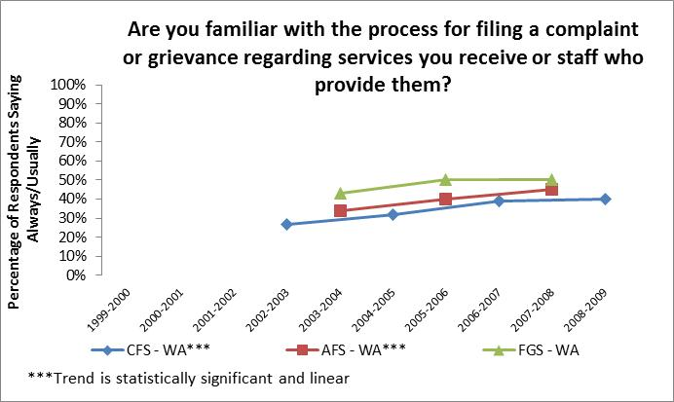

FIGURE 45: SATISFIED WITH GRIEVANCE PROCEDURE
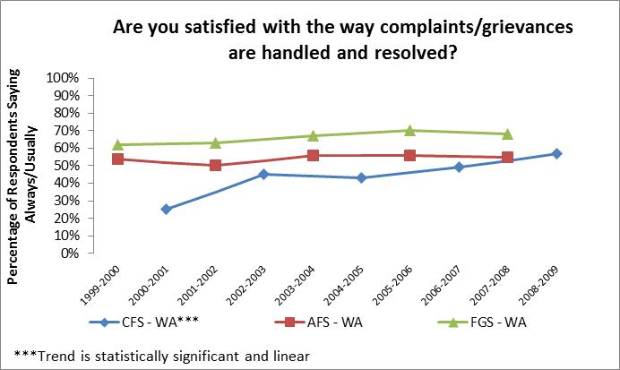

Service Providers
Other than RHCs and a few residences where state employees provide support in a supported living model (State Operated Living Alternatives, or SOLA), Washington State’s services for persons with intellectual or developmental disabilities are primarily delivered by private, contracted entities. Several pivotal events occurred during the first decade of the 21st century, intended to support and strengthen the skills and availability of privately operated direct support professionals.
- Unions: In November 2001, Washington State voters approved an initiative to allow home care workers to unionize. SHB-2475 allowed collective bargaining regarding hours of work for Individual Providers (IPs) beginning in July 2006. Adult Family Home owners receiving Medicaid payments also obtained collective bargaining rights through HB-2111, implemented in July 2007.
- Wage Increases: Individual and agency personal care workers subsequently received increased wages in almost every year’s budget. Even when substantial cuts to service rates for agency residential and employment day program support providers occurred in 2008 and 2009, wages for IPs and agency personal care workers were preserved. Beginning in July 2008, IPs could also receive mileage reimbursement for transporting clients to essential shopping and medical services.
- Training: During the 2000 legislative session, SSB-6502 added additional training requirements for adult family home, boarding homes, individual providers (IPs) and group homes serving individuals with ID/DD. These provisions went into effect in March 2002. Starting in October 2004, IPs were also required to complete a four hour safety training. In 2007, Governor Gregoire signed legislation establishing the Long-Term Care Worker’s Training Workgroup. This group was tasked with making recommendations for new training standards for long-term care workers. Initiative 1163 was approved by voters on November 4, 2008 requiring additional training, continuing education, and certification for long-term care workers, but this would not go into effect until the following decade.
- Benefits: Beginning in July 1999, health care benefits were provided to low income home care workers who work 20 hours per week or more. In October 2004, IPs also became eligible for workers compensation insurance. In January 2005, IPs without other coverage and who work at least 86.6 hours in 3 months became eligible to receive benefits, and in November 2005, all agency home care providers were required to provide health care benefits to workers employed through state contracts for at least twenty hours per week. When a 4% reduction in personal care hours to clients took effect in July 2008, home care workers’ benefits were protected by a temporary reduction in the number of hours IPs must work to receive health care benefits.
- Referral Registry: In January 2005, the Health Care Quality Authority established a referral registry to help potential clients connect with available Individual Providers. A provider search screen for the IP referral registry was implemented in June 2008 to make it easier to connect potential clients with available IPs.
- Contracts: Responsibility for home care agency contracts moved from DDD regional offices to the Central Office contracts office in May 2007, and standardized language for all contracted agencies providing state funded personal care services was implemented in July 2007. The Health Care Quality Authority took over the contracting process for Individual Providers in April 2009.
Service providers in Washington State have always been rated highly in terms of respect and courtesy (see figures 46 and 47), but individuals with ID/DD and their families have seen only very mild change in staff turnover (see figure 48) and little to no change in the perceived health/safety of services provided (see figures 49 and 50).
FIGURE 46: SUPPORT STAFF ARE RESPECTFUL/COURTEOUS
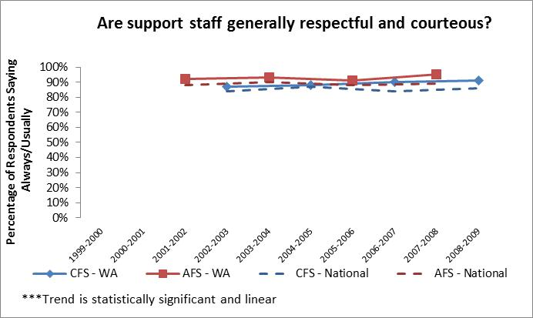

FIGURE 47: SUPPORT STAFF ARE NICE AND POLITE
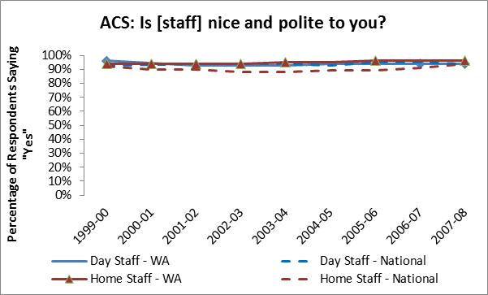

FIGURE 48: FREQUENT CHANGES IN SUPPORT STAFF
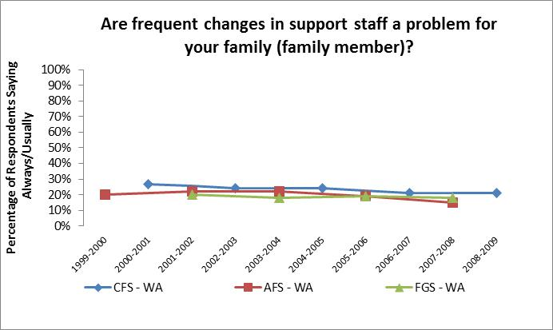

FIGURE 49: PERCEIVED HEALTY/SAFETY OF RESIDENTIAL SETTING
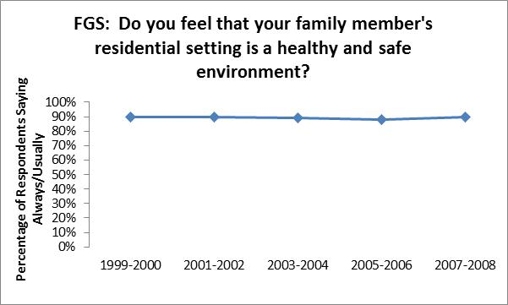

FIGURE 50: PERCEIVED HEALTY/SAFETY OF EMPLOYMENT SETTING
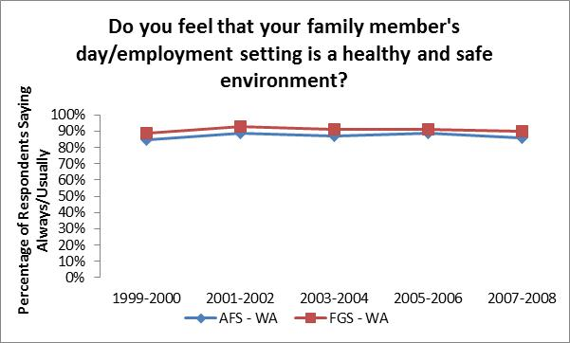

Case Management
Prior to the turn of the century, Washington State’s case management system was performing very poorly on NCI indicators. New service dollars were being allotted to the Division, but additional case management resources to connect individuals to these services and monitor service delivery were not being allotted. Over time, caseload ratios grew dramatically. In a detailed study of case management workload conducted in 1997 and published in March of 1999, researchers found that:
- The average caseworker to client ratio in Washington State is 1:125 clients; whereas the national average is 1:40, ranking Washington State’s caseload ratio as the highest in the nation.
- 55% of the essential work case managers are responsible for doing is not getting done.
- Case managers are only able to have direct contact (in person or by telephone) with half of their caseload during an entire year.
- 67% of the essential work required for a proper match of clients to services and supports is not being accomplished, and half of the caseload has at least one complicating characteristic (e.g., high physical care needs, behavior problems, family issues, language/cultural differences, mental illness) that makes follow-up particularly important to ensure a good match with service providers to ensure their complex needs are being met.
- 63% of the essential work required for monitoring supports/services to ensure quality cannot be accomplished.
In July 2000, the Division established regional Intensive Case Manager positions to provide increased case management support to individuals with developmental disabilities and co-existing mental health/challenging behaviors that placed them at risk for state psychiatric hospitalization. These case managers’ caseloads were limited to a maximum of 30 individuals, similar to the caseloads of social workers in the Voluntary Placement Program. Some consideration was also given to reduce caseloads for case managers overseeing persons with community protection issues. A method of allotting the number of case management and support staff needed per new service slot was developed by the Division so that the appropriate number of staff was included in all future budget requests for expanding services.
Based on the findings of the Workload Standards Study (Administrative Services Division, 1999) and several audits, the Division was given substantial funding in the fiscal year 2002 budget to hire additional case management staff. Instead of the 1:65 ratio recommended by the Workload Standards Study, the Legislature was funding a caseload ratio of 1:75 and this was provided to improve oversight and quality of care for HCBS Waiver participants only. The Division reorganized its case management system into three separate categories and reassigned clients to other case managers who served their particular caseload type. Waiver case managers would serve only HCBS waiver clients and would have caseload ratios of no more than 1:75. Case managers serving clients receiving paid services funded by sources other than the HCBS waiver would have caseload ratios of no more than 1:105. No-Paid Services case managers would provide support to all other persons on the DDD caseload. These caseload members include those who are waiting for service slots to become available and those who do not currently need a paid service but occasionally require the assistance of a case manager for information and referral. Given the limited number of case management staff positions available to the Division, No-Paid Services caseload ratios averaged more than 600 clients per case manager.
In calendar year 2001 into 2002, the Division conducted another Workload Standards Study to update the findings from the previous study (Weber & Langford, 2003). This study was published in April 2003, and found that case managers were still not able to perform minimally essential work, in spite of the addition of new case/resource positions and a decline in service growth. Due to additional processes and new administrative requirements, less time was available to case/resource managers for case management work and the FTE gap had grown larger, from a gap of 198 FTEs to 224 FTEs. The study revised the essential caseload ratio down to 1:64.
Despite an ongoing shortage of case/resource management staff positions, NCI survey results show that the reduced caseload ratios for paid services clients has made a substantial difference for individuals and their families. Washington State’s case managers have always received high ratings for being respectful and effective, but in the early part of the decade, performed substantially below the national average for other case management indicators. After the case management reorganization, Washington State’s NCI data showed substantial improvements on these case management indicators, particularly for individuals being supported in the family home (see figures 51 and 52). Respondents were substantially more likely to report that they were able to contact planning staff when needed (see figure 53), that planning staff helped them figure out their needs (see figures 54 and 55), and that staff helped them obtain those needed supports (see figures 56 and 57). Despite still having caseload ratios that exceed the essential minimum standard, Washington State is now performing similar to the national average on NCI case management indicators.
FIGURE 51: PLANNING STAFF ARE GENERALLY RESPECTFUL/COURTEOUS
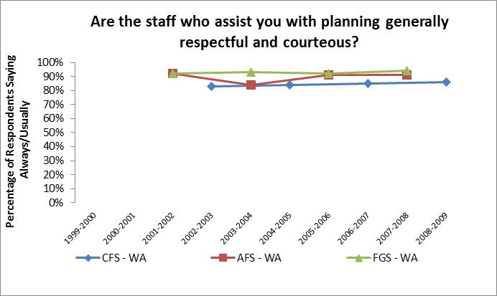

FIGURE 52: PLANNING STAFF ARE GENERALLY EFFECTIVE
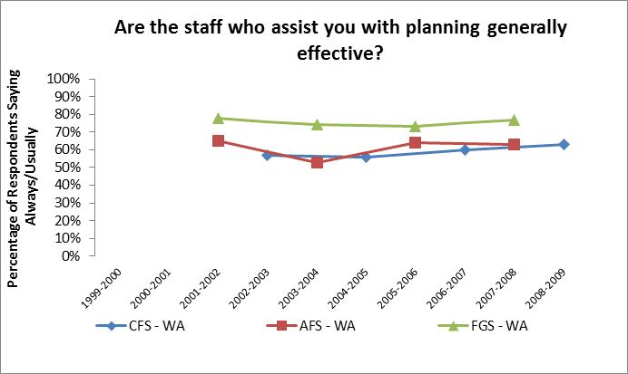

FIGURE 53: CAN CONTACT PLANNING STAFF
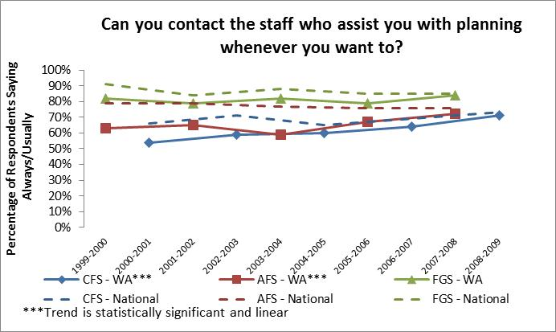

FIGURE 54: PLANNING STAFF HELP FIGURE OUT NEEDS
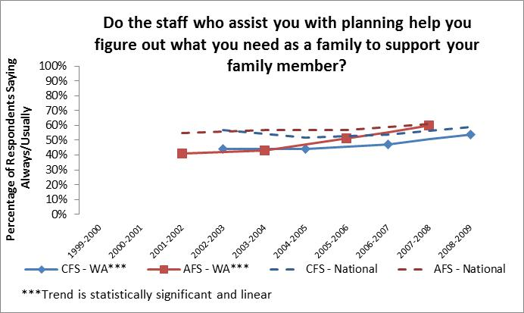

FIGURE 55: SOMEONE INFORMS YOU ABOUT PUBLIC BENEFITS
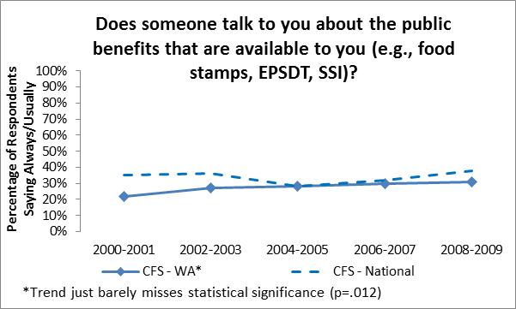

FIGURE 56: CASE MANAGER HELPS GET WHAT YOU NEED
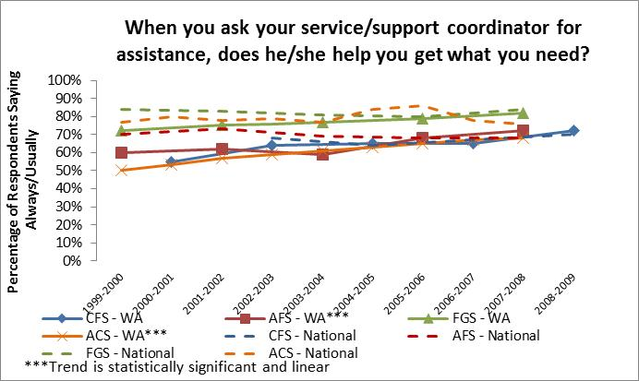

FIGURE 57: SOMEONE HELPS CONNECT TO NATURAL SUPPORTS
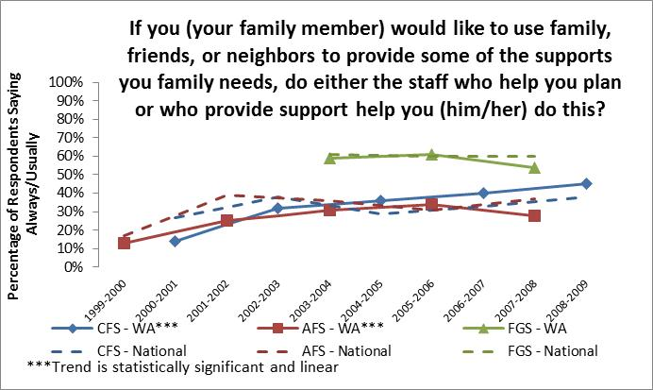

Towards the second Decade of the 21st Century
Although much has been accomplished during the first decade of the 21st century, there is still plenty of room for service system restructuring and enhancement. Washington State has made substantial improvement in its performance on the National Core Indicators, no longer being one of the worst performing states, but it still performs in the average to slightly below average range for most indicators.
Major changes have already occurred in the new decade including:
- Elimination of assigned case managers for the No-Paid Services caseload in January 2011;
- Consolidation of DSHS regional management and business processes from six regions to three regions in May 2011;
- Revision of the Working Age Adult policy in September 2011 to allow clients to choose a day program service after trying a DDD employment program for at least nine months (as directed by the Legislature in HB 1087);
- Closure of Frances Haddon Morgan Center in December 2011;
- Implementation of standardized service rates for employment and day programs in July 2012;
- Consolidation of the Basic and Basic Plus HCBS waivers in September 2012;
- Establishment of the Community Crisis Stabilization Services (CCSS) program in November 2012;
- Medicaid and private health insurance carriers in Washington State are now required to cover ABA services for the treatment of autism for persons age 20 years or younger as of January 2013; and
- Restructuring of the Department of Social & Health Services, upgrading the developmental disabilities service system from a Division to an Administration in February 2013.
However, the service system continues to be primarily a reactionary system whereby those in crisis get served first and little to no resources are allotted for preventative measures. Rising service costs, a growing No-Paid Services caseload, increasing numbers of clients with high support needs, and aging Residential Habilitation Center facilities are additional challenges to be addressed during the second decade of the 21st century. The elevation from Division to Administration status will allow the agency to focus more intensively on issues facing persons with intellectual and/or developmental disabilities in Washington State, and provides greater latitude for addressing those issues.
The legislature made investments in the developmental disabilities service system by expanding Individual & Family Services (IFS) and the Basic Plus Waiver in its 2011-13 Operating Budget, hoping to increase supports for families whose adult sons and daughters continue to reside at home, and at the same time reduce or delay the demand for more expensive crisis-based services or out of home placements created because of the lack of preventive supports available to families. With these new resources, DDA is beginning to see a notable impact on the No Paid Services caseload. And for the first time in many years, DDA was able to absorb anticipated critical community placements within its existing resources without submitting a supplemental budget request for additional residential service slots. The Administration’s work is far from over, however. The No Paid Services caseload is still of great concern and crisis situations are still common.
National Core Indicators results will be useful for tracking the impact of recent and upcoming events for our caseload members; such as, the implementation of health care reform, transfer of training for Individual Providers to the Training Partnership, enhanced information dissemination efforts of the Informing Families Building Trust project, Medicaid coverage reductions and expansions, changes to guardianship laws, and any other events that may occur in the future.
The findings of this report provide evidence that, when targeted efforts are invested in a particular area, real change can and does occur. One of many examples throughout this report is employment. Washington State has achieved a dramatic increase (54%) in the number persons receiving Individual Supported Employment services within a decade. This change was made possible through sustained effort and investment in community-based employment opportunities for individuals with developmental disabilities. Another example is case management indicators. Through investment in additional staffing and restructuring of its case management service system, Washington State has shown substantial improvement on nearly every NCI case management indicator.
Washington State has moved from a poorly performing state to an “average” state for nearly all indicators in a relatively short period of time. Targeted efforts have the potential to be successful in turning Washington State into an above average or exemplary state in selected areas by the end of the next decade. As it has done in the past, the Administration should partner with advocates and stakeholders to determine which areas it will pursue for improvement before the current decade ends in calendar year 2019; and evaluate the success of their chosen efforts via National Core Indicators data upon the conclusion of the next decade.

References
Administrative Services Division, (1999) Workload Standards Study: Case/Resource Management in the Division of Developmental Disabilities, WA State Department of Social and Health Services; available at http://publications.rda.dshs.wa.gov/273/
Administrative Services Division, (1999) An Analysis of Unmet Service Needs for Washington State’s Division of Developmental Disabilities, WA State Department of Social and Health Services; available at http://publications.rda.dshs.wa.gov/269/
American Association on Intellectual and Developmental Disabilities. (2009) Guardianship: Joint Position Statement of AAIDD and The Arc. Retrieved from http://aaidd.org/news-policy/policy/position-statements/guardianship
Boyle CA, Boulet S, Schieve L, Cohen RA, Blumberg SJ, Yeargin-Allsopp M, Visser S, Kogan MD. (2011) Trends in the Prevalence of Developmental Disabilities in US Children, 1997–2008. Pediatrics.
Brian Burwell, Kate Sredl, and Steve Eiken, Medicaid Long Term Care Expenditures in FY 2004, Medstat, May 11, 2005; available at http://nasuad.org/hcbs/article/medicaid-long-term-care-expenditures-fy-2004
Chakrabarti, S., Fombonne, E. (2001) Pervasive developmental disorders in preschool children. Journal of the American Medical Association. 285 (3093-3099).
Centers for Medicare and Medicaid Services. (2002) Washington Medicaid Assessment Report Community Alternatives Program Waiver (Control Number 0050.90.R2). Retrieved from http://www.dshs.wa.gov/word/adsa/ddd/CMS Report 2002.doc
Centers for Medicare and Medicaid Services. (n.d.) Quality Measures Development Overview. Retrieved from http://www.cms.gov/Medicare/Quality-Initiatives-Patient-Assessment-Instruments/QualityInitiativesGenInfo/downloads/QualityMeasuresDevelopmentOverview.pdf
Deer, B. (2009) MMR Doctor Andrew Wakefield Fixed Data on Autism. The Sunday Times (8 February 2009); available at http://www.thesundaytimes.co.uk/sto/public/news/article148992.ece
Developmental Disabilities Administration. (n.d.) Policy Manual, WA State Department of Social and Health Services; available at http://www.dshs.wa.gov/ddd/policy.shtml
Division of Developmental Disabilities. (1988) Residential Service Guidelines, WA State Department of Social and Health Services; available at http://www.dshs.wa.gov/pdf/adsa/ddd/rs_guidelines.pdf
Division of Developmental Disabilities. (1992) County Guidelines, WA State Department of Social and Health Services; available at http://www.dshs.wa.gov/pdf/adsa/ddd/c_guidelines.pdf
Division of Developmental Disabilities. (1998) Strategies for the Future: Long-Range Plan Report Phase 1: 1999-2001, WA State Department of Social and Health Services; available at http://www.dshs.wa.gov/pdf/adsa/ddd/strategy1.pdf
Division of Developmental Disabilities. (2000) Strategies for the Future: Long-Range Plan Report Phase 2: 2001-2003, WA State Department of Social and Health Services; available at http://www.dshs.wa.gov/pdf/adsa/ddd/strategy2.pdf
Division of Developmental Disabilities. (2002) Strategies for the Future: Long-Range Plan Report Phase 3: Final Report, WA State Department of Social and Health Services; available at http://www.dshs.wa.gov/pdf/adsa/ddd/strategy3.pdf
Gunther, DF, Diekema, DS. (2006) Attenuating Growth in Children With Profound Developmental Disability: A New Approach to an Old Dilemma. Archives of Pediatric Adolescent Medicine 160(10): (1013-1017); available at http://archpedi.jamanetwork.com/article.aspx?articleid=205567
Hecht, E., Reynolds, M. (2011) Building a national agenda for supporting families with a member with intellectual and developmental disabilities. Wingspread Family Support Summit, March 6-8, 2011
Janicki MP, Dalton AJ, Henderson CM, Davidson PW, (1999). Mortality and morbidity among older adults with intellectual disability: health services considerations. Disabil Rehabil 21:284-294.
Joint Legislative Audit and Review Committee, (1999). Division of Developmental Disabilities Management Audit Report 99-3, State of Washington. Retrieved from http://www.leg.wa.gov/JLARC/AuditAndStudyReports/1999/Documents/99-3.pdf
Joint Legislative Audit and Review Committee, (2001). Voluntary Placement Program Briefing Report 01-4, State of Washington. Retrieved from http://www.leg.wa.gov/JLARC/AuditAndStudyReports/2001/Documents/01-4.pdf
Joint Legislative Audit and Review Committee, (2002). Division of Developmental Disabilities: Caseload and Staffing Issues Interim Report 02-3, State of Washington. Retrieved from http://www.leg.wa.gov/JLARC/AuditAndStudyReports/2002/Documents/02-3.pdf
Joint Legislative Audit and Review Committee, (2002). Performance Audit of Developmental Disabilities Division Interim Report, State of Washington. Retrieved from http://www.leg.wa.gov/JLARC/AuditAndStudyReports/2002/Documents/02-13InterimReport.pdf
Joint Legislative Audit and Review Committee, (2003). Performance Audit of the Division of Developmental Disabilities Report 03-6, State of Washington. Retrieved from http://www.leg.wa.gov/JLARC/AuditAndStudyReports/2003/Documents/03-6.pdf
Kaiser Commission on Medicaid and the Uninsured, “Medicaid and Long-Term Care,” fact sheet, March 2005; available at www.kff.org/medicaid/2186-03.cfm.
Kitchener, M., Willmott, M., Wong, A., & Harrington, C. (2007) Home and community based services: Federal funding to states. Center for Personal Assistance Services. Retrieved on September 23, 2013 from http://www.pascenter.org/state_based_stats/federal_funding/index.php
Kogan, M., Blumberg, L., Schieve, C., Boyle, J., Perrin, R., et al. (2009) Prevalence of parent-reported diagnosis of autism spectrum disorder among children in the US, 2007. Pediatrics 124: (1395-1403)
Larson, S. (2008) Policy Research Brief: Innovative models and best practices in case management and support coordination. Research and Training Center on Community Living, Institute on Community Integration (UCEDD). College of Education and Human Development, University of Minnesota. 19:1 Retrieved on September 23, 2013 from http://ici.umn.edu/products/prb/191/
Mandell, D., Thompson, E., Weintraub, F., DeStafano, M. (2005) Trends in diagnosis rates of autism and ADHD at hospital discharge in the context of other psychiatric diagnoses. Psychiatric Services, 56(56-62)
Matson, J., Kozlowski, A. (2011) The increasing prevalence of autism spectrum disorders. Research in Autism Spectrum Disorders. 5(1): 418-425
Minnesota Governor's Council on Developmental Disabilities, (2006) Parallels in Time II, A Place to Call Home: The Development of Supports for Having a Home in the Community: The 1990s: Explosion of Community Housing, Institution Free States, A Home of Your Own, Expanding Family Support
slide 76, available at http://www.mnddc.org/parallels2/index.htm.
Nassar, N., Dixon, G., Bourke, C., Bower, E., Glasson, N., de Klerk, et al. (2009) Autism spectrum disorders in young children: Effect of changes in diagnostic practices. International Journal of Epidemiology 38 (1245-1254)
Nelson\Nygaard Consulting Associates Inc. (2009) Special Needs Transportation Coordination: Final Report. State of Washington Joint Transportation Committee, available at http://www.leg.wa.gov/JTC/Documents/ACCT/SpecialNeedsTranspFINALREPORT_010609.pdf
Perkins, E. & Moran, J. (2010) Aging adults with intellectual disabilities. JAMA 304(1):91-92
Shaklee, M; Strong, M; Langford, D; Elliot, F; Longhi, D. (1999) Workload Standards Study: Case/Resource Management in the Division of Developmental Disabilities (Report #5.30), Research and Data Analysis, WA State Department of Social and Health Services. 5.30 Available at http://www.dshs.wa.gov/pdf/ms/rda/research/5/30.pdf
Shirk, C. (2006) Rebalancing long-term care: The role of the Medicaid HCBS Waiver program. National Health Policy Forum. Retrieved on September 23, 2013 from http://www.nhpf.org/library/background-papers/BP_HCBS.Waivers_03-03-06.pdf
State of Washington Office of the Code Reviser. (n.d.) Washington Administrative Code. Washington State Legislature/Statute Law Committee. Available at http://apps.leg.wa.gov/wac/default.aspx?cite=388
Sterling Associates, LLP. (2002) DSHS – Review of the Division of Developmental Disabilities, available at http://www.dshs.wa.gov/pdf/adsa/ddd/DDDFinalReport.pdf
The Arc of Washington State. (2012) The History Booklet: The History of State and National Activities, Events and Policies Impacting People with Developmental Disabilities. Retrieved from http://arcwa.org/index.php/takeaction/washingtonstate/history_of_the_arc/the_history_booklet
Weber, LA; Longhi, D; Tyrell-Smith, J; Stern, J. (1999) An Analysis of Unmet Service Needs for Washington State’s Division of Developmental Disabilities, Research and Data Analysis, WA State Department of Social and Health Services. 5.29 Available at http://www.dshs.wa.gov/pdf/ms/rda/research/5/29.pdf
Weber, LA; Langford D. (2003) Executive Summary: An Update of the DSHS Division of Developmental Disabilities Case/Resource Management Essential Workload Standards, Division of Developmental Disabilities, WA State Department of Social and Health Services.
United States Department of Justice Civil Rights Division. (n.d.) Olmstead: Community Integration for Everyone. Retrieved from http://www.ada.gov/olmstead/olmstead_about.htm
United States Government Accountability Office. (2003) Long-term Care: Federal Oversight of Growing Medicaid Home and Community-Based Waivers Should Be Strengthened. Retrieved from http://www.gao.gov/products/GAO-03-576

Residential Habilitation Centers (RHCs) are state-operated residential settings that provide residential habilitation training, 24-hour supervision, and medical/nursing services for clients who meet Medicaid eligibility and need active treatment services. An RHC may be certified as an Intermediate Care Facility for Individuals with Intellectual Disabilities (ICF/ID) and/or licensed as a Nursing Facility. RHCs are considered institutional settings. There are currently four RHCs in Washington State: Fircrest School, Lakeland Village, Rainier School, and Yakima Valley School. Frances Haddon Morgan Center closed in December 2011.
The Division of Developmental Disabilities Olmstead Agreements are located in Appendix C, Section 4 of the Strategies for the Future Long-Range Plan Report Phase 3: Final Report.
The Medicaid HCBS waiver program is authorized under Section 1915(c) of the Social Security Act. Through this program, states can assist Medicaid beneficiaries by providing a wide array of services that permit them to live in their homes or community and avoid institutionalization in a nursing home facility.
The 2007-09 Biennium budget included $4.9 million for 1,300 new families to receive Family Support; $5.0 million for additional employment support slots for 748 graduates and other adults; and $14.2 million for 236 new community residential placements and support.
The Centers for Medicare & Medicaid Services (CMS), a federal agency and branch of the U.S. Department of Health & Human Services, administers Medicare, Medicaid and the Children’s Health Insurance Program (CHIP) in partnership with state governments and private health insurance programs.
Starting with the 2002-03 data collection cycle, states could include children up to age 22 who were still enrolled in school. Prior to this, the survey population for the Child Family Survey was only children who were under the age of 18. Washington elected to continue surveying only families of children under the age of 18 for consistency with prior data collection and to provide a clear distinction between the Adult Family Survey population and the Child Family Survey population. Washington State also excludes clients receiving only early intervention services and no other paid services so that results will be more representative of the broad array of services the Division offers to families with children of all ages.
Paid Services clients receive one or more services that are paid for via funds from the budget of the Division of Developmental Disabilities.
No-Paid Services clients meet criteria for eligibility to the Division of Developmental Disabilities, but are not currently receiving a service funded from the budget of the division. States can utilize the NCI surveys to explore issues of local interest. The Division has administered surveys similar to the NCI family surveys for its No-Paid Services caseload in the past, but the focus of the current analysis is on the Paid Services caseload only.
The spring 2000 dataset for the Family/Guardian survey was not available, so this statistic was drawn from the “Family Survey: Phase II Technical Report”.
The spring 2000 dataset for the Family/Guardian survey was not available, so this statistic was drawn from the “Family Survey: Phase II Technical Report”.
Data on Washington State’s general population was obtained from the Office of Financial Management’s (OFM) website at www.ofm.wa.gov/population.
This question was not asked in the 1999-2000 Adult Family Survey.
This question is not asked on the adult family surveys.
This question was asked differently on the 2000-2001 Child Family Survey and thus results are not comparable to future years.
Data was analyzed differently in 1999-2000 for this question, so is not directly comparable to data from future years.
The 1999-00 survey only asked about a few other disabilities, so for purposes of comparability across time, the 2001-2002 data was used as the base year.
Data was analyzed differently in 1999-2000 for this question, so is not directly comparable to data from future years.
The 1999-00 survey only asked about a few other disabilities, so for purposes of comparability across time, the 2001-2002 data was used as the base year.
Intermediate Care Facilities for Persons with Intellectual Disabilities (ICF/ID) are residential settings that provide habilitation training, 24-hour supervision, and medical/nursing services for Medicaid eligible clients who are in need of the active treatment services provided in these facilities. ICF/IDs operated by DDD in Residential Habilitation Centers (RHC) are located at Fircrest School, Lakeland Village, and Rainier School. There are also privately-operated ICF/IDs located in King and Pierce Counties. These facilities are considered institutional settings.
The spring 2000 dataset for the Family/Guardian survey was not available, so this statistic was drawn from the “Family Survey: Phase II Technical Report”.
The use of “How Am I Doing” comment cards was suspended in August 2011 as a result of streamlining efforts to meet budget reductions imposed by the Governor.
The spring 2000 dataset for the Family/Guardian survey was not available, so this statistic was drawn from the “Family Survey: Phase II Technical Report”.
This question is not asked on the Family/Guardian Survey.
This question is not asked on the Family/Guardian Survey. For the Adult Family Survey, the wording of this question changed from “Do you choose….” to “Do you or your family member choose….” beginning with the 2003-2004 data collection cycle. Thus, results are not comparable to previous years.
For the adult surveys, the wording of this question changed from “Do you choose….” to “Do you or your family member choose….” beginning with the 2003-2004 data collection cycle. Thus, results are not comparable to previous years.
For the adult surveys, the wording of this question changed from “Do you have….” to “Do you or your family member have….” beginning with the 2003-2004 data collection cycle. Thus, results are not comparable to previous years.
For the adult surveys, the wording of this question changed from “Do you choose….” to “Do you or your family member choose….” beginning with the 2003-2004 data collection cycle. Thus, results are not comparable to previous years.
The spring 2000 dataset for the Adult Consumer survey was not available, so the statistics for this graph were drawn from the “Consumer Survey: Phase II Technical Report”.
This question was asked on the 2000-2001 version of the Child Family Survey, but had different response options and therefore results are not compatible with future years.
The spring 2000 dataset for the Family/Guardian survey was not available, so this statistic was drawn from the “Family Survey: Phase II Technical Report”.
This question was asked on the 2000-2001 version of the Child Family Survey, but had different response options and therefore results are not compatible with future years.
Data for this figure was obtained from Washington State’s Case Management Information System (CMIS).
Data for this figure was obtained from Washington State’s Case Management Information System (CMIS).
Data for this figure was obtained from Washington State’s Administration Web Access (AWA) database.
Data for this figure was obtained from Washington State’s Administrative Web Access (AWA) database.
Data for this figure was obtained from Washington State’s Case Management Information System (CMIS), Administrative Web Access (AWA), and the Social Service Payment System (SSPS) databases.
The spring 2000 dataset for the Family/Guardian survey was not available, so this statistic was drawn from the “Family Survey: Phase II Technical Report”. This question was not asked on the national version of the Child Family Survey during the first year of its implementation (2000-2001), but WA State added this question to their local version of the survey. The statistic presented here for the 2000-2001 Child Family Survey was obtained from a special analysis of WA State local questions added to the NCI surveys that was performed by the University of Washington’s Center for Disability Policy and Research. The question was added to the national version of the Child Family Survey in following years.
This question was not asked on the Family/Guardian Survey until the 2003-04 data collection year.
This question was not asked on the 1999-2000 version of the Adult Family Survey.
Data for this figure was obtained from Washington State’s Case Management Information System (CMIS) and the Fasttrack data system.
Versions of the Adult Family Survey prior to 2003-2004 used different response options. Therefore, data from earlier years is not compatible with data from later years for this question.
This question was not asked in the 1999-2000 versions of the Adult Family Survey and the Family/Guardian Survey. The 2001-2002 version of the Adult Family Survey used different response options for this question. Therefore, results are not compatible with results for future years.
This question was not asked in the 1999-2000 versions of the Adult Family Survey and the Family/Guardian Survey. The question was asked in the 2000-2001 version of the Child Family Survey and the 2001-2002 versions of the adult surveys, but the response options changed from “Yes, or most of the time” to “Always or usually” beginning with the 2002-2003 surveys. The change in wording appears to have influenced the results, so only data from the 2002-2003 surveys forward is presented here.
This unit is currently known as the Office of Quality Programs and Stakeholder Involvement.
This unit is currently known as the Office of Compliance and Monitoring.
This question was not asked in the 1999-2000 versions of the Adult Family and Family/Guardian surveys. The 2001-2002 versions of the Adult Family and Family/Guardian surveys included a similar question, but used different response options and slightly different question wording, therefore is not compatible with results for future years.
The spring 2000 dataset for the Family/Guardian survey was not available, so this statistic was drawn from the “Family Survey: Phase II Technical Report”.
This question was not asked prior to the 2002-2003 surveys. A similar question was asked in previous years, but the question wording and response options were different enough that results were not consistent over time.
On the Adult Consumer Survey version for 1999-2000 and again starting in 2008-2009, staff at day programs and staff at employment programs were two separate questions. The results presented for these years are the weighted average of the percentage of “Yes” responses to the two separate questions.
This question was not asked on the 1999-2000 Family/Guardian Survey. The spring 2002 dataset for the Family/Guardian survey was missing WA State’s data for this question, so this statistic was drawn from the “Family Guardian Survey: Final Report – January 2003, 2001-2002 Data”.
The spring 2000 dataset for the Family/Guardian survey was not available, so this statistic was drawn from the “Family Survey: Phase II Technical Report”.
The spring 2000 dataset for the Family/Guardian survey was not available, so this statistic was drawn from the “Family Survey: Phase II Technical Report”.
Prior to the 2001-2002 data collection cycle, this question asked about “staff” in general, not specifically staff who assist with planning. Therefore, results from early years are not compatible with results from later years.
This question was not asked prior to the 2001-2002 data collection cycle.
Prior to the 2001-2002 data collection cycle, this question asked about “staff” in general, not specifically staff who assist with planning. Therefore, results from early years are not compatible with results from later years.
This question is only asked on the Child Family Survey.
This question was not asked on the national study version of the 2000-2001 Child Family Survey, but WA State did add this question locally. Therefore, WA state results are available for the 2000-2001 Child Family Survey, but there is no national average for comparison.
This question was not asked on the Family/Guardian Survey till the 2003-2004 data collection cycle. The wording and response options for this question changed somewhat in the early years of the Adult Family and Child Family Surveys. This may account for some of the observed increase. However, the trend remained consistent throughout the later data collection cycles when question wording and response options remained consistent.

