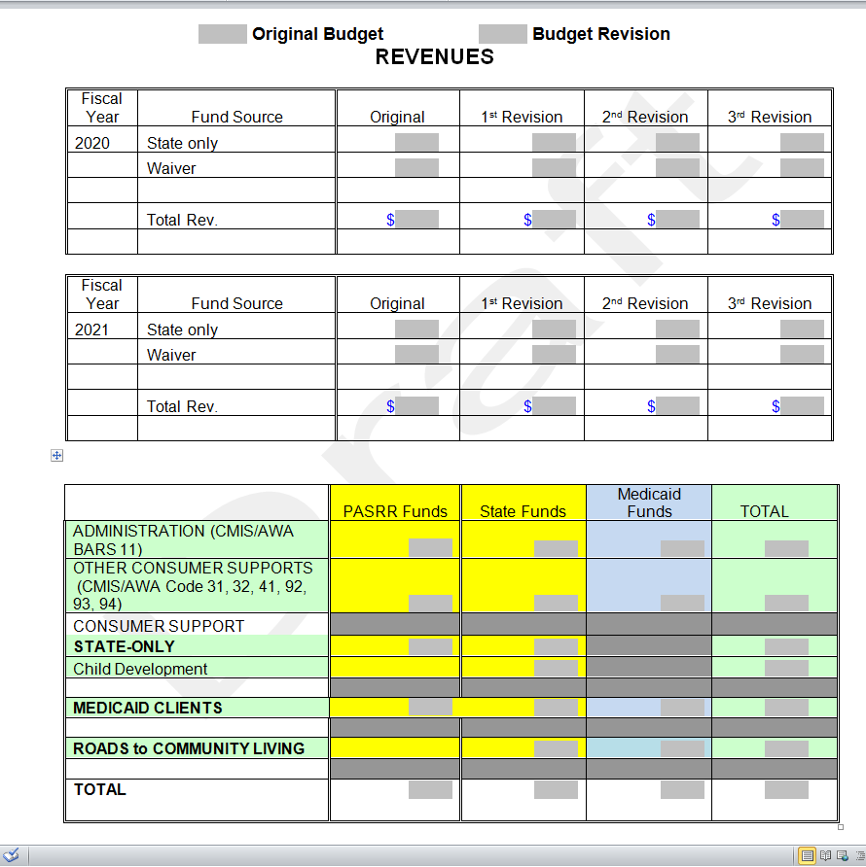
- DSHS/DDA will be amending County spending plans to add a new funding category to “Other Consumer supports” called “Agency Start up”. Funding will be shifted from the “Medicaid” services line to this new category. The % of state and federal match for this category is being finalized.
“Agency Start-up “ will be added here

- A new line for “Agency Start-up” will need to be added to the invoice coversheet completed by the County contracted provider that accompanies the client data submitted with the County billing. Example Below:
 | Description | Amount Billed | Funding Code
A | Employment and Community Inclusion Services | $ | 673800.6610
B. | Employment and Community Inclusion Services  Agency Start-up (Related to COVID-19) | $ | 673800.6610
C. | Total Billed | $

Services will be billed in the same service categories (IE, GSE, CI) and at the same rates established in the County contract. What will change is the documentation provided by the agency and the funding category a portion of services will be costed to.

- The total “Agency Start-up” billed to the County across all providers will be billed in a lump sum through the AWA billing system similar to “other consumer supports”
Add total start up for your county here

