Generations in the Workplace

2020
Facilitator Guide
Developmental Disabilities Administration
Welcome to Beyond First Aid Training: A Direct Support Professional’s guide to managing emergent healthcare needs of individuals with developmental and intellectual disabilities.

Trainer’s Manual for Instructor led courses
Course Title: Generations in the Workplace
Course Code: CE1832700
# of CE hours: 4 hours
Intended Audience: Direct Support Professionals.
Before the event:
- Reserve the room, invite attendees, and determine if you will provide light refreshments and ensure .
- Along with the event, place time on your calendar to practice in advance. No matter how well you know the material, you should go through it before you stand to deliver.
- Prepare certificates. Print one for each person with their name, instructor number (if needed) and the training information. The certificate for this course is available in the master’s section of this guide.
- Prepare packets with handouts and other information to share during the training.
  - Samples can be found at the end of this chapter, or
  - You may have a participant toolkit to print
- Practice using the activities. Ensure that you have written instructions each – including time.
- Gather all materials necessary for the training. Be prepared and organized.
- Arrange the room.
Each example arrangement allows for safe evacuation, small group discussions and easy access to the front of the room so participants can focus on the presenter and visuals.
Place a large table at the front of the room for training materials, laptop, anything you need for your presentation.
- Provide stress-reliever objects for kinesthetic learners such as squishy balls, tangle toys, or pipe cleaners. Also have markers, post-it notes, 3x5 cards, and pens.
- Greet participants as they enter.
- Play entry music. Select ahead of time or add to your PowerPoint.
- Provide instructions on the dry erase board or easel regarding name tags, table tents or what to do to fill their time. (Table challenges or puzzles are a great way to fill time for early guests.)
- Create a sign-in sheet including the course name, date and location. Participants may print names and sign in or pre-print participants’ names and have them initial or sign for each day present. Participants must complete to receive a certificate. Archive the sign-in sheet or an electronic form for six years.
Materials for this course:
- Computer
- Wi-Fi
- Long extension cord
- Monitor / projector and speakers
- Screen or blank white wall
- Blank paper
- Markers
- Easel and paper
Easel sheets to prepare before class:
- Welcome
- Instructions for completing sign-in sheet, name tags, table tents, where to sit
Trainer Tips:
Your tone of voice needs to vary throughout the training. A visual learner likes it to be fast and funny, an auditory learner likes it medium speed and a kinesthetic learner likes it slow and calm. Avoid a monotone voice.
Be intentional in your movement. Stay in one location and if you have to move, be intentional! Some facilitators are also successful with slowly moving around the room.
Use normal hand gestures and arm movements.
Connect with people. Look at faces for no longer than 5 seconds or for a full thought. Looking people in the eye for longer than can make them uncomfortable. Looking over their heads breaks your connection with them. Make brief eye contact with everyone at some point in the training.
Breathe quietly and deeply.
Focus on the group. What do they need? Are they getting tired? Give them a break, or do some movement. Are they hungry? Are they bored? Do not let your need to cover content make you forget that people cannot learn if they are anxious, bored, tired, hungry, or stressed.

When you see this symbol in the facilitator guide you will know that there is activity connected to this part of the curriculum. Read the trainer instructions and prepare ahead of time for this activity.
When you see this symbol in the facilitator guide you will know that there is a handout or visual tool that is connected to this part of the curriculum. Help your participants find the handout before you talk about the concepts.

When you see this symbol in the facilitator guide you will know that there is an IMPORTANT idea or concept that needs to be communicated in this part of the curriculum. Read the trainer instructions and prepare ahead of time for how you will explain this idea or concept or highlight this area of the curriculum
When you see this symbol in the facilitator guide you will know that there are discussion questions connected to this part of the curriculum. Prepare for these discussions questions by answering these questions for yourself and practice how you will guide a group toward an main idea or concept.
When you see this symbol in the facilitator guide you will know that there is a script, story or verbal antidote connected to this part of the curriculum. It is most powerful when you put these scripts, stories or verbal antidotes in your own words—PRACTICE (try not to read this word-for-word)
When you see this symbol in the facilitator guide you will know that there is a video clip or movie connected to this part of the curriculum. Cue up the video ahead of time and prepare for technical difficulties.
When you see this symbol in the facilitator guide you will know that there is easel paper activity connected to this part of the curriculum. Read the trainer instructions and prepare ahead of time for this activity.

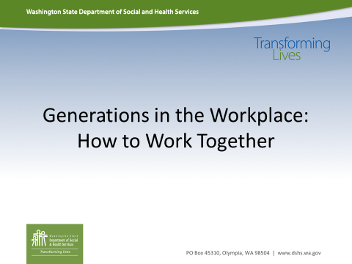 |  | Trainer Instructions: Example below  At the front of the room set out different color name plates:  Red: Baby Boomer (1945-1969)  Green: Generation X (1970-1980)  Yellow: Millennials (1981-2000)  *anyone born after 2000 have them also grab a yellow name tag and participate in the training as a Millennial.  Before the training begins, have each participant write down something they miss from their childhoods, it could be a toy, a TV show, a store or event.  Go around and have each person say their name and share their memory (briefly).
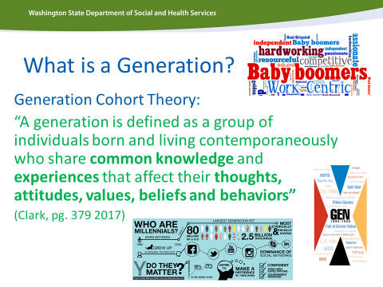 |  | Trainer Note:  This training is based on the Generational Cohort theory.  Have the class read the definition.  You want to empathize that generations are defined by:  - Common knowledge (example—who knows how to use a rotary phone?)  - Common Experiences (who has alive during the Kennedy Assassination)  - That these commonalities shape their thoughts, attitudes, values, beliefs and behaviors.
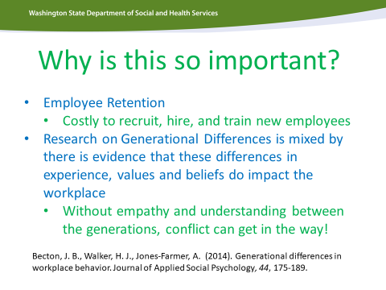 |  | The point of this slide is to speak to two concepts  - Generational cohort theory shows the if employees have empathy and understanding of different generations, how to work best together, retention increases  - the evidence ALSO states that individual experience does not trump generational experience. Some individuals may relate strongly to how their generation is defined and others, who grew up in other countries, who were raised by diverse families, may not relate (as much).
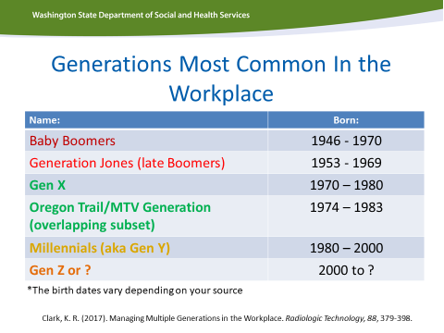 |  | This is the generational breakdown make sure each person has a color coded name plate:  Red: Baby Boomer  Green: Generation X  Yellow: Millennial  This is a chance to talk about, though generations have a long span, events that happen within those generations create subgroupings:  Baby Boomer Subgroup--Generation Jones (Late Boomers): this generation had slightly younger parents, who may not have been WWII veterans and may not have benefitted directly for growing up with the GI bill. These individuals were later to the workplace and experience larger unemployment and increased inflation. This generation is more likely to be indebt because they expected to do better financially (i.e. keeping up with the Joneses).  Generation X (Oregon Train/MTV Generation): later Gen Xers are more tech savvy, they grew up in more of a digital age then older Gen Xers, they are also shaped by TV pop culture
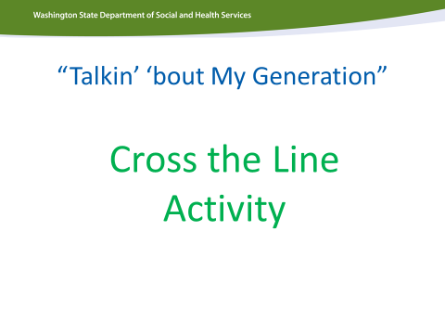 |  | Trainer Notes: (20-30 Minutes)  This activity will show vs. tell how generations are shaped be common experience.  Trainers—you can do this activity two ways:  Option #1—hand out index cards and ask each participant to think of an event that happened in this county that has a huge impact on their life (example---09/11, the Civil Rights Movement, the invention of the internet).  Ask each participant to quietly write down a brief description of the event, the approximate year it happened and hand that in without showing any other class member.  OR  Option #2—you can read for the events listed in the Cross the Line Handout (this handout is ONLY for trainers).  Whichever option you select—divide the room in half with tape on the ground or other divider. Have the participants stand and stand on one side of the room (one side of the line). Read a single event and have anyone who remembers that event cross the line.  It is OK if multiple generations cross the line. Ask if anyone is willing to share their memory, how old were they? How did this event impact their life? Their Generation? In what ways did this event change our communities, county and/or world?  The goal of this activity is to get people really listen to each other’s experience. To see how events really do shape their experience.

Generations In the Workplace: Cross the Line Activity

Instructions: Divide the room in half. Put a line down the middle of the class (rope, tape or an easy to cross divider). At random read one of the experiences below and ask a participant to cross the line if they have experienced this event in history. Have them reflect for a moment on what the event was like. Ask those who crossed the link to speak about that experience. Ask others to just listen no cross talk.

Baby Boomer | Generation X | Millennial
I was a teenage or young adult when the Vietnam War was happening. | As a kid I remember playing Oregon Trail on the computer. | I have never had to use a phone book and I started using google as a child.
When we were kids we had to hide under our desks during bomb drills. I remember the Bay of Pigs event. | As a Teenager I remember the sound of AOL dial up and I remember using or seeing pagers. | The Columbine School Shooting happened when I was a child and the threat of school shootings have been a part of my reality from a young age.
I remember when Neil Armstrong landed on the moon. | I was a child or teenager when the Berlin Wall came down. I remember the famous words President Reagan said “Mr. Gorbachev tear down that wall” | I was a teenager received my first smartphone or my teenage peers had Smartphones (iPhone, android, phone that can access the internet).
I was an adult and remember with Mt. St Helens erupted | I was a kid or teenager when the OJ Simpson trial was on TV. | I was a child when September 11th happened. I grew up in the “War on Terror” era.
I remember Watergate and former President Nixon Resigning | I remember the launch of MTV and I remember when MTV was all music videos | I was a kid or teenager when the first African American President was elected to office in 2008

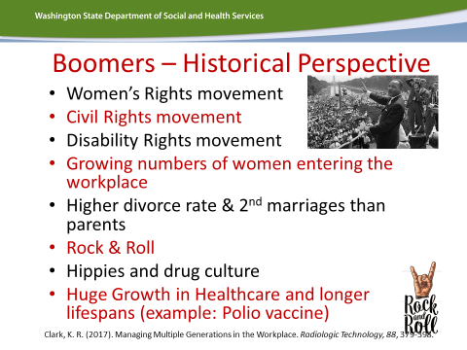 |  | This is where the curriculum takes a turn to looking at these major events that shape each generation.  These are major events that happened during the years the Baby boomers were growing up and into early adulthood. These events shifted culture, prolonged life, shaped the workplace, etc.  Bring out the voices of your baby boomers in trainings, poll to see who remembers these events
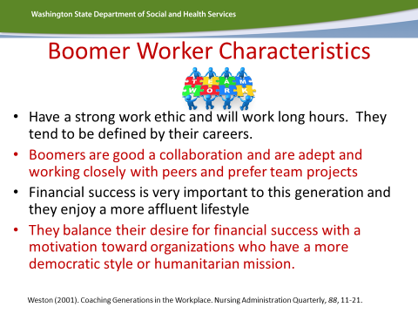 |  | Following the slides around major events that happened that shaped the Baby Boomer generations is this slide the talks about the characteristics, based on generational cohort theory. These characteristics are strongly shaped by the events that happened during and proceeding Baby Boomer generation.
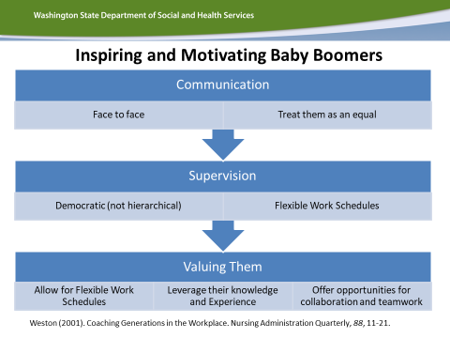 |  | This slide pulls the evidence together to summarize how to best work with a Baby Boomer in the workplace.  Review this slide and talk about each of these tools to inspire and motivate baby boomers.
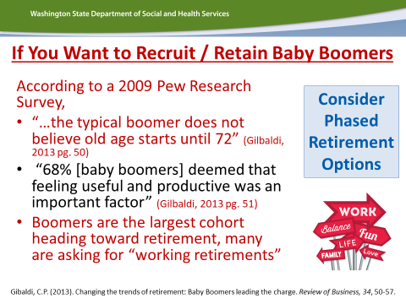 |  | Key points from this slide is that many Baby Boomers are ready to retire and that this generation is reshaping our workforce by working for longer.  Key differences is that though Baby Boomers want to remain in the workplace they want to work flexible schedules and often part-time.
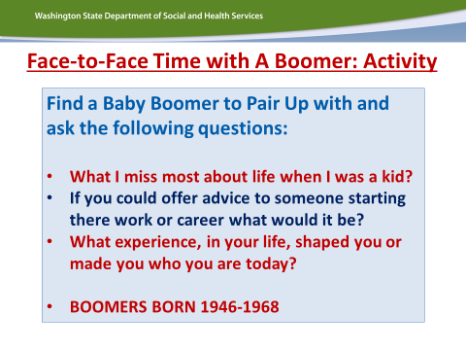 |  | This is a chance to connect your class. Divide the class into small groups. Make sure each small group has at least 1 baby boomer present. Have representatives from the small group ask the baby boomer each of these questions. If there are more than 1 baby boomer in a group, have them take turns answering these questions.  Allow 15 minutes for this activity.
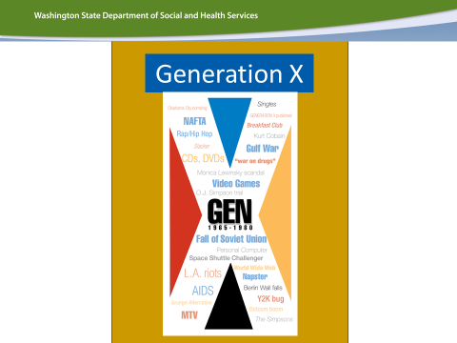 |  | Trainer Note: This is just your transition slide to Generation X. To introduce the next generation.
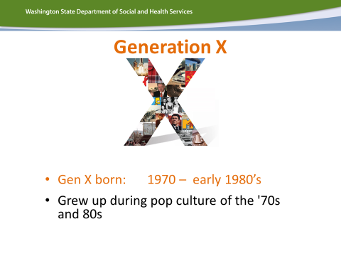 |  | This slide reminds the class the generation (Dates of Birth) for Generation X. Do not spend a lot of time on this slide BUT this might be a good time have the class look around to see who has a green name tag and is part of Generation X cohort.
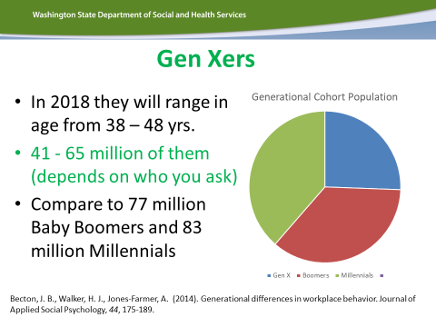 |  | Trainer Notes:  This slide empathizes how small the Generation X cohort is compared to both the Baby Boomers and Millennial generations.  Ask the Class: Why do you think this generational cohort is so small?  **this question will not have a black and white answer but there are reasons on the slides to follow
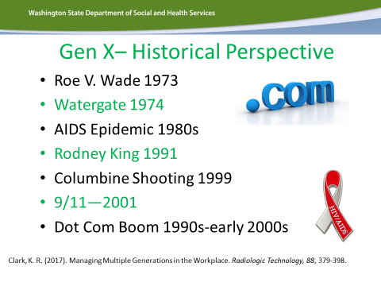 |  | These are the events that shaped Generation X. DON’T ADDRESS THE LOW BIRTHRATE, THAT IS COMING UP NEXT SLIDE  Focus on the dynamic culture issues: Watergate, Rodney King/OJ Simpson trial, development of the internet, 9/11
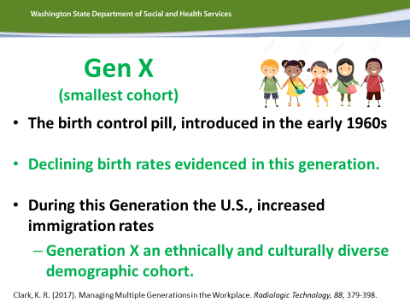 |  | These events give some context who why this might be a smaller cohort, the baby boomers were the parents of Generation X and women entered the workforce at some of the highest rates in history and with the advances in reproductive healthcare/rights family size became smaller and the generation became more culturally diverse.
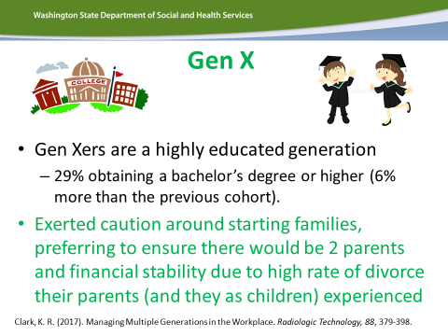 |  | This slide is a good discussion slide.  Discussion Questions:  Why do you think Generation Xers hold higher education degrees than the Baby Boomers?  Why do you think Generation Xers are delaying parenthood later in life and want financial stability?  The answer is not what is important here but you are challenging the class to link events to this generation’s reactions now. Many Generation Xers experiences growing up and into adulthood.
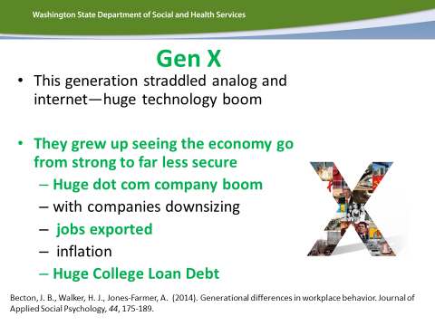 |  | This slide starts to outline how Generation Xers in the workplace. This speaks to their innovations, the cynicism around “the American dream” because they have seen the economy become less and less secure for the middle class and shifts from a manufacturing economic culture to a service oriented culture.
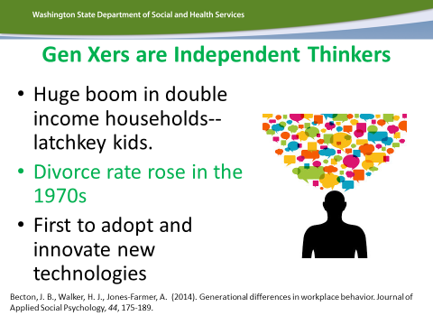 |  | This is a good discussion questions:  What are some of the strengths and challenges (pros and cons) to having a teammate or supervisor who is an independent thinker?
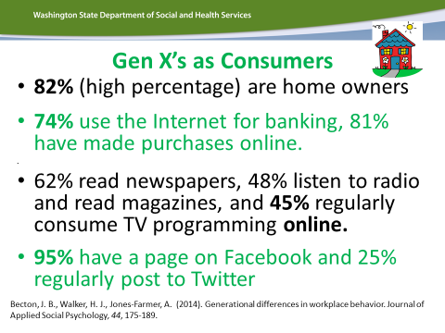 |  | The important concepts of this slide is that Generation Xers consume media and communicate in a way that bridges digital and analogue.  The advantage of this is they can be a bridge between Baby Boomers and Millennials. The enjoy texting and emailing like the millennial. They will also read the paper version of the employee manual and bring paper copies of source material to a staff meeting, which will also meet the need of the baby boomer.
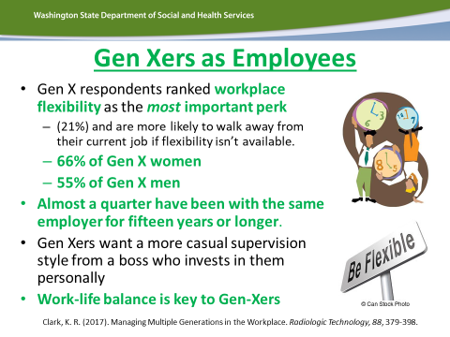 |  | This is a good discussion slide:  If you were the supervisor of a baby boomer, based on this slide, how might you support this worker?  What do you think would motivate and inspire this employee?
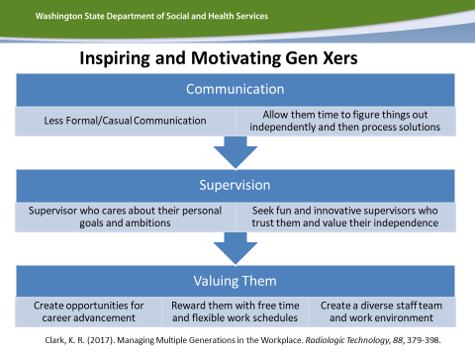 |  | This is another summary slide of how to support a Generation Xer in the workplace based on the evidence.  Discussion:  Any surprises?  Anything you might change about how you approach a co-worker or staff person who is a Gen Xer?
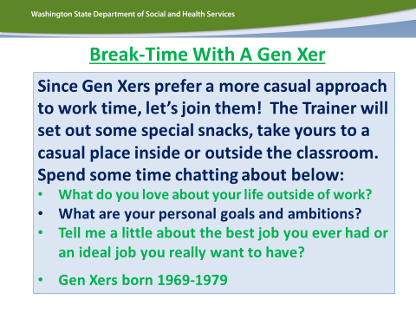 |  | This activity to catered to Generation Xers. Baby Boomers respond to more formal communication and now Generation Xers respond to more casual conversation.  So if you can, bring out some snacks for each table. Break the class into small groups, make sure there is a Gen Xer at each table and ask the group to ask the Gen Xer the questions on the slide.
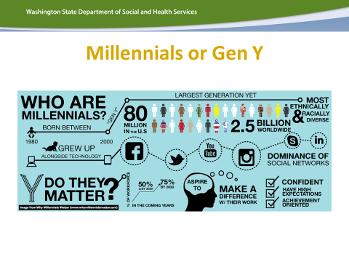 |  | Trainer Note: This is just your transition slide to Millennials. To introduce the next generation.
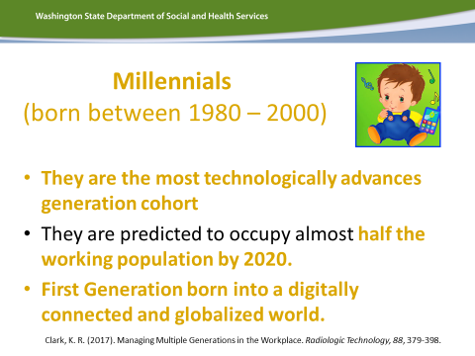 |  | The highlights for this slide is to be strength-based when talking about Millennials. They are the youngest generation and there is a lot in the media about the deficits of Millennials and some frustration about their power and influence. This slide will talk about some of Millennial strengths and how large their influence will be in our workplace.
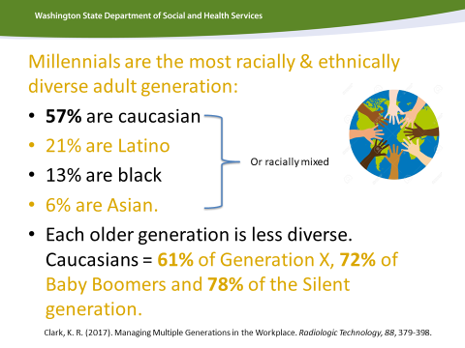 |  | This is a great discussion slide. Ask the class about their reaction to the Millennial generation being the most diverse.  How is this an advantage in a more globally connected worldwide community and workplace?
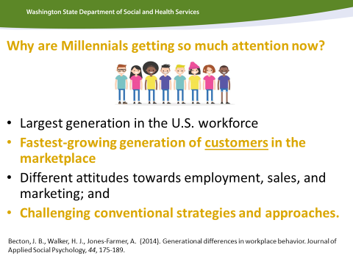 |  | This slide is important because it puts into context about why there is such a focus on Millennials. They already have huge market/consumer power and they also have a huge influence on our workplace.  This slide will help you make the case about why we should understand, empathize and support millennials because they are here to stay and our future.
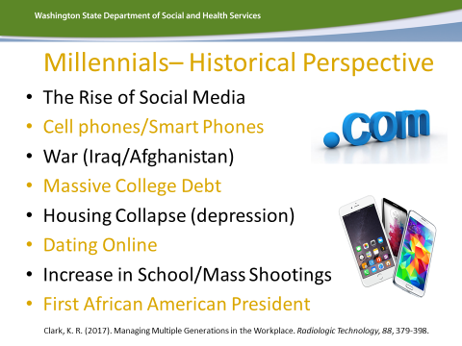 |  | This slide summarizes the major cultural events that shaped the Millennial generation.  This a good time to engage the Millennials and ask if they remember these events? What was their experience?
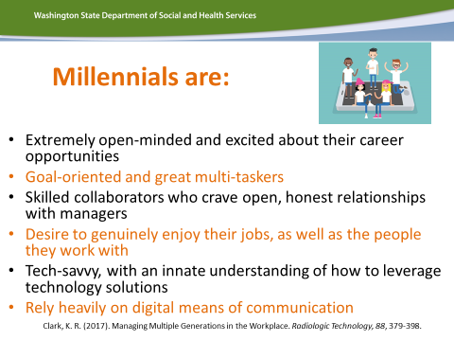 |  | This is a good discussion slide and ask the question, if you were the supervisor or mentor to a Millennial, how might this information help you motivate and inspire a Millennial?  What might you do or do differently?  This is also a great slide to start having a more nuanced conversation about cell phones. Instead of banning cell phones can we manage or set goals about how they are used?  - Googling events, apps that might support the individual, looking up digital directions, etc.
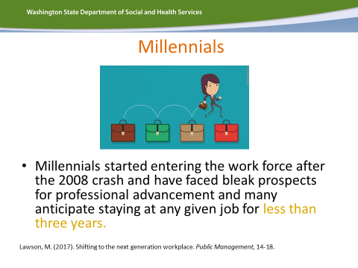 |  | One of the main concerns you will hear from training participants is that Millennials have a high turnover rate and it is exhausting our system of care.  This slide helps put some context to that frustration. The 2008 economic crash really impacted the workforce launch of millennials. It is not uncommon for a Direct Support Professional position to be a first job for a Millennial because when they were launching into eh workplace traditional teenage/young adult jobs (fast food, retail, etc) were occupied by older adults. There was also a lack of employment or a need for millennials to hold 2-3 jobs to make ends meet.
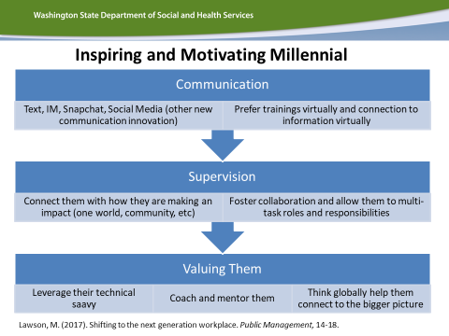 |  | This is another summary slide of how to support a Millennials in the workplace based on the evidence.  Discussion:  Any surprises?  Anything you might change about how you approach a co-worker or staff person who is a Millennials?
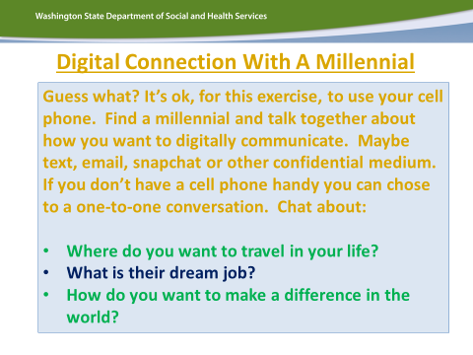 |  | Just as Baby Boomers like more traditional and formal communications and Generation Xers value casual communication, Millennials enjoy digital connections.  Offer to you class (optional, do not mandate this) that if they want to use their cell phones to text or communicate digitally they CAN for this exercise only.  Break them up into pairs or small groups; make sure there is a millennial in each group and have the group ask the millennial the questions on this slide.
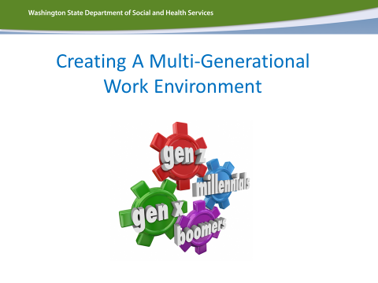 |  | This is a transition slide to summarize:  Now that we have talked about each generation in-depth, it is important to talk about the amazing point in history we are.  Never before have people lived so long and the reason we need to focus in generations in the workplace is because we have 3 and moving to having 4 generations working together in the workplace for an extended time.  So we need to focus on how to build a supportive multigenerational workplace.
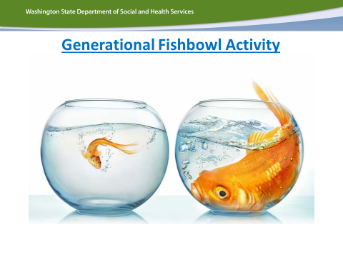  (Continued) | (continued) | This is another chance to show vs. tell and have some fun.  This is the time to break the training participants into small groups according to their generation.  Have baby boomers sit at one table. Generation Xers sit at another table and Millennials sit at a 3rd table.  For this training you need:  1 packet of red index cards: Baby Boomers  1 packet of green index cards: Generation Xers  1 packet of yellow index cards: Millennials  Give the baby boomer group (Red Group):  Green Index Card(s): ask the baby boomers to write ANY question they want to Gen Xers  Yellow Index Card(s): ask the baby boomers to write ANY question they want to Millennials  Give the Generation X group (Green Group):  Red Index Card(s): ask the Gen Xers to write ANY question they want to Baby Boomer  Yellow Index Card(s): ask the Gen Xers to write ANY question they want to a Millennials  Give the Millennial group (Yellow Group):  Red Index Card(s): ask the Millennials to write ANY question they want to Baby Boomer  Green Index Card(s): ask the Millennials to write ANY question they want to a Gen Xers  Collect all of the index cards. Sort them by color. Then read the questions out loud, one at a time to each generational group. Let them answer the questions.  FILTER THE QUESTIONS: try and chose less offensive questions, you can chose funny questions (example—why do Millennials take pictures of their food?)  The goal is for them to laugh, build empathy and have some fun!
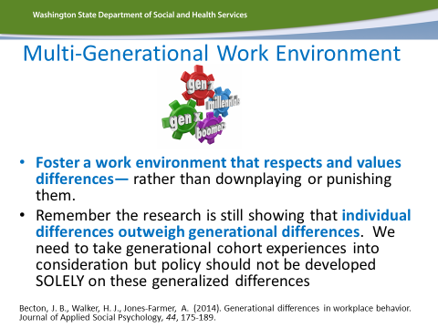 |  | Wrap-up slide #1  This is a summary of what fosters a multigenerational workforce.  It also a final time you can allow for individual differences to be present to lessen resistance. You may have a few participants who do not fit into their generational category and that is ok!
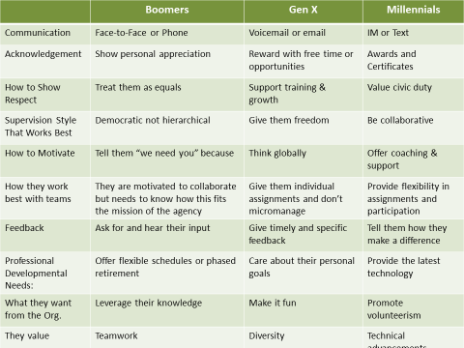 |  | Wrap up slide #3  This is a great (larger) summary of how to support each generation in the workplace.  **This is also a great handout
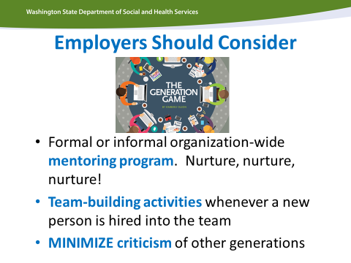 |  | Final Wrap-up slide  These are the main tools employers and workplaces can use to foster a positive multi-generational workplace.
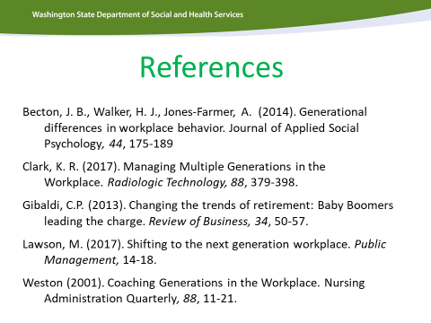 |  | This is the resource material used to develop this training and great resources for participants to look up in they want to need more info.
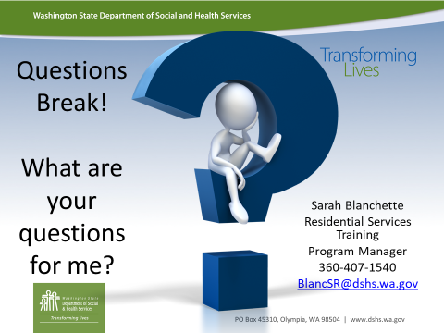 |  | Final Question and Answer slide!  Training complete  Don’t forget to have participants to fill out their evaluations!

Trainer Instructions: Divide into small groups by generation. Have Baby Boomers sit together, Gen Xers sit together and Millennials sit together. For Supplies you will need Red Index Cards, Green Index Cards and Yellow Index Cards (you can use any colors just make sure you have 3 different color cards).

Baby Boomer | Generation X | Millennial
RED Index Card = Baby Boomer | GREEN Index Card = Generation X | YELLOW Index Card = Millennial
On Green Index Cards write:  - Anything you have even wanted to know about a Gen Xer  - One questions per card  - You can write on more than one card | On Red Index Cards write:  - Anything you have even wanted to know about a Boomer  - One questions per card  - You can write on more than one card | On Red Index Cards write:  - Anything you have even wanted to know about a Boomer  - One questions per card  - You can write on more than one card
On Yellow Index Cards write:  - Anything you have even wanted to know about a Millennial  - One questions per card  - You can write on more than one card | On Yellow Index Cards write:  - Anything you have even wanted to know about a Millennial  - One questions per card  - You can write on more than one card | On Green Index Cards write:  - Anything you have even wanted to know about a Gen Xer  - One questions per card  - You can write on more than one card
Turn cards into trainer | Turn cards into trainer | Turn cards into trainer
Be prepared to answer some fun, engaging and sometimes silly questions. The spirit of this activity is to help us get to know each other. | Be prepared to answer some fun, engaging and sometimes silly questions. The spirit of this activity is to help us get to know each other. | Be prepared to answer some fun, engaging and sometimes silly questions. The spirit of this activity is to help us get to know each other.

