Trainer’s Manual for Instructor lead courses
This course was developed by DSHS/DDA. You may add to this course but no other changes are authorized.

Course Title: Turning the tide on Unconscious Bias
Course Code:
# of CE hours: 2
Intended Audience: Everyone

Highlighted areas indicate that you need to add your own information.

Before the event:

- Reserve the room, invite people to attend, determine if you will provide light refreshments or not and ensure that you have marked it off on your calendar so you can prepare. Set aside time to practice. No matter how well you know the material, you should go through it before you stand to deliver.
- Prepare Certificates. Print with person’s name, instructor number (if needed) and the trainer information. Print one certificate for each participant. The certificate for this course is available in the masters section of this Guide.
- Prepare handouts, packets, information you will share during your training.
  - These may be found at the end of this chapter or
  - You may have a participant toolkit to print.
- Prepare activities to use and PRACTICE them. Ensure that you have written instructions for all activities including time.
- Gather all materials that you will need for the training. Be prepared and organized.
- Arrange the room in a friendly lay out.
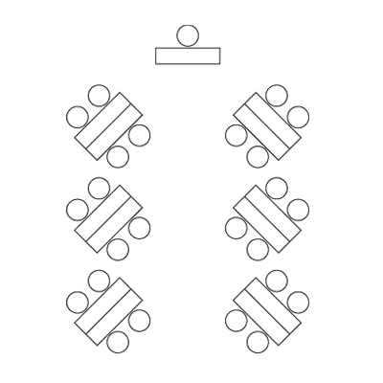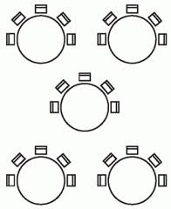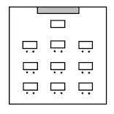

Please note that each arrangements allows for several things, safe evacuation, small group discussions without having to move and easy access to the front of the room so they can focus on the presenter and the screen with visuals.

You will want a large table at the front of the room for your training materials, laptop, projector and whatever you need to have handy during your presentation. Speakers, water bottle, mouse – all take up space so make sure you have enough room.

- Provide stress reliever objects for kinesthetic learners like stress balls, tangle toys, or pipe cleaners, markers, post its, 3x5 cards, pens at each table
- Start on time!
- Greet participants as they enter.
- Play some entry music. Select ahead of time or add to your power point
- Provide instructions on the dry erase board or easel paper regarding name tags, table tents or what to do to fill their time. (Table challenges or puzzles are a great way to fill time for early guests.)
- Create a sign in sheet with the name of the course, date and location. Participants may print their name and sign in or you may pre-print participants’ names and have them initial or sign for each day they are present. Participants must complete your course prior to receiving a certificate. Keep this sign in sheet or an electronic form for 6 years from date of training. RCW

Materials for this course: Modify list as needed.
Computer
Internet cord or Wi-Fi connection
Long extension cord
Monitor or projector and additional speakers
Screen or blank white wall
Blank paper
Markers
Easel sheet and easel

Easel sheets to prepare before class: Modify as needed
Welcome
Instructions for completing sign in sheet, name tags, table tents, where to sit

Objectives: See Bloom’s Taxonomy for verbs to use for learning objectives.

https://www.google.com/search?site=imghp&tbm=isch&source=hp&biw=1536&bih=733&q=remember&oq=remember&gs_l=img.1.0.0l10.2503.3401.0.4877.8.6.0.2.2.0.91.468.6.6.0....0...1ac.1.64.img..0.8.488.BZ4hsEGqykA#imgrc=JFj9We5gHJ4q_M%3A
Here are some trainer tips to review before every presentation!
Your tone of voice needs to vary throughout your training. A Visual learner likes it to be fast and funny, an auditory learner likes it medium speed and a kinesthetic learner likes it slow and calm. Avoid a monotone voice.
Be intentional in your movement. Plant yourself in one location and then if you have to move, move to a spot that is intentional! Some facilitators are also successful with slowly moving around the room.
Use normal hand gestures and arm movements.
Connect with people. Look at their faces for no longer than 5 seconds or for a full thought. Looking people in the eye for longer than this makes them uncomfortable! Looking over their heads breaks your connection with them. Make brief eye contact with everyone at some point in your training.
Breathe quietly and deeply.
Focus on the group. What do they need? Are they getting tired? Give them a break, or do some movement. Are they hungry? Are they bored? Don’t let your need to cover content make you forget that people cannot learn if they are anxious, bored, tired, hungry or stressed.
Best practices for in person training including:
- Read the room
- Start activities with small groups or pairs and move into individual or larger group activities. Creating a safe starting point will help you build trust.
- Meet people where they are – content should not be too basic or too advanced for the group
- Tell people why they are there
- Remind people you are just there to help them
- Ask yourself, what did you learn?
- Leave time for self-reflection on what they learned and what they will apply when they return to work
- Use post it notes first. Some people may not want to share their ideas out loud. By asking each person to write on post its first, allows their voice to be heard for the rest of the activity.
- Answer questions of fact.
- Questions of opinion should be answered by the group.
- Share your expertise when the content in a discussion didn’t get covered.
- Listen effectively. Paraphrase, use active listening skills
- Tell your own story.
- Connect similar ideas throughout the day.
- Have some fun!
FranklinCovey Facilitator Enhancement Day Series, 2016

Visuals used in this Facilitator’s Guide. All visuals are used with permission under a Creative Commons License or were free and are labeled here or in the Power point to attribute the creator.
<a href="http://cliparts.co">Clipart.co</a> | Activity
https://www.google.com/search?biw=1536&bih=733&site=imghp&tbm=isch&sa=1&btnG=Search&q=toolkit+icon&oq=toolkit&gs_l=img.12..0l10.360790.361782.0.370872.7.5.0.2.2.0.96.378.5.5.0....0...1c.1.64.img..0.7.400.HFcvS96-AKo#imgdii=z2HL0bQUte0ESM%3A%3Bz2HL0bQUte0ESM%3A%3BCoqcJzi9rzwALM%3A&imgrc=z2HL0bQUte0ESM%3A | Participant handouts
<a href="http://cliparts.co/clipart/42602">Clip arts</a> | Trainer idea or note
https://commons.wikimedia.org/wiki/File:White_square_with_question_mark.png | Discussion/Questions to ask
http://www.clipartbest.com/clipart-di79jjei9 | What to say, answers to questions
http://www.clipartbest.com/clipart-7caKbeKoi | Video clips
http://cliparts.co/clipart/607993 | Use easel sheets

Add your slides and instructions. Include time for activities and instructions on your slide.

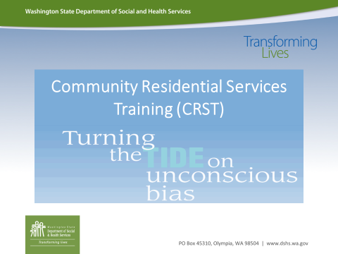 |  | As a part of introductions, ask each person to say their name, agency they are from and ask them what they know about unconscious bias? Why would a training about unconscious bias be important for DSPs working in DDA to participate in?  Then ask you participants to do this:  In your life people have assumed things about you that are NOT true, sometimes they assume characteristics about you just by looking at you. Take a minute and reflect on 1-2 assumptions others have made about you that was hurtful and incorrect. Please write those assumptions down.  TRAINERS: Allow your group 5 minutes to really reflect on this question. Then share something about YOU that others assumed about you that was not true or based on an unconscious bias. The deeper you share, the more you will open space for your participants to share.  Then ask for volunteers to share what they wrote, this exercise has to be completely voluntary, please do not call on anyone to share as this will feel very vulnerable.
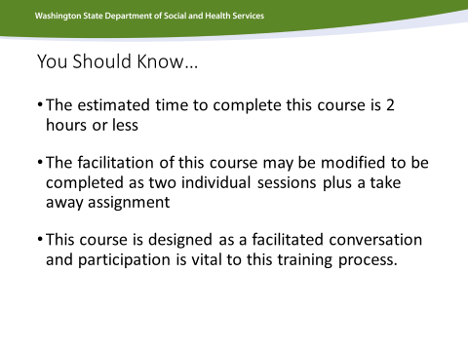 |  | Introductory slide—good time to address NO CELL phones, focus and participation are very important
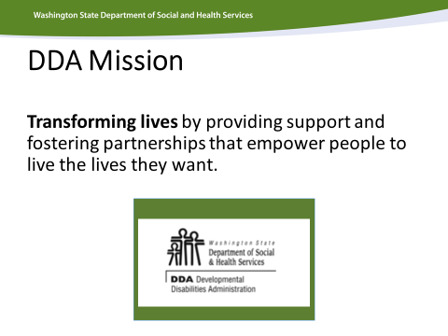 |  | Brief Discussion: How can we transform lives when we are carrying unconscious bias that hurt others? We need to be able to confront not only our unconscious bias but that of others.
 |  | Relate this course to your own Agency’s Mission
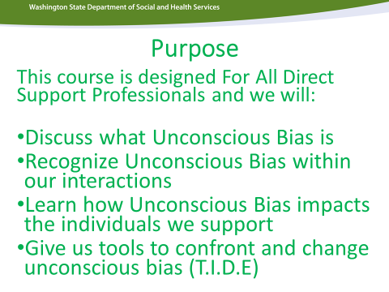 |  | These are your learning objectives! This is what your participants can expect to cover in the course. Do not spend too much time on this slide (mini-agenda)
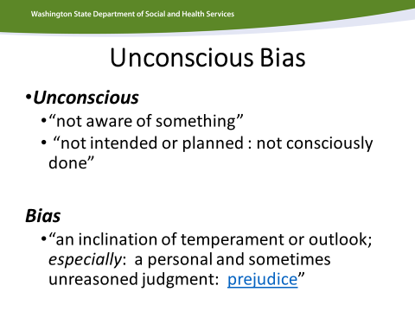 |  | Brief Discussion: talk briefly about these definitions, point out the difference between just a bias and an unconscious bias.
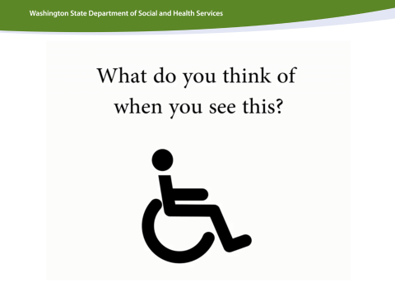 |  | Brief Discussion: ask participants what this symbol means, only spend 5 minutes on this discussion
Activity: watch video and break them into small groups have them list common assumptions people make about individuals with disabilities?

Brief Discussion: have small groups share their lists of assumptions. Write them down on easel paper in front. Point out the misconceptions that are unconscious. Ask them to what it would feel like to walk around in the world who assumes these things about you.

Then have them reflect on the video and ask: “Does this video busts some myths or assumptions people have about what it means to have a disability?”
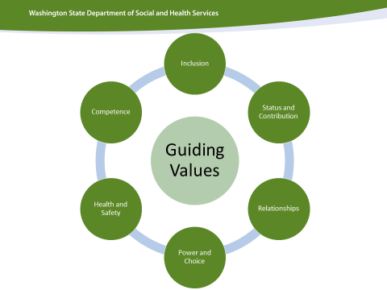 |  | Ask you participants to look again at the paper where they wrote down unconscious bias (hurtful assumptions) people made about each of them personally.  Look at the DDA Guiding Values, when people assume hurtful things about be they devalue me as a person. Ask participants to reflect on how that hurtful assumption impacts their feelings around status and contribution, relationships, Power and Choice, Health and Safety, Competence, and Inclusion. Ask them to share in their small groups how this made them feel.  Large Group Discussion: bring them back together and talk about how unconscious bias is hurtful to us and it does not line up with our Guiding Values in DDA to allow those unconscious biases to negatively impact those we support.
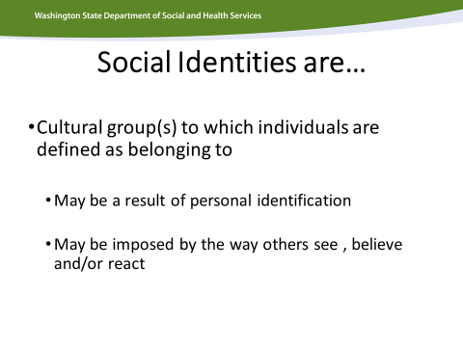 |  | Individually: ask participants to reflect on groups they are a part of, family systems, cultural communities, etc. Then have them share these identities within a small group.  Small Groups: Ask them to then talk about what it means to be part of a group where hurtful things are assumed about an entire group. Ask them to share a story or a time when they became aware of an unconscious bias that negatively impacted their family or communities.
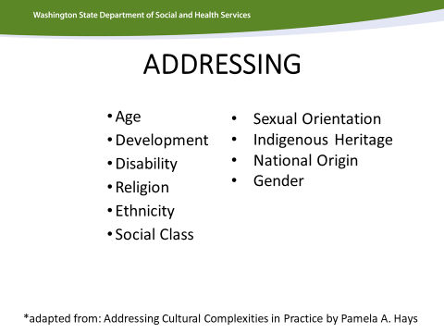 |  | Pass out copies of the Addressing model. Have the class reflect on how individuals with disabilities may experience compounded impacts of unconscious bias (example they are both female and have a developmental disability).  Ask the larger group to talk about ADDRESSING MODEL
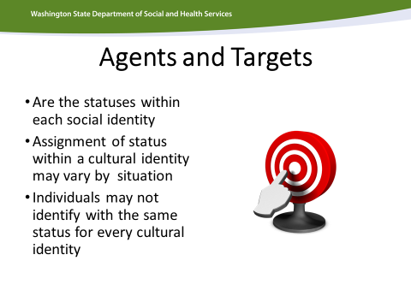 |  | This slide is just a time for reflection on how there are different statuses within each community. For example, elders in certain cultural and ethnic communities hold a greater status then those who are younger. You can ask your class to think of other examples.
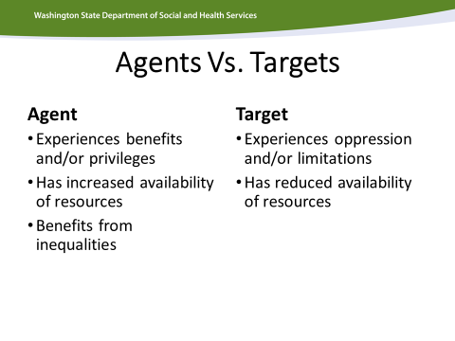 |  | Lead a discussion about situations where an individual with a Developmental Disability might have agency or power? Name a situation or context where they might be a target. Point out that unconscious bias is depending on context and/or situation.
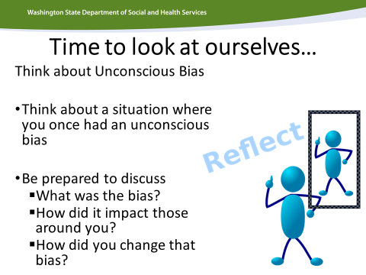 |  | Individually: Have them reflect on these questions and spend about 10 minutes writing down 1-2 unconscious biases they had and how they became aware of that bias and why/how they changed that bias.  Break them into small groups to discuss this  Ask a few people to share in the larger group
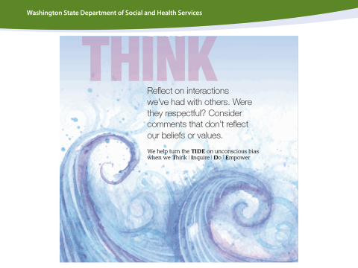 |  | It’s now time to teach them the T.I.D.E. tool.  Have them read the back of the card and discuss in a small group what does it mean to stop and THINK?  Have them briefly discussion this in the larger group.
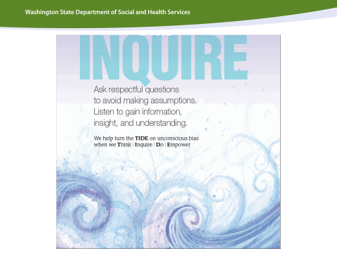 |  | Have them read the back of the card and discuss in a small group what does it means to Inquire? How do we ask respectful questions? Why are questions important?  Have them briefly discussion this in the larger group.
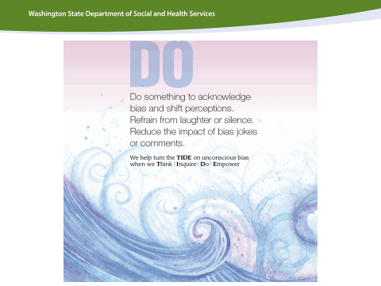 |  | Have them read the back of the card and discuss in a small group what it means to DO or intervene when there are situations where unconscious bias is hurting others. How would they intervene?  Have them briefly discussion this in the larger group.
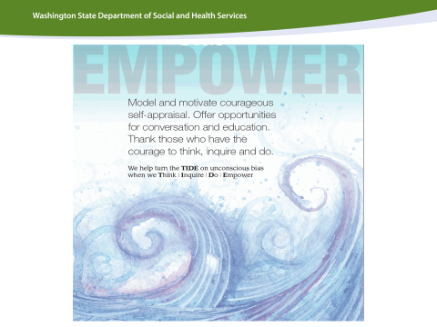 |  | Have them read the back of the card and discuss in a small group what it means to EMPOWER? How do we empower individuals to advocate for themselves? How do we make it safe for individuals with Developmental Disabilities to confront bias.  Have them briefly discussion this in the larger group.
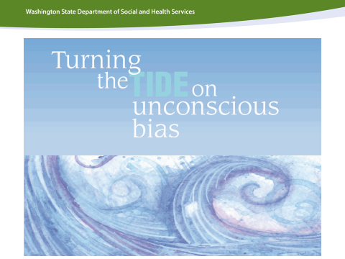 |  | Wrap-up Slide:  Can have a mini-call and response quiz:  What is unconscious bias?  How does it impact our work?  What do we plan to do differently?

Evaluation
Date:
Trainer:
1. List three things you learned today.
1.

2.

3.
2. Something you will do differently in the future as a result of this training:

3. Something that surprised you:
Low high
4. The material was relevant to my job. 1 2 3 4 5
5. The material was well presented and held my interest. 1 2 3 4 5
6. The presenter was knowledgeable. 1 2 3 4 5
7. The presenter was respectful. 1 2 3 4 5

8. My favorite thing about this training:

9. Please contact me: (optional)
Name:
Phone:
Email:

