Invoice Backup Documentation Form

Why do we have to complete this form?
The DSHS DV Services program, which funds your contract, has been required to collect additional financial backup documentation prior to paying invoices. While we collected a form “backing up” the expenditures charged for Goods and Services (and for some contracts, Match), we did not collect similar information for salaries, benefits, and other costs and received an audit finding in our most recent audit. Responsive to this, we expanded our pre-existing Goods and Services/Match documentation forms to include all expenses beginning July 1, 2020.

How do we complete this form?
- Completion of the form when you submit your invoices is intended to be a simple process.
- How did you identify the amounts that you are invoicing for reimbursement? Use the same information to complete the Invoice Documentation form.

How do I know what to put on the form?
- A good place to start is with your application budget. What did your agency intend to charge to this contract?
- Then follow up with the actual costs that were incurred. If someone else prepares your invoices, work with that individual to determine how they normally tabulate your invoice amounts. Where do those numbers come from?

How do I bill for costs that weren’t in my application budget?
It is best practice to contact your contract manager before incurring costs that weren’t in your contract budget.
If you incurred costs that weren’t in your application budget, reach out to your contract manager before submitting the invoice for those costs to confirm the costs are eligible and approved.

Example:
In this example, you are completing an invoice documentation form for your agency, Example Services For Everyone. You will be completing the form for the July, 2020 invoicing period.

Getting Started
First, open the form. DSHS modelled the form on the Goods & Services/Match Documentation form that many of our contractors are familiar with. However, you’ll notice now there are more tabs across the bottom of the screen.

Begin by navigating to the Salaries tab.

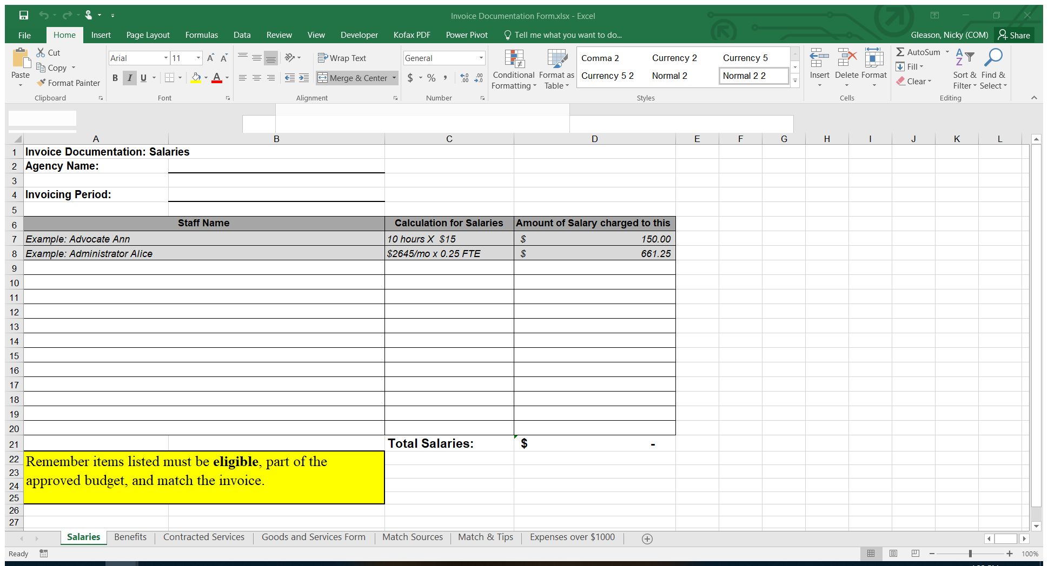

Type your Agency Name in the area indicated. This will populate the same field on all of the rest of the forms.

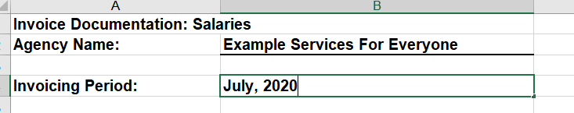

Salaries:
If the invoice is for the month of July, and is for $11,169.59, where did that number come from? It should relate to the number of hours worked by staff on the contract for the month of July. Simply indicate the staff name and calculation that led to that dollar amount. Most often, this will be number of hours.
For staff that are paid a flat rate per month, you may indicate the amount of FTE, but please remember this must be supported by real-time timesheets.
In the example, the agency is asking for reimbursement for three staff member’s salaries: Patty, who provided advocacy, Penny, the bookkeeper, and Elmer, who led the support group. Add their names and the calculations that led to the salaries total on the Salaries worksheet.
The total should equal to Salaries requested on the July invoice.

Benefits:
Now that you are done with Salaries, move on to complete the benefits worksheet roughly the same way. The Benefits worksheet will usually be the same list of staff on the Salaries worksheet. The Benefits worksheet may reference the dollar amounts listed on the Salaries worksheet, depending on how your agency calculates benefits.
In our example, the agency calculates benefits to be 28% of salary cost for hourly employees. So we see Patty and Elmer’s benefit calculations include the dollar amount from the salaries page, x 28%. For Penny, her benefits are calculated based on what percentage FTE was spent on the program this month – her total benefits cost for the month of July is multiplied by the percentage of her FTE spent on this contract.
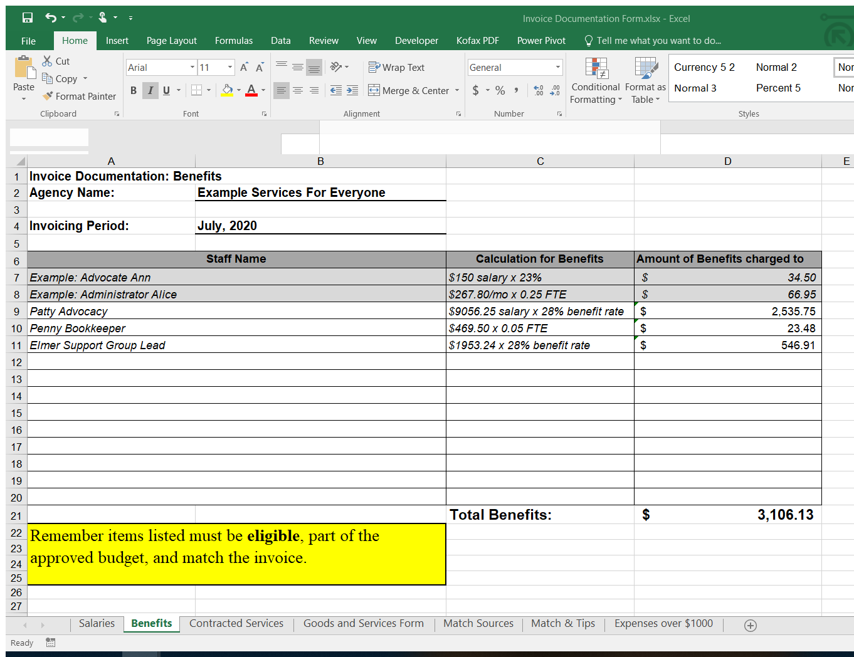
The total should equal to Benefits reimbursement you request on the July invoice.

Contracted Services
Not every contract includes contracted services. If yours does not (reference your contract application if you’re not sure), you can skip the Contracted Services tab.

If you do have contracted services, indicate the amount you paid this reporting period.

In the example below, the example agency contracts with a therapist at a flat rate per hour. The number of hours and the rate per hour were listed in the contract application, so list those on the Contracted Services tab as well.

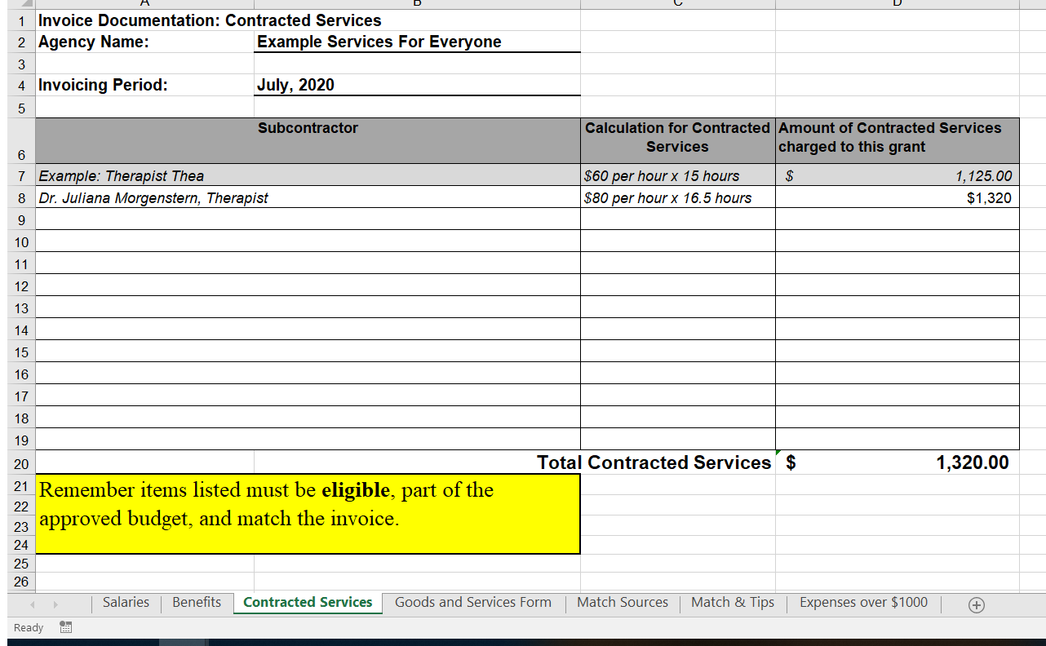

Goods and Services:
For agencies that have been working with DSHS before, the Goods and Services backup form is unchanged – it’s the same form contractors have been completing with invoices for years.
If you are new to working with DSHS, this form is to list the purchases made with your contract funds that don’t fit into other categories. If you’re not sure what this includes, please reference the application budget your agency submitted.

Sometimes costs are allocated across several programs. If you are billing only a portion of the total cost of a particular item, indicate the total cost you paid in the “total bill amount” column and the amount being allocated to this particular contract in the “total charged to this contract” column. A third column, which you do NOT need to edit, will calculate the percentage.

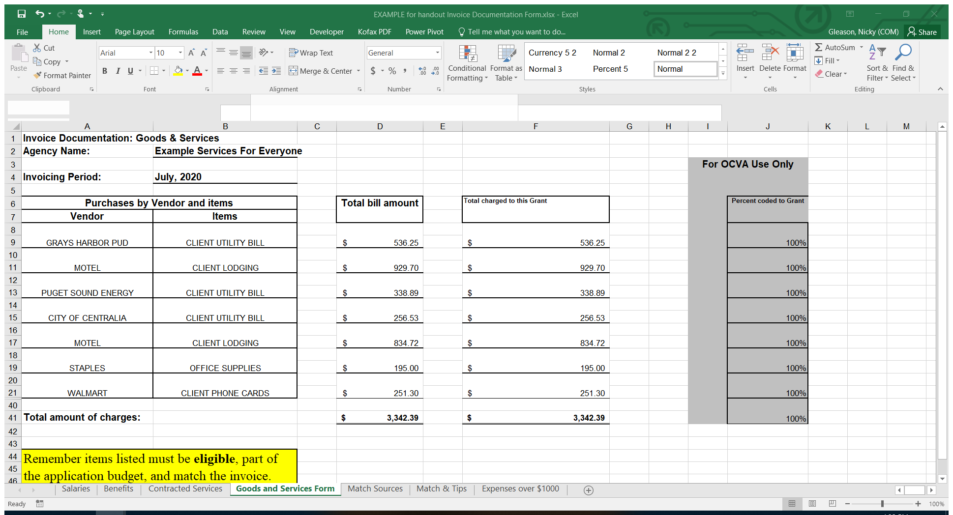
DO NOT, under ANY CIRCUMSTANCES, list a client name on the Invoice Backup Documentation form. That violates that individual’s confidentiality and is considered a breach of personally identifying information.

If a payment was made directly to a vendor on behalf of a client, list the vendor name, and indicate that it was an “Emergency Financial Assistance” payment in the items column.

INVOICES THAT INCLUDE A CLIENT NAME WILL BE REJECTED.

Please ensure all staff that prepare and submit invoices are aware of the confidentiality rules.

Final Steps
At this point, your Invoice Documentation form is complete. Be sure to save your form!
It’s highly recommended that you take a moment to confirm that the amounts listed in the totals for each page exactly match the amounts for those items on your invoice. Even a few dollars discrepancy will result in your contract manager following up for a correction, which can significantly delay your payment.
Once your review is complete, email your invoice packet to your contract manager. The invoice package should include all of the following:
- A-19 Invoice voucher form
- Invoice Documentation Form
- Year-to-date balance tracking spreadsheet, including information listed on the A-19 form

Checklist for invoice review prior to submission:
- Have I ensured that all totals are correct and accurate?
- Do I know where to locate primary back up documentation (receipts, timesheets, volunteer logs) for all costs in my agency’s records?
- Do the totals on the Salaries, Benefits, Contracted Services, and Goods and Services tabs exactly match the total amounts on my invoice?
- Have I ensured there are no client names or any other types of personally identifying client information anywhere on the form(s)?
- Have I followed up with my contract manager about any expenditures that were NOT part of my original application budget?
- Have I attached the invoice documentation form to my invoice?

