Making Payments —Secure Access Washington [SAW] For Employers
Introduction: Secure Access Washington [SAW] is an online portal where employers can report new hires and remit child support for their employees by using DCSOnline. Now that you have created your SAW account, you will need to add your banking information, employees, and then make payments.
Step 1: Log in to SAW by entering your SAW ID and Password
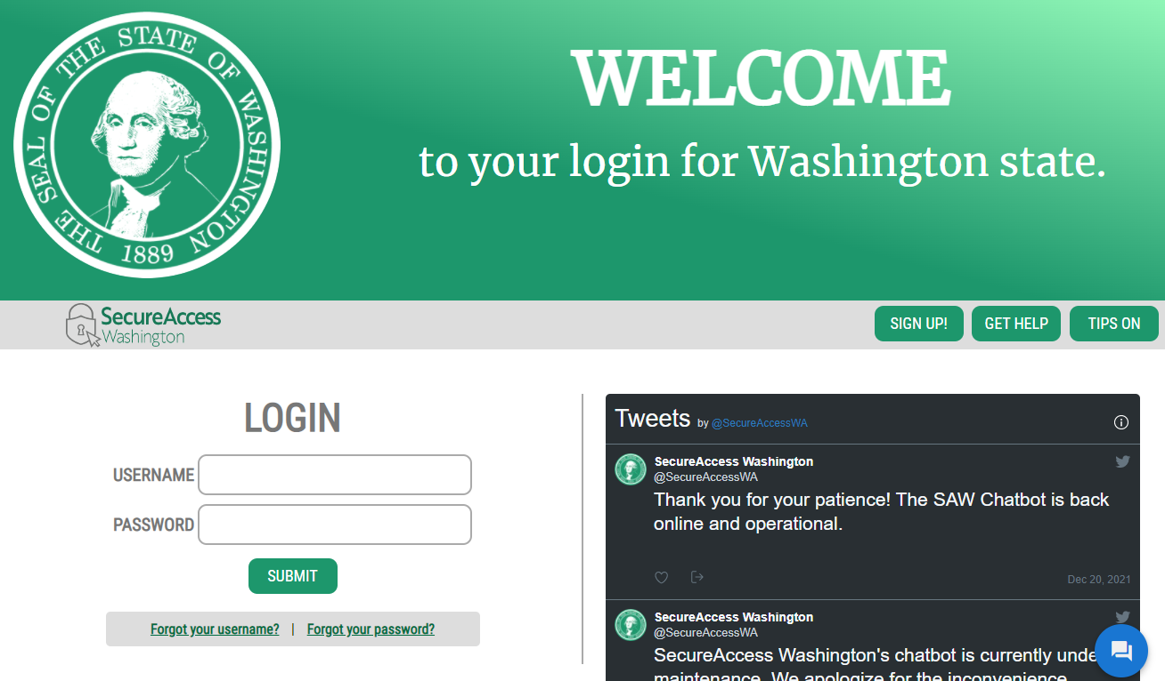
Enter your SAW USERNAME and password

Step 2: Find Division of Child Support Online Services and Click on Access now

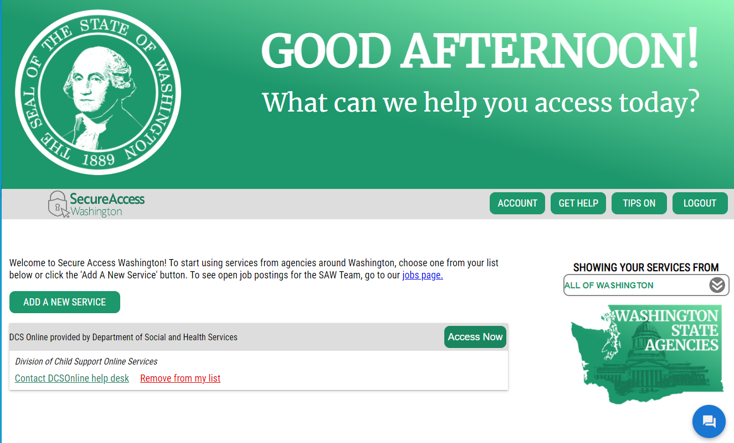
Find Division of Child Support Online Services and…
…. then Click Access Now

Step 3: Add a Bank Account: You need to add information on the bank account you want to make payments from. Click on Manage Bank Account for Making Child Support Payments. If you have already entered your bank account information, go to Step 7.
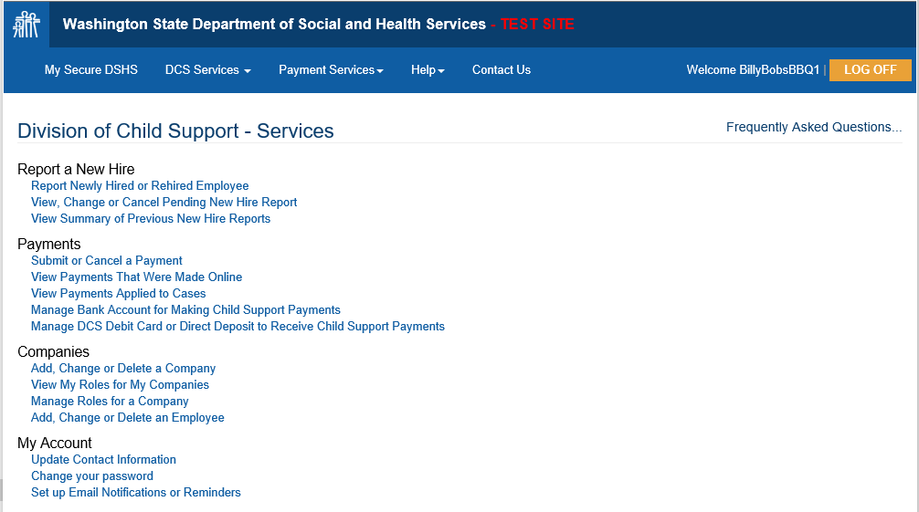
If you haven’t already done so, make sure to add your company then you add your bank account
Click here to add your bank account information

Step 4: Select the On-Line Account you want to use and then add the bank account information.
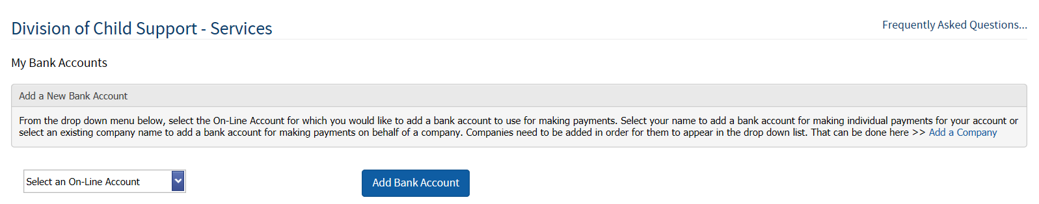
Click here to add a new account
First, click here to select an existing account you want to update

Step 5: Add your information and click Add the Account.
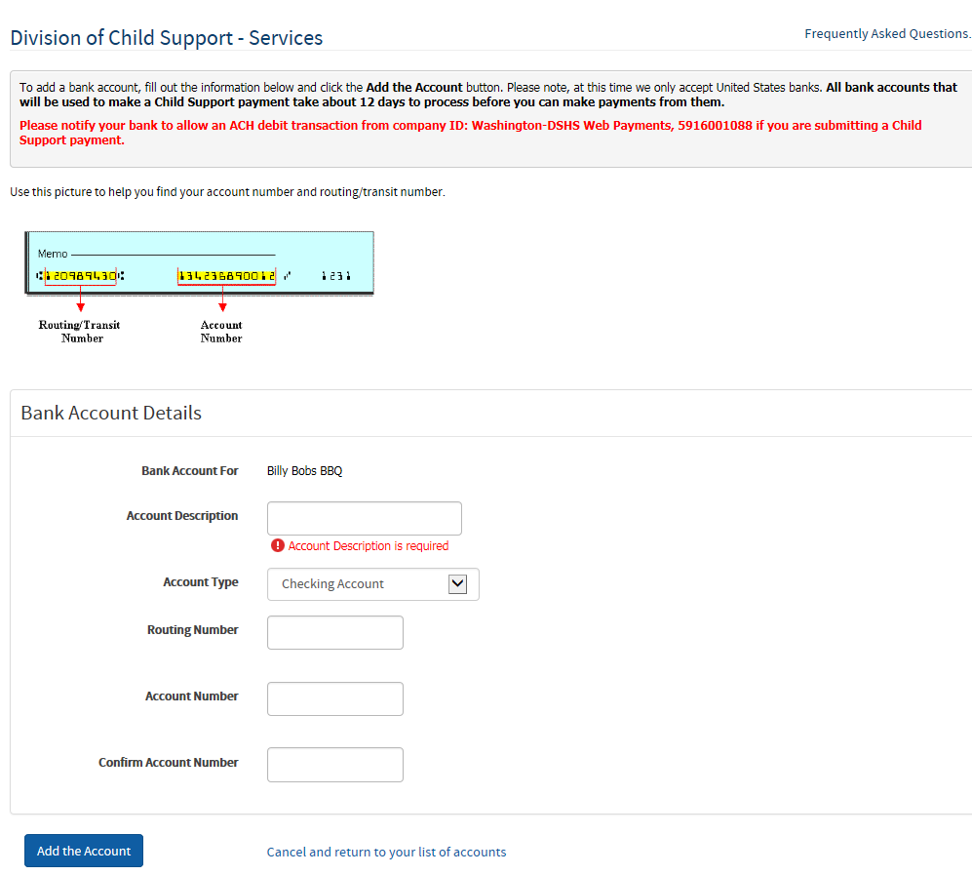
Helpful hint
Click here after entering your banking information.
Enter your banking information

Step 6: Banks need about 7 days to verify your banking information. If this is your first time entering it into the system, you may send payments by check until the waiting period is over.
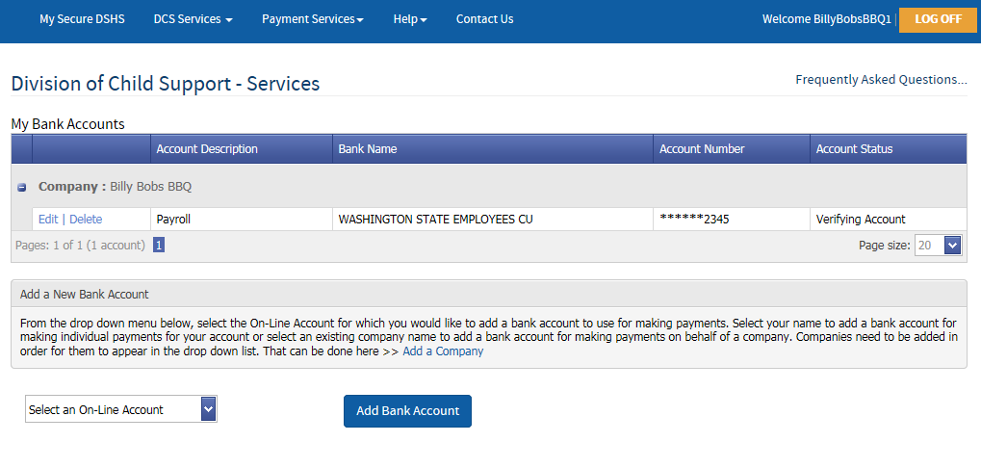
We are waiting for your bank to verify the account
Note: You should receive an email, similar to the one below, confirming receipt and review of your bank information. While you wait for verification, you may want to enter your employee information so that you’ll be ready to make payments.

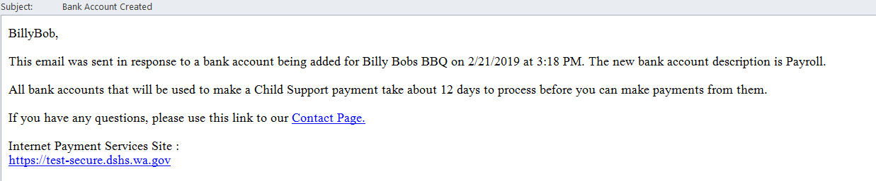

Step 7: Enter your employees into the Payment system. Click on DCS Services and select Main Menu or View/Make a Payment to enter your employees into the system. Note: You may enter employee information while you wait the 12-day period for your bank to accept your online payments.

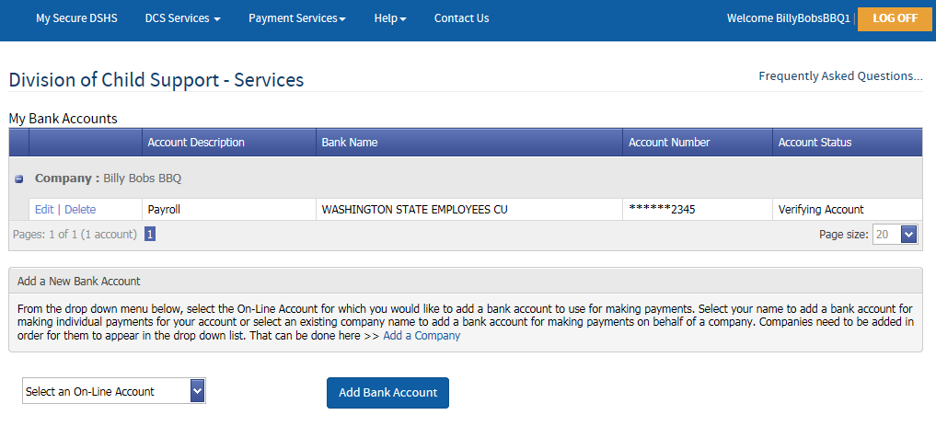
Click here and select Main Menu

Step 8: You should see the screen below. Click on Submit or Cancel a payment.
Click here to access the Child Support Payments menu page, where you can add or change your employee information in the Payments system.
Tip: You can also add or change employee information in the Payment system from here.

Step 9: Click Add, Change or Delete an Employee to add. Skip to step 13 if you do not need to make changes

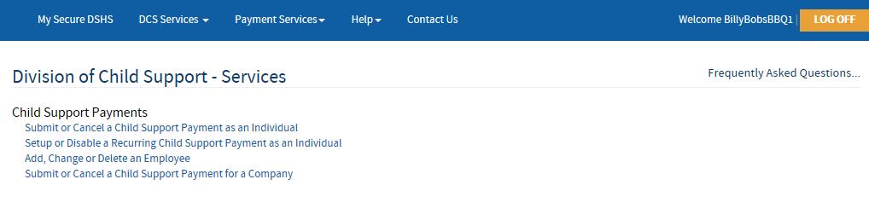
Click here to add employees

Step 10: Add an employee
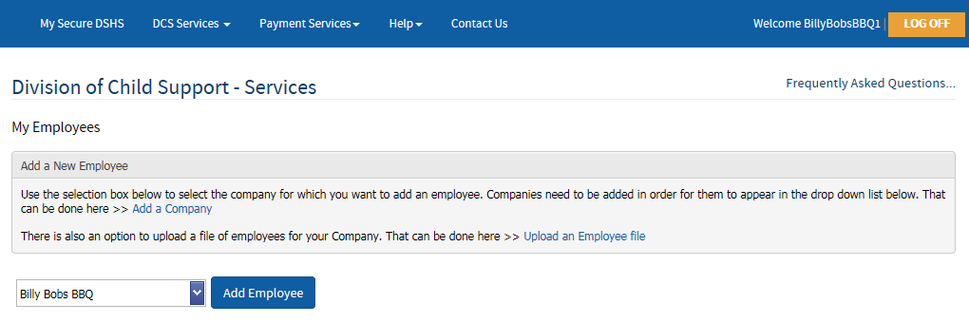
Click here to add an employee
If you are involved in more than one company, select the correct one here

Step 11: Enter the Employee’s information. When done adding employee information, click Add the Employee button.
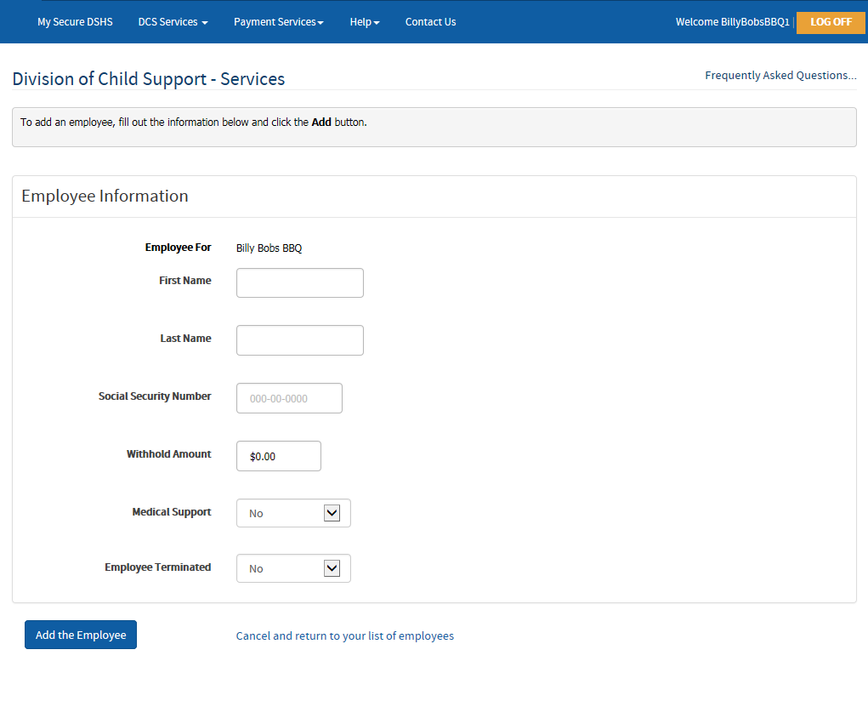
Click here to add the employee
Add the amount you expect to send in from each paycheck

Add the Employee’s personal information

Step 12: You should now see this screen with your employee(s) information on it. Repeat the process to add more employees or select View/Make a Payment from the DCS Services drop down menu to make a payment. You may also go to the main menu by clicking on DCS Services and selecting Main Menu.
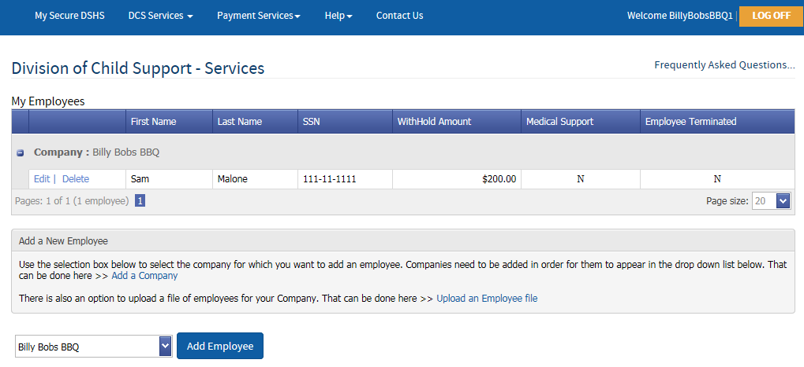
When ready, click here and select View/Make a Payment
Your employee’s information is here
Click here to add another employee
Step 13: Once your bank account has been confirmed and your employees are entered, you can go back into SAW by following steps 1, 2 and then select Submit or Cancel a payment
Click here to make a payment

Step 14: Select Submit or Cancel a Child Support Payment for a Company
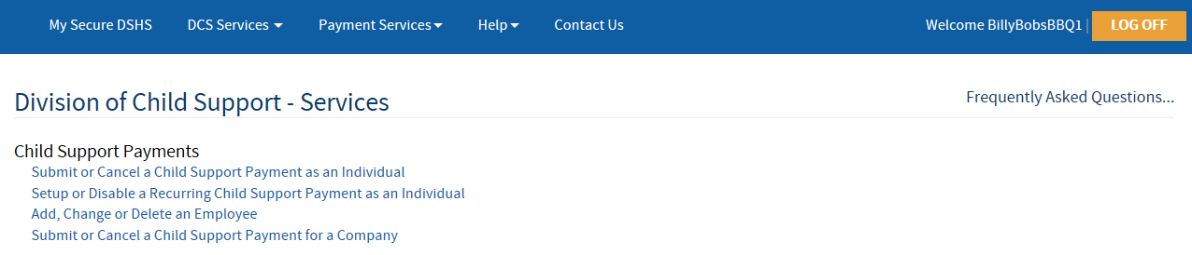
Click here to make a payment for your employee

Step 15: To make a payment, click Schedule a Payment.
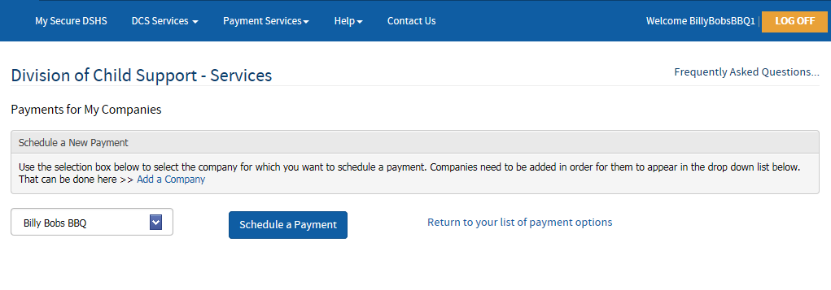
If you are involved in more than one company, select the correct one here
Click here to schedule a payment

Step 16: Start by selecting the employee(s) you want to make a payment for (the system will auto fill in the amounts). Update the payroll and payment dates, verify the total amount and number of cases, and finally, select the account payments come out of.
5. Verify the payment amount and the number of payments you are making
4. Enter the day you want the payment to be delivered
3. Enter the payroll date

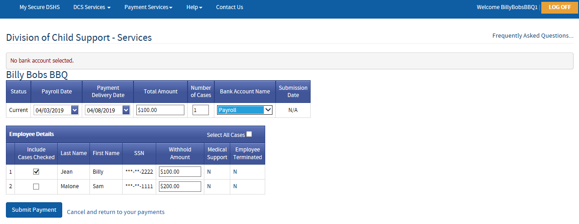
START HERE!
- Select the employee(s)
2. Verify or update the amount you will be paying
6. Select the account you want the money to come out of
7. LAST STEP: after you have taken all the steps above to verify the information, click here to submit the payment

Step 17: You may cancel your payment up to 2 business days prior to the date you selected for the payment to be made. You should also receive an email confirming the payment.
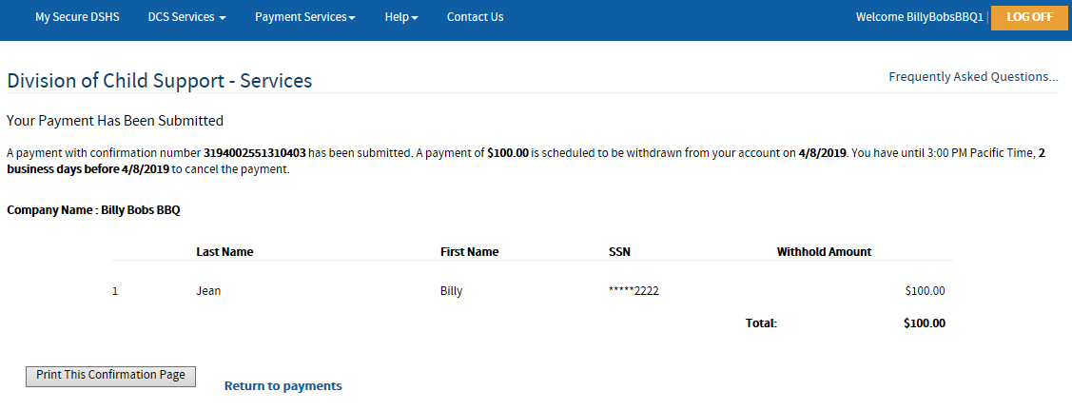
Click here to select other DCS Service
Click here to make another payment or view your online payment history
If you are done and want to log out, click here
Click here to print a confirmation for your records

If you are done and want to log out, click here

Step 18: If you clicked Return to Payments, you should see this:
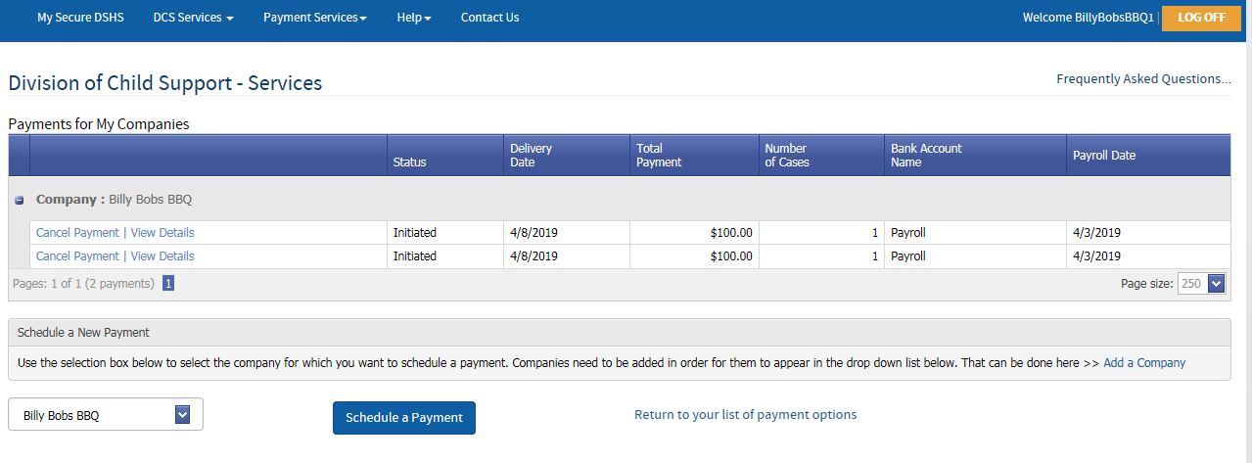
Click here to make another payment
Click here to get the details about the payment you made
Click here to cancel a payment.

If you need additional assistance with DCS Online or have questions regarding Child Support or New Hire Reporting as an employer, please contact the DCS Employer Relations Team at 800-562-0479 or email dcs-ert@dshs.wa.gov. We’re happy to help!

