If you are already using Secure Access Washington [SAW] to access other state agencies, you can log in using the same username and password. You can also access the SAW Login page from those websites. You can find links at the bottom of their agency login pages. See below for a few examples.
Click here to go to SAW
Department of Revenue – bottom right of the page

Department of Labor and Industries – Bottom Left of the page
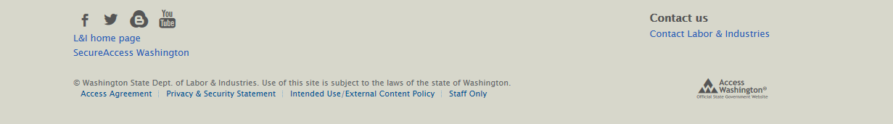
Click here to go to SAW

You will be taken to this website. You can also use www.secureaccess.wa.gov/myAccess/saw/select.do or by googling Secure Access Washington
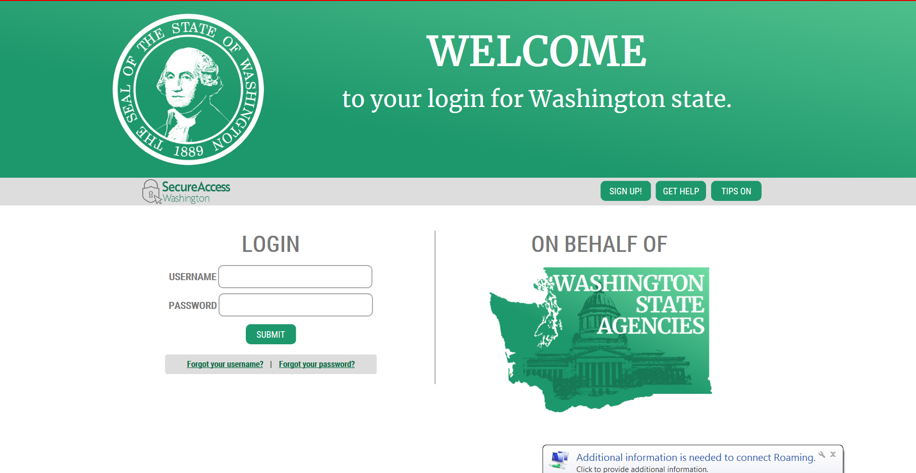
Enter the same username and password you used with the other agencies

You will then be taken to this website.
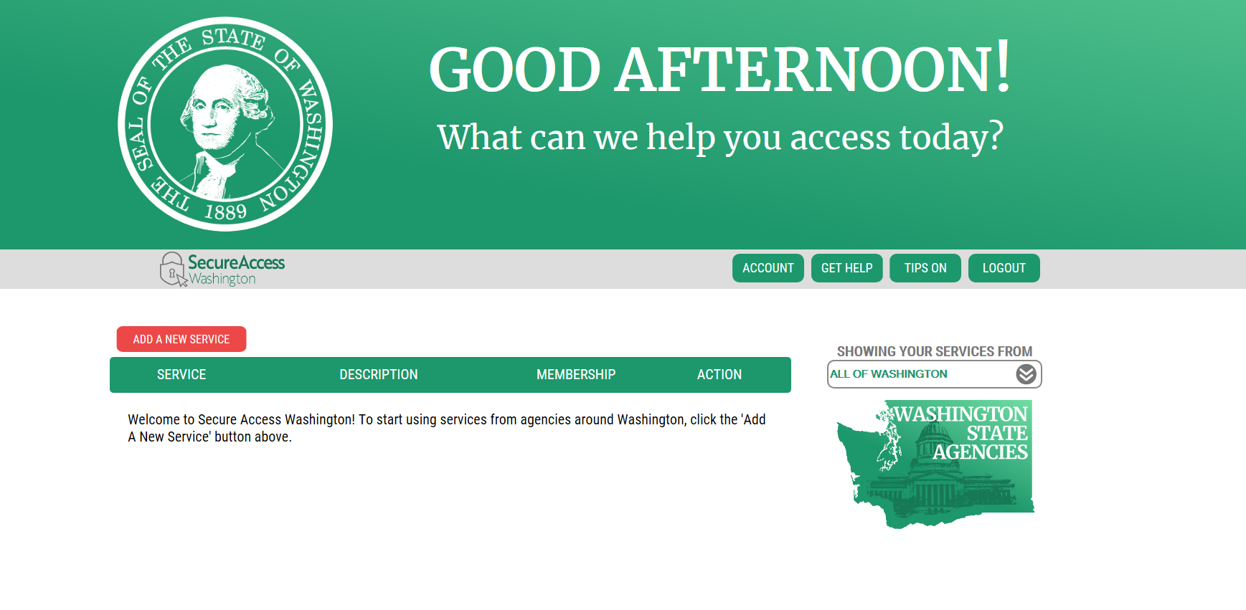
Click here to ADD A NEW SERVICE

You will be taken to this page to add a new service.

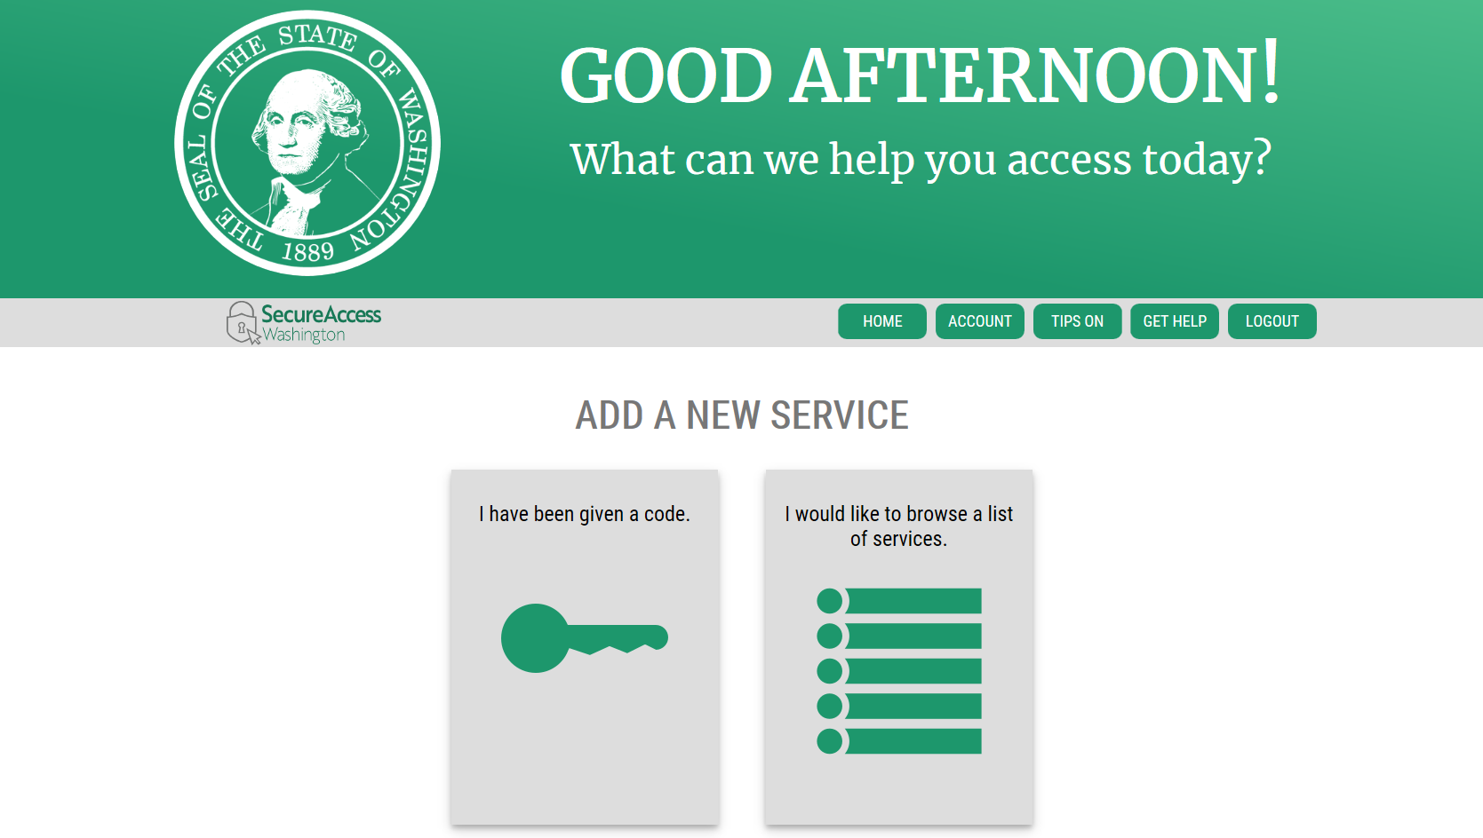

Click here for a list of services

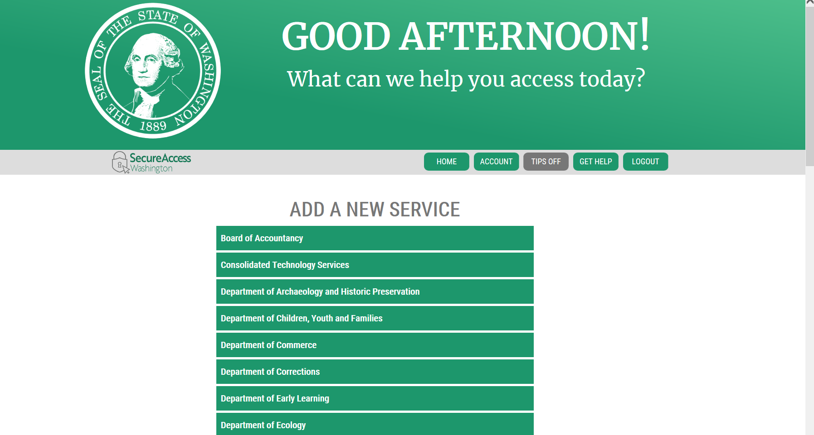
Scroll down using the side bar to Department of Social and Health Services

Click on Department of Social and Health Services

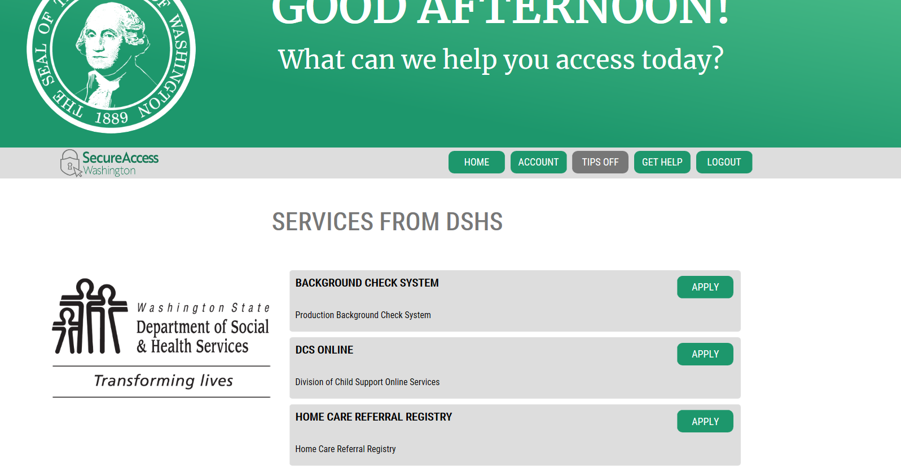
… then Click APPLY
Find DCS ONLINE and …

Your screen should now look like this. Click on DCS Online to continue
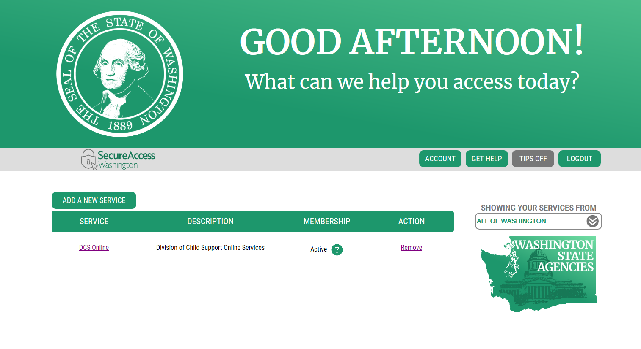
Click DCS Online

You will be taken to this screen. Click Continue
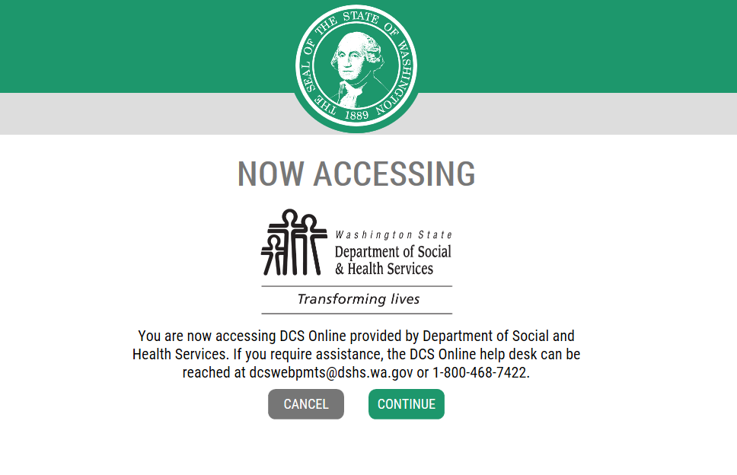
Click Continue
If you need additional assistance with DCS Online or have questions regarding Child Support or New Hire Reporting as an employer, please contact the DCS Employer Relations Team at 800-562-0479 or email dcs-ert@dshs.wa.gov. We’re happy to help!

