Child Support Innovations:
Family-Centered Services and Partnerships
Over the past decade, the Washington State Division of Child Support (DCS) and other child support programs across the country have significantly broadened their services and increased the number of partnering organizations they work with to help parents meet the financial and emotional needs of their children. They have developed new strategies and partnerships to: prevent the need for child support, establish realistic child support orders, reduce child support debt, increase noncustodial parent employment, intervene early when parents struggle to support their children, and address barriers that prevent parents from meeting their children’s needs.
DCS family-centered services and partnerships improve child support outcomes, and support both the Department of Social and Health Services (DSHS) Mission of Transforming Lives, and the federal Office of Child Support Enforcement’s (OCSE’s) efforts to promote child well-being and family self-sufficiency (see the below OCSE Bubble Chart and Fact Sheet).
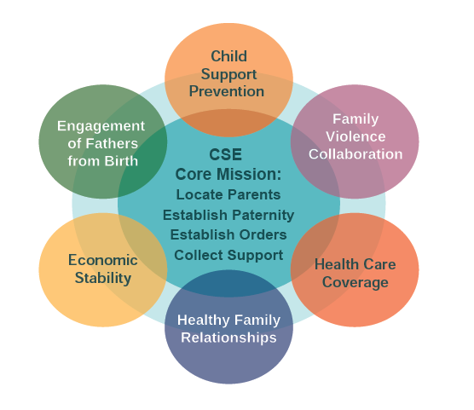
OCSE Fact Sheet:
Promoting Child Well-Being
& Family Self-Sufficiency
For more information, click on (or scroll through) the following family-centered innovations:
- Access and Visitation Grant | - Lower Columbia Community Action Program (LCCAP)
- Alternative Solutions Program | - Northwest Justice Project (NJP) and the Veterans Administration (VA)
- Behavioral Interventions for Child Support Services (BICS) Demonstration Grant | - Project Get Connected
- Community Partnership for Transition Services (CPTS) | - Project Homeless Connect
- Divine Alternative for Dads Services (DADS) | - Resources to Initiate Successful Employment (RISE) Grant Project
- Early Intervention – A Department of Corrections (DOC) and DCS Collaboration | - Spokane Neighborhood Action Program (SNAP)
- Employment Pipeline | - Tribal Relations
- King County Prosecuting Attorney’s Office (KCPA) and Drug Court Connection | - Veteran Stand Downs

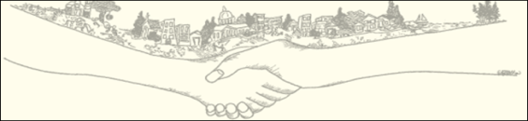
- Access and Visitation Grant: DCS manages this Federal grant program. Funds are typically used to provide mediation and visitation enforcement services, but can also be used to provide services for visitation enforcement, counseling, development of parenting plans, parent education, and guidelines for visitation and alternative custody arrangements. These services are contracted to regional services providers in six locations throughout the state: Bellingham, Olympia, Seattle, Spokane, Vancouver, and Yakima. For more information contact: Kirsten Jenicek at Kirsten.Jenicek@dshs.wa.gov.

- Alternative Solutions Program: In 2013, DCS established an Alternative Solutions Program to assist Non-Custodial Parents (NCPs) who face obstacles in meeting their financial child support obligations. These obstacles may include: unemployment, housing, lack of educational opportunities, transition from justice systems, financial and legal issues, medical issues, addiction, and others. The Alternative Solutions Program connects NCPs with over 3,000 governmental and community resources across the state aimed at increasing their employability, removing barriers, and ultimately creating better lives for children and families. For more information, see the Alternative Solutions Program website, the Community Partners brochure, the brochure for Parents or email AlternativeSolutions@dshs.wa.gov.
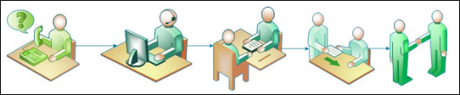
- Behavioral Interventions for Child Support Services (BICS) Demonstration Grant: In 2014, DCS was one of eight states to receive a federal BICS demonstration grant. This five-year project will take place at the Seattle, Everett, and Olympia DCS Field Offices. The Seattle pilot focuses on early parent engagement in the administrative order establishment process, the Everett pilot tests early intervention in the enforcement process, and the Olympia pilot focuses on right-sizing orders and the Conference Board write-off process for incarcerated noncustodial parents at the Washington Corrections Center in Shelton. DCS also received the BICS evaluation grant to provide technical assistance and evaluation services to the eight states that received the BICS demonstration grants. For information about the BICS demonstration grant, contact Megan Schoor at Megan.Schoor@dshs.wa.gov or Kirsten Jenicek at Kirsten.Jenicek@dshs.wa.gov. For information about the BICS evaluation grant, contact Donna Collins at Donna.Collins@dshs.wa.gov or Kirsten Jenicek at Kirsten.Jenicek@dshs.wa.gov.
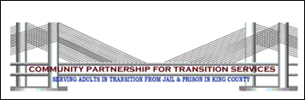
- Community Partnership for Transition Services (CPTS):
This program started in King County, but has expanded to Pierce, Snohomish, Spokane and other counties. Through collaborative partnerships, they seek to assist individuals and families of incarcerated, transition, and reentry populations to successfully transition back into communities. DCS seeks to provide services and connect individuals with various service providers to help ensure that child support is not a barrier to individuals reentering society. For more information about the DCS connection to CPTS: In King County, contact Sylvia Flores at Sylvia.Flores@dshs.wa.gov; Snohomish County, contact Julie McCauley at Julie.Mccauley@dshs.wa.gov; Pierce County, contact Mike Canonica at Michael.Canonica@dshs.wa.gov; and Spokane County, contact Tim Hanson at Timothy.Hanson@dshs.wa.gov.
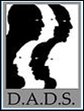
- Divine Alternative for Dads Services (DADS): This community based organization has been very closely linked with Seattle DCS for over ten years. This close partnership between the Seattle Field Office and DADS works to help men address their child support obligation, heal relationships between the parents and kids, and work on visitation and responsible parenting issues. They are recognized as a community leader in turning lives around in the Seattle area. They have served almost 3000 men in the past ten plus years, 90% of whom have a child support case. For information about DADS, see the DADS Website, and for more information about the DCS connection to DADS, contact Kirsten Jenicek at Kirsten.Jenicek@dshs.wa.gov.

- Early Intervention – A Department of Corrections (DOC) and DCS Collaboration: DCS collaborates with DOC to better serve noncustodial parents (NCPs) who become incarcerated in the Washington DOC system. The objective is to identify NCPs when they first enter the DOC system and review their child support obligations for potential modification. The long term goal is to have child support obligations adjusted early on to correctly reflect the NCP’s current situation. NCPs will have an appropriate child support obligation when their incarceration ends, reducing the back child support accrued during incarceration, and increasing the potential for personal and family stability in the future. See the DOC Website for information, and for more information about DOC and DCS collaboration, contact Chuck Donnelly at Chuck.Donnelly@dshs.wa.gov.
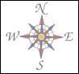
- Employment Pipeline: In 2013, the DSHS Economic Services Administration (ESA) began the Employment Pipeline, seeking employers to create job opportunities for DSHS clients trying to transition off assistance, attain financial independence, and better support their families. The Employment Pipeline how has 29 business and 92 locations and this number continues to grow. The Employment Pipeline is currently working with other employers in many different fields of business who are willing to work with Work First clients, Basic Food recipients, along with custodial and noncustodial clients to offer meaningful long term employment opportunities. ESA has designed a program to provide basic training and skills development to assist clients in getting jobs, and post-employment support to assist with long term employment. DCS has hired clients that were in the Employment Pipeline. For more information, contact: Don Mercer at Don.Mercer@dshs.wa.gov.
- King County Prosecuting Attorney’s Office (KCPA) and Drug Court Connection: As an outshoot of the connections made and conversation held at Project Get Connected, KCPA now interfaces with individuals going through Drug Court more closely and in a much more supportive way. For more information, contact Christine Servin, Christine.Servin@dshs.wa.gov.

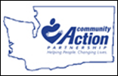
- Lower Columbia Community Action Program (LCCAP): This is a partnership in Southwest Washington that was brought about through the Building Assets for Fathers and Families (BAFF) grant over the past three years. Through this partnership, LCCAP and the Vancouver Field Office have helped many people get on their feet with employment, training, and housing. Support Enforcement Officers refer non-custodial parents to LCCAP and work with LCCAP to link them up with services. For information see the LCCAP Website or contact Tina Burnquist at Tina.Burnquist@dshs.wa.gov.
- Northwest Justice Project (NJP) and the Veterans Administration (VA): This started as one of nine pilot sites around the country to focus on child support issues that homeless veterans face. This Seattle initiative started over three years ago. Positive results have driven expansion of this program this year to a broader statewide legal services effort. A strong collaboration between DCS and NJP has led to case collaboration and removal of child support barriers that were keeping NCPs homeless. For information, see the NJP Veterans Website, the DCS Veterans Website, or contact June Johnson at June.Johnson@dshs.wa.gov.

- Project Get Connected: This Region 10 OCSE initiative started over five years ago and brought together community partners and child support to better collaborate and help NCPs economic stabilization by job referrals, training and other support. The King County Prosecuting Attorney’s Office (KCPA) and the public defender’s office are close partners with this work. After five years, OCSE ended the initiative and DCS is picking up on this type of work through the Alternative Solution Program now. For more information, contact the DCS Alternative Solutions Program at AlternativeSolutions@dshs.wa.gov.

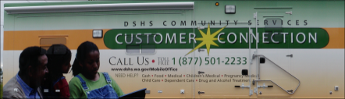
- Project Homeless Connect: Project Homeless Connect is an initiative to end homelessness. Events are held to reach out to homeless non-custodial parents and custodial parents to work through child support issues, remove child support barriers, and bring together a wide array of services from haircuts and dental services, to services offered by DSHS programs. For more information, in Pierce County contact Kimm Wilson at Kimm.Wilson@dshs.wa.gov; Snohomish County contact John Hilty at John.Hilty@dshs.wa.gov; Skagit County contact Kris Lindor at Kris.Lindor@dshs.wa.gov; and Whatcom County contact Tyson Taylor at Tyson.Taylor@dshs.wa.gov.

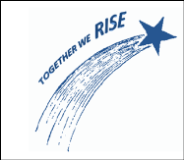
- Resources to Initiate Successful Employment (RISE) Grant Project: The Community Services Division (CSD) was awarded a $22 million grant to allow DSHS to work with SNAP (food assistance) recipients who face multiple barriers and challenges to self-sufficiency. CSD will run and manage this grant through the Washington State Basic Food Employment and Training (BFET) program. Pilot projects will run from 10/1/2015 – 9/30/2018 in King, Pierce, Yakima and Spokane counties. The RISE project will focus on long-term unemployment, homeless, and Limited English Proficiency (LEP) clients, as well as, veterans and delinquent noncustodial parents by providing Work-Based Learning (WBL) opportunities and Comprehensive Case Management (CCM) services to these targeted populations. Noncustodial parents who are behind on their child support obligations or in non-paying status and receiving SNAP benefits can volunteer to participate in the RISE project. For more information, contact Ted Thornton at Ted.Thornton@dshs.wa.gov.

- Spokane Neighborhood Action Program (SNAP): Like LCCAP (see above), SNAP was an important partner in WA’s Building Assets for Fathers and Families (BAFF) grant exploratory work. A strong tie was built over the years between SNAP and the Spokane Field Office. SNAP is a great community partner that helps people with a wide variety of needs and services. Now child support awareness and issue resolution is part of their toolbox of services too. For more information, contact the DCS Alternative Solutions Program at AlternativeSolutions@dshs.wa.gov.
- Tribal Relations: The DCS Tribal Relations Team (TRT) oversees DCS’ commitment to work government to government with Indian Tribes in coordination with DCS Leadership and over 25 statewide Tribal Liaisons, who manage DCS tribal cases and serve as local contacts for Tribes and tribal members. DCS partners with Tribes in an effort to improve child support services to families in Indian Country by: strengthening state/tribal relationships, supporting tribal interest in operating federally-funded child support programs, negotiating cooperative child support agreements and processes, coordinating child support services, providing technical assistance and training, sharing critical information, and ensuring DCS policy and legislation honors tribal sovereignty. For more information, see the DCS Tribal Relations Website or contact the DCS Tribal Relations Program at DCSTribalRelations@dshs.wa.gov.
- Veteran Stand Downs: DCS staff across the state participate in Veteran Stand Downs. These are big community events held periodically to focus on providing resources to homeless vets. These events help connect veteran NCPs who may be avoiding child support and provide them with information, tools, and resources to remove child support barriers. For more information, see the DCS Veterans Website or contact June Johnson at June.Johnson@dshs.wa.gov.

