TRIBAL NEWS
Want to know what State/Tribal relations is all about? Here is a brief glimpse. The Washington State Division of Child Support (DCS) has twenty-seven Tribal Liaisons throughout the State who manage specialized tribal caseloads and serve as local contacts for staff, Tribes, and tribal members. Along with three staff from the DCS Headquarters Tribal Relations Team (TRT), we partner with twenty-nine federally recognized Tribes to improve the lives of children and families in Indian Country. For over twenty-five years, DCS and Indian Tribes have worked together to develop innovative processes and agreements to address child support. The work of DCS’s tribal relations efforts begins with a commitment to recognize the sovereignty of each Indian Tribe and together build and strengthen our relationships. We work with each Tribe to understand each other’s governments and concerns regarding child support. DCS continues to look for new and better ways to partner with Tribes. We recently sought tribal input in developing DCS’s Strategic Plan, surveyed Tribes for specific input into how DCS was performing in tribal relations, and we are using that input to develop a detailed business plan to advance tribal relations and services to Tribes and tribal members. Please visit our Tribal Relations website at www.dshs.wa.gov/dcs/tribal to find Contact information, the history of State/Tribal Relations, information on Washington’s Tribes, News, links to State and Federal Child Support Policy, and links to all of our Agreements and Contracts with Tribes.
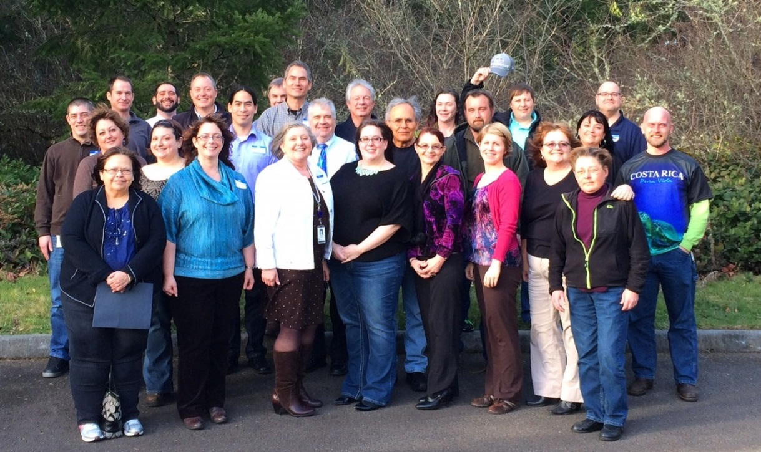
DCS TRT Business Planning Meeting Participants 2/13/2014

