 |   WHY SELF-GOVERNANCE? | 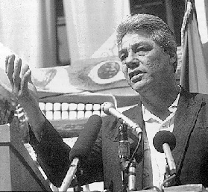
 | THE HISTORY AND GOALS OF TRIBAL SELF-GOVERNANCE
FOR THE SELF-GOVERNANCE
COORDINATOR
SELF-GOVERNANCE
DEFINITIONS
 | Indian Health Service 20 year report Card. (PDF)  Department of the Interior: Tribal Self-Governance ScoreCard. (PDF)  "Where Eagles Fly" (Educational Short Film)   |  | The Late Joseph Burton DeLaCruz  1937- 2000  "No right is more sacred to a nation, to a people, than the right to freely determine its social, economic, political and cultural future without external interference. The fullest expression of this right occurs when a nation a nation freely governs itself. We call the exercise of this right Self-determination. The practice of this right is Self-government."
Self-Governance: A Legacy - the next chapter (Educational Short Film)


