A REVIEW OF THE WASHINGTON STATE CHILD SUPPORT SCHEDULE

March 2003

Completed under Contract for the
Washington State Division of Child Support

Kate Stirling, Ph.D.

Professor
Department of Economics
University of Puget Sound
Tacoma, WA 98416

Contact Information:
253-879-3590
Stirling@ups.edu

TABLE OF CONTENTS
Beginning Page Number
Executive Summary 1
Background and Introduction 3
Income and Child Support Awards in Washington State, overall sample 5
Income and Child Support Awards, noncustodial fathers v. noncustodial mothers 5
Relationship between number of children and the amount of child support, overall sample 8
Number of children and the amount of child support, noncustodial fathers v. noncustodial mothers 8
Deviations from the presumptive amount in the Child Support Schedule, overall sample 11
Deviations, noncustodial fathers 11
Deviations, noncustodial mothers 15
Comparison of this review with the 1991 and 1995 reviews 15
Likelihood of adherence to the Child Support Schedule 17
The impact of child support on the economic well-being of children and the noncustodial household 18
Comparison of child support orders for different regions of the State 22
Income Imputation 25
Review of outlying cases in the sample 29
Types of order in the sample 30

LIST OF FIGURES

Figure 1: Income and child support, for noncustodial fathers 6
Figure 2: Income and child support, for noncustodial mothers 7
Figures 3 and 4: Number of Children and Child Support, for noncustodial fathers 9, 10
Figures 5 and 6: Number of Children and Child Support, for noncustodial mothers 12, 13
Figure 7: Deviations, for noncustodial fathers 14
Figure 8: Deviations, for noncustodial mothers 16
Figure 9: Economic well-being, noncustodial fathers compared to custodial mothers and children 20
Figure 10: Economic well-being, noncustodial mothers compared to custodial fathers and children 21
Figure 11: Distributions of child support orders across the State 23
Figure 12: Child Support orders across the State, noncustodial fathers 24
Figure 13: Child Support orders across the State, noncustodial mothers 26
Figure 14: Imputation of income, noncustodial fathers 27
Figure 15: Imputation of income, noncustodial mothers 28
Figure 16: Distribution of order types in the sample 31
A REVIEW OF THE WASHINGTON STATE CHILD SUPPORT SCHEDULE
Executive Summary

March 2003

- Given the income and other data for child support orders in the sample analyzed for the purposes of this review, the estimated compliance with Washington State’s Child Support Schedule is high, with an overall error rate of only one - three percent. The majority of these errors appear to arise due to inaccurate rounding.

- While compliance to the Schedule’s instructions appears to be near complete, children and custodial parents are found to be much worse off than noncustodial parents. The standard of living of noncustodial parents is more than fifty percent higher than that of the custodial parent and children’s household. This suggests that children are bearing a large degree of the economic burden associated with the division of their parents’ financial resources between two households.

- A comparison of this study with the previous reviews of the Schedule in 1991 and 1995 indicates that: 1) the proportion of income ordered in child support has decreased, and 2) the likelihood of deviating from the presumptive amount in the Schedule has increased.

- For all orders in the sample, the median child support order is $283, representing 17.9 percent of the noncustodial parent’s net income. While order amounts vary with income, the proportion of income ordered in child support is similar across income levels.

- Deviations from the presumptive amounts established in the Schedule are common: the overall deviation rate is 28.5 percent. The vast majority of these deviations (87 percent) reduce the order from the presumptive amount in the Schedule. Further, the magnitude of these deviations is substantive, representing a 35 percent decrease from the presumptive amount in the Schedule.

- Because additional children entail additional costs, child support order amounts are greater for those with more children, and they require a larger portion of the noncustodial parent’s income. One child requires 16.9 percent of the noncustodial parent’s net income, while two children require 23.4 percent of income.

The above findings represent all orders in the database, which includes a diverse sample of orders across Washington State. In the review, important distinctions are found between those orders where the father is the noncustodial parent contrasted to those cases where the mother is the noncustodial parent. Another comparison drawn throughout the report is between the orders of the Washington State Child Support Division Title IV-D agency and non-IV-D orders, which are, on average, higher income.

1
Executive Summary, continued

- Noncustodial fathers are ordered to pay 19.0 percent of their income in child support, a higher proportion than noncustodial mothers who pay 15.2 percent of their income.

- Mothers – whether custodial or noncustodial – typically face a very low level of economic well-being.

- While deviations are common overall, they are almost twice as likely among non-IV-D orders (with a 43 percent deviation rate) than IV-D orders (with a 22 percent deviation rate).

- The pattern of deviations varies depending upon whether the noncustodial parent is the mother or the father. Noncustodial mothers are more likely to have a downward deviation than noncustodial fathers: among those with a deviation, 95 percent of noncustodial mothers’ orders deviate downward, compared to 85 percent of the noncustodial fathers’ orders.

- The magnitude of the reduction from the presumptive amount is also greater for noncustodial mothers, whose orders are reduced by 77 percent for non-IV-D orders (compared to a 35 percent decline for noncustodial fathers) and decreased by 42 percent for IV-D orders (compared to 30 percent for noncustodial fathers). This result, and the one above, may help explain the finding that noncustodial mothers are ordered to pay a smaller proportion of their income than noncustodial fathers. The primary reason stated for noncustodial mothers’ deviations is that they have incomes below the poverty level. This may suggest that some adjustment in the Schedule is needed for those families with very low incomes.

- Orders from the Urban West region of the state enjoy the highest incomes ($1791 per month) and thus their order amounts are highest ($317). Orders from the East region show the lowest incomes ($1254) and subsequently have the lowest child support orders ($234). Orders in the Urban West are slightly higher in terms of the proportion of income ordered in child support (18.3 percent) compared to the orders in the East (17.8 percent). A similar pattern is displayed for both IV-D and non-IV-D orders.

- When the income of the noncustodial parent is unknown, the Schedule requires that imputed income be used to establish the child support order. This review indicates that imputing income is common; for the sample overall, 45.8 percent rely on imputed income. Imputation is more frequent among the IV-D orders, where 52.2 percent are based on imputed income compared to the non-IV-D orders, which utilize imputed income in 32.4 percent of the cases.

2
A REVIEW OF THE WASHINGTON STATE CHILD SUPPORT SCHEDULE

MARCH 2003

Background
The 1984 Child Support Enforcement Amendments required each state to establish a child support guideline, a move prompted by the widespread consensus that child support obligations were generally inadequate and inequitable. The Family Support Act of 1988 made the guidelines presumptive rather than advisory. Since then, judges and other child support administrators have been required to use their state’s child support schedule in setting child support orders unless there was a written, specific finding to deviate from the presumptive amount. In compliance with these federal requirements, Chapter 275, 1988 Washington Laws, established the State’s child support schedule and was codified at RCW 26.19.

RCW 26.19.025 requires that the legislature review the child support schedule every four years, in accordance with Federal Regulation 45 CFR 302.56. This regulation requires that the review “analyze case data, gathered through sampling or other methods, on the application of, and deviations, from the guidelines.” The purpose of the review is to ensure that the schedule “results in the determination of appropriate child support award amounts.”

This report presents the analysis of the case data, as required by RCW 26.19.025, for the review of the Washington State Child Support Schedule. The review is based upon a sample of 4329 orders, drawn between October 1, 2000 and February 28, 2001.

This review compares child support orders to determine whether they are set in compliance with the Washington State Child Support Schedule. The review assesses the differences between those parents’ orders that become part of the caseload of the Washington State Child Support Division, which is the Title IV-D agency for the state, and those orders in which the parties transfer child support privately or through the Washington State Support Registry.

Organization of this Review
This review presents the findings in terms of the key questions surrounding child support. The primary questions revolve around the amount of child support obligations and whether they represent a significant portion of the noncustodial parent’s income. These questions are also explored based on the number of children in the order. Additionally, as required by the federal regulations, this review examines the extent of deviations from the presumptive amounts in the Schedule.

For each of these questions, we first provide the findings for the overall sample. These are followed by a breakdown of the findings between the IV-D cases (66 percent of the orders in the sample) and the non-IV-D cases (34 percent of the orders in the sample).

3
Given these two categories generally represent different income levels, this breakdown also allows for the examination of differences in child support awards based upon differences in income.

Because the review found that significant differences arise in child support orders depending upon whether the noncustodial parent is the father (82 percent of the orders) or the mother (18 percent of the orders), the breakdown of those orders is presented. A series of charts accompanies the findings for the breakdown between noncustodial fathers and noncustodial mothers.

In order to determine how the use of the Schedule has changed over time, the findings of this review are then compared to the two previous reviews of the Schedule in 1991 and 1995. To assess whether the Schedule is being followed correctly, an estimate of the error rate in establishing child support orders is provided.

The next section of the review examines the effectiveness of the Schedule in meeting the needs of children by measuring the differential impact of child support on the noncustodial parent compared to that of the custodial parent and children.

The final section presents findings on how child support orders vary for different regions of the State, the frequency of income imputation in setting child support orders, the administering of outlying cases, the types of orders in the database, and additional information about the sample.

Introduction
The Washington State Child Support Schedule is based on the “income-shares” model, which is by far the most popular model, used in 33 states. It is based on the concept that children should receive the same proportion of income that they would have received if their family was intact. The child support obligation is based on the parents’ combined net monthly income and is then divided between the parents, based on their proportionate share of total income. This amount may include extraordinary health care, day care, and special expenses. Additionally, credits may be given for payments of such expenses directly to third parties. The Schedule’s instructions also allow for adjustments to be made to the child support order in the case of very low incomes or cases where the order would require more than 45 percent of the noncustodial parent’s income. The sum of these calculations establishes the presumptive amount of the child support order. Unless a deviation is granted, this presumptive amount is the child support order amount (the “transfer amount” from the noncustodial to the custodial parent).

However, once the presumptive amount of child support is established, the Schedule, as required by federal law, provides for the possibility of a deviation from that presumptive amount (assuming such reasons for deviation are “set forth in the written findings of fact and supported by the evidence…”). If a deviation is granted, the child support order (“transfer amount”) reflects the presumptive amount plus any adjustment made to it as a result of the deviation.

4

- What is the net monthly income of noncustodial parents in the sample and how much are they ordered to pay in child support?

For the overall sample, net median income is $1500 and the order amount is $283, representing 17.9 percent of the noncustodial parent’s income.

(Throughout this report, the “median” value will be reported, meaning ½ of the values lie above it and ½ below it. When examining figures that involve income, the median is considered to be a better measure than the mean.)

The child support order amount given above represents the total amount the noncustodial parent is ordered to pay in child support: 1) it is not the amount per child, and 2) it includes any deviation from the presumptive amount established by the Washington State Child Support Schedule.

As indicated earlier, the income levels -- and thus award amounts -- are much different depending upon whether the case is an IV-D or a non-IV-D order.

For the non-IV-D orders, median net monthly income is $2496, and the median child support order is $465.

Incomes of the IV-D orders are only about ½ those of the non-IV-D orders, with a median value of $1259. Their order amounts are subsequently much less, at $239.

While their income levels are significantly different, the proportion of income ordered in child support is very similar for both IV-D and non-IV-D orders. Child support requires 18.4 percent of the noncustodial parent’s income for non-IV-D orders and 17.6 percent of income for IV-D orders.

- Do these findings vary depending upon whether the noncustodial parent is the father or the mother?

Yes, some significant differences exist.

First, we look at noncustodial fathers. For the non-IV-D noncustodial fathers, median net monthly income is $2709 and the median child support order is $508.

For the IV-D noncustodial fathers, net monthly income is $1407 and the child support order amount is $272. These findings are consistent with the requirements of the Child Support Schedule: lower income is associated with a lower child support order.

For non-IV-D orders, noncustodial fathers are ordered to pay 19.4 percent of their net income. A very similar percent is found for the IV-D orders: the amount is 18.9 percent of their income.

Figure 1, on the next page, displays these results. Figure 2, on the following page, present these results for noncustodial mothers.

For both IV-D and non-IV-D orders, noncustodial mothers’ income is much less than that of noncustodial fathers and, given those much lower incomes, as prescribed by the Schedule, their child support orders are thus lower.

5

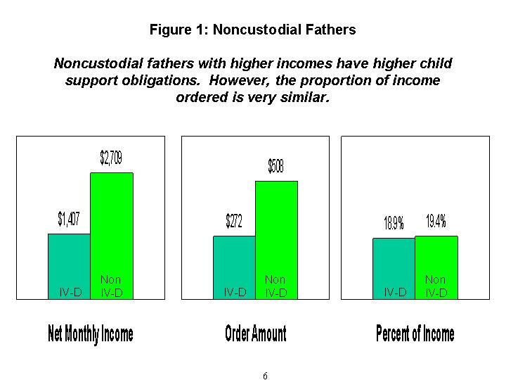
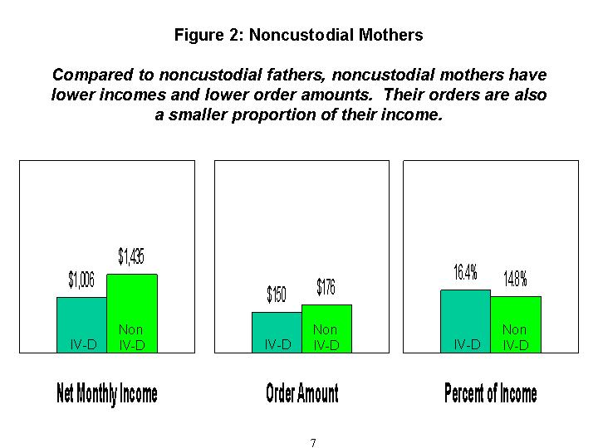

Comparison between noncustodial mothers and fathers, continued:
While adherence to the Schedule would result in lower orders for noncustodial mothers (due to their lower incomes), Figure 2 also indicates that the percent of income that noncustodial mothers are ordered to pay is less than noncustodial fathers.

Specifically, child support orders for IV-D noncustodial mothers represent 16.4 percent of their income, compared to 18.9 percent for noncustodial fathers. Child support orders for non-IV-D noncustodial mothers require 14.8 percent of their income, compared to 19.4 percent for noncustodial fathers. A potential explanation for this finding is discussed in the section on deviations.

- The Schedule guidelines incorporate the fact that additional children entail additional costs, while at the same time recognizing that two children are not twice as costly as one. Are the findings in this review consistent with these guidelines?

Yes. In general, the data indicate that both the amount of child support and its proportion of income increase as the number of children in the order increases.

Because most orders -- over 90 percent -- involve one or two children, the discussion below will focus only on those orders. The charts, however, provide data for all family sizes. The number of children in the non-IV-D cases is slightly greater with an average of 1.59 children, compared to the IV-D cases with an average of 1.34 children.

For the overall sample, the data show that the median award amount for one child is $247; for two children, the amount is $451. These figures account for 16.9 percent and 23.4 percent, respectively, of the noncustodial parent’s income.
Examining these data by the IV-D and non-IV-D categories reveals the same pattern we observed earlier: that is, non-IV-D orders have higher incomes and thus higher award amounts, but the proportion of income ordered in child support is quite similar.

Specifically, for one child the award amount is $392 for the non-IV-D orders, representing 16.4 percent of income; for the IV-D orders, the amount is $225 or 17.1 percent of income.

For two children, the award amount is $608 for the non-IV-D orders, representing 23.4 percent of income; for the IV-D orders, the amount is $314 or 23.5 percent of income.

- How do these findings vary according to whether the noncustodial parent is the mother or the father?

We begin with noncustodial fathers. As shown in Figure 3, the median order amount for one child is $285; with two children, the order amount rises to $531. Correspondingly, Figure 4 shows that two children require a larger proportion of income (24.9 percent) than one child (17.8 percent).

8

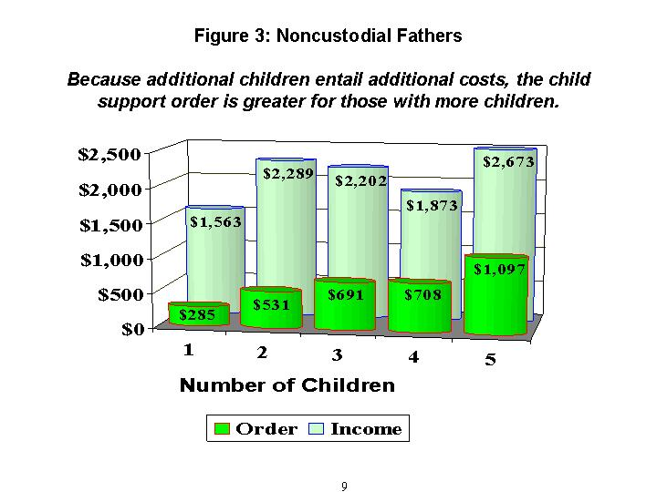
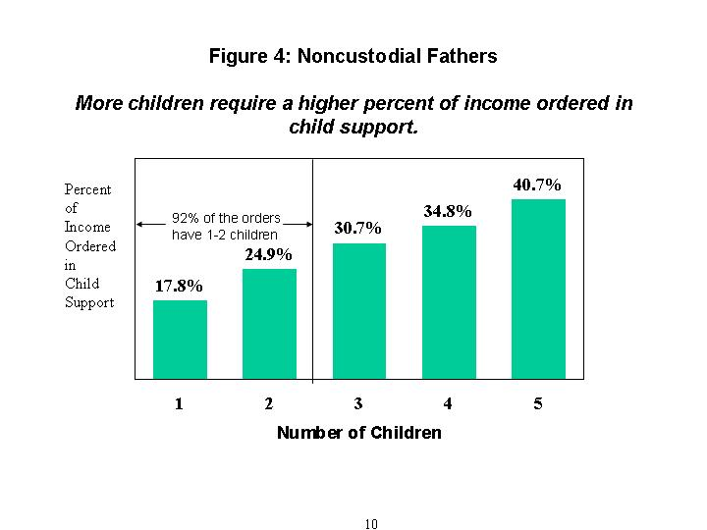

The findings for noncustodial mothers are also consistent with the Schedule, in that additional children require a greater award amount and a larger percentage of income. As shown in Figure 5, the median order amount for one child is $160; with two children, the order amount rises to $173. As a result, shown in Figure 6, two children require a larger proportion of income (17.8 %) than one child (15.2 %).

However, comparing the outcomes for noncustodial mothers and fathers, the increase for additional children in both the amount and percent of income is much lower for noncustodial mothers than for noncustodial fathers. A possible explanation for this finding is discussed in the next section, in the review of deviations.

- As required by 45 CFR 302.56 in the federal regulations, the Washington Child Support Schedule allows for deviations from the established presumptive amounts. How frequently do such deviations occur?

Deviations are common. For the sample overall, almost 30 percent (28.5%) deviate from the presumptive amount established in the Schedule. The vast majority of deviations (87%) reduce the child support order from the presumptive amount (as contrasted to 13% of the deviations which increase the order amount).

While deviations are common overall, they are almost twice as likely among non-IV-D orders (with a 42.7% deviation rate) than IV-D orders (with a 22.1% deviation rate). Virtually all (98%) of the IV-D orders with a deviation reduce the order from the presumptive amount, while 75 percent of the non-IV-D orders with a deviation lower the order.

The magnitude of the downward deviation differs somewhat between the IV-D and non-IV orders: IV-D orders have their order reduced by 33 percent from the presumptive amount, compared to the non-IV-D cases that see their order reduced by 44 percent.
These findings also vary depending upon whether the noncustodial parent is the father or the mother. We begin with an examination of the deviations for noncustodial fathers. These findings are displayed in Figure 7.

Comparing the non-IV-D orders to the IV-D orders for noncustodial fathers, the findings show that, while deviations are frequent in both types of orders, they occur much more often for the non-IV-D orders. Forty-one percent of the non-IV-D orders deviate from the presumptive amount in the Schedule, contrasted to 23.4 percent of the IV-D orders.

Most deviations (85 percent) are downward: that is, they reduce the order amount from that prescribed by the Schedule.

In addition to the frequency of deviations, the magnitude of the deviations is also significant. For non-IV-D orders, the amount of the downward deviation is $183, representing a decline in the order from the presumptive amount of 35 percent. For IV-D orders, the amount of the downward deviation is $90, representing a decline in the order from the presumptive amount of 30 percent.

11

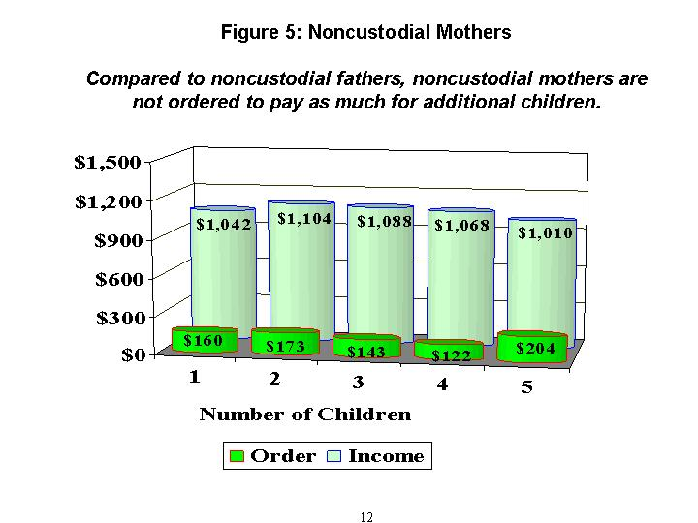
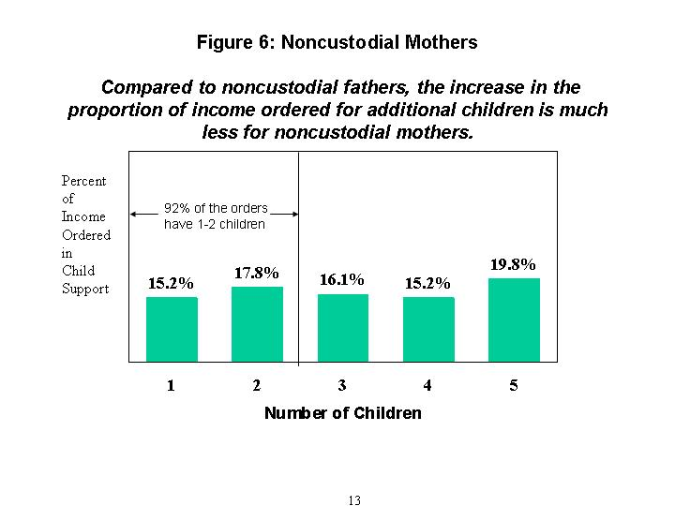
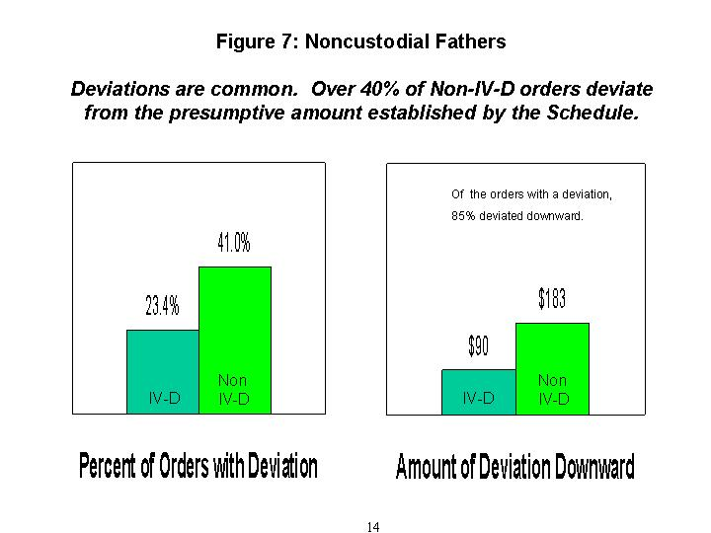

- What do the findings show regarding deviations for noncustodial mothers?

Deviations are also common for noncustodial mothers.
As we saw for noncustodial fathers, deviations are much more likely among the non-IV-D orders. For noncustodial mothers, over half of the non-IV-D cases deviate from the presumptive amounts, while just over 17 percent of the IV-D orders do. Also, similar to noncustodial fathers, the vast majority of deviations (95%) reduce the order from the presumptive amount in the Schedule. These findings for noncustodial mothers are shown in Figure 8.

Earlier in this review, we saw that noncustodial mothers not only have lower child support orders, as would be expected given their lower incomes, but also that the proportion of income they are ordered to pay in child support is lower than noncustodial fathers. The analysis of the deviations for noncustodial mothers may provide an explanation for this finding.

First, noncustodial mothers are somewhat more likely to have a downward deviation (95 percent) than noncustodial fathers (85 percent).

Of greater potential significance, however, is the magnitude of the deviation. For non-IV-D orders, the deviation constitutes a 77 percent decrease from the presumptive amount in the Schedule. For IV-D orders, the order is reduced by 42 percent.

While no one reason for a deviation predominates for noncustodial fathers, this is not the case for noncustodial mothers: almost half of the deviations arise from a singular cause: their incomes are below the poverty level.

For both noncustodial mothers and fathers, the data also show that both the likelihood of a deviation and the amount of the deviation increases with the number of children in the order.
- The Schedule was reviewed twice before, in 1991 and in 1995. How do the findings of this review compare to those previous reviews?

The previous reviews were based on a different data source: a sampling from the “Child Support Order Summary Report” filed with the county clerk and forwarded to the Washington Office of the Administrator for the Courts. Given the different data sources, the findings for this review may not be strictly comparable with the previous reviews. Some general comparisons, however, may be made and these are discussed in this section. We begin with a comparison of the current review with the 1991 study.

The 1991 review found that noncustodial fathers were ordered to pay a median child support amount of $338 or 22 percent of their income. The findings of this review indicate that, while incomes have increased since 1991, the median order amounts have fallen to $311 or 18.5 percent of income. (All figures include all children in the order and any deviation.)

The award amounts and the proportion of income ordered in child support for noncustodial mothers have also decreased since the 1991 review.

15

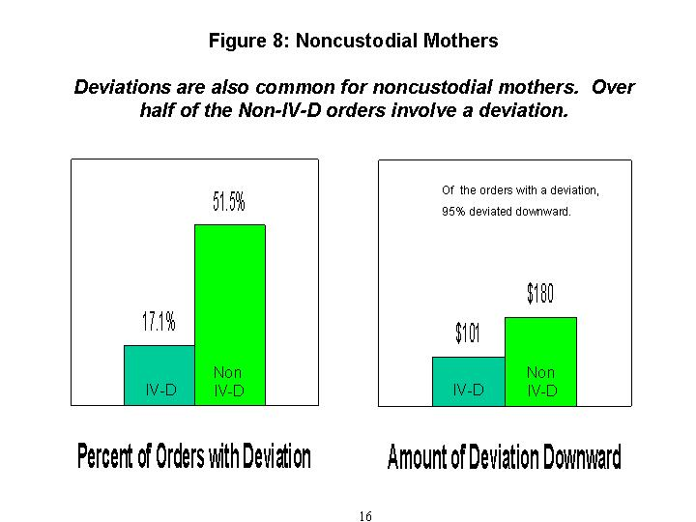

Comparison with the 1991 Schedule review, continued:
The decrease in the proportion of income ordered in child support from the 1991 study to the present study is exhibited across all income levels. That is, from low incomes to high incomes, all orders exhibited a decline in the percent of income ordered in child support.

Additionally, a reversal has occurred with respect to noncustodial mothers and fathers. In 1991, noncustodial mothers were ordered to pay a larger percent of their income in child support (24 percent compared to 22 percent for noncustodial fathers). The present review finds that noncustodial mothers are ordered to pay a smaller proportion: 15 percent compared to 18.5 percent for noncustodial fathers.

The 1991 review found that 19 percent of the orders deviated from the presumptive amount in the Schedule. Since then, the likelihood of deviating has increased: the findings of this review show that 28.5 percent deviate.

Comparison with the 1995 Schedule Review
The 1995 review was limited to noncustodial fathers and nonpaternity orders. Comparable orders in the current review show that, while the award amount has increased, from $420 to $508, the proportion of income ordered in child support has decreased from 24 percent in 1995 to 19.4 percent in the current review.

Similar to the 1991 comparison, the decline in the proportion of income ordered in child support between the 1995 study and the current one occurred across all income levels, from low incomes to high incomes.

In 1995, the deviation rate for noncustodial, nonpaternity fathers' orders was 28 percent. Comparable orders in the current review indicate a significant increase in the deviation rate, to 41 percent.

In summary, the comparison of this study with both of the previous reviews indicates two major findings:
1) The proportion of income ordered in child support has decreased, and 2) the likelihood of deviating from the presumptive amount in the Schedule has increased.

- The child support obligation is computed based on the parents’ combined income and then it is apportioned between the parents based on their proportion of income. Do we know whether these steps in the Schedule are followed correctly in determining the amount of the child support award?

Given the income and expense data as provided in the order, the estimated overall error rate is between one and three percent.

The majority of these errors appear to arise due to inaccurate rounding.

(Be aware that difficulties arise in this analysis because we cannot independently confirm the accuracy of the net income figures or the expenses associated with health care and day care. The report and the methodology explaining the above estimate is available from DSHS, Division of Child Support.)

17
- The primary purpose of child support is to ensure the economic security of children, while at the same time being cognizant of the impact of child support on the noncustodial parent’s household. This section of the review of Washington’s Child Support Schedule analyzes how the needs of children are balanced with the financial circumstances of their noncustodial parents.

What do the data tell us about the impact of child support on the economic well-being of the custodial family compared to the effects on the noncustodial household?

The differing effects of child support on the custodial and noncustodial households have been estimated for this review and are discussed in this section.

It is important to recognize that the data are not as complete as would be desirable to undertake this analysis, and thus the results must be viewed cautiously. The most significant limitation in the data pertains to the IV-D cases, whose income for the purpose of the order does not include any public assistance they might receive. The inclusion of such assistance would clearly result in a measured improvement in the economic well-being of these households.

To perform this analysis, we need to have a measure of “economic well-being” for the household. The most frequently used measure is a variable called “income-to-needs” in which “income” is gross income of the household – including the child support amount for the custodial household, while child support is excluded from the income of the noncustodial parent. “Needs” is the poverty threshold based on the size of the household, so the children in the order will not be counted in noncustodial household size, but will be counted in the custodial household.

For example, if a household has an income-to-needs of 1.5, it means this household’s income is 50 percent above the poverty level. Similarly, if the income-to-needs is less than one, it means the household’s income is not sufficient to meet the poverty level.

For the sample overall, the noncustodial parent’s income-to-needs is 1.66, compared to the custodial parent and children’s income-to-needs of 1.24. An analysis of their relative income-to-needs indicates that noncustodial parents enjoy a 56 percent higher standard of living than custodial parents and their children.

If we restrict this comparison to the non-IV-D cases (which entail fewer potential problems with the measurement of their income), the findings show that the income-to-needs ratio of the noncustodial parent is 3.97, compared to the custodial household’s 2.73. Again, the noncustodial parent’s is substantially greater – forty-one percent higher – than the custodial parent and children’s.

Similar figures for the IV-D orders show that the economic well-being of the noncustodial parent is 1.48 compared to that of the custodial household’s 0.68, indicating a sixty-seven percent higher standard of living for the noncustodial parent. (As noted above, these figures should be viewed cautiously.)

18
- How do the findings on economic well-being vary depending upon whether the father or the mother is the noncustodial parent?

First, we turn to the findings for those orders where the father is the noncustodial parent, presented in Figure 9. For the non-IV-D cases, the income-to-needs of the noncustodial father is 4.17, compared to that of the custodial mother and children’s income-to-needs of 2.70. These data indicate that the economic well-being of noncustodial fathers is more than fifty percent greater than that of custodial mothers and their children.

For the IV-D cases, the income-to-needs of the noncustodial father is 1.60, compared to that of the custodial mother and children’s income-to-needs of 1.09. While neither household is enjoying a high degree of economic well-being, the noncustodial father is much better off than the mother and children. His income-to-needs is sixty percent higher than his children’s household.

Thus, for both IV-D and non-IV-D orders, the standard of living of the noncustodial father is more than fifty percent greater than the custodial mother and the children.

- Are the findings on economic well-being similar when the mother is the noncustodial parent?

No, two differences are observed: 1) for non-IV-D orders, the situation is reversed from that observed in the previous figure, and 2) for IV-D orders, the relative disparity between the custodial and noncustodial households is much greater.

Figure 10 presents income-to-needs where the mother is the noncustodial parent. We begin with a discussion of the non-IV-D orders, displayed on the right-hand side of the chart.

Whereas Figure 9 showed that noncustodial fathers enjoy a fifty percent greater level of economic well-being than custodial mothers and the children, Figure 10 indicates that when mothers are the noncustodial parent, their economic status is almost forty percent less than that of the custodial fathers and the children.

Noncustodial mothers have an income-to-needs of 2.04, while that of the custodial fathers’ household is 3.35. This finding may derive from mothers allocating more income to their children than fathers do, as other research has shown. The outcome may also be the result of the lower earnings of mothers compared to fathers.

Next, we examine the findings for the IV-D orders where the mother is the noncustodial parent and the father is the custodial parent, shown on the left side of Figure 10.

These data are particularly troubling: while the noncustodial mother is clearly not well-off with an income-to-needs of 1.32, the custodial fathers and children face severe economic insecurity. Their income-to-needs is only 0.16, suggesting their income is 84 percent below the poverty line.

The result above stems from the fact that almost ¾ of the IV-D custodial fathers show zero income of their own in the order. This fact, coupled with the very low incomes of the IV-D mothers ordered to pay child support, means that these fathers and children are left with extremely limited financial resources.

19

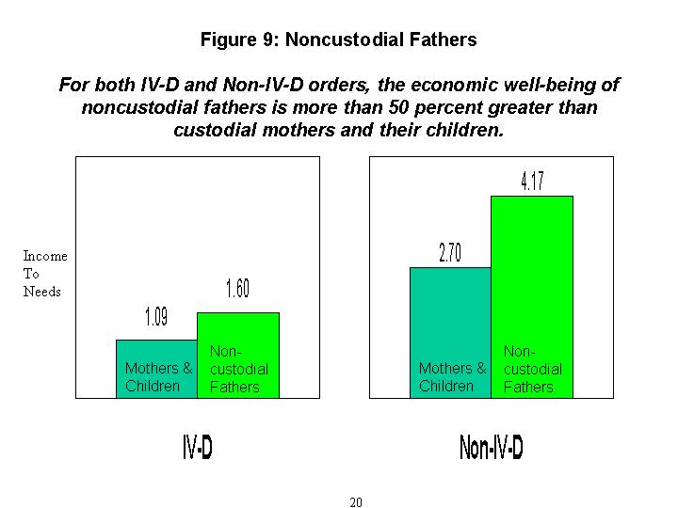
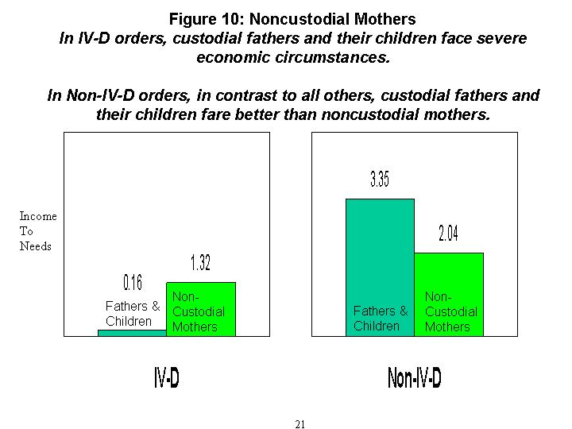

Income-to-needs for IV-D orders, continued:
As indicated in the caution about interpreting these results, “income” for the purpose of establishing child support does not include public assistance, but given that many of the IV-D households in fact receive such assistance, their economic plight is likely less severe than these results suggests.

While child support may serve to complement the custodial parent’s own resources to provide for his or her children, the finding above that – without public assistance – these households face dire economic insecurity serves to highlight the critical importance of such assistance to low-income families.

Two conclusions emerge from this analysis: 1) Mothers, whether custodial or noncustodial, typically face a very low level of economic well-being; and 2) Given the vast majority of children are in their mother’s custody, they experience a much lower standard of living than their noncustodial fathers, indicating that they are bearing a large degree of the economic burden associated with the division of their parents financial resources between two households.

- How do child support orders vary for different regions of the state?

As shown in Figure 11 on the next page, the orders are distributed across the state as follows:
45.3 percent of the orders are from the Urban West;
22.8 percent from the Non-urban West; and
31.9 percent from the East.
For the overall sample, the data show that the income and child support orders are highest in the Urban West region of the state, with net monthly incomes of $1791 and order amounts of $317. The East shows the lowest income values and order amounts of $1254 and $234, respectively.

Urban West orders are also required to pay a slightly higher percentage of income in child support, 18.3 percent, than other regions. The East has the lowest proportion of income in child support: 17.8 percent.

The same pattern, as above, is observed when the data are broken down by IV-D orders compared to non-IV-D orders.

We now turn to how orders across the state vary depending upon whether the noncustodial parent is the mother or the father. The results confirm the patterns indicated above: regardless of which parent is the noncustodial parent, incomes and orders in the Urban West are the highest among the three regions. Additionally, the proportion of income ordered in child support is slightly higher in the Urban West than the other regions of the state.

These data are shown in Figure 12, which shows that noncustodial fathers in the Urban West enjoy the highest incomes, with a median value of $2073 per month, and given their higher incomes, order amounts are highest in the Urban West also.

The East region of the state shows the lowest incomes, at $1428, and thus their child support orders are subsequently the lowest, as established by the Schedule.

22

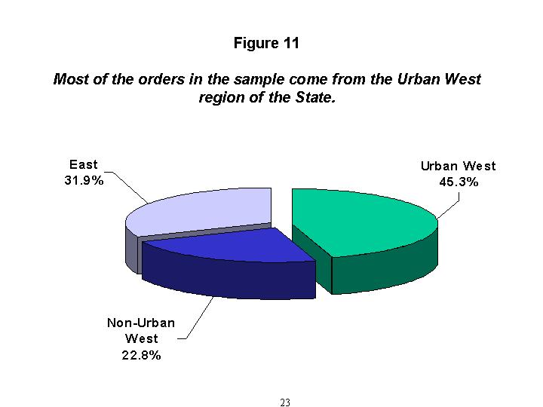
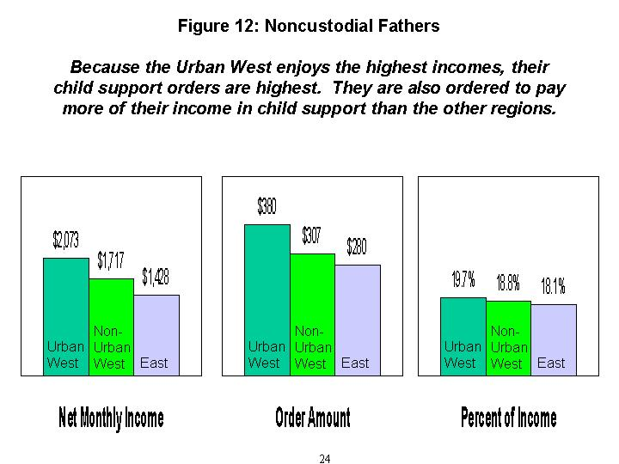

Comparison among regions of the State, continued:
The orders in the Urban West, however, are also higher in terms of their proportion of income (19.7 percent) compared to the orders in the East (18.1 percent), as shown in Figure 12.

For those in the non-Urban West, their incomes, order amounts, and the percent of income ordered in child support lie between those of the Urban West and East regions of the state.

The same pattern -- although lower values overall -- is found for noncustodial mothers. These findings are displayed in Figure 13.

- The Schedule requires that income be imputed when a parent is unemployed, underemployed or the income is unknown. How frequently does imputation occur? How do the imputed orders differ from orders based on actual income?

While some information is available in the database on imputation, it is not complete. The best estimate is that 45.8 percent of the orders are based on imputed income. The likelihood of imputation is greater among the IV-D orders, which utilize imputed income in 52.2 percent of the orders, than in non-IV-D orders, which rely on imputed income in 32.4 percent of the cases.

The likelihood of imputation varies somewhat depending upon whether the noncustodial parent is the mother or the father. As Figure 14 shows, just over one-half (50.3%) of IV-D orders for noncustodial fathers are based on imputed income, while over one-quarter (28%) of non-IV-D cases utilize imputed income.

The imputation rate is estimated to be even higher for noncustodial mothers: over 60 percent for IV-D orders and almost 60 percent for non-IV-D orders, as shown in Figure 15.

For both IV-D and non-IV-D noncustodial fathers, imputed income is 77 percent of actual income. That is, when estimating unknown income, the estimated amount is 23 percent less when income is known.

For IV-D noncustodial mothers, imputed income is 78 percent of actual income, while non-IV-D imputed income is 80 percent of actual income.

There is very little variation between actual and imputed income orders in terms of the percent of income ordered in child support. Nor is there much variation between actual and imputed orders in terms of the likelihood of a deviation from the presumptive amounts in the Schedule. (These latter findings are not presented in a chart.)

25

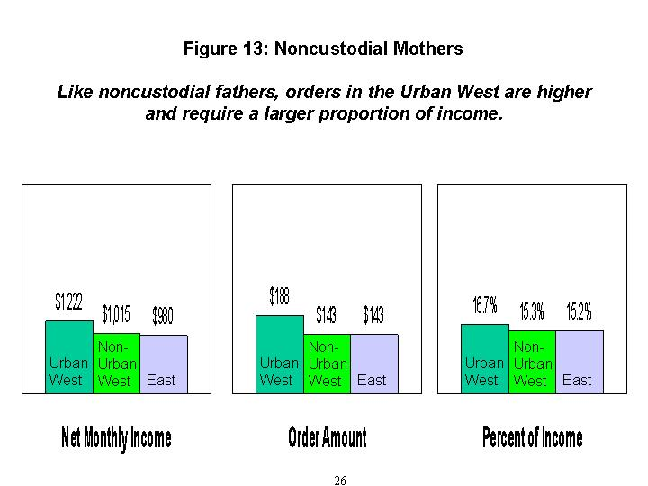
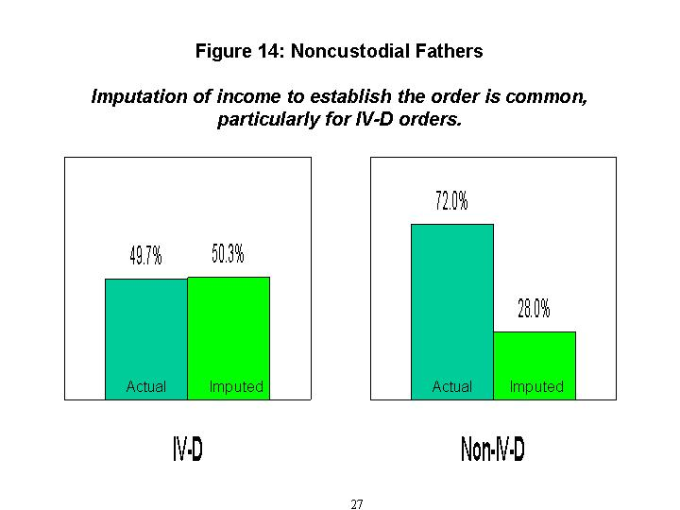
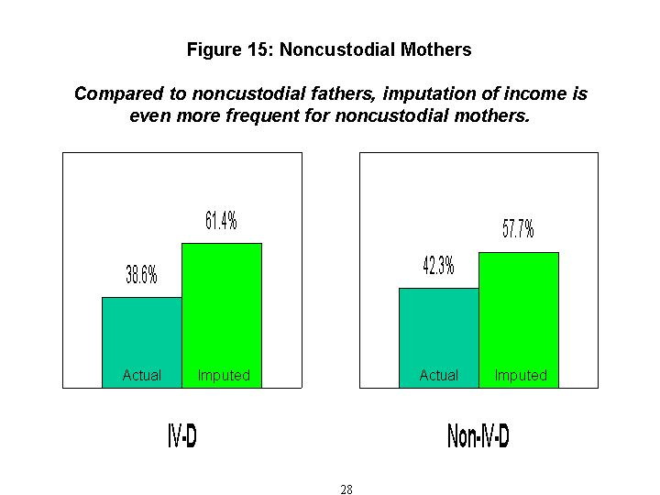

- The Schedule provides for adjustments from the presumptive amount for specific outlying cases, such as those when the order amount is a very large percentage of income, or where income is very high or low. This section summarizes the findings on these outlying cases.

1. Orders in excess of 45 percent of net income:
Such orders are rare, comprising only 1.4 percent of noncustodial fathers and even fewer noncustodial mothers. These orders have lower median income than other orders and much higher upward deviation amounts.

2. Orders with income greater than $5000:
Slightly less than 14 percent of the orders have combined incomes over $5000; most of these involve noncustodial fathers. While most of these orders comply with the Schedule’s instructions, between 23 percent and 29 percent do not. Similarly, for the 5.3 percent of orders with income in excess $7000, most adhere to the Schedule’s instructions. However, between 16 percent and 19 percent (depending on the number of children) are not ordered to pay the expected minimum amount.

3. Orders with income below $600:
For these 171 orders (4.1 percent of all orders), the median order amount is $25 for one child and $50 for two children. No child support is ordered for 20 percent of the noncustodial fathers in these cases and 38 percent of the noncustodial mothers.

- Orders with an order amount of zero:
There are 153 orders (4.7 percent) in which the noncustodial father is ordered to pay nothing. Compared to those with nonzero order amounts, these are associated with lower median incomes and lower deviation rates. They are more likely to be an Administrative order and equally likely to be based on imputed income. The findings for noncustodial mothers with orders of zero are similar.

5. Orders based on zero income:
There are 114 orders (3.5 percent) in which there zero income is reported for the noncustodial father. While the median transfer amount for these fathers is $25, 24 percent are ordered to pay nothing. These orders are much less likely to involve a deviation and more likely to be Court IV-D orders. The most common order type for these cases is “Judgment/Paternity” and they are much less likely to rely on imputed income. Noncustodial mothers with zero income are more likely to be “Administrative Notice Default” and found in the Administrative IV-D category. Like noncustodial fathers, they are much less likely to involve a deviation or to be based on imputed income.

29
Child support orders may arise for a variety of reasons. For example, they may be the result of a divorce or a paternity order. The following material summarizes the different types of orders in the database and how they vary between IV-D and non-IV-D orders:

As shown in Figure 16 on the next page, the most common type of order is divorce, accounting for 28 percent of the orders in the sample overall. The next most common are:
Administrative Notice Default (21 percent);
Paternity Orders (18 percent);
Modifications of a previous order (15 percent).

The IV-D and non-IV-D categories differ substantially in the types of orders they determine. Most of the divorces (89 percent) are non-IV-D orders, while all (100 percent) of Administrative Notice Default and most (93 percent) of the paternity orders are IV-D cases.

The IV-D and non-IV-D categories are broken down as follows:

The IV-D category is comprised of two types:
- “Court Ordered,” and
- “Administrative.”

The non-IV-D category is comprised of two types:
- “Direct Pay,” where one party pays child support to the other directly, and
- “Payment Service Only,” where payment is made through the registry.

30

