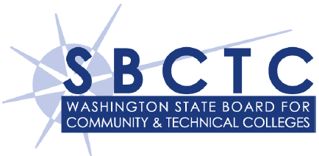
WorkFirst Degree Completion Request

(For SBCTC providers seeking DC component approval)
Student Name (Last, First, M.I.): |  |  |  |  |  |  |  | e-JAS ID:
County of Residence: |  |  |  |  |  |  |  | Date:

Institution & Program Information

Community or Technical College:

Program Title:
Award Type: |  |  |  |  |  |  |  |  |  | Student Attendance: |  | ◻ FT ◻ PT
Credits Required: |  |  |  |  | Credits Completed: |  |  |  | Credits Remaining:

Expected Completion Date:

Labor Market Research

Employment Outcomes

Using employment data from Employment Security Department’s Occupations in Demand List, complete the following information for the career(s) this certificate or degree program will lead to. A copy of the report(s) used to verify this information must be attached to this form.
Standard Occupational Classification (SOC) # | Career Title |  |  |  |  |  |  | Median Wage |  |  | Demand
◻ Demand
◻ Balanced
◻ Decline
◻ Demand
◻ Balanced
◻ Decline
◻ Demand
◻ Balanced
◻ Decline
◻ Demand
◻ Balanced
◻ Decline
Submission & Review
Please complete this form electronically and send through secure email with supporting documentation to: jdellinger@sbctc.edu
Staff Contact Name:
Staff Contact Phone:
Staff Contact Email:

For SBCTC Use Only
Component History: |  | VE |  | HW |  | DC | Remaining VE/HW/DC Months:
The request is:  ◻ Approved (DC)  ◻ Denied |  |  | Finding notes:  Denial Recommendation:

