ATTACHMENT D: BIDDER RESPONSE FORM
This form is broken into Seven sections: Section 1. Administrative Response; Section 2. EO 18-03 Response; Section 3. Washington Small Business; Section 4. Certified Washington Veteran-owned Business; Section 5. Management Response; Section 6. Technical Response; and Section 7. Quotation/Cost Proposal. Bidders must respond to all questions in the order and in the expandable space provided. If a question requires Bidder to submit additional documents, please attach them to this document and label them clearly as part of your response to this Attachment D.
1 |  | BIDDER INFORMATION (ADMINISTRATIVE RESPONSE)  Bidder’s response to the questions in this Section 1, combined with the information provided in Bidder’s Submittal Letter and Certifications and Assurances, comprise Bidder’s Administrative Response to this Solicitation. While the Administrative Response is not given a number score, the information provided as part of Bidder’s Administrative Response may cause the Bid to be disqualified and may be considered in evaluating Bidder’s qualifications and experience. | MAXIMUM TOTAL POINTS
a |  | Please indicate whether you employ or Contract with current or former state employees. If the answer is yes, provide the following information with respect to each individual: 1. name of employee or contractor; 2. the individual’s employment history with the State of Washington; 3. a description of the Individual’s involvement with the response to this Solicitation; and 4. the Individual’s proposed role in providing the services under this any Contract that may be awarded. | NOT SCORED
ANSWER: Yes.

Name | Andrea Nagel
Employment History/Exit Year | Department of Social and Health Services (DSHS), Public Benefits Specialist, 2013 to 2021
Description of Involvement with Solicitation | None as it pertains to this solicitation.
Proposed Role | None as it pertains to this solicitation.
Name | Crystal Hilton
Employment History/Exit Year | Department of Children, Youth, and Families (DCYF), Lead Secretary, 2015 to 2021
Description of Involvement with Solicitation | None
Proposed Role | Program build and monitoring
Name | Caitlyn McKenzie
Employment History/Exit Year | DSHS, Public Benefits Specialist, 2016 to 2021
Description of Involvement with Solicitation | None as it pertains to this solicitation.
Proposed Role | None as it pertains to this solicitation.
Name | Jaela Peters
Employment History/Exit Year | DSHS, Public Benefits Specialist and Supervisor, 2016 to 2022
Description of Involvement with Solicitation | None as it pertains to this solicitation.
Proposed Role | None as it pertains to this solicitation.
Name | Jessica Warwick
Employment History/Exit Year | DSHS, Public Benefits Specialist, 2020 to 2021;
Description of Involvement with Solicitation | None
Proposed Role | Intake Specialist
Name | Lisa Fields:
Employment History/Exit Year | DCYF, Public Benefits Specialist, 2013 to 2022;
Description of Involvement with Solicitation | None as it pertains to this solicitation.
Proposed Role | None as it pertains to this solicitation.
Name | Josie Contreras
Employment History/Exit Year | State of Washington Employment Security, Work First Career Coach, February 2021 – February 2022
Description of Involvement with Solicitation | None as it pertains to this solicitation.
Proposed Role | None as it pertains to this solicitation.
Name | Katie Woodwise
Employment History/Exit Year | DSHS - DSHS/DCFY; Public Benefits Specialist; October 2013 - April 2022
Description of Involvement with Solicitation | None as it pertains to this solicitation.
Proposed Role | None as it pertains to this solicitation.
Name | Kate Day-Babcock
Employment History/Exit Year | DSHS, Work First Program Specialist - Pierce South CSO, 03/2013-MARCH 2022
Description of Involvement with Solicitation | None as it pertains to this solicitation.
Proposed Role | None as it pertains to this solicitation.
Name | Kia Ornelas
Employment History/Exit Year | Department of Social and Health Services (DSHS)-Yakima County Prosecutor's Office Child Support Division, Office Technician, Office Specialist, Office Coordinator/Court interpreter; 2022
Description of Involvement with Solicitation | None as it pertains to this solicitation.
Proposed Role | None as it pertains to this solicitation.
Name | Leandro Lessin
Employment History/Exit Year | Office of Superintendent of Public Instruction (OSPI), Emergency Substitute Teacher , East Valley School District; 2022
Description of Involvement with Solicitation | None as it pertains to this solicitation.
Proposed Role | Associate Program Manager II
Name | David Choi
Employment History/Exit Year | Employment Security Department, Unemployment Insurance Specialist; 2021
Description of Involvement with Solicitation | None as it pertains to this solicitation.
Proposed Role | None as it pertains to this solicitation.

b |  | Please list the names and contact information of three individuals you agree may serve as Bidder references and may freely provide information to DSHS regarding the reference’s experience and impressions of Bidder. In providing these names, Bidder represents that it shall hold both DSHS and the organizations and individuals providing a reference harmless from and against any and all liability for seeking and providing such reference. | NOT SCORED
ANSWER:
1. Margaret Hinson, Spokane Site Director, International Rescue Committee (425) 414-6821, margaret.hinson@rescue.org. Ms. Hinon’s prior role was with the City of Spokane as the Covid Program Manager.
In 2020, the City of Spokane deployed FORWARD to distribute more than $2.4 million in CARES Act funds to small businesses and nonprofits in less than six weeks. FORWARD conducted outreach to the community, collected applications, reviewed applications based on the City’s eligibility criteria, and distributed funds. FORWARD worked with local business support organizations to run webinars and training events so the organizations could aid the business owners. FORWARD also provided weekly updates and a final program report to City leadership. The program received 300 applications, of which 148 were approved. Half of the awardees were minority-, women-, and LGBTQ-owned businesses. The average award amount was $16,000.
The City expanded their contract to use the FORWARD platform to distribute $22.4 million in emergency rental assistance through the Emergency Rental Assistance (ERA1 and ERA2) and Treasury Rent Assistance Program (T-RAP1 and T-RAP2). To date, these programs have provided funds to more than 1,500 tenants and landlords across the City. The City was also the first in the state that has successfully distributed 100% of its ERA1 funds. Furthermore, ensuring fair access to support is a fundamental component of our FORWARD solution, seamlessly incorporated across all program stages. Our objective is to minimize both perceived and actual barriers to assistance, such as insufficient awareness, limited access to technology, and language barriers. As part of this effort, we have implemented strategies like offering paper applications and we adjusted our marketing approaches to target areas where the expected application volume was lower than we anticipated. We also held in-person events in areas with limited access to an online application.
FORWARD created strong partnerships with local CBO’s who effectively engaged populations of need within the community and allowed the program to exceed all equity delivery goals. 36.2% of the City’s ERA1 and T-RAP1 funds were disbursed to BIPOC applicants (including 12.1% and 8.3% to Black/African American- and Hispanic- identifying applicants, respectively; both groups have historically been disproportionately impacted by housing insecurity). Nearly 8.6% of the recipients were youth (ages 18 to 24) heads of households. 61% of recipients were below poverty level: the median income for recipients was $14,440, which is substantially less than the median income of $58,293 across all Spokane residents. FORWARD was the end-to-end solution for both business and household assistance programs; it was leveraged for conducting outreach to the community, collecting applications, reviewing the applications, distributing the funds, and providing all required reporting.

2. Kathy Kinard, Managing Director, Homeless Assistance Unit, Washington Department of Commerce, (206) 256-6100, kathy.kinard@commerce.wa.gov
FORWARD disbursed $51 million in incentives to eligible Homeless Provider workers across the State of Washington. As part of this program, we worked with the Department of Commerce to develop and configure the FORWARD to support a centralized and universal application intake, eligibility verification and determination, funds disbursement, program workflows, program integrity and fraud mitigation, and customer support. FORWARD hosted a directory of over 170 homeless providers to ensure equitable access across the state.

3. Alex Andrade, Economic Development Director, City of Milpitas, (408) 586-3046; aandrade@ci.milpitas.ca.gov
The City partnered with FORWARD to administer $864,500 in relief funds to the community. This program provided up to $5,000 in rent relief or up to $15,000 in mortgage relief to eligible households in the City. FORWARD provided full program administration services, including application portal, intake and eligibility verification, funds disbursement, and reporting.

c |  | Please indicate whether your Response contains any variations from the requirements of the Solicitation Document. If the answer is yes, list each variation with specificity and include the pertinent page numbers containing the variation. | NOT SCORED
 |  | ANSWER: No, our response does not contain any variation from the requirements in the solicitation document.
d |  | Please indicate whether you are requesting that DSHS consider any exceptions and/or revisions to the sample contract language found in Attachment A. If so, state the page of Attachment A on which the text you request to change is found, and state the specific changes you are requesting. DSHS shall be under no obligation to agree to any requested changes, and will not consider changes to contract language or negotiate any new language not identified in response to this question. | NOT SCORED
ANSWER: Yes.
FORWARD is proposing revisions to the following items:

Page Number | Proposed Text | Rationale
Page 4-5.  (6) | 6. Confidentiality, Ownership and Intellectual Property  (7) Nothing in this Contract will be construed to confer any ownership interest, license or other rights as to the Data or any other intellectual property of the Contractor, except as expressly stated in this Contract.  - Unless otherwise provided for herein and excluding Contractor Background Technology (as defined below), all finished and unfinished works, tangible or not, created under this Contract including, without limitation, documents, materials, data, reports, manuals, specifications, artwork, drawings, sketches, blueprints, studies, memoranda, computation sheets, computer programs and databases, schematics, photographs, video and audiovisual recordings, sound recordings, marks, logos, graphic designs, notes, websites, domain names, inventions, processes, formulas, matters and combinations thereof, and all forms of intellectual property originated and prepared by Contract or its Subcontractors under this Contract (each a “Work Product”; collectively “Work Products”) shall be and remain the exclusive property of DSHS for its use in any manner DSHS deems appropriate. For the avoidance of doubt, Work Product does not include any software, content, works of authorship, intellectual property or other technology created by Contractor prior to or independent of this Contract, or any improvements or modifications thereto (“Contractor Background Technology”). | We propose adding "Ownership and Intellectual Property" to provision 6. (Confidential) to clearly define and protect both parties' rights and responsibilities regarding confidential information and intellectual property. This is intended to ensure a mutual understanding of how sensitive information is handled and to explicitly outline the ownership of any intellectual outputs resulting from this contract, thereby safeguarding our respective interests.
Page 6. (12) | 12. Inspection. The Contractor shall, at no cost, provide DSHS and the Office of the State Auditor with reasonable access to Contractor’s place of business, Contractor’s records, and DSHS client records, wherever located. These inspection rights are intended to allow DSHS and the Office of the State Auditor to monitor, audit, and evaluate the Contractor’s performance and compliance with applicable laws, regulations, and these Contract terms. These inspection rights shall survive for six (6) years following this Contract’s termination or expiration. Such audits may not be performed more than once per calendar year, unless any prior audit revealed non-compliance with this Contract by Contractor. | We propose limiting audit frequency to provision 12. (Inspection) to once per calendar year, unless prior audit reveals issues, to minimize operational disruptions while maintaining robust compliance checks and aims to balance the need for contractual oversight of our day to day operations.
Page 7.  (17), (b) | 17. Contract Renegotiation, Suspension, or Termination Due to Change in Funding. If the funds DSHS relied upon to establish this Contract or Program Agreement are withdrawn, reduced or limited, or if additional or modified conditions are placed on such funding, after the effective date of this contract but prior to the normal completion of this Contract or Program Agreement, DSHS will immediately notify the Contractor. Furthermore:  b. At DSHS’s discretion, DSHS may shall give a five (5) days written notice to Contractor to suspend performance when DSHS determines that there is reasonable likelihood that the funding insufficiency may be resolved in a timeframe that would allow Contractor’s performance to be resumed prior to the normal completion date of this contract. | We propose including notification to provision 17. (Contract Renegotiation, Suspension, or Termination Due to Change in Funding.) so we can properly plan and coordinate if needed.  (b) Proposed to balance the needs and right of both parties fostering a more cooperative and manageable relationship.
Page 8. (24) | 24. Indemnification and Hold Harmless  a. The Contractor shall be responsible for and shall indemnify, defend, and hold DSHS harmless from any and all third-party claims, costs, charges, penalties, demands, losses, liabilities, damages, judgments, or fines, of whatsoever kind of nature, arising out of or relating to a) the Contractor’s or any Subcontractor’s performance or failure to perform this Contract, or b) the breach of this Contract acts or omissions of the Contractor or any Subcontractor.  b. The Contractor’s duty to indemnify, defend, and hold DSHS harmless from any and all third-party claims, costs, charges, penalties, demands, losses, liabilities, damages, judgments, or fines shall include DSHS’ personnel-related costs, reasonable attorney’s fees, court costs, and all related expenses.  c. The Contractor waives its immunity under Title 51 RCW to the extent it is required to indemnify, defend, and hold harmless the State and its agencies, officials, agents, or employees. in accordance with this Contract. | We propose the revision to the provision 24. (Indemnification and Hold Harmless) to further clarify the responsibilities of FORWARD, with specific focus on this Contract. This adjustment aims to avoid any potential for bread interpretation, ensuring a clear and mutual understanding of the obligations and liability as per the terms of our Contract.
Page 9.  (29) | 29. Subcontracting. Except as otherwise provided in this Contract, the Contractor shall not Subcontract any of the contracted services without the prior written approval of DSHS. Contractor is responsible to ensure that all terms, conditions, assurances and certifications set forth in this Contract are included in any and all Subcontracts. Any failure of Contractor or its Subcontractors to perform the obligations of this Contract shall not discharge the Contractor from its obligations hereunder or diminish DSHS’ rights or remedies available under this Contract. For the avoidance of doubt, Contractor’s use any third-party hosting providers, such as Microsoft Azure or Google Cloud, in the hosting of any online services provided by Contractor will not be considered Subcontractors for the purposes of this Contract. | We propose the revision to 29. (Subcontracting) for clarity and to streamline our operations while maintaining compliance with the Contract terms
Page 10.  (b. 3)  (d.) | 30. Subrecipients.  b. Single Audit Act Compliance. If the Contractor is a subrecipient and expends $750,000 or more in federal awards from any and/or all sources in any fiscal year, the Contractor shall procure and pay for a single audit or a program-specific audit for that fiscal year. Upon completion of each audit, the Contractor shall:  Submit to the DSHS contact person the data collection form and reporting package specified in 2 CFR Part 200, Subpart F, reports required by the program-specific audit guide (if applicable), and a copy of any management letters issued by the auditor;  Follow-up and develop corrective action for all audit findings; in accordance with 2 CFR Part 200, Subpart F; prepare a “Summary Schedule of Prior Audit Findings” reporting the status of all audit findings included in the prior audit's schedule of findings and questioned costs.  - For Contractors that are a for-profit entity, alternative program and financial reviews equivalent to the Contractor’s operational scale and the nature of the provided services shall be pursued, focusing on ensuring the integrity and compliance of the Contractor’s financial and program management practices adhering to applicable laws as outlined herein.  d. The Contractor shall cooperate with DSHS to address and rectify any overpayments identified through its financial review processes, ensuring corrective actions are taken in a manner consistent with the principles of fairness and responsibility as outlined in clause 27. (Notice of Overpayment) and as appropriate. | We propose the revision to 30. (Subrecipients) Added for clarity surrounding program and financial reviews adhering to applicable laws and cooperation.
Page 19.  (9), (2) | 9. Culturally Relevant Services. The Contractor shall in good faith ensure all services are provided in the cultural context of the individual and/or individual’s family.  2. Record Keeping. The Contractor shall maintain the documentation required as outlined in this Contract and make it available upon reasonable prior written notice to ORIA for monitoring purposes. | We propose the revision to 9. (Culturally Relevant Services) to add "in good faith" to ensure this provision is both aspirational and practical.  We propose the revision to 2. (Record Keeping) to ensure a balance and efficient process for both parties intended to facilitate orderly and planned documentation sharing, respecting the operational needs of both the Contractor and DSHS.
Page 20.  (6), (7) | 6. Program Training. The Contractor shall ensure all of its employees who provide services under this Contract attend ORIA Contract Orientation/Training as requested by DSHS. Training may be conducted either in-person or via remote methods, as mutually agreed upon by the Contractor and DSHS with advance notice. If an employee is unable to attend scheduled training, the Contractor shall coordinate with DSHS to arrange alternative training methods or reschedule as necessary.  7. Reduction of Funds. Funding for this contract is based upon an estimated number of clients the Contractor will serve. If Should the Contractor’s billing patterns indicate the estimate was too high, DSHS reserves the right to adjust those estimates and reduce funding accordingly propose an adjustment to those estimates. Any proposed funding reduction will be based on transparent and mutually agreed-upon criteria. The Contractor will be given an opportunity to review and discuss the proposed changes before any reduction is finalized. Any adjustments to funding will In the event DSHS chooses to exercise this right, DSHS will notify the Contractor in writing of the amount of the reduction. Both parties to this Contract agree that require a written Amendment to this Contract, mutually agreed upon by both parties, and this Amendment will be considered proper written notice. | We propose the revision to 6. (Program Training) to add both in-person and remote training while ensuring flexibility and minimizing potential operational disruptions or additional costs while fulfilling the training requirements of the Contract.  We propose the revision to 7. (Reduction of Funds) aiming to promote a collaborative decision-making process in the event of reduction of funds.

FORWARD is open to a review of processes and procedures.
e |  | If Bidder considers any information that is submitted as part of its Response to be proprietary, please identify the numbered pages of Bidder’s Response containing such information and place the word “Proprietary” in the lower right hand corner of each of these identified pages. | NOT SCORED
 |  | ANSWER: N/A
f |  | Please indicate whether you have had a contract terminated for cause or default within the past five (5) years. If so, please provide the terminating party’s name, address and telephone number and provide a summary describing the alleged deficiencies in Bidder’s performance, whether and how these alleged deficiencies were remedied and any other information pertinent to Bidder’s position on the matter. “Termination for Cause” refers to any notice to Bidder to stop performance due to Bidder’s asserted nonperformance or poor performance and the issue was either (a) not litigated; (b) litigated with a resulting determination in favor of the other party; or (c) is the subject of pending litigation. | NOT SCORED
 |  | ANSWER: No, FORWARD has not had a contract terminated for cause or default within the past five (5) years.
g |  | Please identify any prior contracts Bidder has entered into with the State of Washington within the past ten (10) years and identify the dates and nature of the contract and primary agency contact for each. | NOT SCORED
ANSWER:
Below is a list of the contracts FORWARD has entered into with the State of Washington in the past ten years.

FORWARD
Customer | Dates | Contract Description | Contact Person
Washington
Washington State Department of Commerce (COMMERCE) | Jan 2023 to Jun 2023 | Hospitality & Lodging Grant Resources  (Contract# 23-733C0-001)  In early 2023, COMMERCE worked with FORWARD to launch its Hospitality & Lodging Grant program, which offered $100 million in one-time grants to eligible restaurants, hotels, motels and other qualifying businesses that have been negatively impacted by the COVID-19 pandemic. This program was intended to support eligible small businesses that demonstrated a 25% reduction in gross receipts or sales as a result of the pandemic. Additionally, a portion of funding was directed to reimburse lodging establishments that experienced loss during the state’s eviction moratorium. FORWARD provided full program administration services, including application portal, intake and eligibility verification, funds disbursement, and reporting. | Linda Womack, Director of the Minority Business Development Agency  Phone: (206) 256-6151  Email: linda.womack@commerce.wa.gov
Washington State Department of Commerce (COMMERCE) | Dec 2022 to Jun 2023 | Northwest Disaster Grant Program  (Contract# 23-732C0-001)  In January 2023, COMMERCE expanded its contract with FORWARD to distribute $17 million in individual grants to eligible businesses (including nonprofits) in Northwest Washington that sustained physical damage or economic loss due to the flooding that occurred between October 2021 and April 2022. The grants were used for payroll, utilities and rent, marketing and advertising, building improvements or repairs, replacing damaged inventory and equipment, and other operational and business expenses. FORWARD provided full program administration services, including application portal, intake and eligibility verification, funds disbursement, and reporting. | Rob Zerr  (206)256-6111  Email: robb.zerr@commerce.wa.gov
Washington State Department of Commerce (COMMERCE) | Jul 2022  to Jun 2023 | Homeless Service Provider Stipend (Contract #22-46143-502)  FORWARD was selected to administer the Homeless Service Provider Stipend program. FORWARD disbursed $51 million in incentives to eligible workers across the State of Washington. As part of this program, we worked with the Department of Commerce to develop and configure the FORWARD platform that supported a centralized and universal application intake, eligibility verification and determination, funds disbursement, program workflows, program integrity and fraud mitigation, and customer support. We partnered with BDS Planning and Urban Design to assist with marketing and outreach. | Kathy Kinard, Section Manager, Office of Family & Adult Homelessness  Phone: (206) 256-6100  Email: kathy.kinard@commerce.wa.gov
Washington State Department of Commerce (COMMERCE) | 2021  to current | Emergency Rental Assistance and Program Data Reporting (Contract #4619C-901)  In 2021, the Washington State Department of Commerce (Commerce) leveraged the FORWARD platform's data reporting functionality for the collection of Emergency Rental Assistance program data across Washington's 39 counties. FORWARD was instrumental in creating the user-friendly online application within our platform, which allowed Commerce to expand levels of assistance quickly and efficiently. The primary objectives were to develop reports aligning with the U.S. Department of Treasury's requirements and to generate customized reports illustrating the scale, operations, and outcomes of rental assistance programs at both county and state levels.  Beyond fulfilling reporting obligations, FORWARD actively facilitated the disbursement of rental and utility payments to eligible households in Clark and Pacific Counties. This encompassed addressing both past-due and future rent payments to prevent evictions. The process involved meticulous verification of completed applications, diligent follow-up with landlords and tenants for necessary information, and the equitable distribution of funds. Utilizing custom prioritization rubrics and data models, FORWARD ensured a fair and just allocation of resources to support households in need. FORWARD reviewed and approved over 900 applications and distributed over $7.3 million in rental assistance for these two counties. | Kathryn Dodge, Treasury Rent Assistance Program Manager  Phone: (360) 764-9682  Email: kathryn.dodge@commerce.wa.gov
Washington State Department of Agriculture (WSDA) | May 2022  to Dec 2023 | Seafood Processors Pandemic Response and Safety (SPRS) Grant Program (Contract #K3930)  The Seafood Processors Pandemic Response and Safety (SPRS) Block Grant Program provided grants to support seafood processors, including at-sea processing vessels, to respond to coronavirus, including for measures to protect workers against COVID-19. FORWARD distributed $2,445,520 to eligible businesses to provide relief to eligible seafood processors who incurred costs due to the COVID-19 pandemic. Grants amounts are variable depending on impact and the quantity of applications. | Laura Butler, Aquaculture Coordinator  Phone: (360) 902-1842  Email: lbutler@agr.wa.go
 | 2021  to 2021 | WSDA Relief and Recovery Grant (Contract #K3341)  In 2021, WSDA contracted FORWARD to distribute $14 million to nearly 1,000 applications to businesses in four sectors that were economically hurt due to marketplace disruptions created by the necessary public health measures during the COVID-19 pandemic: wineries/breweries, shellfish farmers, farmers markets, and agritourism.  At the end of the 11-week project term, FORWARD approved 839 applications for funding, with the average award amount being $17,000. One third of these awardees were minority-, women-, and LGBTQ-owned.  Funds were used for a variety of relief and recovery reasons, including reduced income, increased costs, staff retention, operating expenses (rent, lease, mortgages, and supplies), pandemic compliance measures, and others.  FORWARD supported WSDA’s program with the following services: Administration, application collection and processing, payment processing, funds disbursement, and reporting. FORWARD also partnered and worked with community partners in each of the sectors for program awareness and outreach. | Laura Raymond, Regional Markets Program Manager  Phone: (206) 379-3480  Email: LRaymond@agr.wa.gov
WA State Department of Social and Health Services (DSHS) | June 2022 to June 2023 | Immigrant Relief Fund (Round 3)  In 2022, FORWARD was selected to administer the DSHS Immigrant Relief Fund (Round 3), which disbursed $312 million in one-time grant payments to eligible undocumented immigrants across the State of Washington. As part of this program, FORWARD worked with DSHS to develop and configure the platform to support a centralized and universal application intake, eligibility verification and determination, funds disbursement, program workflows, program integrity and fraud mitigation, and customer support.  - In total, 101,678 individuals from all 39 counties in Washington State received grant awards.  - The program received 116,216 applications with 101,678 grants approved.  - A total of 150,231 calls were received through the program duration. FORWARD and partners supported 18,379 calls in January, 87,186 calls in February, and 55,104 calls in March. | Sarah Peterson, MSW  Washington State Refugee Coordinator  Phone: (360) 890-0691  Email: sarah.peterson@dshs.wa.gov

h |  | Please indicate whether Bidder has been the subject of a lawsuit or administrative proceeding alleging a failure to comply with laws relating to the types of services Bidder proposes to provide pursuant to this Competitive Solicitation. If the answer is yes, please list the nature of the allegations, docket number, disposition and date (if applicable) and Bidder’s explanation of how it has changed its practices or operations relative to any alleged deficiencies since that proceeding was filed. | NOT SCORED
ANSWER:
No, FORWARD has not been the subject of a lawsuit or administrative proceeding alleging a failure to comply with laws relating to the types of services Bidder proposes to provide pursuant to this Competitive Solicitation.
i |  | Please describe your proposed plans for the use of Subcontractors in performing this Contract, listing each Subcontractor, its proposed role, and the estimated percentage of the Contract that will be performed by each Subcontractor. Please indicate whether each Subcontractor self-identifies or is certified as a Washington small business, a minority-owned business, a woman-owned business, a disadvantaged business enterprise, or a veteran-owned business. If the answer is yes, please identify the type of organization(s) and provide details of any certifications. Note that all Subcontractors must be approved by DSHS. | NOT SCORED
ANSWER:
N/A, FORWARD does not propose the use of Subcontractors in performing this Contract.
J |  | Please describe any programs, policies or activities of your organization that support human health and environmental sustainability in your business practices. If a program, policy or activity is specifically applicable to this Contract, please indicate so. | NOT SCORED
ANSWER:
Health Sustainability Programs:
- FORWARD recognizes the importance of employee well-being in contributing to overall human health. In addition to providing company-paid health benefits, FORWARD employs an 8-person Culture Committee to drive our Health Sustainability Program that includes both staff-led activities and a $500 annual wellness stipend. This initiative cultivates a sense of community and peer support through curated events. Notable activities include the Spring Fitness Challenge—a cross-departmental competition based on voluntary workout minutes, and the Fall Mental Health Challenge, focusing on nutrition and stress relief techniques. These initiatives embody our commitment to a workplace culture that prioritizes holistic well-being, encouraging healthy habits and camaraderie among our team members. These programs, complete with stipends, focus on physical health, mental well-being, and work-life balance.
Remote Work:
- To reduce commuting-related environmental impacts and support employee well-being, FORWARD is a fully-remote company. This not only contributes to a healthier work-life balance for employees but also reduces carbon emissions associated with daily commuting.
Paperless Office Initiatives:
- As a fully-remote company, FORWARD is dedicated to a paperless office initiative that optimizes efficiency and aligns with our commitment to environmental sustainability. We prioritize digital documentation, communication, and collaboration through cloud-based tools, electronic signatures, and online project management systems. Virtual meetings and conferencing are standard practices, and training materials are accessible through digital portals. Our financial processes incorporate digital expense management and electronic invoicing. Emphasis on document security measures ensures the confidentiality of digital files. Recognizing the environmental impact, we promote responsible digital practices among our remote team members, encouraging a reduction in unnecessary printing and the use of energy-efficient devices. By embracing these practices, FORWARD not only enhances operational efficiency but also contributes to a more sustainable and eco-friendly work environment.

2 |  | BIDDER EO 18-03 CERTIFICATION | MAXIMUM TOTAL POINTS
EO |  | Are your employees required to sign, as a condition of employment, a mandatory individual arbitration clause and/or a class or collective action waiver?  Please Note: Points for this question will be awarded to bidders who respond that they do not require these clauses and waivers. If you certify here that your employees are NOT required to sign these clauses and waivers as a condition of employment, and you are the successful Bidder, a term will be added to your Contract certifying this response and requiring notification to DSHS if you later require your employees to agree to these clauses or waivers during the term of the Contract. | 5
 |  | ANSWER: No, FORWARD does not require employees to sign, as a condition of employment, a mandatory individual arbitration clause and/or a class or collective action waiver.
3 | BIDDER CERTIFICATION –WASHINGTON SMALL BUSINESS |  | MAXIMUM TOTAL POINTS
 | Are you a Washington Small Business as defined under RCW 39.26.010?  According to Chapter 39.26.010 RCW, to qualify as a Washington Small Business, Bidder must meet three requirements:  - Location. Bidder’s principal office/place of business must be located in and identified as being in the State of Washington. A principal office or principal place of business is a firm’s headquarters where business decisions are made and the location for the firm’s books and records as well as the firm’s senior management personnel.  - Size. Bidder must be owned and operated independently from all other businesses and have either: (a) fifty (50) or fewer employees; or (b) gross revenue of less than seven million dollars ($7,000,000) annually as reported on Bidder’s federal income tax return or its return filed with the Washington State Department of Revenue over the previous three consecutive years.  - WEBS Certification. Bidder must have certified its Washington Small Business status in Washington’s Electronic Business Solution (WEBS). |  | 10
 | ANSWER: No, FORWARD is not defined as a Washington Small Business.
4 | BIDDER CERTIFICATION – CERTIFIED WASHINGTON VETERAN-OWNED BUSINESS |  | MAXIMUM TOTAL POINTS
 | Are you a Certified Washington Veteran-Owned Business as defined under RCW 43.60A.190?  According to Chapter 43.60A.190 RCW, to qualify as a Certified Washington Veteran-Owned Business, Bidder must meet four requirements:  - 51% Ownership. Bidder must be at least fifty-one percent (51%) owned and controlled by:  - A veteran is defined as every person who at the time he or she seeks certification has received a discharge with an honorable characterization or received a discharge for medical reasons with an honorable record, where applicable, and who has served in at least one of the capacities listed in RCW 41.04.007;  - A person who is in receipt of disability compensation or pension from the  Department of Veteran’s Affairs; or  - An active or reserve member in any branch of the armed forces of the United States, including the national guard, coast guard, and armed forces reserves.  - Washington Incorporation/Location. Bidder must be either an entity that is incorporated in the state of Washington as a Washington domestic corporation or, if not incorporated, an entity whose principal place of business is located within the State of Washington.  - WEBS Certification. Bidder must have certified its Veteran-Owned business status in Washington’s Electronic Business Solution (WEBS).  - WDVA Certification. Bidder must have provided certification documentation to the Washington Department of Veterans’ Affairs WDVA) and be certified by WDVA and listed as such on WDVA’s website (WDVA – Veteran-Owned Businesses). |  | 10
 | ANSWER: No, FORWARD is not certified as a Washington Veteran-Owned Business.

5 | BIDDER QUALIFICATIONS AND EXPERIENCE (MANAGEMENT RESPONSE) | MAXIMUM TOTAL POINTS
 | MANDATORY EXPERIENCE AND QUALIFICATIONS | NOT SCORED
A | Does your firm have experience working with refugee and immigrant communities? | Pass/Fail
ANSWER: Yes.
In May of 2022, FORWARD was honored to partner with the Department of Social and Health Services to achieve incredible success in bolstering immigrant communities across all 39 counties in Washington state. FORWARD successfully distributed more than $312 million to immigrants in Washington, and an impressive 98% of the recipients used their funds. With programs like this, there is always concern about fraud. We were able to identify and stop over $12 million in fraudulent activities.
This program was the third round of the Washington COVID-19 Immigrant Relief Fund (WIRF). The first two rounds successfully administered $127.6 million dollars in individual grants. For the 2022-2023 period, the Washington State Legislature through Senate Bill 5092 appropriated $340 million in federal Cares Act funds to administer the third and largest grant program.
Through a competitive bidding process, the Department of Social and Health Services (DSHS) selected organizations to help administer three separate aspects of this program. Washington Community Alliance and Pyramid Communications were selected to provide Communications and Engagement, 15 CBOs were selected for Outreach and Application Assistance and FORWARD was selected to administer the Program. In concert with DSHS, FORWARD oversaw the infrastructure, technology, customer support, application process, technology support for CBOs, data reporting and funds disbursement
The program was divided into three phases:
Phase 1: Pre Launch, Program Discovery and Design
Phase 2: Application Submission, Outreach, and Review
Phase 3: Award Distribution and Closeout.
Phase 1 began in May of 2022. The eligibility pre-screen and application submission launched on September 19, 2022, at 8:00 AM PST. It was live for 27 days, and closed November 14, 2024 at midnight. The program received a total of 116,216 applications.
- In total, 101,678 individuals from all 39 counties in Washington State received grant awards. Individual award amounts were $3,075.
- Total amount distributed was $312,659,850 which was more than the original amount of $306,000,000 agreed in the contract.
- DSHS was able to add $8,650,000 additional funds for distribution in January, 2023.
- 87,641 individuals chose checks as their method of payment for a total of $269,496,075. 14,037 individuals chose prepaid debit cards as their method of payment for a total of $43,163,775.
- During January, 2023 awardees were notified of their award funding, and fund disbursements began on February 6, 2023.
- The program officially closed on June 30, 2023.

“Collaborating with FORWARD on the WA Immigrant Relief Fund was a game-changer…With their support, we were able to ensure that community members of African descent in Washington received the financial assistance they deserved. Thank you FORWARD team for providing us the real time support throughout the WA Immigrant Relief Fund.”
Martha Lucas, Executive Director
Washington State Coalition of African Community Leaders
“[FORWARD’s] collaboration has allowed us to efficiently and quickly provide much needed assistance to community members left out of the COVID relief. FORWARD’s streamlined approach and user-friendly solution have empowered our team to reach more individuals and families, making a tangible difference in their lives.”
African Young Dreamers
“We are grateful for FORWARD’s comprehensive training and support on the Washington Immigrant Relief Fund (WIRF) throughout our partnership…FORWARD’s expertise and dedication have been invaluable.”
Ethiopian Community Center

We believe in representation. FORWARD is immigrant-led: Our founder is a first-generation immigrant who has experienced the challenges of being an immigrant in the United States and as an immigrant, built the FORWARD business in Washington state. We also have multiple team members who are immigrants as well. Not only do we bring an effective solution to this project, we also bring empathy from lived experiences as immigrants ourselves.
B | Does your firm have experience managing a housing assistance program and issuing rental payments? | Pass/Fail
ANSWER: Yes, in the past three years, FORWARD partnered with 11 municipalities across three states to deploy our comprehensive FORWARD solution to help manage their housing programs. In total, we distributed more than $140M in direct rental assistance to over 22,000 households.

Washington
Washington State Department of Commerce | Emergency Rental Assistance and Program Data Reporting  In 2021, the Washington State Department of Commerce (Commerce) leveraged the FORWARD platform's data reporting functionality for the collection of Emergency Rental Assistance program data across Washington's 39 counties. FORWARD was instrumental in creating the user-friendly online application within our platform, which allowed Commerce to expand levels of assistance quickly and efficiently. The primary objectives were to develop reports aligning with the U.S. Department of Treasury's requirements and to generate customized reports illustrating the scale, operations, and outcomes of rental assistance programs at both county and state levels.  Beyond fulfilling reporting obligations, FORWARD actively facilitated the disbursement of rental and utility payments to eligible households in Clark and Pacific Counties. This encompassed addressing both past-due and future rent payments to prevent evictions. The process involved meticulous verification of completed applications, diligent follow-up with landlords and tenants for necessary information, and the equitable distribution of funds. Utilizing prioritization rubrics and data models, FORWARD ensured a fair and just allocation of resources to support households in need. FORWARD reviewed and approved over 900 applications and distributed over $7.3 million in rental assistance for these two counties.  Project Manager: Scott Hoiland  Timetable: Jan 2022 - Fall 2023  Number of Applicants: 917  Volume: $7,340,451
Skagit County | Rent/Utility Assistance Programs  The County used FORWARD to distribute over $13 million in emergency rental assistance. FORWARD partnered with 6 CBO’s who applied on behalf of applicants. The CBOs received all application communications and could check the status of the applications at any time. FORWARD supported paper and digital applications to prioritize equity. FORWARD provided the end-to-end solution for community outreach, collecting applications, reviewing the applications, and distributing rental assistance funds.  Project Manager: Haley Smith, Kelsey Martin  Timetable: Summer 2021 - June 2023  Estimated Number of Applicants: 3,000  Volume: $14M
Thurston County | Housing Essential Needs (HEN) Program  FORWARD was deployed in August, 2022 to administer the $3.4 million Thurston County HEN program to provide access to essential needs items and potential rental assistance for low-income individuals who are unable to work for at least 90 days due to a physical and/or mental incapacity. FORWARD provided payment distribution services and reporting.  Project Manager: DeAnna OFlaherty  Timetable: 3 months, Aug 2023 - Oct 2023  Estimated Number of Applicants: 566  Volume: $3.4M  Emergency Rental Assistance Program  The County used FORWARD to transition applications from a prior rental assistance funding round and distribute over $21 million in emergency rental assistance in 2022 to prevent eviction for households financially impacted by the COVID-19 pandemic. Low-income households living in Thurston County could receive funds to cover past due, current, and future rent and utility bills. FORWARD supported paper and digital applications to prioritize equity. FORWARD provided the end-to-end solution for community outreach, collecting applications, reviewing applications, and distributing rental assistance funds.
Yakima County | Rent/Utility Assistance Programs  Yakima County brought FORWARD on after their Washington State ERA program (T-RAP) was already up and running; they are using the FORWARD solution to disburse their remaining T-RAP1 funds and to administer their entire T-RAP2 program.  Project Manager: DeAnna OFlaherty  Timetable: 2022 - ongoing  Estimated Number of Applicants: 9,000  Volume: $23M
Grays Harbor | Rent/Utility Assistance Programs  Grays Harbor contracted with FORWARD to provide outreach, communication, technical assistance, and rental/utility payments to eligible households for their Eviction Rental Assistance Program. The County utilized the FORWARD platform to collect applications, track payments, and provide reporting tools to program stakeholders.  Project Manager: Jonathan Feller  Timetable: Jan 2023 - July 2023  Estimated Number of Applicants: 48  Volume: $250,000
City of Spokane | Rent/Utility Assistance Programs  The City expanded their contract to use our FORWARD platform to distribute $22.4 million in emergency rental assistance through the Emergency Rental Assistance (ERA1 and ERA2) and Treasury Rent Assistance Program (T-RAP1 and T-RAP2). We exceeded our equity delivery goals and effectively engaged populations in need within the community. FORWARD was the end-to-end solution for the rental assistance programs. FORWARD provided the end-to-end solution for community outreach, collecting applications, reviewing applications, distributing rental assistance funds, and provided all required reporting.  Project Manager: Kelsey Martin  Timetable: Dec 2021 - Jun 2022  Estimated Number of Applicants: 3,733  Volume: $22.4M
Missouri
City of St. Louis | Emergency Rent/Utility Assistance Programs  In collaboration with FORWARD, the City of St. Louis swiftly implemented an Emergency Rent/Utility Assistance Program to distribute ERA-2 funds, utilizing the FORWARD platform as a central hub for streamlined application processing. FORWARD's user-friendly interface, transparent reporting features, and robust eligibility verification processes contributed to the success of the program, ensuring a rapid and impactful response to the urgent financial needs of the community.  Project Manager: Kelsey Martin  Timetable: Dec 2021 - 2022 (closed)  Estimated Number of Applicants: 2,066  Volume: $12.4M
County of St. Louis | Emergency Rent/Utility Assistance Programs  St. Louis County, in strategic partnership with FORWARD, successfully deployed the FORWARD platform to manage and expedite its Emergency Rent/Utility Assistance Program, committing a substantial $30 million to address critical financial challenges faced by vulnerable households. In the initial program month, FORWARD's efficient processing and commitment of $6.3 million supported 1,500 households within the County. The platform's comprehensive application handling, timely fund distribution, and transparent reporting tools empowered St. Louis County to monitor the program's progress, ensuring an impactful and accountable response to the community's urgent financial needs.  Project Manager: Kelsey Martin  Timetable: Dec 2021 - 2022 (closed)  Estimated Number of Applicants: 5,000  Volume: $30M
California
City of Milpitas | Rent and Mortgage Relief Program  The City partnered with FORWARD to administer $864,500 in relief funds to the community. This program provides up to $5,000 in rent relief or up to $15,000 in mortgage relief to eligible households in the City. FORWARD provides full program administration services, including application portal, intake and eligibility verification, funds disbursement, and reporting.  Project Manager: James Fisher  Timetable: Sept 2022 - Present (ongoing)  Estimated Number of Applicants: 98  Volume: $864,500
Marin County | Rent and Mortgage Relief Program  The County partnered with FORWARD to administer over $3M in Emergency Rental Assistance Program (ERA2) funds to provide rent assistance to prevent households from experiencing evictions and homelessness due to the financial and health impacts of COVID-19. FORWARD provided full program administration services, including application portal, intake and eligibility verification, funds disbursement, and reporting.  Project Manager: Jaela Peters  Timetable: May 2022 - September 2022  Estimated Number of Applicants: 1,144  Volume: $3,594,395

C | Does your firm have a Washington State business license? | Pass/Fail
ANSWER: Yes, Unified business ID# 603195346
UEI Number: ZNJ2VMKM5NS5
D | Does your firm have the business capacity and financial stability to procure and pay for a single audit or program specific audit each fiscal year (October 1 -September 30), pursuant to Attachment A: Sample Contract General Terms and Conditions Section 29. b.? | Pass/Fail
 | ANSWER: Yes
 | DESIRED EXPERIENCE AND QUALIFICATIONS | Maximum Total Points: 25
I | Please provide a description of your organization and how its mission will align with the work under this solicitation. | 5
ANSWER:
Mission Alignment:
FORWARD is driven by our mission to be the trusted partner to accelerate opportunities and access for communities. This mission finds vivid expression in our role as a trusted administrator of the $312 million Washington Immigrant Relief Fund (Round 3) for DSHS in 2022. Being the trusted partner to administer this program positions us as a valuable asset to accelerate opportunities and access for immigrant communities in Washington through the Housing Stabilization Services program.
Our extensive organizational and team experience uniquely situates FORWARD to comprehend and address the distinctive needs of immigrant communities. With longstanding relationships with several of the 12 Community-Based Organizations (CBOs) currently involved in the Housing Stabilization Services program, we exemplify a commitment to collaborative efforts that seamlessly align with ORIA's program objectives. These connections empower us to enhance program effectiveness by leveraging established networks and fostering a comprehensive approach to housing assistance.
Founded by a first-generation immigrant who intimately understands the challenges faced by immigrants in the United States, FORWARD has deep roots in Washington, reflecting a profound connection to the local immigrant experience. The composition of our team, which includes multiple immigrants, provides us with diverse perspectives and a genuine empathy rooted in shared lived experiences.
Our commitment to representation extends beyond delivering effective solutions; it is woven into the very fabric of FORWARD. We recognize the barriers faced by refugee and immigrant families in securing stable housing and acknowledge the pivotal role stable housing plays in successful resettlement.

History of FORWARD
Established in 2015, FORWARD has been helping local, state, and federal government customers to serve their communities better. It represents a vision of bridging disparate goals, processes, and systems efficiently and securely through a single integrated program administration solution. FORWARD enables customers to connect community, social, human services, and other programs to targeted constituents, including individuals, households, businesses, and nonprofits.
We launched our integrated program administration solution, in response to the COVID-19 pandemic as a tool for economic recovery. Since launch, FORWARD has helped state and local governments around the United States to streamline community development, communication, and compliance to maximize their recovery and resiliency efforts and lighten their workload. We are a trusted steward of administering programs funded through the American Rescue Plan Act (ARPA), Coronavirus Aid, Relief, and Economic Security (CARES) Act, Community Development Block Grant (CDBG), Coronavirus State and Local Fiscal Recovery Funding (CSLFRF), and more.

Below are examples of programs administered by FORWARD:

Types of Programs Supported by FORWARD
Individuals and Households | Businesses and Nonprofits
- Rent, Utility, and Mortgage Assistance  - Down Payment, and First-time Homebuyer Assistance  - Housing Upgrades, Rehabilitation, and Weatherization  - Cash Assistance  - Immigrant Assistance, Relief, and Support  - Basic/Guaranteed Income  - Retail Purchase Incentives/Rebates  - Sustainability Initiatives | - Relief, Recovery, and Growth Grants for Large/Small Businesses, Microenterprises, and Nonprofits  - Tax Credits  - Facade Improvement  - Economic Development Loans  - Workforce Development, Recruitment, and Retention Stipends/Incentives  - Business Licenses & Certifications  - Retail Purchase Incentives/Rebates  - Sustainability Initiatives

We continue to add more programs and locations to our portfolio. Our success is based on a scalable platform that integrates processes, operations, staffing, and resources in a seamless manner. Program processes—including program design, application completion, eligibility review, application approvals or denials, client communications, and funds disbursement—are built into our solution with appropriate levels of automation. This allows us to quickly and efficiently implement, launch, and support programs.
J | Please describe your organization’s experience with the development and implementation of a housing assistance program. | 5
ANSWER:
FORWARD brings extensive experience to the development and implementation of housing assistance programs, having successfully executed several initiatives across the country. Notably, we have administered over $140 million in rental payments in the States of Washington, California, and Missouri, processing over 22,000 applications, demonstrating a proven track record in efficiently managing and distributing public funds for housing support.

FORWARD's Impact on St. Louis County's Housing Assistance Program
In the wake of the COVID-19 pandemic, communities across the nation faced unprecedented challenges, with housing security emerging as a critical concern. St. Louis County, burdened with the responsibility of immediately distributing over $25 million in funds to prevent evictions, found an invaluable partner in FORWARD.
In response to a competitive solicitation process, FORWARD emerged as the chosen partner to address the County's challenges in managing a program of considerable magnitude. Leveraging the FORWARD platform, our engagement surpassed simple implementation, as we took a central role in crafting a streamlined and effective housing assistance program, poised to significantly benefit the lives of local residents.
One of the initial challenges St. Louis County faced was the sheer scale of the program. While the County had experience with rental programs, the size and scope of this initiative demanded a level of efficiency beyond their current capacity. FORWARD's expertise in developing innovative solutions became instrumental in overcoming these hurdles.
The cornerstone of our collaborative effort was the creation of a tailored application and user profiles within the FORWARD platform. This proved to be the linchpin for the success of the housing assistance program, facilitating the enrollment of households, collection of eligibility documents, and verification of landlords. The platform's efficiency was a game-changer, allowing for swift and accurate processing of applications.
One of the key features of the FORWARD platform was its ability to automate eligibility processes wherever possible. This included parcel searches to ensure that households were within the County limits, streamlining the verification process and minimizing the risk of errors and fraud. This automation not only expedited the distribution of funds but also enhanced the overall accuracy of the program.
FORWARD's involvement went beyond the technical aspects. We worked closely with St. Louis County to design custom dashboards and robust reporting mechanisms. These tools allowed the County to transparently showcase the equitable distribution of funds across different regions, fostering trust among the public and other stakeholders. The dashboards not only provided real-time insights but also demonstrated a commitment to accountability and fair resource allocation.
FORWARD's collaboration with St. Louis County in implementing and developing the housing assistance program became a beacon of hope for residents facing eviction during a tumultuous period. By combining technological innovation with a focus on equity, we not only addressed the immediate needs of the community but also laid the groundwork for a more resilient and responsive system in the future.

The following list of successfully administered rental assistance contracts showcase more of FORWARD's expertise in housing assistance programs. Similarly to our administration of St. Louis County’s program, we actively engage in program design, align with best practices, and implement lessons learned for each contract, ensuring effective development and execution.

Washington
Washington State Department of Commerce | Emergency Rental Assistance Program Data Reporting  In 2021, the Washington State Department of Commerce (Commerce) leveraged the FORWARD platform's data reporting functionality for the collection of Emergency Rental Assistance program data across Washington's 39 counties. FORWARD was instrumental in creating the user-friendly online application within our platform, which allowed Commerce to expand levels of assistance quickly and efficiently. The primary objectives were to develop reports aligning with the U.S. Department of Treasury's requirements and to generate customized reports illustrating the scale, operations, and outcomes of rental assistance programs at both county and state levels.  Beyond fulfilling reporting obligations, FORWARD actively facilitated the disbursement of rental and utility payments to eligible households in Clark and Pacific Counties. This encompassed addressing both past-due and future rent payments to prevent evictions. The process involved meticulous verification of completed applications, diligent follow-up with landlords and tenants for necessary information, and the equitable distribution of funds. Utilizing prioritization rubrics and data models, FORWARD ensured a fair and just allocation of resources to support households in need. FORWARD reviewed and approved over 900 applications and distributed over $7.3 million in rental assistance for these two counties.  Project Manager: Scott Hoiland  Timetable: Jan 2022 - Fall 2023  Number of Applicants: 917  Volume: $7,340,451
Skagit County | Rent/Utility Assistance Programs  The County is using FORWARD to distribute over $13 million in emergency rental assistance. FORWARD is supporting paper and digital applications to prioritize equity. FORWARD is providing the end-to-end solution for community outreach, collecting applications, reviewing the applications, and distributing rental assistance funds.  Project Manager: Haley Smith, Kelsey Martin  Timetable: Summer 2021 - June 2023  Estimated Number of Applicants: 3,000  Volume: $14M
Thurston County | Housing Essential Needs (HEN) Program  FORWARD was deployed in August, 2022 to administer the $3.4 million Thurston County HEN program to provide access to essential needs items and potential rental assistance for low-income individuals who are unable to work for at least 90 days due to a physical and/or mental incapacity. FORWARD is providing payment distribution services and reporting.  Project Manager: DeAnna OFlaherty  Timetable: 3 months, Aug 2023 - Oct 2023  Estimated Number of Applicants: 566  Volume: $3.4M  Emergency Rental Assistance Program  The County is using FORWARD to transition applications from a prior rental assistance funding round and distribute over $21 million in emergency rental assistance in 2022 to prevent eviction for households financially impacted by the COVID-19 pandemic. Low-income households living in Thurston County can receive funds to cover past due, current, and future rent and utility bills. FORWARD is supporting paper and digital applications to prioritize equity. FORWARD is providing the end-to-end solution for community outreach, collecting applications, reviewing the applications, and distributing rental assistance funds.
Yakima County | Rent/Utility Assistance Programs  Yakima County brought FORWARD on after their Washington State ERA program (T-RAP) was already up and running; they are using the FORWARD solution to disburse their remaining T-RAP1 funds and to administer their entire T-RAP2 program.  Project Manager: DeAnna OFlaherty  Timetable: 2022 - ongoing  Estimated Number of Applicants: 9000  Volume: $23M
City of Spokane | Rent/Utility Assistance Programs  The City expanded their contract to use our FORWARD platform to distribute $22.4 million in emergency rental assistance through the Emergency Rental Assistance (ERA1 and ERA2) and Treasury Rent Assistance Program (T-RAP1 and T-RAP2). We exceeded our equity delivery goals and effectively engaged populations of need within the community. FORWARD was the end-to-end solution for both business and household assistance programs; it was leveraged for conducting outreach to the community, collecting applications, reviewing the applications, distributing the funds, and all required reporting.  Project Manager: Kelsey Martin  Timetable: Dec 2021 - Jun 2022  Estimated Number of Applicants: 3,733  Volume: $22.4M
Missouri
City of St. Louis | Emergency Rent/Utility Assistance Programs  The City leveraged the FORWARD solution and our community partners to expedite ERA-2 application and payment processing for $12.4 million in emergency rent/utility assistance funds. This program was launched earlier this year and has met all program expectations to date. In just the first month of the program, FORWARD distributed or committed $6.3 million to 1,500 households within both the City and County.  Project Manager: Kelsey Martin  Timetable: Dec 2021 - 2022 (closed)  Estimated Number of Applicants: 2,066  Volume: $12.4M
County of St. Louis | Emergency Rent/Utility Assistance Programs  The County leveraged the FORWARD solution and our community partners to expedite ERA-2 application and payment processing for nearly $30 million in emergency rent/utility assistance funds. This program was launched earlier this year and has met all program expectations to date. In just the first month of the program, FORWARD distributed or committed $6.3 million to 1,500 households within both the City and County.  Project Manager: Kelsey Martin  Timetable: Dec 2021 - 2022 (closed)  Estimated Number of Applicants: 5,000  Volume: $30M
California
City of Milpitas | Rent and Mortgage Relief Program  The City partnered with FORWARD to administer $864,500 in relief funds to the community. This program provided up to $5,000 in rent relief or up to $15,000 in mortgage relief to eligible households in the City. FORWARD provided full program administration services, including application portal, intake and eligibility verification, funds disbursement, and reporting.  Project Manager: James Fisher  Timetable: Sept 2022 - Present (ongoing)  Estimated Number of Applicants: 98  Volume: $864,500
Marin County | Rent and Mortgage Relief Program  The County partnered with FORWARD to administer over $3M in Emergency Rental Assistance Program (ERA2) funds to provide rent assistance to prevent households from experiencing evictions and homelessness due to the financial and health impacts of COVID-19. FORWARD provided full program administration services, including application portal, intake and eligibility verification, funds disbursement, and reporting.  Project Manager: Kelsey Martin  Timetable: May 2022 - Sep 2022  Estimated Number of Applicants: 1,144  Volume: $3,594,395

Our approach involves collaborating closely with jurisdictions to design programs that adhere to best practices and maximize equity. FORWARD takes an active role in assisting jurisdictions in developing eligibility criteria, ensuring that programs are inclusive and reach those who need assistance the most. Our commitment to equity extends beyond mere administration, as we strive to enhance the effectiveness of housing assistance programs by optimizing eligibility parameters.
Recognizing the importance of safeguarding public funds, FORWARD employs advanced fraud detection measures. This ensures that resources are maximized for the benefit of communities and that funds are directed toward their intended purpose—supporting those in need of housing assistance.
One of the key strengths of FORWARD lies in our cutting-edge platform, designed to provide custom reports and dashboards. This feature allows communities to showcase the impact of the housing programs we administer. The FORWARD platform not only streamlines program processes, including eligibility review, approvals, and funds disbursement but also provides comprehensive reporting tools. This empowers communities to track and illustrate the tangible outcomes of housing initiatives, fostering transparency and accountability.
The FORWARD team combines technological innovation with hands-on program management expertise. This synergy enables us to navigate the complexities of the rental assistance landscape, providing a holistic and efficient solution for program participants. Our commitment to excellence, backed by the unique strengths our team members bring to the table, ensures the delivery of a program that meets and exceeds the expectations outlined in the solicitation.

K | Please describe your project management and quality assurance processes and how they will be applied to the DSHS-ORIA rental assistance project. | 5
ANSWER:
FORWARD employs robust project management and quality assurance processes to ensure the successful execution of initiatives, and these will be meticulously applied to the DSHS-ORIA rental assistance project. Our solution employs a team of qualified organization leaders, domain experts, and support staff with extensive experience, depth of expertise, and demonstrated capacity to support administration, operations, and customer services for the Program.
This team has proven experience and expertise in program administration, communications, implementation, launch, operations, and management, having launched and worked on multiple types of assistance programs. Below is an outline of our key project management processes:

- Program Planning: FORWARD's commitment to the DSHS-ORIA Housing Stabilization program begins with a meticulous program design and planning phase. Together with DSHS-ORIA, we will define clear project goals, outline key milestones, and establish a detailed timeline for implementation. This collaborative approach ensures that the program design aligns precisely with the specific objectives and requirements of the rental assistance project, setting the foundation for a successful and targeted initiative.
- Cross-Functional Collaboration: The effective administration of the Housing Stabilization program hinges on seamless cross-functional collaboration within FORWARD. Our technology, operations, and client services teams work in harmony throughout the project lifecycle. This integrated approach guarantees a holistic strategy, fostering synergy among different functions to address the diverse challenges and complexities inherent in rental assistance programs.
- Staff Performance Monitoring: FORWARD is committed to team stability and proactively manages potential changes in the project team composition. We understand the importance of consistency in team dynamics. Any necessary substitutions or changes in project team members will be discussed transparently with DSHS-ORIA, allowing for review and approval before their involvement in the program. Our goal is to prevent employee attrition whenever possible, but in cases where it occurs, we have internal resources ready to provide interim support until a suitable replacement is onboarded.
- Agile Methodology: Embracing agile methodology, FORWARD ensures adaptability and flexibility in response to evolving project needs. This iterative approach enables prompt adjustments based on user and stakeholder feedback, emerging challenges, or changing program requirements. By employing agile principles, we enhance our ability to navigate uncertainties and deliver optimal outcomes for the Housing Stabilization program.
- Performance Monitoring and Reporting: Transparency is at the core of FORWARD's operational ethos. Our robust performance monitoring and reporting mechanisms incorporate advanced tools and custom dashboards, providing real-time insights into project progress. Regular reports, encompassing key performance indicators, achievements, and encountered challenges, will be shared with DSHS-ORIA. This ensures that you remain well-informed, fostering a collaborative environment that enhances the overall success of the program.
- Client Collaboration: Close collaboration with DSHS-ORIA is prioritized throughout the Housing Stabilization program. Open communication channels, frequent status updates, and collaborative decision-making characterize our approach. This ensures alignment between both parties on project goals and facilitates adjustments when necessary. Our commitment to close collaboration enhances the responsiveness and effectiveness of the Housing Stabilization Services.

Quality Assurance and Internal Controls
FORWARD recognizes the critical importance of establishing clear internal controls to ensure the effective and responsible management of the program. Our commitment to accountability, transparency, and ethical practices drives the implementation of the following internal controls:
1. Segregation of Duties: To prevent any potential conflicts of interest, we ensure a clear segregation of duties among our team members. Different teams handle various aspects of the program, including application processing, eligibility assessment, grant monitoring, and financial management. This division of responsibilities ensures checks and balances are in place.
2. Secured and Streamline Application Process: The FORWARD platform integrates a secure and streamlined application process tailored to the specific needs of the DSHS-ORIA Housing Stabilization program. Our application form is meticulously designed to capture essential information necessary for comprehensive eligibility assessment and evaluation. Applicants are required to submit supporting documentation, reinforcing the security and validity of the application process.
3. Thorough Eligibility Review: A dedicated team conducts a meticulous eligibility review for all grant applications within the Housing Stabilization program. This team meticulously verifies each applicant's adherence to the defined criteria, assuring that only eligible individuals and households proceed to the subsequent evaluation phase.
4. Secondary Expert Review: We established a secondary expert review team comprising individuals with expertise in rental assistance programs. This team evaluates applications based on predefined criteria, providing unbiased and informed recommendations.
5. Transparent Evaluation Process: The evaluation process adheres to predefined scoring guidelines, with all team members consistently applying these criteria. Transparency is maintained throughout the process, and applicants are informed of their evaluation results. If during program design, it is decided that denials can be appealed, the evaluation process will include details on how an applicant may file an appeal.
6. Payment Monitoring and Compliance: FORWARD maintains regular communication with recipients to ensure ongoing project monitoring and compliance with the agreed-upon milestones and budgets for the Housing Stabilization program. Progress reports and financial documentation are regularly submitted and reviewed.
7. Financial Management and Audit: Our dedicated finance team manages rental assistance funds responsibly and transparently. We maintain comprehensive financial records, including rental disbursements, expenses, and receipts. Regular internal audits are conducted to verify accuracy and compliance with financial processes.
8. Technology Security and Privacy Measures: We implement stringent technology security measures to protect the confidentiality and integrity of sensitive data collected during the application and grant management processes. Data access is restricted to authorized personnel only.
9. Training and Development: In alignment with the dynamic nature of the DSHS-ORIA Housing Stabilization program, FORWARD prioritizes ongoing training and development for team members. This commitment ensures that our staff remains well-versed in relevant legislation, best practices, compliance requirements, and technological advancements, fostering a high level of proficiency and expertise in effectively managing the rental assistance program.

FORWARD is dedicated to upholding the highest standards of internal controls to administer the program successfully. With a strong focus on accountability, transparency, and efficiency, we are committed to supporting eligible participants, driving housing stabilization within Washington's communities.

L | Please describe the technical expertise your team possesses in building online systems and applications, especially for government agencies and housing programs. | 5
ANSWER:
FORWARD boasts a highly skilled and experienced team with significant technical expertise in building online systems and applications, particularly tailored for government agencies and housing programs. Our proficiency is exemplified by the proprietary FORWARD platform, which has been successfully administering programs for several years.
- Extensive Experience: The FORWARD engineering team has a wealth of experience in developing and maintaining online systems, having successfully implemented solutions for various government agencies and housing programs. Our experience spans multiple projects, enabling us to understand the nuanced requirements of each program.
- Government Agency Focus: We specialize in developing solutions for government agencies, and our engineering team is well-versed in the regulatory and operational intricacies associated with public programs. This expertise ensures that our online systems align seamlessly with the unique needs and compliance standards of government initiatives. Over 80% of our staff has public sector experience.
- Housing Program Expertise: FORWARD's engineering team has specific expertise in designing and implementing online systems for housing programs. This includes a deep understanding of the eligibility criteria, application processes, and fund disbursement mechanisms integral to successful housing initiatives.
- Proprietary FORWARD Platform: The FORWARD platform serves as a testament to our technical capabilities. Having administered programs for several years, the platform is a proven and reliable tool for managing various aspects of program administration. It is not a static solution; rather, it evolves with each program based on lessons learned and user feedback.
- Continuous Improvement: FORWARD is committed to continuous improvement. With each program run, we actively learn from the experience and gather feedback from customers and users. This iterative approach allows us to enhance and add features to the platform, ensuring that it remains cutting-edge and responsive to the evolving needs of government agencies and housing programs.

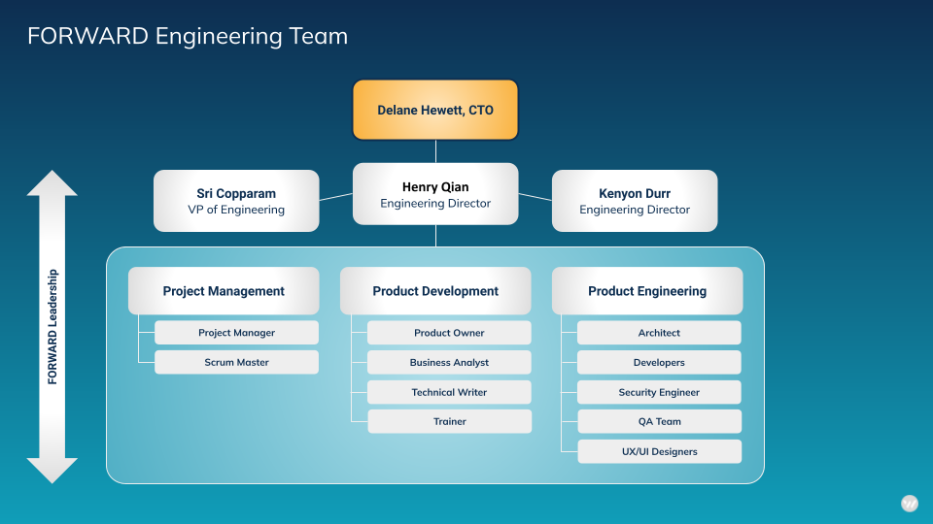

Name/Title | Number of Years of Experience | Programs Supported While at FORWARD | Responsibilities
Srivaths Copparam, VP of Engineering | 25 | FORWARD Sync on Microsoft Marketplace  NW Washington Disaster Relief Program  St. Louis Guaranteed Basic Income (GBI)  Philadelphia Real Estate Tax Relief Fund | The Vice President of Engineering oversees end-to-end software development, delivering high-quality custom platforms and applications. Collaborating with cross-functional teams, this role drives technical innovation, ensures strategic alignment with business objectives, and fosters a customer-centric approach to software development.
Henry Qian  Director of Product Management | 28 | FORWARD Sync on Microsoft Marketplace  DSHS Immigrant Relief Fund  St. Louis Guaranteed Basic Income (GBI)  Philadelphia Real Estate Tax Relief Fund  Long Beach First Time Home Buyer Assistance  LA Domestic Violence Survivors  LA Financial Coaching  Whatcom Long Term Recovery Group Case Manager  New York ESD Tourism  Gwinnett County Small Business Grants  Harris County, TX, Small Business Grants  City of Milpitas Microenterprise Assistance Program | The Director of Product Management leads the technical product and program management team and is responsible for defining the FORWARD platform’s product roadmap and strategy, managing product releases to align with business strategy, and meeting customer needs.
Kenyon Durr, Engineering Director | 18 | FORWARD Sync on Microsoft Marketplace  St. Louis Guaranteed Basic Income (GBI)  Philadelphia Real Estate Tax Relief Fund  Long Beach First Time Home Buyer Assistance  LA Domestic Violence Survivors  LA Financial Coaching  Whatcom Long Term Recovery Group Case Manager  New York ESD Tourism  Gwinnett County Small Business Grants  Harris County, TX, Small Business Grants  City of Milpitas Microenterprise Assistance Program | The Engineering Director actively leads and guides the engineering team in executing end-to-end software development, consistently delivering high-quality custom platforms and applications. This role involves collaborative efforts with cross-functional teams, driving technical innovation, aligning strategies with business objectives, and instilling a customer-centric approach within the software development process.
Greg White  Senior Software Engineer | 18 | FORWARD Sync on Microsoft Marketplace  Long Beach First Time Home Buyer Assistance  Whatcom Long Term Recovery Group Case Management  LA Domestic Violence Survivors  LA Financial Coaching  New York ESD Tourism  Gwinnett County Small Business Grants  Harris County, TX, Small Business Grants  St. Louis Guaranteed Basic Income (GBI)  Philadelphia Real Estate Tax Relief Fund  City of Milpitas Microenterprise Assistance Program | The Senior Software Engineer leads the design, development, and delivery of cutting-edge software solutions. The position also actively participates in cross-functional collaborations, implements best practices, and contributes to the success of complex projects.
Joyce Farrell  Managing Staff Engineer | 24 | FORWARD Sync on Microsoft Marketplace  St. Louis Guaranteed Basic Income (GBI)  Philadelphia Real Estate Tax Relief Fund  Whatcom Long Term Recovery Group Case Manager  Gwinnett County Small Business Grants  Harris County, TX, Small Business Grants  City of Milpitas Microenterprise Assistance Program | The Managing Staff Engineer leads comprehensive software development initiatives, spearheading technical excellence within the team. The position also guides and mentors engineering professionals, ensuring a steadfast commitment to delivering high-quality results.
Shelby Isa/Sr. Backend Engineer | 9 | Long Beach First Time Home Buyer Assistance  Whatcom Long Term Recovery Group Case Management  LA Domestic Violence Survivors  LA Financial Coaching  New York ESD Tourism  Gwinnett County Small Business Grants  Harris County, TX, Small Business Grants  St. Louis Guaranteed Basic Income (GBI)  Philadelphia Real Estate Tax Relief Fund  FORWARD Sync on Microsoft Marketplace  City of Milpitas Microenterprise Assistance Program | The Senior Backend Engineer leads the design and developing robust backend solutions, leveraging expertise to actively contribute to the end-to-end software development process. The position also delivers scalable and efficient systems to meet project requirements.
Dirk Keamy, Sr. Engineer Manager | 24 | LA Domestic Violence  LA Financial Coaching  NY Tourism ESD  Gwinnett County Small Business Grants  Harris County, TX, Small Business Grants  St. Louis Guaranteed Basic Income (GBI)  Philadelphia Real Estate Tax Relief Fund  FORWARD Sync on Microsoft Marketplace | The Senior Engineer Manager performs a key leadership role by overseeing and mentoring a team of engineers. They conduct strategic planning, allocate resources, and actively ensure the successful execution of software development projects while fostering a collaborative and high-performance team culture. The position also manages software testing and assesses security.
Francesco Pesotti / Senior UX Designer | 14 | LA Inside Safe  State of Tennessee, Self-Sufficiency Navigator  Washington State – Cannabis RFP  Long Beach – Case management  Indiana State – Energy Savings Rebate program  Massachusetts – LIHEAP Program  Washington State – ORIA  NYC – MyCity Payment Solution  FORWARD Sync Zendesk | The Senior UX Designer drives user-centered design strategies to create seamless and intuitive experiences for products. They collaborate closely with cross-functional teams, leading the crafting of compelling user interfaces, and championing the integration of user-centric principles throughout the design process.

M | Please identify the key personnel your company will utilize in performing this contract. Please ensure your answer specifies the number of and identifies the personnel who will be serving as project manager(s) for this contract. Please note that if awarded a Contract, Bidder shall not make changes to such Key Personnel during the term of this contract except as requested or approved by DSHS. | 5
ANSWER:
The FORWARD solution employs a team of qualified organization leaders, domain experts, and support staff with extensive experience, depth of expertise, and demonstrated capacity to support administration, operations, and customer services for the program. This team has demonstrated experience and expertise in program administration, communications, implementation, launch, operations, and management, having launched and worked on other assistance programs for households facing a housing crisis.
FORWARD will make every effort to mitigate changes in the project team composition over the life of the contract. Any necessary substitutions/changes in project team members will be discussed with DSHS with as much advance notice as possible. DSHS will have the opportunity to review and approve substitutions prior to their starting work on the program. If DSHS feels that a project team member is not performing according to contractual requirements, FORWARD will first first coach and counsel the team member to resolve the issue; if necessary, we will work to find a suitable replacement.

Name/Title | Number of Years Experience in Housing Programs | Responsibilities
Tahmina Martelly, Director, Client Services | 20+ | Project Manager: Oversees program strategy and execution, ensuring alignment with organizational goals and effective collaboration with DSHS.
Amanda Kopchynski, Senior Program Manager | 15 | Leads program development, implementation, and evaluation, managing staff and ensuring compliance with DSHS requirements.
Leandro Lessin, Associate Program Manager | 5 | Supports the Senior Program Manager in daily operations, stakeholder coordination, and program initiative execution.
Andy Olson, Program Manager | 10+ | Manages the overall development, implementation, and evaluation of the program, overseeing staff, coordinating stakeholder engagement, and ensuring compliance with program requirements.
Khayam Ahmadi, Associate Program Manager | 2 | Supports the Senior Program Manager in daily operations, stakeholder coordination, and program initiative execution.
Laura Todd, Intake & Review | 5 | Conducts secondary review of housing assistance applications from CBOs, ensuring accuracy and eligibility.
Blanca Salamym Intake & Review | 2 | Conducts secondary review of housing assistance applications from CBOs, ensuring accuracy and eligibility.
Mercedes Bradford, Landlord Specialist | 7 | Facilitates communication between participants and landlords, ensuring smooth payment disbursement and addressing landlord concerns.
Alejandra Luna, Team Lead | 6 | Supervises Intake & Review staff, providing leadership and training for consistent and efficient application reviews.
Khayam Ahmadi, Customer Support | 2 | Assists and trains Community-Based Organizations (CBOs) for efficient participation in the program.

About Tahmina Martelly: (Project Manager) Champion for Immigrant Communities and Innovative Program Architect
Tahmina Martelly, a trailblazing advocate for immigrant communities, brings over three decades of dynamic experience to her role as the leader of FORWARD's administration of DSHS’s Housing Stabilization Program.
Tahmina 's journey began with hope as an asylum grantee in 1986, marking the inception of a lifelong commitment to transforming the lives of immigrant communities. Her role as the driving force behind FORWARD's solution is not just a job—it's a calling fueled by passion, compassion, and unwavering dedication.
In the sprawling landscape of public health and community development, Tahmina's impact is nothing short of profound. Her years with the state of Utah saw the creation of statewide programs promoting healthy living and chronic disease prevention. Tahmina's initiatives touched the lives of countless individuals, creating a ripple effect of positive change that extended to every corner of the state.
Tahmina's story takes a poignant turn with her work at the International Rescue Committee and World Relief, where she became a lifeline for thousands of resettled individuals each year. Through her tireless efforts, she crafted programs addressing the unique challenges faced by newcomers—programs that went beyond conventional assistance to touch the very heart of the immigrant experience.
World Relief became a canvas for Tahmina's visionary projects, and it was there that she etched a tale of resilience and empowerment. The green stormwater infrastructure she pioneered became not just a symbol of environmental sustainability but a living testament to the strength and unity of refugee families. This initiative, featured on NBC's Today Show, showcased Tahmina's ability to blend innovation with compassion.
Yet, it's not just the grand projects that define Tahmina's legacy; it's the sewing program for pre-literate Afghan women, the teaching commercial kitchen fostering skills and independence, and the refugee youth summer camp that became a sanctuary for learning and belonging. Tahmina's heartstrings are intricately woven into every program she has championed, ensuring that each initiative is not just a statistic but a narrative of hope, resilience, and human connection.
As a compassionate advocate, Tahmina's impact extends beyond the professional realm. At the University of Utah, she taught not only the anthropology of nutrition but also the profound cultural aspects of food, connecting people and fostering understanding. Her mission is not merely to dream and build; it's to touch lives, bring solace to the weary, and create spaces where the immigrant story is one of triumph.
Tahmina's leadership is more than a title—it's a promise to continue weaving a tapestry of compassion, innovation, and advocacy for immigrant communities. In her, FORWARD has found not just a leader but a soulful storyteller and a compassionate advocate whose journey is etched in the very fabric of hope.

6 | BIDDER’s SOLUTION AND PROPOSED APPROACH (TECHNICAL RESPONSE) | MAXIMUM TOTAL POINTS: 115
A | Please describe your company’s plan to build and host the Housing Stabilization Services application. Please highlight how you will:  - Develop the application content.  - Utilize and implement a computer-based system to manage and protect client data.  - Develop and implement a standardized eligibility determination process.  - Develop and implement an application review process.  - Implement a payment distribution system.  - Provide application and payment support to applicants.  - Any other relevant information  - Clearly outline if your organization will subcontract services with third parties and provide their role in this project. | 20
ANSWER:
FORWARD's plan to build and host the Housing Stabilization Services application for DSHS is comprehensive and designed in a six-phased approach to ensure a user-friendly, secure, and efficient process, all contained within the existing FORWARD Platform.
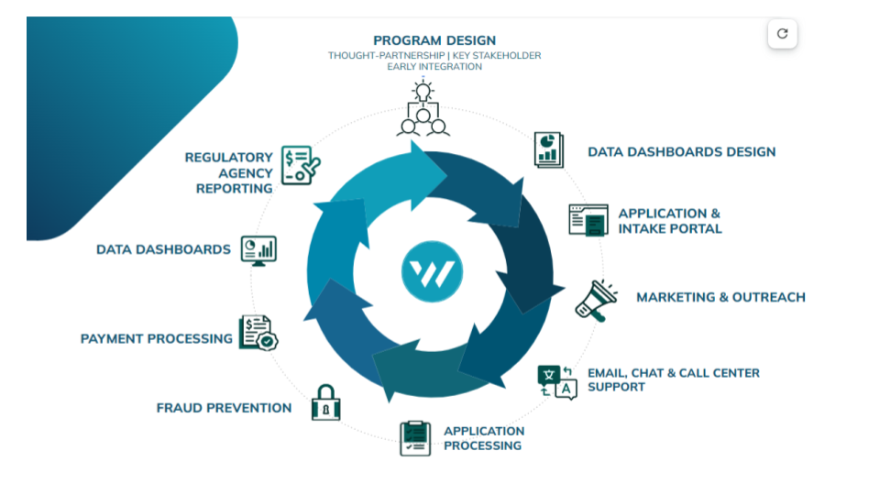

Deliverables:
- An accessible online application platform (3.a)
- Language accessibility (3.a.i.)
- DSHS-ORIA access (3.a.ii.)
- Centralized applications (3.b.)

FORWARD's existing platform provides a robust foundation for building and hosting the Housing Stabilization Services application, delivering on the specified requirements outlined by DSHS-ORIA. Leveraging our live platform, FORWARD will provide the following:
- Accessible Online Application Platform: FORWARD's centralized computer-based and mobile-friendly system is designed to facilitate online applications for rental assistance and emergency eviction prevention. Our platform supports application submissions, eligibility determination, status tracking, communication, prioritization scoring, and a comprehensive dashboard with program updates and reports.
- Language Accessibility: The application is accessible in multiple languages, including Arabic, Dari, English, Pashto, Ukrainian, Russian, Spanish, and Somali. This multilingual capability ensures that DSHS-ORIA HSS contractors can engage with the platform in the language most comfortable for the participants, enhancing accessibility and inclusivity.
- Unique Contractor Access: DSHS-ORIA HSS contractors will have unique and secure access to the platform, enabling them to complete applications, make updates, and monitor the status of applications and rental assistance disbursements. This tailored access ensures efficient collaboration and streamlined communication between contractors and the system.
- Collaborative Development: FORWARD commits to partnering with DSHS and its partnering CBOs during the application development process. Seeking feedback and input from key stakeholders ensures that the application content aligns with the program's objectives and meets the specific needs of the target population. All components of the application will be pre approved by DSHS-ORIA before the official launch.
- Pre-Approval and Compliance: The proposed system will undergo pre-approval processes with DSHS and the Office of the Chief Information Office to ensure alignment with state-specified standards for data security and retention. FORWARD is committed to meeting and exceeding these standards, providing a secure and compliant platform for the HSS application.

Phase 1: Project Initiation and Planning

Deliverables:
- A standardized eligibility determination process (3.c.)
- Prioritization scoring tool (3.e.)

- Kickoff Meeting and Needs Assessment:
  - Conduct a kickoff meeting with key stakeholders from DSHS to align expectations and gather specific program requirements.
  - Perform a comprehensive needs assessment to identify critical components for the Housing Stabilization Services program.
  - Establish milestones and deliverables for the development and implementation process.
- Collaborative Program Design:
  - Engage in collaborative sessions with DSHS and partnering CBOs to co-design the program, outlining key features, eligibility criteria, and desired outcomes.

Creation of Scoring Rubric and Prioritization Tool:
FORWARD recognizes the importance of a comprehensive scoring rubric and prioritization tool to effectively categorize and prioritize applications for payment approval. The process involves collaborative development with valuable input from DSHS and the twelve partner Community-Based Organizations (CBOs) who possess deep insights into the specific needs of the population.
- Partner-CBO Collaboration:
  - Engage in extensive collaboration with partner CBOs to gather insights into the unique challenges and highest needs of the population served.
  - Leverage the expertise and lived experiences of CBOs to identify key metrics and criteria that accurately reflect the priorities of applicants.
  - Collaborate closely with CBOs and DSHS to tailor culturally sensitive and appropriate messaging for emails, texts, and notifications sent to tenants and caseworkers, ensuring effective communication aligned with diverse cultural contexts.
- Metrics Alignment:
  - Ensure alignment of the scoring rubric with the metrics outlined in the scope of the project.
  - Incorporate key indicators that directly correlate with the greatest needs of applicants, as identified in consultation with partner CBOs.
  - Provide dashboards reflecting program performance from the inception, through completion across a spectrum of insights; Application and workflow process volumes and movements, Demographic/equity/opportunity analysis, Location/Map-based visualizations, Needs assessments, Referrals, Rubric payout distributions.
  - Ability to export raw PII-abstracted/anonymized data for external organizations
  - Ability for Internal dashboards as well as Public-facing dashboards
- Equity and Inclusivity:
  - Prioritize equity and inclusivity by incorporating diverse perspectives into the development process.
  - Implement measures to prevent bias and ensure fair assessment, considering the varied circumstances and challenges faced by applicants.
- Transparent Scoring Criteria:
  - Develop a transparent scoring criteria document that clearly outlines the factors influencing the priority ranking of applications.
  - Provide detailed guidelines to ensure consistency and clarity in the application of the rubric by both FORWARD and partner CBOs.
- Regular Feedback Loop:
  - Establish a continuous feedback loop with partner CBOs throughout the rubric development process.
  - Iterate and refine the scoring rubric based on ongoing input and insights from CBOs to ensure its effectiveness in capturing genuine needs.
- Adaptive Approach:
  - Adopt an adaptive approach, allowing for adjustments to the scoring rubric based on real-time feedback, program evolution, and changing community dynamics.
By engaging closely with partner CBOs, FORWARD aims to create a scoring rubric and prioritization tool that not only aligns with the project scope but also authentically reflects the urgent needs of the population served.

Phase 2: Application Development

Deliverables:
- Centralized applications (3.b.)

FORWARD's system implementation for the DSHS ORIA Housing Stabilization program is a comprehensive solution designed to cater to various aspects of the program. The installation involves deploying several key components to ensure a seamless and effective platform. Here's a breakdown of the system components:
- Application System:
  - The core of our implementation is the online application within the FORWARD platform. This component is accessible to caseworkers from the twelve partnering CBOs and ensures a standardized and centralized process for applying for rental assistance and emergency eviction prevention.
  - The application system includes multi-language support (Arabic, Dari, English, Pashto, Ukrainian, Russian, Spanish, Somali, etc.) to cater to the diverse linguistic needs of participants.
- Phone Support Line:
  - We implement a dedicated phone support line in multiple languages to provide immediate assistance to participants and caseworkers. This component facilitates real-time communication, allowing inquiries, concerns, and support requests to be addressed promptly.
- Landing Page:
  - A user-friendly landing page is created to serve as the entry point for both caseworkers and participants. The landing page provides essential information, program updates, and quick access to relevant resources.
- Educational Resources (FAQ, Videos, Training Materials):
  - The implementation includes a comprehensive repository of educational resources. Frequently Asked Questions (FAQs), instructional videos, and training materials are made available to guide both caseworkers and participants through the application process, platform functionalities, and program requirements.
- Dashboard and Reporting Tools:
  - A dashboard is implemented to offer real-time insights into the progress of the program. Reporting tools provide DSHS-ORIA with key performance indicators, achievements, and any challenges encountered, fostering transparency and informed decision-making.
- Communication Hub:
  - The platform serves as a communication hub, facilitating seamless interactions between caseworkers, participants, and the review team. Features include messaging functionalities in multiple languages and notifications to keep all parties informed about application status and updates.

The FORWARD platform excels in centralizing the application process among the partnering CBOs, fostering collaboration and efficiency. Through the unified and centralized FORWARD platform, all CBOs will have access to the single approved application, mitigating the risk of duplicated services and ensuring a streamlined review process. This centralized approach not only enhances transparency but also simplifies the participant's journey, as they can access resources seamlessly, regardless of the specific CBO they engage with.
FORWARD will elevate the application development process by incorporating valuable insights from our partner Community-Based Organizations (CBOs) to ensure cultural sensitivity and responsiveness to the diverse needs of the population. Additionally, the application will prioritize accessibility by being available in the required languages, including Arabic, Dari, English, Pashto, Ukrainian, Russian, Spanish, Somali, and more, fostering inclusivity and broad participation.
- Co-design application with DSHS and CBO partners
  - Collaborative Workshops: Initiate collaborative workshops with CBO representatives to gather input on the design and structure of the application.
  - Feedback Sessions: Actively seek feedback from CBOs regarding the application's layout, content, and functionality to ensure alignment with the unique cultural nuances and preferences of the target population.
  - Iterative Design Process: Engage in an iterative design process where CBOs play a crucial role in shaping the application's user interface, navigation, and overall user experience.
- Multilingual Accessibility:
  - Language Inclusive Design: Implement a language-inclusive design approach to cater to the linguistic diversity of the community, including Arabic, Dari, English, Pashto, Ukrainian, Russian, Spanish, Somali.
  - Translation Services: Collaborate with professional translation services to accurately translate application content into the required languages, ensuring clarity and cultural appropriateness.
  - Support line: offer multi-lingual services through the FORWARD communications center.
- Content Development by Multidisciplinary Team:
  - Assembling Expertise: Assemble a multidisciplinary team comprising language specialists, cultural experts, and user experience designers to collaboratively develop comprehensive application content.
  - Alignment with Program Objectives: Ensure that the application content is strategically aligned with the objectives outlined by DSHS-ORIA, reflecting the program's goals and guidelines.

The application interface within the FORWARD platform will be user-friendly, guiding partner CBOs through the submission process and allowing secure documentation uploads. By integrating CBO input and addressing multilingual accessibility, FORWARD aims to develop an application that not only meets program requirements but also resonates with the community it serves, fostering a sense of inclusivity and user empowerment.

Phase 3: Eligibility Determination

Deliverables:
- A standardized eligibility determination process (3.c.)

Development and Implementation:
FORWARD's commitment to a transparent, efficient, and aligned eligibility determination process begins with the development and implementation of a standardized workflow within the FORWARD platform. This entails creating a dynamic application workflow that seamlessly manages the entire eligibility determination process. Our goal is to ensure that the process adheres strictly to program guidelines, aligning with the criteria set forth during the program's design phase.
- Workflow Management:
  - The application workflow is meticulously designed to capture all necessary information for eligibility assessment. This includes essential data points such as income, household size, and documentation requirements.
  - Each step in the workflow is mapped out to facilitate a logical and systematic progression from application submission to eligibility determination. This ensures that all applications undergo a consistent and thorough evaluation from all partnering CBOs entering data.
- Transparency and Efficiency:
  - The eligibility determination process is engineered to be transparent, providing clear visibility into how applications move through the system.
  - Automation features within the workflow enhance efficiency by automating routine tasks, allowing caseworkers to focus on critical decision-making aspects and applicant support.
- Alignment with Program Guidelines:
  - FORWARD collaborates closely with DSHS-ORIA and the partnering CBOs to align the eligibility determination process with the established program guidelines.

Training and Documentation:
FORWARD takes an educational approach by providing comprehensive training sessions for DSHS-ORIA staff and CBOs involved in the eligibility determination process. These sessions cover the intricacies of the workflow, emphasizing key criteria, decision points, and any nuances specific to the program.

FORWARD's approach to standardized eligibility determination is rooted in collaboration, transparency, and efficiency. The FORWARD platform becomes a tool that empowers caseworkers and ensures a fair and consistent evaluation process for applicants across diverse communities.

Phase 4: Application Review

Deliverables:
- Application review process (3.d.)

- Review Process Implementation:
  - Design and implement a streamlined application review process, integrating best practices and lessons learned.
  - Conduct training sessions for staff and CBOs involved in the review process.
- Quality Assurance and Continuous Improvement:
  - Establish quality assurance measures to ensure the accuracy and fairness of application reviews.
  - Implement mechanisms for continuous improvement based on feedback and performance metrics.
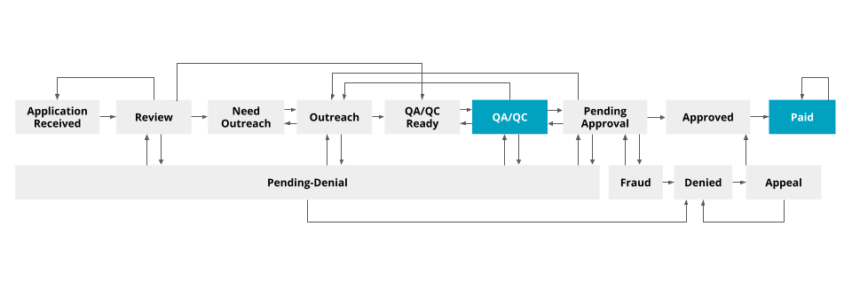
FORWARD helps CBOs and participants efficiently complete applications within the platform.
- Application Received: When a participant is determined eligible for the program, the CBO caseworker enters the household and landlord/payment information into the platform. The system can check across all partnering CBOs using name, email, or address to ensure the participant is not already receiving rental/utility assistance from a different CBO.
- Review/Outreach: If data or documents are missing from the application, the CBO casework staff are able to conduct outreach either to the applicant or the landlord by utilizing the embedded phone, email, and text capabilities of the platform.
- QA/QC Ready: When the documentation is complete, the workflow sends the information to a FORWARD reviewer to do a final check and approve payment.
- Pending Approval/Approved: After an application is approved, all applicants and CBO’s will receive decision notifications via platform and email, SMS or text.
- Paid: Applicants who have successfully passed the multi-step review and met eligibility criteria will receive an award notification and funds will be sent to the landlord or utility company directly. Applicants who did not pass the review and/or did not meet eligibility criteria will receive a denial notification. If during program design, it is decided that denials can be appealed, this notification will include instructions for filing an appeal.
Communication Center for Notifications:
Applicants and CBOs will receive decision notifications via the platform by text and email. This includes award notifications for successful applicants and denial notifications for those who do not meet eligibility criteria. The secure Communication Center consolidates all notifications, notes, and communications, creating a seamless and confidential way to track communication for each applicant.
Data Security and Privacy:
FORWARD places a strong emphasis on data security and privacy. The platform's role-based security measures protect critical and sensitive applicant information from unauthorized access. This ensures that the Payment Distribution System operates within a secure environment, instilling confidence in participants and stakeholders.
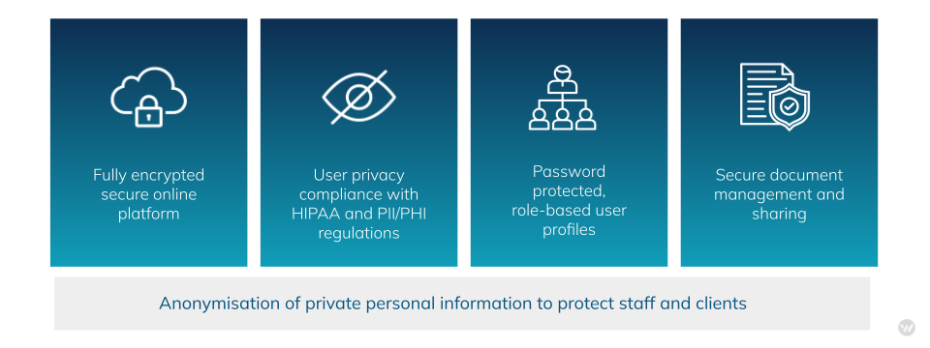

Phase 5: Payment Distribution System
- Payment Distribution Framework:
  - Implement a robust payment distribution system within the FORWARD platform, aligned with program objectives.
  - Conduct simulations and testing to validate the efficiency of the payment distribution process.
- Training and Support Mechanisms:
  - Develop comprehensive training materials for all stakeholders involved in the payment distribution system.
  - Establish a support system to address inquiries and provide assistance during the payment distribution phase.
FORWARD has designed a robust Payment Distribution System within the FORWARD Platform to ensure the timely and secure disbursement of funds for approved applicants. The system is built on principles of efficiency, transparency, and direct impact on housing stability.
Direct Payments to Landlords and Utility Companies:
Upon successful completion of the eligibility review, FORWARD facilitates direct payments to landlords and utility companies on behalf of participants. This direct payment mechanism is a strategic approach to swiftly address housing-related financial obligations and enhance the overall effectiveness of the Housing Stabilization Services program.
Real-time Tracking and Transparency:
All financial transactions are recorded and tracked in real-time within the FORWARD platform. This transparency allows participants, caseworkers, and partner CBOs to monitor the status of fund disbursements. Partnering CBOs applying on behalf of clients can access information about when payments are processed and anticipate when the funds will reach landlords or utility providers.
Mitigation of Administrative Barriers:
FORWARD will actively work with DSHS-ORIA to identify strategies that drive fair access across targeted communities while mitigating any administrative barriers to participation. This includes optimizing the Payment Distribution System to reduce delays and ensure a seamless flow of funds to recipients.

Financial Transparency and Security:
To uphold the highest standards of financial transparency and security, FORWARD is committed to maintaining separate bank accounts dedicated exclusively to the funds allocated for this program. This segregation ensures the complete avoidance of commingling with other funds, providing a clear and accountable financial structure. As part of our commitment to transparency, FORWARD will regularly provide banking reconciliations, offering a comprehensive view of financial transactions. Moreover, our strong and collaborative partnership with JPMorgan Chase enhances the program's security measures. FORWARD maintains a direct line of communication with the Chase Fraud department, ensuring prompt action and response in case of any potential security concerns. Additionally, our integration with Chase Bank systems further fortifies the security protocols, particularly in safeguarding the sensitive banking information of program awardees.

Phase 6: Ongoing Support, Reporting and Dashboards

Deliverables:
- Post-payment support (3.g.)
- Housing contractor support system (3.h.)
- Program integrity and fraud prevention process (3.i.)
- Reporting and Fiscal Administration (3.j.)

- Continuous Improvement:
  - FORWARD will implement a continuous improvement plan, collecting feedback from users and stakeholders to enhance the program's efficiency and user experience.
  - FORWARD will provide ongoing support for partnering CBOs, addressing inquiries related to both application submission and payment-related concerns.
  - FORWARD's communications center features an exceptional multi-lingual support line, providing participants with comprehensive assistance and information in their preferred language including Arabic, Dari, English, Pashto, Ukrainian, Russian, Spanish, and Somali, fostering inclusivity and accessibility.

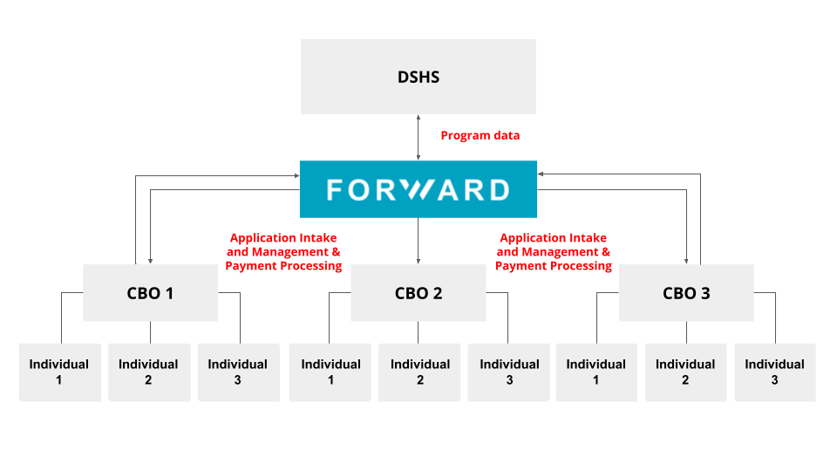Ongoing Application and Payment Support:
FORWARD will collaborate with the 12 Community-Based Organizations (CBOs) serving as key partners in the Housing Stabilization Services program. These CBOs handle the initial intake process, interacting directly with applicants and collecting essential information. This strategic partnership allows FORWARD to extend its reach into local communities through trusted channels.
Training and Support for CBOs:
Recognizing the pivotal role of partner CBOs, FORWARD provides extensive training and ongoing support to ensure the efficient use of the platform. Training sessions cover platform functionalities related to application submission, documentation upload, and communication tools within the FORWARD platform. This approach aims to streamline administrative tasks for CBOs, enabling them to dedicate more time to their core mission—assisting immigrant participants.

Transparent Tracking in the Platform:
All interactions, transactions, and progress are meticulously tracked within the FORWARD platform. Participants, partner CBOs, and caseworkers can access real-time updates on the status of applications, eligibility reviews, and fund disbursements. This transparency empowers participants to stay informed about the progress of their housing assistance and when payments are expected to reach landlords and utility providers.
Program Integrity and Fraud Prevention:
FORWARD's commitment to preventing duplicate applications and ensuring the credibility of landlords/companies is multifaceted. We employ a dedicated, full-time Fraud Subject Matter Expert who investigates suspected fraudulent cases and guides our recourse processes, ensuring thorough data collection and mitigation efforts. To prevent duplicate user accounts, we employ a stringent process that restricts the use of the same email address for multiple users, and if the participant does not have an email address, we use name and address checks to prevent duplicate payments.
Our application review process includes a comprehensive 10-point check to detect possible benefit duplication, complemented by advanced probabilistic models that flag cases for potential fraudulent activities. Leveraging a proven fraud detection engine, we process large-scale signals from diverse sources, including applications, devices, and banking. Real-time fraud checks are conducted using Microsoft's industry-leading cloud infrastructure, ensuring scalability to meet program needs.
In addition to automated fraud checking systems, we incorporate human reviewers in a hybrid process to provide nuanced understanding and insight. The FORWARD team, drawing on extensive experience, remains vigilant in deciphering, interpreting, and adhering to federal and state rules, regulations, and guidance. Continuous monitoring and compliance efforts, along with adherence to reporting and auditing requirements, underscore our commitment to program integrity and alignment with regulatory frameworks. Furthermore, our proactive approach involves staying abreast of any rule and guidance adjustments, ensuring ongoing responsiveness to evolving program needs. This comprehensive strategy ensures the highest standards of integrity and compliance within the DSHS Housing Stabilization program.

Reporting and Dashboard Implementation:
FORWARD is committed to meeting the reporting and fiscal administration requirements outlined by DSHS for the Housing Stabilization program.

- Monthly Rental Assistance Client Data Reports:
  - FORWARD will generate detailed monthly reports on rental assistance clients, including application status, approval, denial, and demographic data.
  - The reports will be formatted according to DSHS specifications, providing a comprehensive overview of program metrics and participant characteristics.
  - Reports will be securely delivered to DSHS through an approved portal, ensuring the confidentiality of client information.
Ongoing Emergency Eviction Client Data Reports:
  - Similar to rental assistance reports, FORWARD will provide monthly data reports on emergency eviction prevention clients, covering application outcomes, demographic information, and any relevant metrics specified by DSHS.
  - These reports will be securely transmitted to DSHS through a designated portal, in compliance with privacy and confidentiality standards.
Project Progress Dashboard:
  - FORWARD will maintain and update a dynamic Project Progress Dashboard on a monthly basis.
  - The dashboard will include key performance indicators such as the total number of applications received and processed, rental assistance and eviction prevention payments made, applicant demographics, and third-party vendor information.
  - This real-time dashboard will serve as a visual tool for DSHS to monitor program progress and outcomes.
Final Report:
  - At the conclusion of the program, FORWARD will submit a comprehensive final report to DSHS.
  - The narrative section will provide insights into successes, challenges, and opportunities for improvement, offering a qualitative overview of program implementation.
  - The numerical section will include detailed statistics on applications submitted, approved, denied, and demographic data, ensuring a comprehensive overview of program impact.
Electronic Reporting and Confidentiality:
  - All reports containing client data will be submitted electronically through a secure portal, meeting DSHS's confidentiality and security standards.
  - FORWARD will implement robust internal policies to safeguard client confidentiality, ensuring privacy and compliance with all privacy regulations.

Through these measures, FORWARD aims to provide DSHS with transparent, accurate, and secure reporting, enabling effective oversight and evaluation of the Housing Stabilization program.

Other Relevant Information:
Centralized Communication Hub:
FORWARD's communications center deserves special note, as it serves as a centralized hub, replacing email and other non-centric channels. It unifies all communication within the platform, offering real-time messaging (including texting), document sharing, and collaboration features. By eliminating information silos, providing audit trails, and ensuring secure internal messaging, FORWARD streamlines and secures participant engagement, promoting efficiency and accountability. Our approach encompasses the following features:
- Unified Document Delivery:
  - The communications center facilitates the issuance of crucial documents, such as application letters, warning letters, terminations, and approval letters.
  - Documents are generated and distributed seamlessly through the platform, ensuring consistency and accuracy.
- Real-Time Notifications:
  - Participants, including landlords and households, receive real-time notifications about the status of their applications, renewals, or any relevant updates.
- Secure Message Processing:
  - Emphasizing data security, the communication center employs encrypted channels for the delivery of sensitive information and documents.
  - Secure transmission ensures the confidentiality of communications, aligning with privacy standards.
- User-Friendly Interface:
  - Participants can access the communication center through a user-friendly interface, promoting ease of use and accessibility. Phone numbers and email addresses are hidden unless needed specifically for specific roles in administration.
  - Intuitive design enhances the overall participant experience, fostering engagement and understanding.
- Historical Communication Tracking:
  - The platform archives all communication history within redundant encrypted cloud storage , allowing users to track and reference past interactions.
  - Historical data provides an audit trail and supports accountability in communication processes.

FORWARD's commitment to minimizing administrative burden extends to empowering partner CBOs with the tools, skills and knowledge needed to navigate the platform efficiently. This includes optimizing workflows, utilizing reporting features, and leveraging the Communications Center for effective outreach. Caseworkers no longer need to rely on personal email accounts for communication. The FORWARD platform serves as a centralized hub for all communication, enabling caseworkers to send and receive phone calls, texts, and messages—all within a secure and integrated environment. This consolidation of communication channels simplifies the user experience, reducing the need to navigate multiple platforms. The platform offers robust case note-taking features, providing caseworkers with a comprehensive tool to document and track participant interactions seamlessly. This functionality ensures that important details, updates, and milestones are recorded efficiently, enhancing communication and collaboration among team members. Furthermore, the platform's innovative multi-line feature facilitates effective communication by allowing the inclusion of interpreters or family members on a call line. The platform supports multilingual engagement but also provides a mechanism for recording and transcribing calls. These features not only ensure accurate record-keeping but also facilitates efficient case management. The ability to log interactions directly within the platform enhances accountability, transparency, and the overall organization of communication records. Supervisors or other caseworkers can be assigned to view or manage communication records, providing a collaborative environment. In cases where a household needs to be transferred or additional assistance is required, this feature allows for a smooth transition of communication responsibilities. Supervisors can easily step in to support ongoing cases or facilitate seamless transfers between caseworkers.
The goal is to enhance the overall experience for partner CBOs, allowing them to focus on what they do best - providing personalized support in the language of preference to participants without undue administrative complexities.
Subcontracting:
FORWARD does not plan to subcontract services with third parties for this project. All aspects of the application development, data management, eligibility determination, application review, payment distribution, and support will be handled by FORWARD's experienced and dedicated team.

B | Please describe how your company will develop and implement a single application that responds to rental assistance and emergency eviction prevention. Include the following information in your response:  - Description of the system/process to collect information.  - Description of the system/process used to review and process applications.  - Description of the system/process used to issue payments to landlords and/or utility companies. | 15
ANSWER:
FORWARD's platform ensures a streamlined and user-friendly process for collecting information from applicants seeking both rental assistance and emergency eviction prevention.
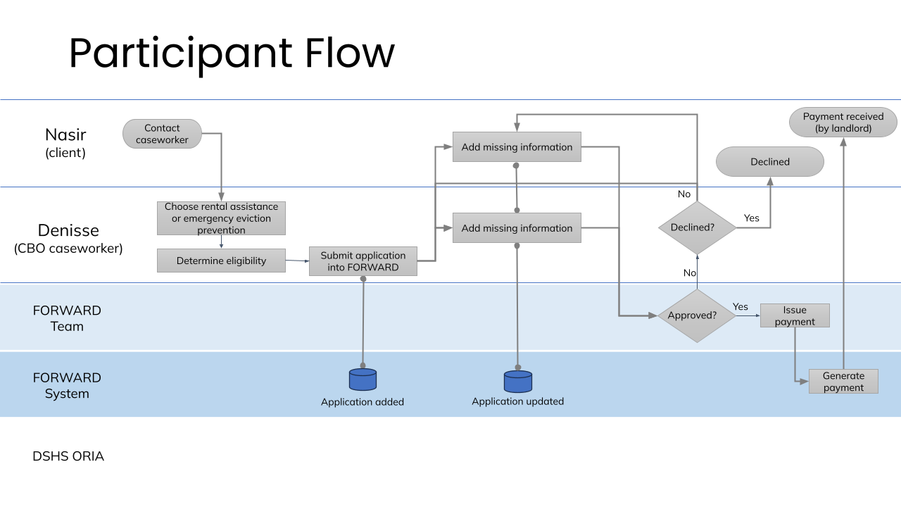

1. Information Collection System/Process:
The application interface within the FORWARD platform will guide applicants/assigned CBO caseworkers through the submission process. Caseworkers from partnering CBOs can efficiently collect necessary documentation, leveraging the user-friendly, guided submission interface. The system supports 24/7 access via desktop and mobile devices, enhancing accessibility for applicants.
Participant Journey:
Nasir, a recently arrived Afghan humanitarian parolee, faced a crisis when he required emergency surgery, rendering him unable to work for several months. As the sole earner for his family, Nasir reached out to his caseworker, Denisse, for assistance. Recognizing the diverse needs of Nasir and his family, Denisse initiated the process within the FORWARD platform to secure housing assistance through DSHS’s Housing Stabilization program.
Denisse enters Nasir's information, conducts a preliminary eligibility check, and informs Nasir about the next steps.
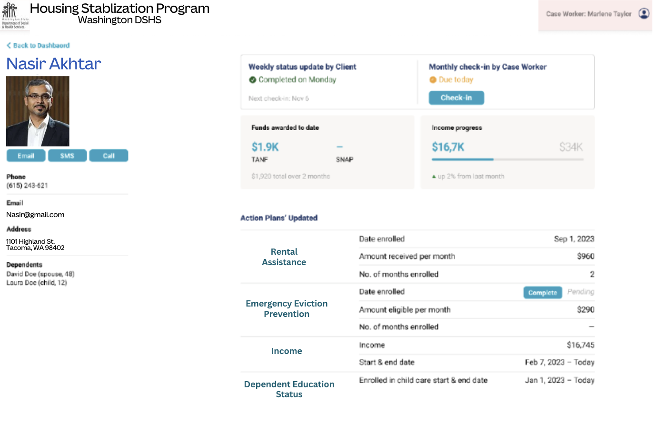

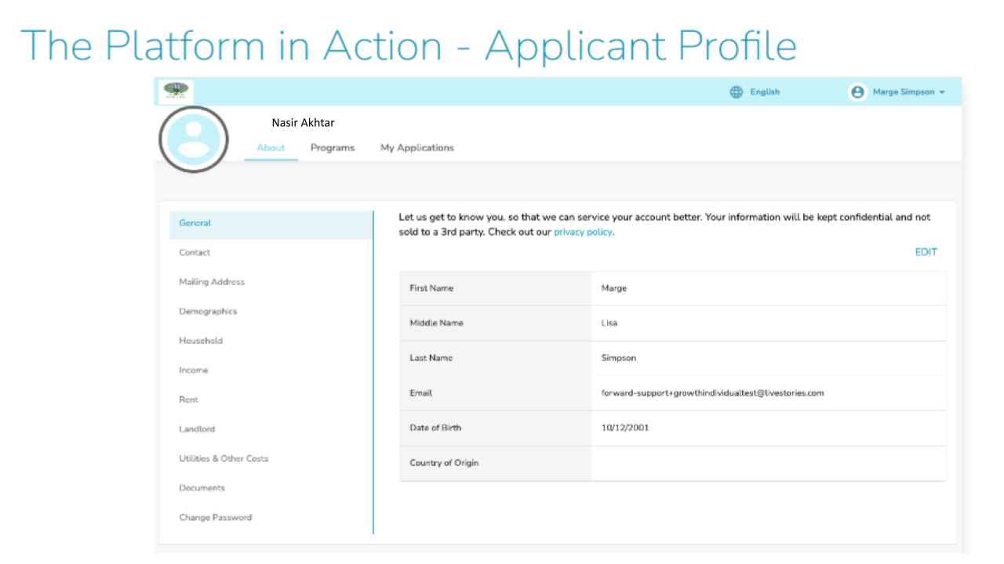

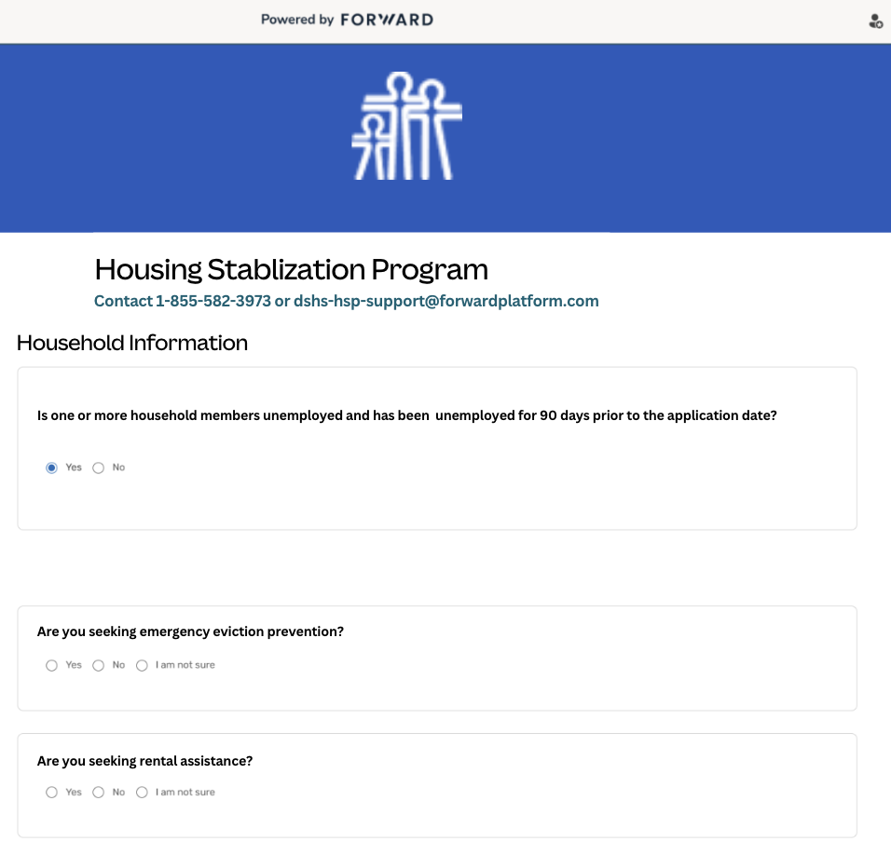

2. Application Review and Processing System/Process:
The FORWARD platform employs a multi-step review process, facilitated by caseworkers who use the system to assess the eligibility of applicants. Caseworkers leverage the standardized eligibility determination process established during program design. The system ensures that applications align with program requirements, and caseworkers can easily track and review the status of applications in real-time. The platform's role-based security enables supervisors or other caseworkers to provide assistance or oversight if needed, ensuring a collaborative and efficient review process.
Participant Journey:
Denisse, leveraging the FORWARD platform's capabilities, applies for the housing program on behalf of Nasir. The platform's user-friendly interface allows Denisse to seamlessly navigate the application process and upload the necessary documentation. Nasir, guided by Denisse, provides the required information, making the application process accessible and straightforward.
Nasir is able to take pictures of his required eligibility documentation without having to physically go back to the agency’s office. Denisse, using the FORWARD platform, guides Nasir through the document upload process, ensuring that all required information is securely submitted. Nasir’s documents are secure, as they are entered directly into the platform and not to a caseworker’s phone. If Nasir needs assistance, he can always bring documents to Denisse’s office. The FORWARD platform's simplicity makes the application journey collaborative and supportive. If Denisse notices any other missing information, she can simply text, call, or email Nasir through the platform to obtain it.
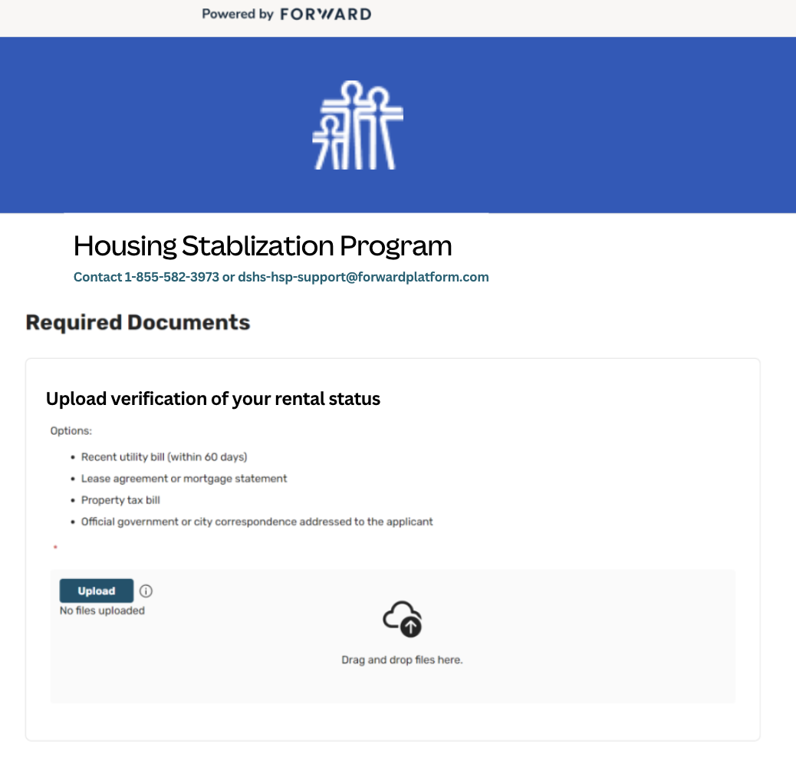

3. Payment Issuance System/Process:
To issue payments to landlords and utility companies, FORWARD's platform features a secure and efficient Payment Distribution System. Successful applicants receive decision notifications via the platform by text and email, including award notifications. Payments are made directly to landlords and utility providers, eliminating delays and enhancing the impact of assistance. The system tracks all financial transactions in real-time, providing transparency for participants and stakeholders. The process ensures that participants can monitor the status of their assistance and anticipate when payments will reach their housing providers.
Participant Journey:
Denisse shares the exciting news about the approval with Nasir through the FORWARD platform. The platform's communication features enable Denisse to reassure Nasir about the upcoming steps in the process including when payments will be made and in what amounts.

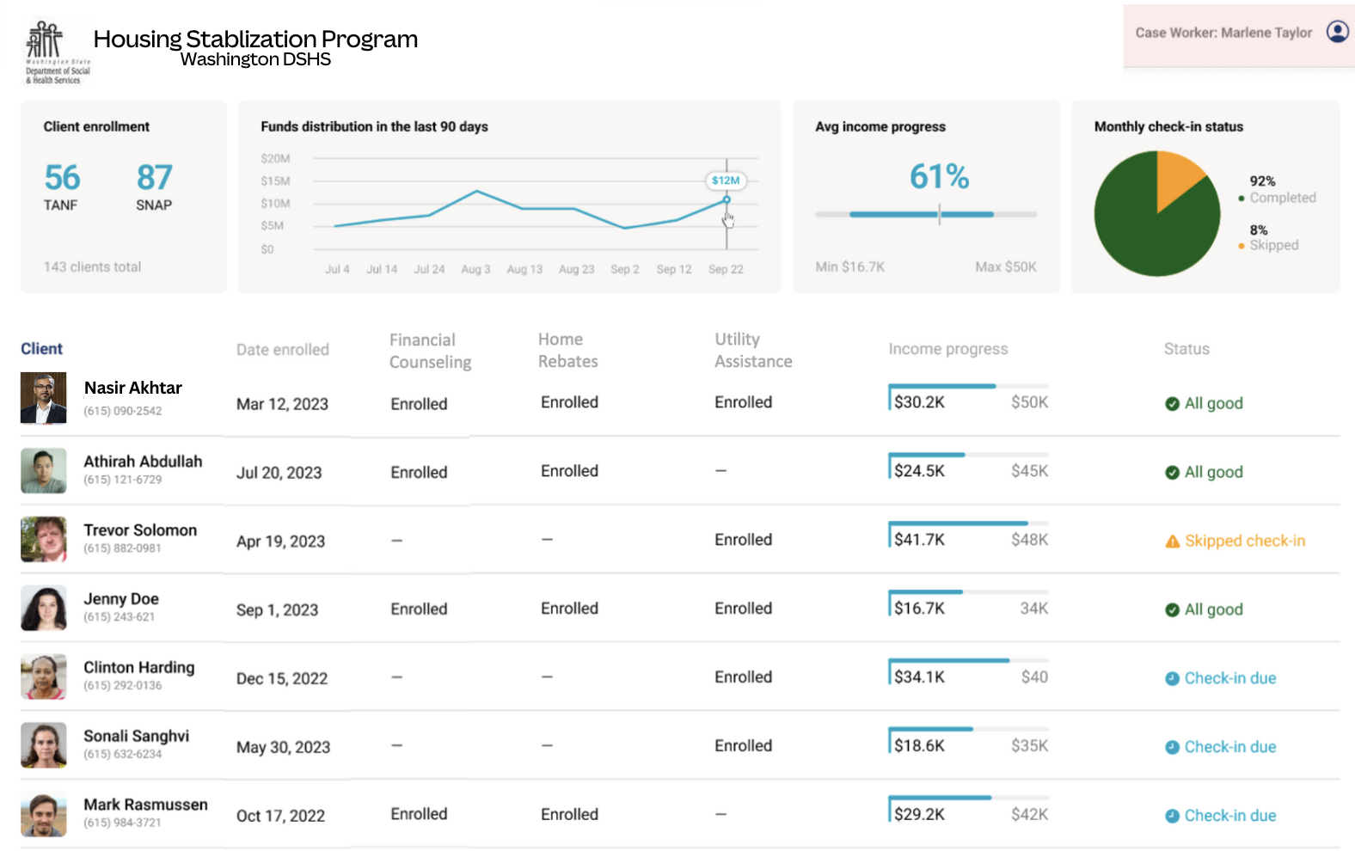

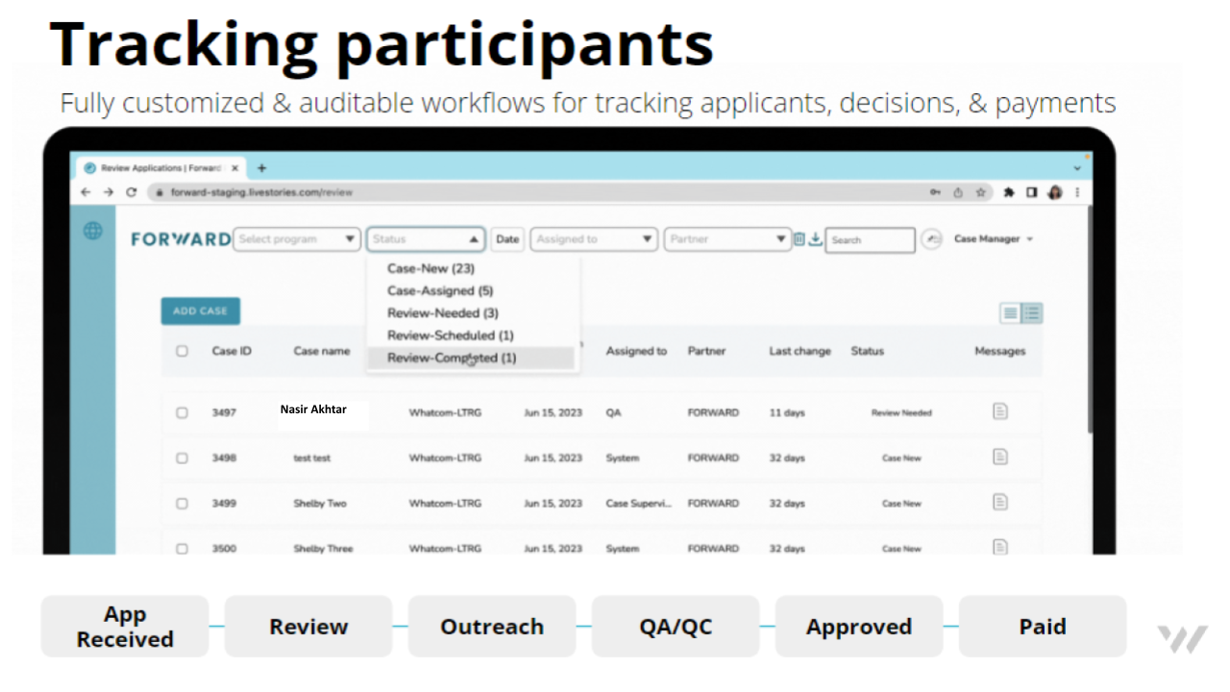

4. Progress Monitoring and Ongoing Support:
As the program unfolds, FORWARD takes a proactive approach to monitor progress and report regularly to DSHS. Simultaneously, ongoing support mechanisms are in place to address any inquiries participants may have regarding their applications or payments. Training sessions for DSHS staff and CBOs persist, ensuring everyone involved remains well-equipped to navigate the program effectively.
Participant Journey:
Nasir receives regular updates through the FORWARD platform, keeping him informed about the status of his application and payment disbursement. He appreciates the transparency and timely notifications, providing a sense of security in the program. Should Nasir have any inquiries or concerns, he utilizes the platform's communication features. Denisse, the CBO caseworker, actively engages with Nasir, addressing his questions and ensuring a smooth participant experience. If Denisse has any questions about the FORWARD platform’s capabilities or follow-up mechanisms, she can contact her assigned FORWARD Associate Program Manager. Denisse attends training sessions conducted by FORWARD staff to stay well-equipped in supporting participants like Nasir. These sessions enhance Denisse's ability to navigate the program effectively, ensuring optimal assistance to Nasir and others.

5. Program Integrity and Security:
Safeguarding participant data and maintaining program integrity are paramount. FORWARD implements robust systems to protect against fraud and unauthorized access. Continuous assessments and enhancements to security protocols occur, providing participants with the confidence that their information is handled with the utmost care.
Participant Journey:
Nasir receives clear communication from FORWARD about the robust security measures in place to protect his data. FORWARD conducts regular assessments and enhancements to security protocols.

6. Re-assessment and Continuous Improvement:
Recognizing that participants' needs may evolve, the program incorporates a re-assessment and follow-up mechanism. Periodic reviews consider changes in participants' circumstances, ensuring that the support remains aligned with their ongoing requirements. Additionally, FORWARD actively seeks feedback, facilitating continuous program optimization based on real-time data and participant experiences.
Participant Journey:
Periodic reviews of Nasir's needs and circumstances take place, ensuring the program remains aligned with his evolving requirements. FORWARD actively seeks feedback from Nasir through the platform, encouraging him to share experiences and suggestions. Nasir feels empowered, knowing his input contributes to the continuous improvement of the program.

7. Ongoing Program Support:
Participants and CBOs can rely on ongoing support from FORWARD, not only during the initial phases but throughout the program's duration. Any inquiries, concerns, or requests for assistance are promptly addressed. The platform remains a central hub for communication, allowing participants to stay informed and connected with the support they need.
Participant Journey:
Nasir experiences ongoing support from Denisse through the platform, with prompt assistance for any inquiries or concerns. The platform serves as a central hub for communication, providing a convenient way for Nasir to connect with the support he needs. Denisse continues to engage with Nasir, ensuring he feels supported throughout the program's duration. The collaborative effort between FORWARD and CBOs enhances the overall participant experience.

8. Future Program Enhancements:
In the spirit of adaptability, the program undergoes continuous optimization based on feedback, data analysis, and changing requirements. FORWARD remains committed to exploring opportunities for expansion or modification to enhance the program's effectiveness. This commitment ensures that the program evolves dynamically to better serve participants and meet the evolving landscape of their needs.

C | The successful bidder will need to prioritize applicants on a monthly basis for rental assistance while responding to emergency eviction prevention applications as they come in. Please describe how your company will determine applicant eligibility, including the criteria and processes utilized to prioritize applicants. | 15
ANSWER:

Creation of Scoring Rubric and Prioritization Tool:
FORWARD recognizes the importance of a comprehensive scoring rubric and prioritization tool to effectively categorize and prioritize applications for payment approval. Our team is dedicated to establishing a fair and transparent eligibility determination process, placing a strong emphasis on incorporating the expertise and lived experience of the twelve partnering Community-Based Organizations (CBOs). The process of prioritizing applicants on a monthly basis involves collaborative development with valuable input from DSHS and the partner CBOs.
- Partner-CBO Collaboration:
  - Engage in extensive collaboration with partner CBOs to gather insights into the unique challenges and highest needs of the population served.
  - Leverage the expertise and lived experiences of CBOs to identify key metrics and criteria that accurately reflect the priorities of applicants.
- Metrics Alignment:
  - Ensure alignment of the scoring rubric with the metrics outlined in the scope of the project.
  - Incorporate key indicators that directly correlate with the greatest needs of applicants, as identified in consultation with partner CBOs.
  - Provide dashboards reflecting program performance from the inception, through completion across a spectrum of insights; Application and workflow process volumes and movements, Demographic/equity/opportunity analysis, Location/Map-based visualizations, Needs assessments, Referrals, Rubric payout distributions.
  - Ability to export raw PII-abstracted/anonymized data for external organizations
  - Ability for Internal dashboards as well as Public-facing dashboards
- Equity and Inclusivity:
  - Prioritize equity and inclusivity by incorporating diverse perspectives into the development process.
  - Implement measures to prevent bias and ensure fair assessment, considering the varied circumstances and challenges faced by applicants.
- Transparent Scoring Criteria:
  - Develop a transparent scoring criteria document that clearly outlines the factors influencing the priority ranking of applications.
  - Provide detailed guidelines to ensure consistency and clarity in the application of the rubric by both FORWARD and partner CBOs.
- Regular Feedback Loop:
  - Establish a continuous feedback loop with partner CBOs throughout the rubric development process.
  - Iterate and refine the scoring rubric based on ongoing input and insights from CBOs to ensure its effectiveness in capturing genuine needs.
- Adaptive Approach:
  - Adopt an adaptive approach, allowing for adjustments to the scoring rubric based on real-time feedback, program evolution, and changing community dynamics.

The process will unfold as follows:
1. Criteria for Eligibility:
- Financial Need: FORWARD will assess financial need, taking into account factors such as income, household size, existing housing expenses, and number of months in arrearage.
- Imminent Eviction Threat: Priority will be given to applicants facing an immediate threat of eviction, acknowledging the urgency of their circumstances.
- Vulnerability: Vulnerable populations, including newly arrived immigrants, refugees, individuals with disabilities, and those with limited support networks, will be considered in the prioritization process.
2. Application Submission and Preliminary Check:
- CBO’s will submit applications on the behalf of applicants through the FORWARD platform.
- CBO caseworkers will conduct a preliminary eligibility check, leveraging both systematic criteria and community-specific insights.
3. Monthly Prioritization Process:
- A monthly review will be conducted to prioritize eligible applicants for rental assistance.
- The prioritization process will benefit from the input and expertise of partnering CBOs, who contribute insights from their own experiences and community knowledge.
4. Emergency Eviction Prevention Applications:
- Applications for emergency eviction prevention will be processed as they come in, with urgent cases expedited to address immediate crises.
- Partnering CBOs play a crucial role in identifying and flagging urgent cases based on their intimate understanding of community dynamics.
5. Collaboration with Partner CBOs:
- FORWARD recognizes the invaluable role of partnering CBOs in shaping the prioritization process.
- FORWARD will actively engage with the partner CBOs, seeking their input on either utilizing existing prioritization tools or collaboratively creating new ones tailored to the specific needs of the program.

This participant-centered approach underscores FORWARD's commitment to harnessing the expertise and lived experiences of our partnering CBOs, ensuring that the eligibility determination and prioritization process is not only systematic but also deeply rooted in the community it serves.

D | Please describe how your company will disburse payments to landlords and utility companies on behalf of qualified applicants. Please include the following details in your response:  - Provide an overview of the step by step process your company will follow for payment disbursement.  - Explain how you will verify the eligibility of applicants before disbursing funds.  - Explain how you will confirm the credibility of the landlords and/or utility company prior to payment disbursement.  - Specify timeframes for disbursing payments once applications are approved.  - Explain how you will provide transparency, updates, and reporting to DSHS-ORIA and the applicants regarding their payment. | 15
ANSWER:
FORWARD ensures a meticulous and transparent payment disbursement process, prioritizing efficiency, credibility verification, and timely communication.
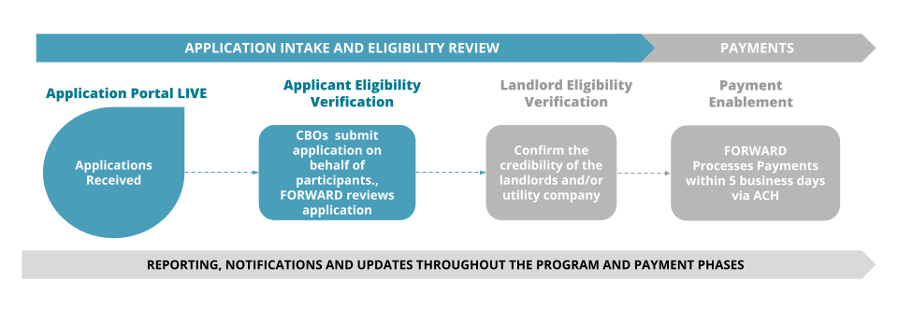
1. Eligibility Verification:
- Upon receiving applications from the twelve partnering CBOs, FORWARD initiates a thorough eligibility verification process.
- FORWARD intake specialists review submitted documentation, ensuring alignment with program requirements and eligibility criteria.
2. Secondary Eligibility Check:
- FORWARD conducts a secondary check to re-verify eligibility and completeness of the application, enhancing the accuracy of the verification process.
3. Landlord and Utility Company Verification:
- FORWARD staff collaborate with partnering CBOs to verify the credibility of landlords and utility companies by thoroughly reviewing documentation including rental agreements, utility bills, and official correspondence.
- The platform verifies the contact information provided for landlords and utility companies. This may include cross-referencing phone numbers and addresses to ensure they align with official records, adding an extra layer of confirmation.
- Document verification and cross-referencing with public records and reliable databases are conducted to confirm the legitimacy of payment recipients.
- FORWARD will verify all W9’s submitted by landlords prior to payments being made.
- FORWARD will conduct fraud checks on all applications prior to payments being made.
4. Payment Approval:
- Once eligibility and credibility checks are successfully completed, FORWARD approves the payment.
- The platform generates an electronic payment request, specifying the approved amount and recipient details.

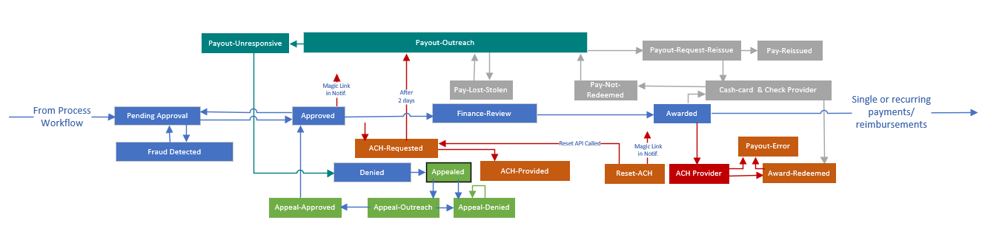

5. Disbursement to Landlords and Utility Companies:
- FORWARD ensures direct payment to verified landlords and utility companies within 7 business days of receiving an approved application.
- Payments are made through secure and reliable financial channels, prioritizing efficiency and accuracy.
6. Transparency and Updates:
- Throughout the process, applicants, partnering CBOs, and DSHS-ORIA will receive real-time updates through the FORWARD platform.
- Caseworkers use the platform's communication tools to notify applicants of payment approval, providing transparency and reassurance.
7. Reporting to DSHS-ORIA:
- FORWARD provides regular and comprehensive reports to DSHS-ORIA, highlighting the program's progress, achievements, and outcomes.
- The platform's reporting and analytics capabilities contribute to data-driven insights for program improvement.
8. Ongoing Communication:
- The FORWARD platform facilitates ongoing communication between caseworkers, applicants, and DSHS-ORIA.
- Caseworkers use the platform's Communication Center to address inquiries, provide updates, and ensure a seamless experience for all stakeholders.
9. Timely Notifications:
- Applicants receive notifications regarding the status of their payment through the FORWARD platform.
- The platform ensures timely updates, including confirmation of payment disbursement and relevant details.
10. Participant Access to Information:
- The FORWARD platform allows applicants to access a secure portal where they can track the status of their application, eligibility verification, and payment disbursement.
- This transparency fosters trust and empowers participants with real-time information.

FORWARD's payment disbursement process combines thorough eligibility verification, landlord/utility company credibility checks, timely disbursement, transparent communication, and comprehensive reporting. The platform's features are leveraged to ensure a seamless and accountable experience for applicants, partnering CBOs, and DSHS-ORIA. Our fraud prevention and financial controls serve to minimize instances where illegitimate payments are made and funds recapture is needed. A duplication of benefits check is performed for all applications during the eligibility process and before funds are disbursed. FORWARD also utilizes fraud prevention features from its banking partner JPMorgan Chase. In the event FORWARD finds error in a payment, FORWARD will:
- Issue a Stop Payment process for all check recipients
- Initiate a ACH recapture process for all ACH payments
- Contact DSHS-ORIA through established protocols for investigation/enforcement

E | Please describe how housing navigators will be able to securely interface with your application system to submit applications on behalf of applicants, as well as check application and grant funding status. Please ensure your response includes a description of the application system protocols in place to ensure that only authorized housing navigators at the request of an applicant, can access application data, status, and grant funding status. | 5
ANSWER:
FORWARD prioritizes the security and confidentiality of applicant information. The platform is designed to enable housing navigators to seamlessly interface with the application system while implementing robust protocols to safeguard data access. Here's how the process is structured:
1. Account Creation and Authorization:
- Housing navigators undergo a secure account creation process within the FORWARD platform.
- Authorization protocols are in place to ensure that only authorized housing navigators can access and submit applications on behalf of applicants.
2. Secure Authentication:
- Housing navigators utilize secure authentication methods, such as unique usernames and strong passwords, to access the FORWARD platform.
- Multi-factor authentication is employed to add an extra layer of security.
3. Role-Based Access Control:
- The FORWARD platform implements role-based access control, defining specific roles for housing navigators.
- Access privileges are carefully assigned to ensure that navigators can only view and modify the data relevant to their responsibilities.
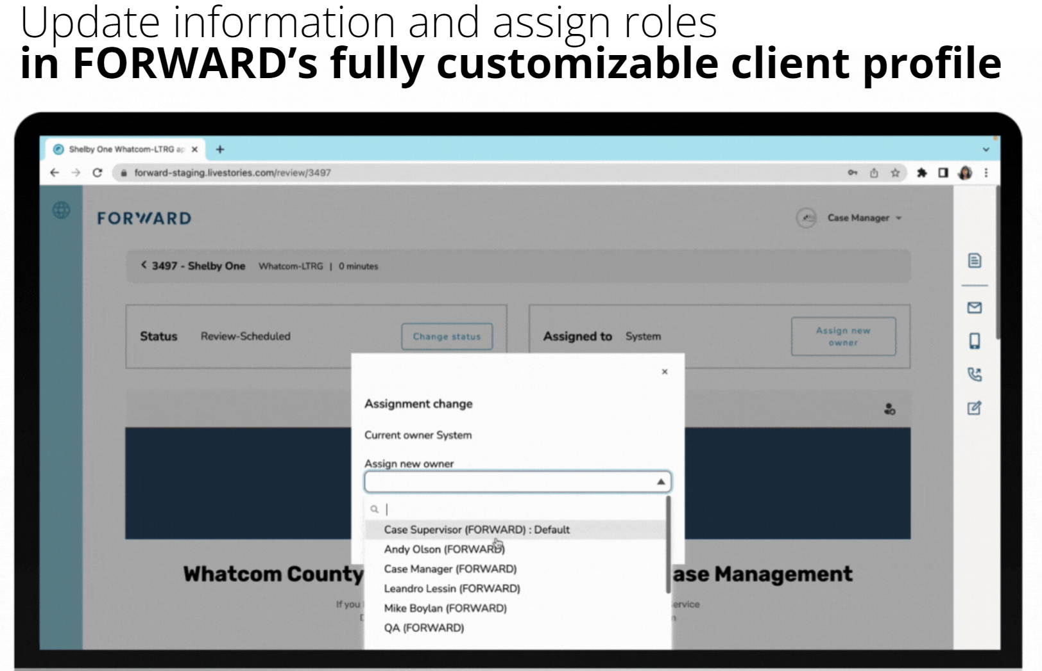

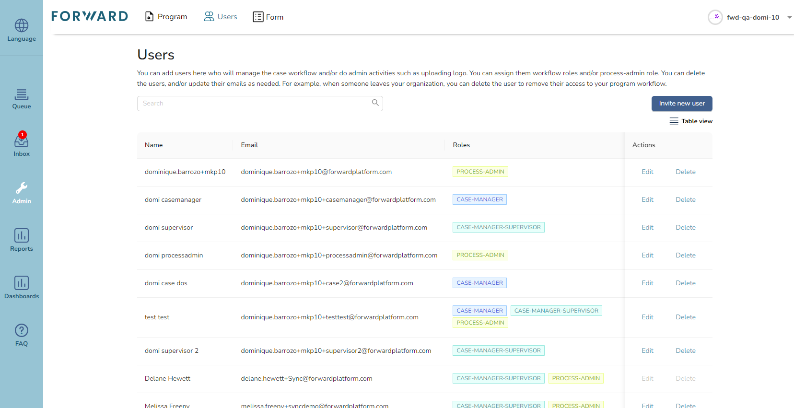

4. Secure Application Submission:
- Authorized housing navigators can initiate and submit applications on behalf of applicants through the secure application interface.
- 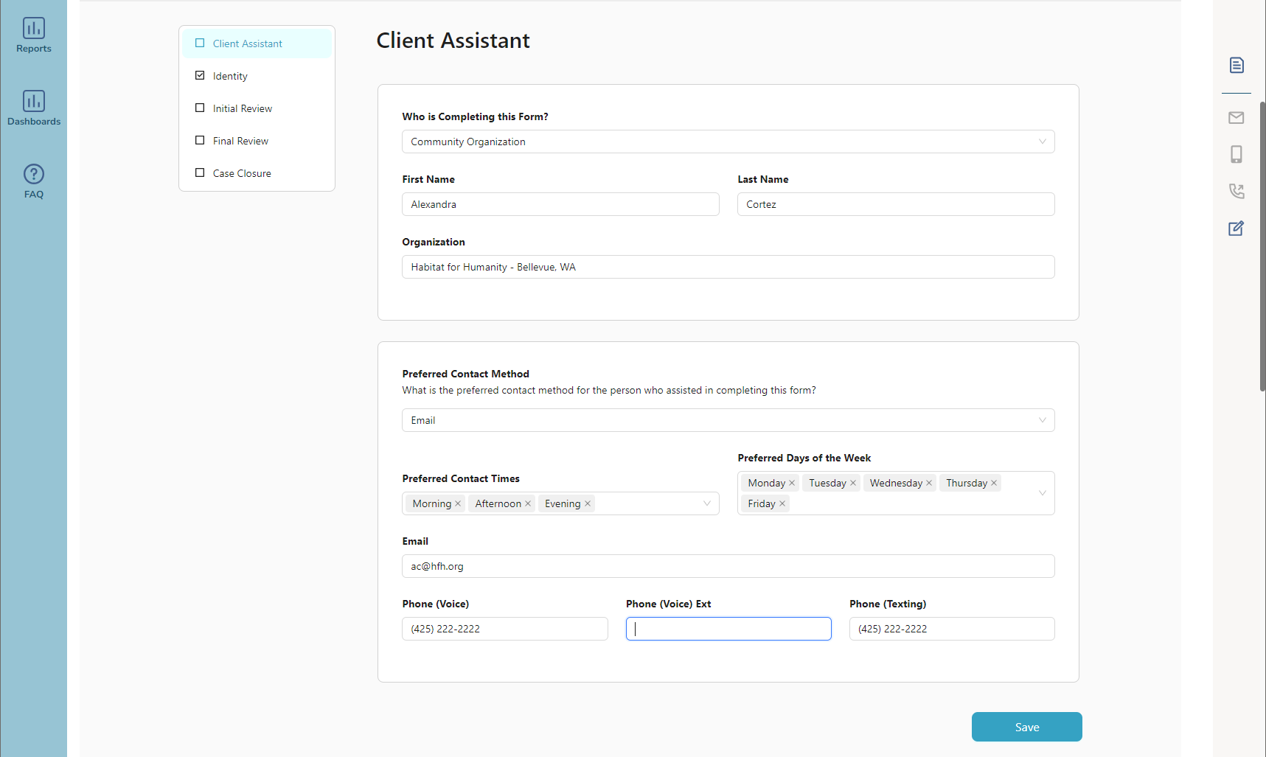
- The interface is user-friendly, guiding navigators through the submission process while maintaining data security.
5. Real-Time Application Status Checking:
- Housing navigators have the capability to check the real-time status of applications they've submitted.
- The platform provides a dashboard or dedicated section where navigators can view the progress of applications, ensuring transparency and accountability.
6. Granular Data Access Control:
- The FORWARD platform employs granular data access controls, ensuring that navigators can only access information related to the applicants they are assisting.
- This prevents unauthorized access to sensitive data and maintains the confidentiality of applicant information.
7. Encrypted Communication:
- Communication between housing navigators and the FORWARD platform is encrypted to protect the confidentiality of data in transit and at rest.
- Secure communication channels, such as HTTPS, ensure that information exchanged remains private and secure.
8. Notification Alerts:
- The platform sends real-time notification alerts to housing navigators regarding changes in application status or any required actions.
- Notifications are delivered through secure channels to ensure that only authorized individuals receive critical information.
- All notifications with their content are stored chronologically within the communication center for viewing/audit
9. Regular Security Audits:
- FORWARD conducts regular security audits to identify and address potential vulnerabilities.
- Ongoing assessments contribute to the platform's resilience against security threats.
10. Training and Compliance:
- Housing navigators will undergo training on FORWARD’s security protocols and compliance with data protection regulations.
- Regular updates and compliance checks ensure that navigators remain informed about best practices and policy changes.
The FORWARD platform provides a secure and user-friendly interface for housing navigators, balancing accessibility with stringent data protection measures. The implementation of secure authentication, role-based access control, encrypted communication, and ongoing security measures ensures that only authorized individuals can access and interact with application data, status, and grant funding information.

F | Please describe how your company will provide post payment support. Include the following information in your response: How you will track payment utilization  - How you will provide support for DSHS-ORA housing navigators to report a payment that has not been issued or receive  - What protocol you will implement when payments need to be canceled or reissued  - What methods will be used to provide the applicants with updates and changes | 5
ANSWER:
FORWARD provides robust support for DSHS-ORIA housing navigators, ensuring a seamless process for issue reporting and resolution. With direct access to the FORWARD platform, navigators can efficiently report payment-related concerns and can assign the issue to a FORWARD manager. A dedicated member of our application services receives a notice to promptly address discrepancies or delays, fostering personalized support. Collaborative efforts between FORWARD staff and navigators contribute to effective issue resolution, facilitated by the platform's seamless communication features. In instances requiring escalation, clear protocols guide designated personnel, including supervisors, to address complex matters. All assignments and messages are stored within the platform for future auditing purposes.
Our team is committed to providing comprehensive post-payment support, ensuring transparency, accountability, and efficient resolution of any issues that may arise. Here's how the post-payment support process is structured:
1. Tracking Payment Utilization:
- FORWARD's platform generates detailed and comprehensive reports on how funds are utilized by landlords and utility providers.
- Caseworkers and administrators have access to granular information, including specific expenses covered by the assistance funds.
- The platform facilitates itemized tracking of expenditures related to rental assistance and utility payments.
- Caseworkers can review and analyze individual transactions, providing a clear breakdown of how funds are allocated.
- FORWARD allows customizable expense categories to align with the diverse needs of applicants.
- Caseworkers can categorize and track payments based on specific criteria, providing a nuanced understanding of fund utilization.
- FORWARD conducts audits of payment utilization to ensure adherence to program guidelines.
- FORWARD's reporting tools offer transparent and actionable insights to DSHS-ORIA.
- Reports highlight trends, success stories, and areas for attention, facilitating collaborative decision-making.
- The platform's data analytics capabilities are leveraged to identify trends and patterns in payment utilization.
- Insights from analytics contribute to program improvement, ensuring that assistance programs evolve based on real-world data.

2. Support for DSHS-ORIA Housing Navigators:
- DSHS-ORIA housing navigators have direct access to the FORWARD platform for reporting issues related to payment issuance.
- A dedicated Associate Program Manager is assigned and available for housing navigators to report any discrepancies, delays, or issues with payment issuance.
- FORWARD staff assigned to DSHS-ORIA housing navigators collaborate closely to address reported payment issues.
- The platform facilitates seamless communication between caseworkers, enabling them to work collaboratively toward solutions.
- In cases where issues require escalated attention, FORWARD implements clear escalation protocols.
- Designated personnel, such as supervisors or specialized support teams, step in to address more complex or urgent matters.
3. Protocol for Payment Cancellation or Reissuance:
- In cases where payments need to be canceled or reissued, FORWARD follows a well-defined protocol.
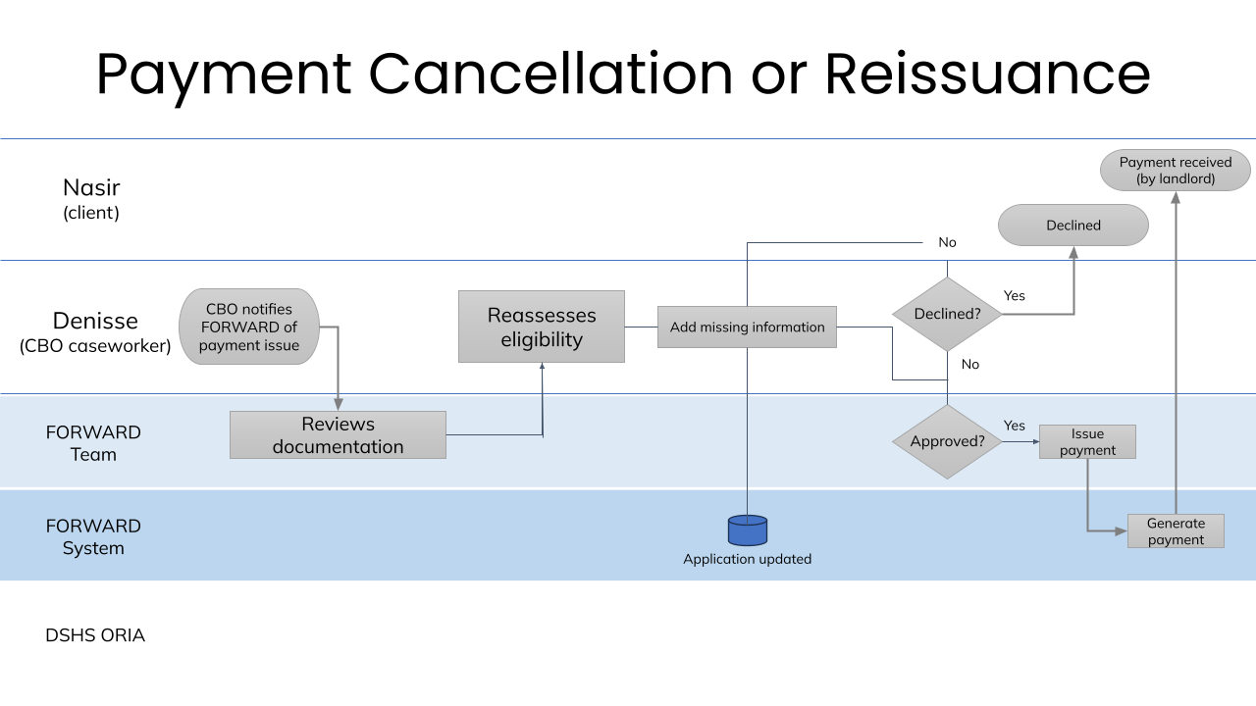 FORWARD staff conduct an initial assessment to determine the nature of the payment issue. They will determine whether the issue is due to an error in documentation, eligibility, or other factors. FORWARD staff review the documentation related to the original payment request and verify the accuracy and completeness of the documentation, ensuring it aligns with program guidelines. FORWARD staff reassign the case to the partner CBO to reassess the eligibility of the applicant to receive the payment and confirm that the applicant still meets the eligibility criteria for the specific assistance. Based on the assessment, a decision is made regarding payment cancellation or reissuance. Factors such as eligibility, documentation accuracy, and program compliance are considered in the decision-making process. If the payment cancellation or reissuance affects the applicant, clear and transparent communication is initiated. Applicants are informed of the decision, reasons for the action, and any necessary steps they may need to take.
- Authorized personnel, following verification and approval processes, can initiate payment cancellations or reissuance through secure channels.

4. Applicant Updates and Changes:
- Applicants receive real-time updates through the FORWARD platform regarding the status of their payments.
- Changes in payment status, cancellations, or reissuance are communicated to applicants through secure notifications via the platform.
5. Communication Channels:
- FORWARD employs secure communication channels within the platform to notify applicants of any updates or changes.
- Caseworkers have access to tools like the Communication Center to send secure messages, ensuring transparent and confidential communication.
6. Ongoing Caseworker Support:
- Caseworkers provide ongoing support to applicants, addressing queries and concerns related to payment utilization or changes.
- The platform facilitates direct communication between caseworkers and applicants for a seamless support experience.
7. Reporting and Analytics:
- FORWARD's reporting and analytics features contribute to a comprehensive understanding of payment utilization patterns.
- Regular reports are generated to highlight any trends, issues, or areas that may require attention, enabling proactive support.
8. Training and Resources:
- DSHS-ORIA housing navigators receive continuous training on utilizing the platform's post-payment support features.
- Resources and documentation are provided to navigate common issues, ensuring housing navigators can effectively support applicants.
9. Applicant Portal Access:
- Applicants have access to a secure portal within the FORWARD platform, allowing them to track payment utilization, report issues, and receive updates.
- The platform serves as a centralized hub for applicants to manage and monitor their assistance journey.

FORWARD's post-payment support strategy leverages the platform's features for efficient tracking, communication, and issue resolution. With a focus on transparency and user-friendly interfaces, the support system ensures that both DSHS-ORIA housing navigators and applicants experience a seamless and responsive post-payment process.

G | Please describe your company’s plan to maintain program integrity and prevent fraud, including details of your internal auditing processes to avoid duplicate applications, those submitted under pseudonyms, etc. | 5
ANSWER:
Program Integrity, Fraud Prevention, and Recourse
Our solution provides financial management, compliance, and controls at both the operations and program levels to ensure that the program remains in compliance with federal requirements, maintain program integrity, and identify and mitigate fraud.
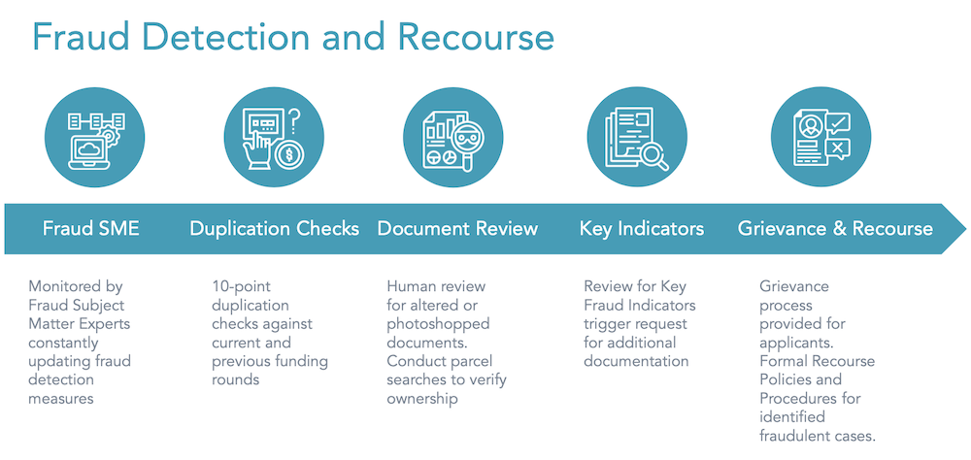
Our team is continually analyzing our data for indicators of potential fraud and incorporating our learnings into processes proactively and reactively to help inform our recourse processes.
- Employ a dedicated, full-time Fraud Subject Matter Expert, to whom all suspected fraudulent cases are referred for data collection, investigation, and mitigation (including recourse and recovery, if needed)
- Populate the FORWARD database with any available historical data, including submitted applications and payments
- To prevent duplicate user accounts, we employ a stringent process that restricts the use of the same email address for multiple users, and if the participant does not have an email address, we use name and address checks to prevent duplicate payments.
- A stringent application review and verification process and performance of a 10-point check on submitted applications to detect possible duplication of benefit
- Use advanced probabilistic models to flag cases for possible fraudulent activities
- Deploy proven enterprise-grade fraud detection engine that can process large-scale signals from multiple sources like application, device, banking, and environment.
- Perform fraud checks in real-time using Microsoft's industry-leading cloud infrastructure that can scale based on the program needs
- Utilize a hybrid process that will leverage automated fraud checking systems as well as human reviewers
Additionally, the FORWARD team will utilize their collective experience to decipher, interpret, and comply with federal and state rules, regulations, and guidance; we will also stay on top of any future rule and guidance adjustments. As part of our compliance efforts, we will follow all reporting and auditing requirements from federal and state authorities, as appropriate and applicable to this program.

Fraud and Other Loss Reporting
FORWARD acknowledges the inherent risks in running any type of direct assistance program and employs stringent policies and procedures surrounding these risks. If there is any suspected fraud or other loss of funds, we will promptly enact our recourse procedures to achieve full fund recovery utilizing the following steps:
- Conduct an initial investigation of the suspected or known fraud within 3 business days of initial written notification
- Provide report on investigations to DSHS as appropriate
- In collaboration with DSHS staff, determine appropriate recourse which may include some or all of the following:
  - Escalation to appropriate law enforcement agencies or investigative body
  - Applicant repayment of funds
  - Authorized entity repayment of funds
  - If participant or authorized entity repayment is not possible or feasible, FORWARD will assume the risk of the funding integrity
- Provide final report on notified fraud investigations to DSHS upon case closure

Protection of Personal and Financial Information:
- Both DSHS and applicants will be reassured that their personal and financial information is safe when using the FORWARD platform. Stringent fraud detection and prevention measures help guard against identity theft and unauthorized access to sensitive data, providing peace of mind to applicants that their information will not be misused.
Fairness and Integrity:
- FORWARD’s stringent fraud detection ensures that DSHS funds are awarded to eligible and deserving recipients, preventing any fraudulent or dishonest attempts to manipulate the system. This ensures fairness in the selection process and guarantees that the grants go to those who genuinely need them, which builds trust in the program's integrity.
Efficient Processing:
- By detecting and preventing fraud early in the process, the FORWARD platform avoids delays caused by investigations into suspicious activities or questionable applications. This helps DSHS streamline the entire allocation process, ensuring that resources are distributed promptly to those who qualify.
Cost Savings:
- Fraudulent activities can lead to financial losses for the program and, in turn, may reduce the overall funds available for eligible applicants. With stringent fraud prevention measures in place, FORWARD minimizes the risk of financial losses for DSHS, thus maximizing the amount of money available to support the intended beneficiaries.
Long-Term Program Viability:
- Preventing fraud ensures the longevity and sustainability of DSHS’s housing programs. By safeguarding against misuse and improper allocation of funds, the program can continue to support communities that genuinely need assistance, fostering positive long-term impacts.
The FORWARD platform provides protection, credibility, fairness, efficiency, cost savings, regulatory compliance, customer satisfaction, and long-term program viability. By prioritizing security, FORWARD effectively serves our customers and ensures the successful implementation of the program.

H | Please describe your company’s plan to maintain program integrity and prevent fraud, including details of your internal auditing processes to avoid duplicate applications, those submitted under pseudonyms, etc. | 5
ANSWER:
Program Integrity, Fraud Prevention, and Recourse
Our solution provides financial management, compliance, and controls at both the operations and program levels to ensure that the program remains in compliance with federal requirements, maintain program integrity, and identify and mitigate fraud.
Our team is continually analyzing our data for indicators of potential fraud and incorporating our learnings into processes proactively and reactively to help inform our recourse processes.
- Employ a dedicated, full-time Fraud Subject Matter Expert, to whom all suspected fraudulent cases are referred for data collection, investigation, and mitigation (including recourse and recovery, if needed)
- Populate the FORWARD database with any available historical data, including submitted applications and payments
- To prevent duplicate user accounts, we employ a stringent process that restricts the use of the same email address for multiple users, and if the participant does not have an email address, we use name and address checks to prevent duplicate payments.
- A stringent application review and verification process and performance of a 10-point check on submitted applications to detect possible duplication of benefit
- Use advanced probabilistic models to flag cases for possible fraudulent activities
- Deploy proven enterprise-grade fraud detection engine that can process large-scale signals from multiple sources like application, device, banking, and environment.
- Perform fraud checks in real-time using Microsoft's industry-leading cloud infrastructure that can scale based on the program needs
- Utilize a hybrid process that will leverage automated fraud checking systems as well as human reviewers
Additionally, the FORWARD team will utilize their collective experience to decipher, interpret, and comply with federal and state rules, regulations, and guidance; we will also stay on top of any future rule and guidance adjustments. As part of our compliance efforts, we will follow all reporting and auditing requirements from federal and state authorities, as appropriate and applicable to this program.

Fraud and Other Loss Reporting
FORWARD acknowledges the inherent risks in running any type of direct assistance program and employs stringent policies and procedures surrounding these risks. If there is any suspected fraud or other loss of funds, we will promptly enact our recourse procedures to achieve full fund recovery utilizing the following steps:
- Conduct an initial investigation of the suspected or known fraud within 3 business days of initial written notification
- Provide report on investigations to DSHS as appropriate
- In collaboration with DSHS staff, determine appropriate recourse which may include some or all of the following:
  - Escalation to appropriate law enforcement agencies or investigative body
  - Applicant repayment of funds
  - Authorized entity repayment of funds
  - If participant or authorized entity repayment is not possible or feasible, FORWARD will assume the risk of the funding integrity
- Provide final report on notified fraud investigations to DSHS upon case closure

Protection of Personal and Financial Information:
- Both DSHS and applicants will be reassured that their personal and financial information is safe when using the FORWARD platform. Stringent fraud detection and prevention measures help guard against identity theft and unauthorized access to sensitive data, providing peace of mind to applicants that their information will not be misused.
Fairness and Integrity:
- FORWARD’s stringent fraud detection ensures that DSHS funds are awarded to eligible and deserving recipients, preventing any fraudulent or dishonest attempts to manipulate the system. This ensures fairness in the selection process and guarantees that the grants go to those who genuinely need them, which builds trust in the program's integrity.
Efficient Processing:
- By detecting and preventing fraud early in the process, the FORWARD platform avoids delays caused by investigations into suspicious activities or questionable applications. This helps DSHS streamline the entire allocation process, ensuring that resources are distributed promptly to those who qualify.
Cost Savings:
- Fraudulent activities can lead to financial losses for the program and, in turn, may reduce the overall funds available for eligible applicants. With stringent fraud prevention measures in place, FORWARD minimizes the risk of financial losses for DSHS, thus maximizing the amount of money available to support the intended beneficiaries.
Long-Term Program Viability:
- Preventing fraud ensures the longevity and sustainability of DSHS’s housing programs. By safeguarding against misuse and improper allocation of funds, the program can continue to support communities that genuinely need assistance, fostering positive long-term impacts.
The FORWARD platform provides protection, credibility, fairness, efficiency, cost savings, regulatory compliance, customer satisfaction, and long-term program viability. By prioritizing security, FORWARD effectively serves our customers and ensures the successful implementation of the program.
I | Please describe your company’s ability to comply with all sub-recipient requirements as detailed in Section A.9. Sub-recipient Status, of the RFP Document and General Terms and Conditions Section 24. Sub-recipients, of Attachment A – Sample Contract of the Solicitation Document. | 10
ANSWER:
While FORWARD acknowledges our capability to comply with all subrecipient requirements, we would like to formally request exceptions to the contract, as indicated in section 1.d. of this response. FORWARD requests a change to the text on page 9, section 29.b of Attachment A, as it pertains to the single audit requirement.

Current language: Single Audit Act Compliance. If the Contractor is a subrecipient and expends $750,000 or more in federal awards from any and/or all sources in any fiscal year, the Contractor shall procure and pay for a single audit or a program-specific audit for that fiscal year. Upon completion of each audit, the Contractor shall:
    - Submit to the DSHS contact person the data collection form and reporting package specified in 2 CFR Part 200, Subpart F, reports required by the program-specific audit guide (if applicable), and a copy of any management letters issued by the auditor;
    - Follow-up and develop corrective action for all audit findings; in accordance with 2 CFR Part 200, Subpart F; prepare a “Summary Schedule of Prior Audit Findings” reporting the status of all audit findings included in the prior audit's schedule of findings and questioned costs.

Proposed language: Per 2 Code of Federal Regulations (CFR) Part 200.501 (h), for-profit entities are exempt from undergoing a single audit. DSHS ORIA, as the pass-through entity will be responsible for setting contract requirements to ensure compliance to federal funding guidelines. Monitoring for compliance will occur throughout the contract period. A for-profit subrecipient may still be obligated to undergo a program-specific review and monitoring.

We believe that this exception aligns with the nature of our engagement and the specific services we aim to provide. It is our understanding that the characteristics of our role in this project warrant consideration for an exception, and we are committed to working collaboratively with DSHS to ensure successful program implementation while addressing any concerns related to subrecipient status.

J | Please provide a general budget narrative that describes the proportion of funding dedicated to:  - Technology (platform).  - Application review and processing.  - Funding Disbursement.  - Overall program administration. | 20
ANSWER:
In developing the budget for the proposed project, FORWARD has meticulously considered the allocation of funds to various components to ensure the efficient implementation and success of the Housing Stabilization Services program. The following outlines the proportion of funding dedicated to key areas:
- Technology (Platform):
  - A significant portion of the budget, approximately 43% of the total funds, has been allocated to the development, maintenance, and enhancement of the FORWARD platform. This includes the creation of an accessible online application platform, ongoing technical support, security measures, and any necessary updates to ensure a seamless and secure user experience.
- Application Review and Processing:
  - The budget designates 33% of the total funds for the application review and processing phase. This encompasses the cost of personnel involved in the efficient review, assessment, and approval of applications. FORWARD also allocates resources for a multilingual help line within our budget. This vital resource ensures real-time assistance in various languages, fostering inclusivity and providing applicants with the guidance they need.
- Funding Disbursement:
  - Approximately 19% of the budget is earmarked for the secure and timely disbursement of rental assistance funds to eligible and approved applicants. This includes the development and utilization of a reliable payment distribution system, as well as any associated transaction fees, ensuring that funds reach landlords and utility providers in a streamlined manner.
- Overall Program Administration:
  - The remaining 4.85% of the budget is allocated to overall program administration. This encompasses various aspects such as progress monitoring and reporting, ongoing support and training for DSHS-ORIA HSS contractors, program integrity and security measures, as well as any unforeseen contingencies that may arise during the program's operation. Additionally, FORWARD commits to funding an audit in alignment with program requirements.
FORWARD’s budget allocation has been strategically determined to optimize the impact of the Housing Stabilization Services program. FORWARD is committed to transparent financial management and will provide detailed reports to DSHS-ORIA, highlighting the prudent use of funds and the positive outcomes achieved through the program.

7 | BIDDER’S PROPOSED PRICING (QUOTATION OR COST RESPONSE) | MAXIMUM TOTAL POINTS: 20
A | Please identify all allocated costs, together with the total charges Bidder is willing to accept in consideration of the full performance of the Contract. | 20
ANSWER: TOTAL MAXIMUM BID AMOUNT: $979,600

Technology (platform): $406,374
Application Review and Processing: $348,089
Funding Disbursement: $174,161
Overall Program Administration: $50,976

TOTAL: $979,600

Technology (platform) | $406,374
Program costs ($406,374)
Application Review and Processing | $348,089
Employee costs ($348,089)
Funding Disbursement | $174,161
Program costs ($174,160)
Overall Program Administration | $50,976
Employee costs ($50,976)

BIDDERS ARE REQUIRED TO PROVIDE AN ALLOCATED COST DETAIL SAMPLE BY COMPLETING ATTACHMENT E: BUDGET RESPONSE TEMPLATE. AFTER COMPLETING THE SPREADSHEET, BIDDERS MUST SUBMIT IT IN EXCEL FORMAT WITH YOUR BID RESPONSE. BIDDER RESPONSES IN ATTACHMENT E WILL BE USED TO DETERMINE THE SCORING PROVIDED IN THIS SECTION. BIDDERS WHO SEND AN INCOMPLETE SPREADSHEET WILL HAVE THEIR TOTAL COST SCORE REDUCED IN ACCORDANCE WITH SECTION E.4 OF THE SOLICITATION DOCUMENT.

