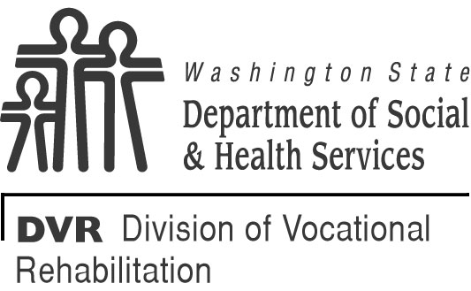 | DVR Referral to Office of Financial Recovery (OFR)
1 through 12. Completed by DVR Field Staff
1. SOCIAL SECURITY NUMBER |  | 2. BIRTHDATE |  | 3. TODAY’S DATE
4. CUSTOMER’S FIRST NAME |  | MIDDLE INITIAL |  | LAST NAME
5. STREET ADDRESS |  | CITY |  | STATE | ZIP CODE
6. TELEPHONE NUMBER (INCLUDE AREA CODE)  ( ) |  |  |  | 7. AMOUNT  $
7. REASON FOR AMOUNT OWED TO DVR (IF EQUIPMENT, LIST ITEMS NOT RECOVERED)

8. DESCRIPTION OF EFFORTS TO COLLECT MONEY OR EQUIPMENT ITEMS PRIOR TO FINAL CERTIFIED LETTER

9. STATEMENT INDICATING WHETHER OR NOT FRAUD IS SUSPECTED

10. REQUEST FOR DEBT FORGIVENESS / PAYMENT PLAN, IF APPLICABLE
Administrative error (explain):

Hardship (explain):
Payment plan needed (explain):
Other (explain):
11. DOCUMENTATION ATTACHED
Copy of customer letter requesting return of equipment / reimbursement of funds.
Copy of AFPS and invoices.
Copy of DVR loan agreement in STARS (previously referred to as the Load Agreement for Tools, Equipment, Initial Stock and Supplies, DSHS 19-074).
Certified Mail Receipt (proof of delivery).
Copy of STARS case narrative(s) documenting attempts to collect money or items prior to mailing certified customer OFR referral letter with appeal options.
12. FINAL STEPS
- Case note in STARS “Referred to OFR.”
- Mail copy of referral form with attached documentation to DVR Fiscal Unit.
- If customer returns equipment / payment following referral, notify Fiscal Unit.
13 through 16. Completed by Fiscal Staff at the DVR State Office only
13. WARRANT / EFT DATES |  |  | 14. AFRS CODING
15. FISCAL STAFF’S NAME |  |  | 16. FISCAL STAFF’S TELEPHONE NUMBER (INCLUDE AREA CODE)  ( )

