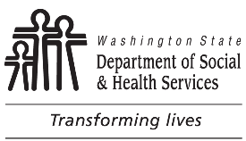 | STATE OF WASHINGTON  DEPARTMENT OF SOCIAL AND HEALTH SERVICES  DIVISION OF CHILD SUPPORT (DCS)  Declaration of Lawful Custody
Instructions
You must complete and return this form before the Division of Child Support (DCS) can send you child support payments. Except for your signature, print all responses in blue or black ink.
DCS may close your case if we do not receive this form before .
Return this form to DCS address listed below.
I, , am the: (check the box that applies to you)
1. Legal custodian of the children listed below.
2. Physical custodian of the children listed below. I have the legal custodian’s permission to care for the children.
Children’s Names |  | Social Security Numbers | Birth Dates
The children came into my custody on .
DATE

I declare, under penalty of perjury under the laws of Washington State, that the foregoing is true and correct.

Signed at , Washington.

MM/DD/YYYY
DATE SIGNATURE

CASE NUMBER
DIVISION OF CHILD SUPPORT
PO BOX 11520
TACOMA WA 98411-5520
Within calling area
Outside calling area
TTY/TDD services available for the speech or hearing impaired.
Visit our web site at: www.dshs.wa.gov/esa/division-child-support

No person because of race, color, national origin, creed, religion, sex, age, or disability, shall be discriminated against in employment, services, or any aspect of the program's activities. This form is available in alternative formats upon request.

