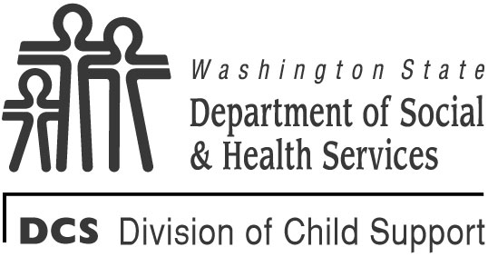 | STATE OF WASHINGTON  DEPARTMENT OF SOCIAL AND HEALTH SERVICES  DIVISION OF CHILD SUPPORT (DCS)
Washington State Addendum to Box 2 of Part B - Plan Administrator Response
TO: |  |  | RE:  SSN:  IV-D CASE NUMBER:
EMPLOYER:
FROM: (Name of Plan Administrator or Employer Representative)
The children listed in Part B, Medical Support Notice to Plan Administrator are enrolled in the following plan(s).
Send all claims to the names and addresses provided below.
HEALTH INSURANCE PLAN
COMPANY NAME AND ADDRESS |  | POLICY NUMBER:
 |  | GROUP NUMBER:
 |  | TELEPHONE NUMBER:
 |  | EFFECTIVE DATE:

DENTAL INSURANCE PLAN
COMPANY NAME AND ADDRESS | POLICY NUMBER:
 | GROUP NUMBER:
 | TELEPHONE NUMBER:
 | EFFECTIVE DATE:

PRESCRIPTION DRUG INSURANCE PLAN
COMPANY NAME AND ADDRESS | POLICY NUMBER:
 | GROUP NUMBER:
 | TELEPHONE NUMBER:
 | EFFECTIVE DATE:

VISION INSURANCE PLAN
COMPANY NAME AND ADDRESS | POLICY NUMBER:
 | GROUP NUMBER:
 | TELEPHONE NUMBER:
 | EFFECTIVE DATE:
Amount of monthly premium required to cover the children: $
Check the applicable box below.
ID cards/benefit information: Will be sent to the children’s custodian.
Will be sent to the Division of Child Support.
Will not be sent.

