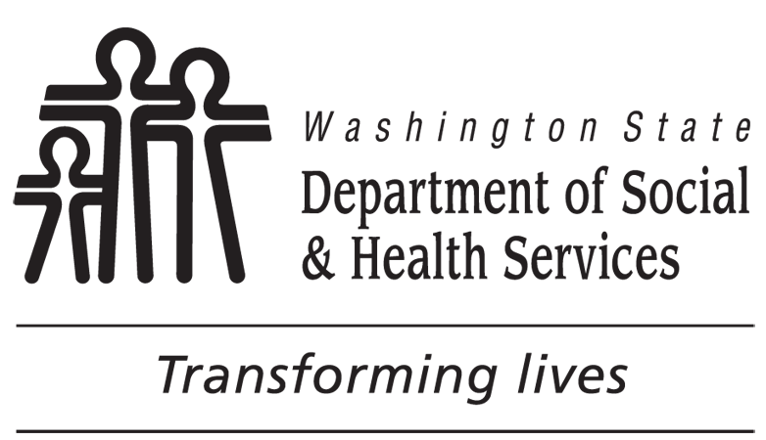 |  | Disqualification Consent Agreement  For Washington Food Assistance Programs
OFA NUMBER | CLIENT’S NAME |  | CLIENT’S SSN |  | CLIENT’S BIRTH DATE | CLIENT ID NUMBER
I, , understand that:
FIRST NAME, MIDDLE NAME, LAST NAME
If the accused individual is not the head of the household, the head of the household must also sign the Disqualification Consent Agreement as stated in 7 CFR 273.16(h)(l)(ii)(A)
I, , understand that:
HEAD OF HOUSEHOLD’S FIRST NAME, MIDDLE NAME, LAST NAME
All remaining adult members of my food assistance unit and I are responsible for repayment of the resulting claim, unless an adult member has already repaid the claim as a result of meeting the terms of the agreement.
2. I have not been found guilty of civil or criminal misrepresentation or fraud. However, when I sign this agreement, I will not receive food assistance benefits for myself and my assistance unit may receive a lower amount of food benefits when I am disqualified.
3. When I sign this Disqualification Consent Agreement, I understand I will be disqualified for:
12 months 24 months Ten (10) years Permanently
This is my: First violation; Second violation; Third violation; OR
I received duplicate food benefits from more than one office or state.
Explanation of Your Constitutional Rights
Before you are questioned, you are advised of your rights, as follows:
- You have the right to remain silent;
- Anything you say can be used against you in a court of law;
- You have the right at this time to an attorney of your own choosing and have him / her present before and during questioning or making of any statement;
- If you cannot afford an attorney, you are entitled to have one appointed for you by a court without cost to you and to have him / her present before and during questioning or the making of any statement;
- You have the right to exercise any of the above rights at any time before or during any questioning and the making of any statement.
Food Assistance Program Penalty Warning
Under WAC 388-446-0020, a person will not receive food assistance benefits for:
One year for knowingly violating a food assistance or Supplemental Nutrition Assistance Program(SNAP) rule;
Two years for a second such violation; or a first conviction for buying, selling, or trading food assistance or SNAP benefits for a controlled substance;
Ten years for knowingly giving false identity or residence information to get duplicate benefits;
Lifetime for:
- Knowingly breaking a food assistance or SNAP rule a third time;
- A second conviction for buying, selling, or trading food benefits for a controlled substance;
- Conviction for buying, selling, or trading food benefits for firearms, ammunition, or explosives; or
- Conviction for buying, selling, or trading food benefits worth $500 or more.
Persons who knowingly and intentionally violate a food assistance rule can be prosecuted and fined up to $250,000 or imprisoned up to twenty years or both. They are also subject to prosecution under other applicable federal laws.
DISQUALIFIED PERSON’S SIGNATURE DATE |  |  |  | HEAD OF HOUSEHOLD’S (HH) SIGNATURE DATE  (IF THE ACCUSED IS NOT THE HEAD OF HOUSEHOLD)

