 |  | AGING AND LONG-TERM SUPPORT ADMINISTRATION (ALTSA)  Nursing Services Basic Skin Assessment  (Integumentary System – Skin, Hair, Nail) |  |  |  |  |  | DATE OF SERVICE
 |  |  |  |  |  |  |  | CM / RN NAME
 |  |  |  |  |  |  |  | REFERRING RN NAME
CLIENT NAME |  |  | DATE OF BIRTH |  |  |  | CLIENT ACES ID |  | CLIENT PROVIDER ONE ID
REQUEST RELATED TO (REQUESTOR COMPLETES): CHECK ALL THAT APPLY
Skin Observation
Other referral type (describe):
Documentation to be sent back to: By: Fax Email Hard Copy
Injuries Assessment Section
Beginning with any pressure injuries, number all integumentary issues consecutively, starting with #1, #2, #3, etc. (Skin, Hair and Nails)
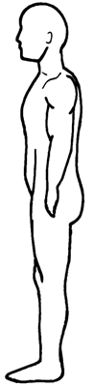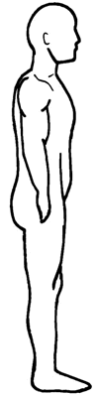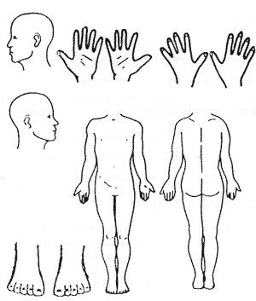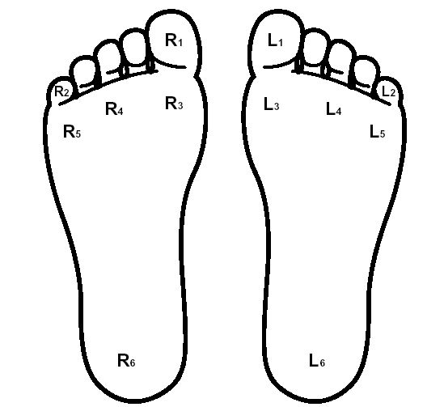
Skin Issues
Specify all types below as numbered / designated above: The number, skin issue type and comments.
Examples of possible types of skin issues from CARE include pressure injuries, abrasions, acne / persistent redness, boils, bruises, burns, canker sore, diabetic ulcer, dry skin, hives, open lesions, rashes, skin desensitized to pain / pressure, skin folds / perineal rash, skin growths / moles, stasis ulcers, sun sensitivity, and surgical wounds. Please note there are many other skin issues not mentioned here such as irregular skin area such as boggy or mushy skin area, discoloration area(s).
Please note: Any current pressure injuries require further detailed documentation on Pressure Ulcer Assessment and Documentation, form DSHS 13-783.
NUMBER | SKIN ISSUE TYPE AND LOCATION |  |  | COMMENTS (PROVIDE FURTHER (NON-PRESSURE INJURY) DOCUMENATION IN ADDITIONAL NOTES SECTION. FURTHER PRESSURE INJURY DOCUMENTATION REQUIRES FORM DSHS 13-783.)
Basic Skin Assessment – Additional Detail (Check – Off and Notes)
CONSIDER HISTORY OF SKIN CONDITION
- How long has the condition been present?  - How often does it occur or recur?  - Are there any seasonal variations?  - Is there a family history of skin disease? |  |  |  |  | - Any habits, behaviors or hobbies or other affecting the skin?  - What medication is client taking?  - Any known allergies?  - Include previous and present treatments and their effectiveness.
Color: Pale WNL Cyanotic Jaundice Other (describe):
Notes:
Temperature: Afebrile Warmer than normal (febrile) Other (describe):
Notes:
Turgor: Normal Slow (tenting)
Notes:
Any foul odor: Yes No
Notes:
Moisture: WNL Dry Diaphoretic Other (describe):
Notes:
Skin integrity: WNL / intact See problem list
Notes:
Moles: Present
- Asymmetry Yes No
- Border Regular Irregular
- Color
- Diameter
Notes: Referral and follow-up for suspect / abnormal or irregular mole:
Hair: Even distributed Hair loss Other (describe):
Notes:
Nails: WNL Thickened Clubbing Discolored Other (describe):
Cap Refill: < 3 sec > 3 sec
Notes:
Non-injury recommendations to CM / CRM (for follow-up with HCP, treatment, care planning, or other directions):

RN SIGNATURE DATE |  |  |  |  |  | PRINTED RN NAME
Additional forms / documentation attached

