Person’s Name |  |  |  |  |  |  | Date of Birth |  |  |  | ProviderOne Number
 |  | Developmental Disabilities Administration (DDA)  Skin Observation  You do not need permission to call 911.
Date of Protocol Creation |  |  | POLST DNR/I on file  Yes No |  |  | Where is the POLST DNR/I located? |  |  |  |  | Date Signed
When to call healthcare provider:

Call 911 and START FIRST AID as trained if:
Below are possible signs of infection which could be life threatening.
- The person is not breathing or is blue / gray in color.
- The person is having difficulties breathing or making abnormal noises while breathing.
- The person appears ill; and you are concerned about their immediate health and safety.
- The person has a temperature greater than or less than .
- Other:
After 911 has been notified, follow instructions from the dispatcher. Notify the dispatcher if there is a POLST DNR/I in place.
After calling 911 and stabilizing the person:
- Contact your supervisor.
- Document per agency protocol in the person’s chart.
General Signs of Skin Injury
- Changes in the color of skin.
- Changes to the texture of skin.
- Changes to temperature of the skin: cold or warm to touch
- Pain or discomfort to an area of the skin.
- Swelling or open areas of the skin.
- Drainage from an area of the skin.
Common areas for Pressure Injuries
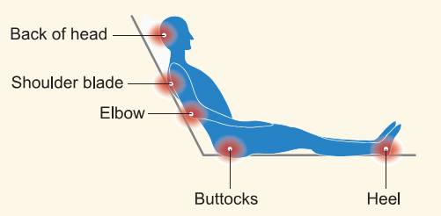 |  |  |  |  |  |  |  | 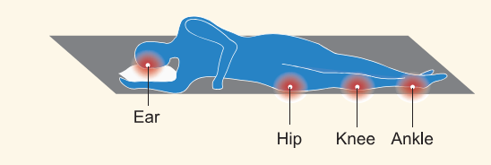
Pressure Injury Stages
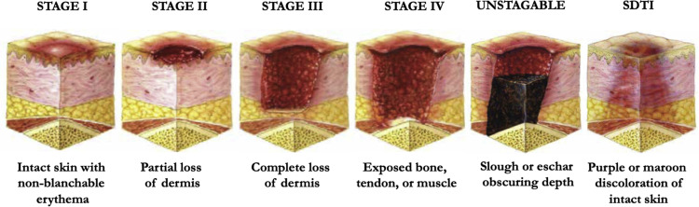
*SDTO – Deep Tissue Pressure Injury
Get to Know Me and My Skin
I need the following things to keep my skin healthy:
I need the following assistance with position change: Independent Some Assistance Total Assistance
Comments:
I have a prescribed positioning schedule in place: Yes No
Comments:
I need the following assistance with toileting: Independent Some Assistance Total Assistance
Comments:
I use the following medications / treatments to help with my skin’s integrity (per MAR):
None
Medication Name |  |  |  | Medication Dose |  |  |  |  | Medication Frequency
I use the following medications / treatments as needed (PRN) to help with my skin’s integrity (per MAR):
None
Medication Name |  |  |  | Medication Dose |  |  |  |  | Medication Frequency
I have current pressure injuries: Yes No
Location of pressure injuries:
I have a history of pressure injuries: Yes No
Locations of previous pressure injuries:
I have a wound care program: Yes No
If yes, describe program:
I have a wound care treatment provider: Yes No
If yes, wound care treatment provider name / contact / schedule:
Wound Care Provider’s Name |  |  |  |  | Wound Care Provider’s Contact Information
Wound Care Provider’s Schedule

I have a Nurse Delegator who trains staff on medication administration: Yes No
Delegator’s Name |  |  |  |  |  |  |  | Delegator’s Phone Number
Notify my Nurse Delegator when I (follow Nurse Delegation Instructions and Task form):
How to Prevent a Pressure Injury
- Complete daily skin inspections with person consent and privacy.
- Get recommended amount of fluids.
- Eat a well-balanced diet of fruits, vegetables, carbohydrates, and proteins.
- Good skin hygiene: clean skin immediately after becoming soiled, use a mild soap and soft cloth, hydrate the skin with lotion and barrier creams, per physicians’ orders.
- Change positions at least every two hours or as prescribed.
- Other:
Additional Information

Plan Completed by: |  |  |  |  |  |  |  |  |  | Date Plan Completed
Health Care Provider’s Signature |  |  |  |  |  |  |  |  |  | Date Signed

Health Care Provider’s Name |  |  | Phone
Date of last review (enter signature and date):

