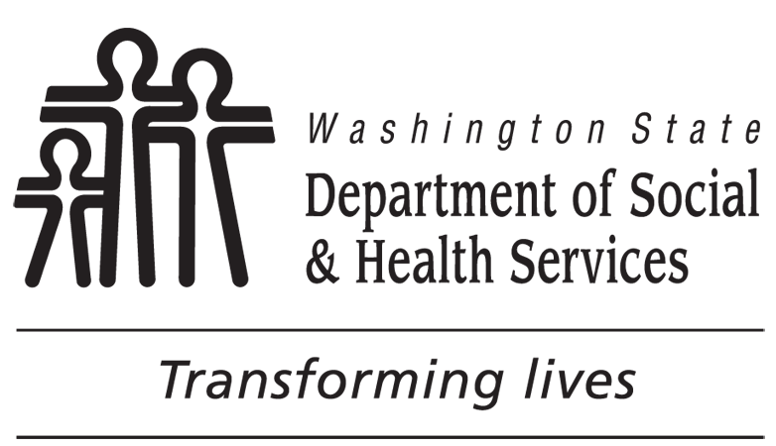 | DEVELOPMENTAL DISABILITIES ADMINISTRATION (DDA)  Information Needed
Date
APPLICANT NAME AND ADDRESS |  | LEGAL REPRESENTATIVE NAME AND ADDRESS
Dear :
DDA received your “Request for DDA Eligibility Determination” on .
DDA has not yet received the requested information from the following source:

You may want to follow-up to make sure that the information is sent to DDA within the next thirty (30) days. An eligibility determination will be made at that time based on the information we have received.
If there will be a delay in our getting this information or if there are things you would like to add, please contact me.
Thank you,

NAME TELEPHONE NUMBER EMAIL ADDRESS

