Removing communication barriers for people who are
Deaf • Hard of Hearing • Late-Deafened • Deaf-Blind • Speech Disabled
TED Program Pilot Project:
Application for Emergency Alerting Device KIT
The Telecommunication Equipment Distribution (TED) program within the Office of the Deaf and Hard of Hearing (ODHH) is conducting a pilot project to provide Emergency Alerting Device (EAD) Kits to Deaf and Hard of Hearing TED Program clients.  Washington State residents ages 4 and up who are deaf, hard of hearing, late-deafened, or deaf-blind are eligible to apply to receive EAD Kits.  This application has the information you will need to complete the process. If you have any questions or need help filling out the application, you may contact the TED Program. |  |  |  |  | CONTENTS
Cover Page 1
FAQ 2
KIT Contents 2
Application 3 – 4*
* You MUST return both pages of this form.
Office of the Deaf and Hard of Hearing
Telecommunication Equipment Distribution Program
TED Program  PO Box 45301  Olympia, WA 98504-5301 |  | (800) 422-7930 V/TTY  (360) 725-3450 V/TTY  (360) 725-3456 FAX |  | Videophone: 360-339-7755  E-mail: robiskd@dshs.wa.gov  Web : http://odhh.dshs.wa.gov
To receive equipment, you must:  Complete the Application for EAD Kit  Mail your application to the TED Program at the address above or send by email to odhh@dshs.wa.gov. |  |  | When your application is accepted and processed, we will:  - Send you a letter telling you the status of your request.  - Add your name to the next equipment distribution list.  - Ship the equipment to you.  For more information about the application process, see Frequently Asked Questions in Program Information (page 2).
Applications can be made available in other formats. Please contact ODHH to request an alternate format or other languages.

Frequently Asked Questions (FAQ)
Do I have to pay for equipment?
Because ODHH is conducting a pilot project, the emergency alerting kits are being provided at no cost to clients in exchange for feedback on the devices being issued. The equipment will become the property of the client. As a participant in the Pilot Project, you may be asked to participate in a survey to assist us in identifying what equipment works best for clients and what other equipment might be necessary.
What income must be reported?
You must report any and all sources of income including but not limited to wages, disability benefits, retirement income, social security, and interest. While your reported income will not disqualify you for participation in the Pilot Project, we ask that you provide the information to help us determine how best to implement a permanent EAD Kit program.
What equipment may I choose from?
The TED Program has worked with Teltex, Inc. to create a basic Emergency Alerting Device (EAD) Kit that contains a Master Unit with built in alarm clock and land line telephone notification, Wireless Doorbell Button, Vibration Disc, Smoke/CO Transmitter, and Smoke/CO Detector. Optional accessories such as Baby Cry Sound Signaler Kit, Pager Receiver, and Smartphone Bluetooth Transmitters may be provided if funding is available.
What professionals are authorized to sign my Pilot Project application form?
The following individuals are authorized to certify an applicant’s eligibility:
  - A person who is licensed or certified by the Department of Health to provide health care in the state of Washington;
  - An audiologist or hearing aid fitter / dispenser in the State of Washington;
  - A deaf specialist or coordinator at one of the community service centers for the deaf and hard of hearing in the state;
  - Staff from a qualified Washington state agency;
  - A vocational rehabilitation counselor within the State of Washington;
  - A deaf‐blind specialist or coordinator at an organization that serves deaf‐blind people within the State of Washington;
When will I receive equipment?
The process to receive equipment can take four (4) to eight (8) weeks depending on inventory availability. EAD KITS will be shipped directly to you by our vendor. Because this is a pilot project, there is a limited number of kits available during the initial phase of the trial.

Tear off the application |  | TED Program Pilot Project: Application for Emergency Alerting Kit |  |  |  |  |  |  | OFFICE USE ONLY
 |  |  |  |  |  |  |  |  | Date Received
 | Incomplete applications may be returned and result in a delay of service. Print or type clearly and send to ODHH@dshs.wa.gov or mail to: TED Program, PO Box 45301, Olympia, WA 98504-5301.
 | How did you hear about the TED EAD program?  Friend or family member Magazine or newsletter  Medical professional Presentation or information booth  TV advertisement Other: |  |  |  |  |  |  | Have you received equipment from the TED Program in the past?  Yes No Don’t know
 | Section 1. Applicant Information
 | 1. Last name, first name, middle initial |  |  |  |  |  |  |  | 2. Gender  Male Female
 | 3. Home address (include apartment number) City State Zip Code
 | 4. Mailing address (if different) City State Zip Code
 | 5. Community / Facility name (i.e., nursing home, apartment complex) |  |  |  |  |  |  |  | 6. County
 | 7. Telephone number (include area code)  Voice VP TTY |  |  |  | 8. Cell phone number (include area code)  Voice VP TTY
 | 9. Email address
 | 10. Social Security Number (optional) |  |  | 11. Best times to contact |  |  |  |  | 13. Date of Birth (required)
 | 14. Alternate contact person / message  Name |  |  |  |  |  |  |  | Relationship
 | Telephone number (include area code)  Voice VP TTY |  |  |  | E-mail address
 | Section 2. Profile
1. Financial information (required):
Family size: Monthly income: $ Annual income: $
 | 2. Disability (required for eligibility)  Deaf Deaf-Blind  Hard of Hearing  Late-Deafened |  |  |  | 3. In addition to hearing loss or speech disability:  a. Do you have low vision? Yes No  b. Are you blind? Yes No  c. Do you have limited mobility? Yes No
 | 4. Communication preferences
 | a. Sign language:  ASL PSE  SEE Tactile |  | b. Spoken:  Speaking  Lip reading |  |  | c. Writing
 |  |  |  |  |  | d. Other:
e. What language do you speak?
English Other:
f. Do you need an interpreter? Yes No
5. Are you of Hispanic origin? Yes No
The Spanish / Hispanic / Latino question is about ethnicity, not race. Please continue to answer the following question by marking one or more boxes to indicate what you consider your race to be (check all that apply):
White American Indian or Alaskan Native Native Hawaiian or Pacific Islander
Black or African American Asian Other race
Section 3. Equipment Selection
- Basic Emergency Alert Kit.
Standard EAD Kit contains: Master unit with alarm clock and landline phone notification, wireless doorbell button, vibration disc, Smoke / CO Transmitter, and Smoke / CO Detector
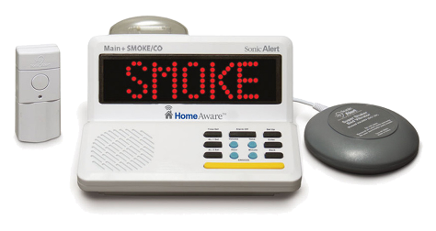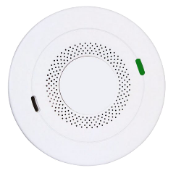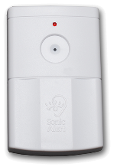
2. When funding is available, optional accessories to the EAD Kit may be provided. The following optional devices are compatible with the Standard EAD kit:
Baby Cry Sound Signaler Pager vibrating receiver Smartphone Bluetooth Transmitter
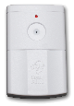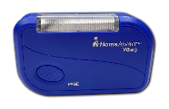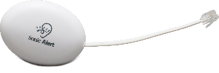
By signing Section 4. below, you authorize ODHH to provide your name, mailing address, and contact information to the contracted vendor for the purpose of shipping equipment and providing warranty services.
Section 4. Client Signature
I certify (or declare) under penalty of perjury under the laws of the State of Washington that information on this form is true and correct.
1. Signature Date

2. Person completing application (if other than applicant)  Name |  |  |  |  |  |  | Relationship
Telephone number (include area code)  Voice VP TTY |  |  |  |  |  |  | E-mail address
Section 5. Professional Certification
Professional must sign the application to certify hearing loss.
Instructions to “Professional”: By signing below, you attest that you are aware of the extent of the applicant’s hearing loss believe they can benefit from the requested equipment in Section 3.
1. Professional information:  Doctor Hearing Aid Fitter / Dispenser  Audiologist State Agency Employee  Deaf Specialist Voc Rehab Counselor  Deaf-Blind Specialist  Other: |  |  |  |  |  |  | 2. Professional certification
 |  |  |  |  |  |  | Signature Date
 |  |  |  |  |  |  | Printed name and title
 |  |  |  |  |  |  | Telephone number
 |  |  |  |  |  |  | License / certificate number (if applicable)

