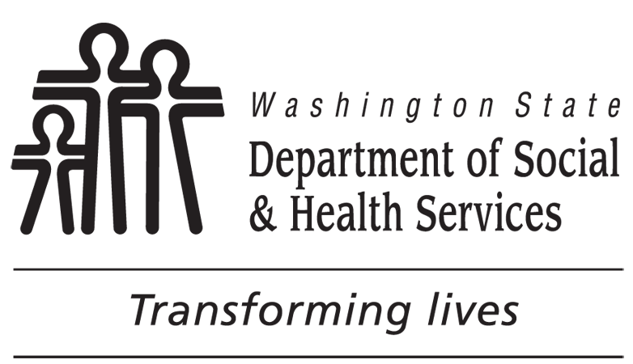 |  |  | DEVELOPMENTAL DISABILITIES ADMINISTRATION (DDA)  Person Centered Service Plan Meeting Survey
Please take a few moments to tell us about your recent person centered service plan meeting with your Case Manager. The survey is anonymous. It may be completed by you or by someone else on your behalf and is used to help us do a better job in serving you. Please check the box that best describes your response to each question and send the survey back to us in the self-addressed envelope provided.
NO. | (1)  YES | (2)  NO | (3)  NOT SURE | DDA Person Centered Service Plan MEETING SURVEY
1. |  |  |  | Did you get to choose who came to your meeting?
2. |  |  |  | Did you get to choose the time and place of your meeting?
3. |  |  |  | Did your input guide the meeting?
4. |  |  |  | Were your personal goals discussed in developing your plan?
5. |  |  |  | Did your case manager talk to you about what service choices were available to you?
6. |  |  |  | Were you given a choice of your service providers?
7. |  |  |  | Did you choose where and how the services will be provided?
8. |  |  |  | Did your case manager review last year’s plan to ask you what supports are working and which are not?
9. |  |  |  | Were any concerns you may have had addressed in your new plan?
10. |  |  |  | Did you receive information about resources and services available to meet your goals?
11. |  |  |  | Were plans made to meet any health and safety concerns you may have had?
12. |  |  |  | Did your case manager talk with you about your plan for emergencies?
13. |  |  |  | Do you know who to contact if your needs change before the next assessment?
14. |  |  |  | Did your case manager tell you that you can call 1-866-END-HARM (1-866-363-4276) any time to report abuse or neglect?
15. |  |  |  | Did your case manager explain the Planned Action Notice and how to appeal if you disagree with DDA about your services?
16. |  |  |  | Are you happy with the services you receive?
17. Please use the space below to provide information about what went well or to tell us what suggestions you have to improve your meeting.

Please return using the enclosed stamped, addressed envelope, or mail to:
Department of Social and Health Services
Developmental Disabilities Administration (DDA)
Attention: Quality Assurance
PO Box 45310
Olympia WA 98504-5310

