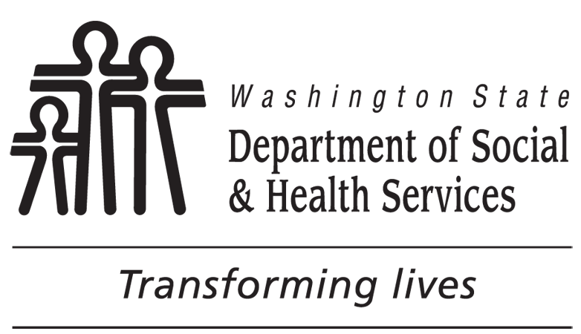 | DEVELOPMENTAL DISABILITIES ADMINISTRATION (DDA)  COMMUNITY PROTECTION PROGRAM  Refusal of Services Statement
I, , DDA Number , am voluntarily leaving the Community Protection Program on this date .
I am accepting full responsibility for my actions and realize that by leaving the program I am giving up my residential services, therapy services and employment program. I understand that participation in all Developmental Disabilities Administration (DDA) paid services is voluntary and I have the right to decline or terminate services at any time.
I understand that my providers may contact the police or county sheriff, the Department of Corrections, my physician, therapist, family members, and anyone else that DDA deems necessary.
I understand that by my refusal of Community Protection Services, I will also be removed from the Home and Community Based Services Waiver because my health and safety needs can no longer be met. I understand that if I request Community Protection Services in the future that my placement is not guaranteed and that any request will be evaluated based on program availability, risk evaluation, DDA eligibility, and other factors.
I understand that I will continue to be identified as an individual with community protection issues with the Developmental Disabilities Administration.
I further understand that refusal to sign this statement will be considered refusal of Community Protection Program services.
CLIENT’S SIGNATURE DATE

LEGAL REPRESENTATIVE’S SIGNATURE DATE
Explain if legal representative is not available.

I have explained the consequences of the decision that is making and he / she still wants to leave the program.
has been provided information regarding the following potential resources (e.g., crisis services, Social Security, in-home personal care): .

The treatment team was notified on .
DATE
DDA REPRESENTATIVE’S SIGNATURE TITLE DATE

