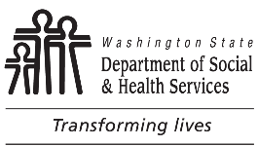 | DEVELOPMENTAL DISABILITIES ADMINISTRATION (DDA)  Service Request Contact Notice
Dear:
On you made a request for services. In order to determine what services you are eligible for, we must complete an assessment of your needs. I tried to contact you to schedule this assessment on and .
If you still want services, please contact me within ten (10) days of the date of this letter regarding your availability to schedule this assessment. You may also contact me if you have any questions or concerns.
If I do not hear from you within the next 10 days, the request will be withdrawn. If your request is withdrawn, you can make a new request for an assessment by calling the Service Request and Information Line at . You can also make a request online at www.dshs.wa.gov/dda/service-and-information-request.

Thank you.

CASE MANAGER / SOCIAL WORKER NAME TITLE

TELEPHONE NUMBER (INCLUDE AREA CODE) EMAIL ADDRESS

