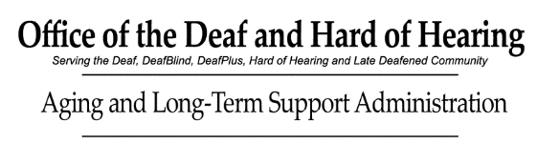
Preferred Sign Language Interpreter List
Hello, my name is:
I am Deaf Hard of Hearing DeafBlind Late Deafened and/or Deaf Plus.
I am requesting for a reasonable accommodation, a qualified* Sign Language Interpreter to communicate effectively with my medical provider.
To ensure effective communication, please request the following Interpreters for my appointment (not in any given order):
Please DO NOT contact these interpreters for my medical appointments:

Please give this form to your medical provider when requesting a follow-up appointment.
* Qualified Interpreter means according to Americans with Disabilities Act definition: an interpreter who is able to interpret effectively, accurately, and impartially. Receptively and expressively using necessary specialized vocabulary.

