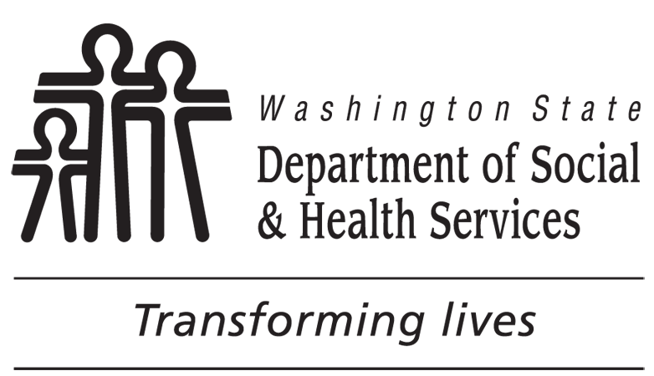 | DEVELOPMENTAL DISABILITIES ADMINISTRATION (DDA)  Family Agreement to Children’s Intensive In-Home  Behavioral Support (CIIBS) Program
CHILD / YOUTH’S NAME |  | CHILD / YOUTH’S DATE OF BIRTH |  | ADSA ID NUMBER |  | AGREEMENT DATE
PARENT/GUARDIAN |  |  | PRIMARY CAREGIVER (IF OTHER THAN PARENT/GUARDIAN)
PARENT/GUARDIAN |  |  | PRIMARY CAREGIVER (IF OTHER THAN PARENT/GUARDIAN)
I commit to full participation in the CIIBS program for as long as my child is enrolled. I will work with my DDA case resource manager to develop a meaningful family vision statement that will serve as the foundation of the team’s mission. I understand that when the objectives laid out in the team mission statement have been accomplished, continued enrollment on the CIIBS waiver may no longer be necessary.
I understand that the CIIBS program will work best if all the people that support my child work together. I agree to help build a team of people who will participate in team meetings. I agree to meet with my DDA case manager at least monthly for the first two months prior to the first team meeting, which will occur within the first 90 days of CIIBS waiver enrollment. This team will include my family, friends, community members, service providers, school staff, and other involved professionals. Since the purpose of this team is to support my child’s success, I will ensure that all members respect my child as a part of the team. I will encourage my child to make choices about likes, dislikes, needs, activities, and strategies. After that, the team will meet at least every three months.
I understand that CIIBS waiver services, alone, may not meet the full needs of my child. The DDA case resource manager may assist me in connecting to other medically-necessary services, such as Applied Behavioral Analysis, through private insurance and/or the Medicaid state plan. I will consent to information being shared between my DDA case manager and other professional providers involved in addressing my child’s challenging behavior.
I understand that the CIIBS waiver will not be available to my child beyond the age of 21 and that I will be asked to begin transition planning a year prior.
I understand all personal information will be kept confidential. Reports about the program will not use names or other information that might identify us.
I agree to play a positive, active role in supporting my child and in addressing behaviors through the help of my child’s support team.
PARENT / GUARDIAN’S SIGNATURE(S) |  |  |  |  | DATE
PARENT / GUARDIAN’S SIGNATURE(S) |  |  |  |  | DATE
PRIMARY CAREGIVER’S SIGNATURE (IF OTHER THAN PARENT/GUARDIAN) |  |  |  |  | DATE
PRIMARY CAREGIVER’S SIGNATURE (IF OTHER THAN PARENT/GUARDIAN) |  |  |  |  | DATE
YOUTH’S SIGNATURE (IF OTHER THAN PARENT/GUARDIAN) |  |  |  |  | DATE
CASE / RESOURCE MANAGER’S SIGNATURE |  |  |  |  | DATE AGREEMENT RECEIVED

