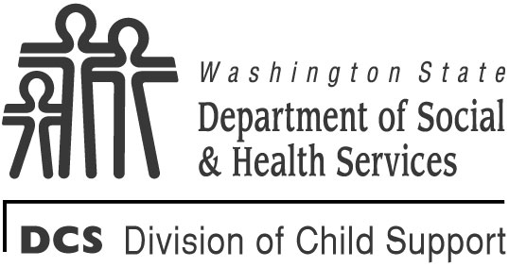 | STATE OF WASHINGTON  DEPARTMENT OF SOCIAL AND HEALTH SERVICES  DIVISION OF CHILD SUPPORT (DCS)  Paternity Information
The Division of Child Support requires information from you to establish paternity and to obtain child support for the child named below. Unless you give us a good reason for not completing this form, the Community Services Division may reduce your Temporary Assistance for Needy Families grant by 25 percent.
I. Information About the Natural Mother of the Child Listed in Section II
FULL NAME (FIRST / MIDDLE / LAST) |  |  |  |  |  | Maiden Name
Social Security Number |  |  | Date of Birth (Month/Day/Year) |  |  | Client ID Number
II. Information About the Child
FULL NAME (FIRST / MIDDLE / LAST) |  |  |  |  |  | Date of Birth (Month/Day/Year)
I believe I became pregnant with this child between (Month / Year) and (Month / Year)
Could you have become pregnant in Washington State? No Yes
PlACES you could have become pregnant (City / State) |  |  |  | PLACE THE CHILD WAS BORN (CITY / STATE)
III. Marriage / Registered Domestic Partnership Information
Were you married or in a Registered Domestic Partnership when you became pregnant or the child was born?
No Yes. If yes, answer the next two questions.
Husband / wife / partner Full Name (FIRST / MIDDLE / LAST) |  |  |  |  |  | Date of Marriage / entrance into partnership (Month/Day/Year)
Has the marriage / partnership been dissolved? No Yes. If yes, answer the next two questions.
Date of Divorce / DISSOLUTION |  | Place Divorce / Dissolution Decree Filed (City / County / State)
IV. Paternity Acknowledgment Information
Did you and any man sign a paternity acknowledgement for this child? No Yes. If yes, answer the next two questions.
Date Filed |  | Place Paternity Acknowledgement Filed (City / County / State)
V. Information About the Possible Father
Is there more than one possible father? No Yes. If yes, complete a form for each possible father.
During the time I became pregnant, I had sexual intercourse with (First / Middle / Last Name)

Social Security Number |  |  | Date of Birth (Month / Date / Year) |  | Telephone Number
Current Address Street City State Zip Code

VI. Declaration
I declare that if I have not provided any information requested in this form, it is because I do not have that information.
I declare under penalty of perjury, under the laws of the state of Washington, that the foregoing is true and correct.
Signed at:
City State Date (Month/Day/Year)

Signature of Mother (Full Legal Name)

