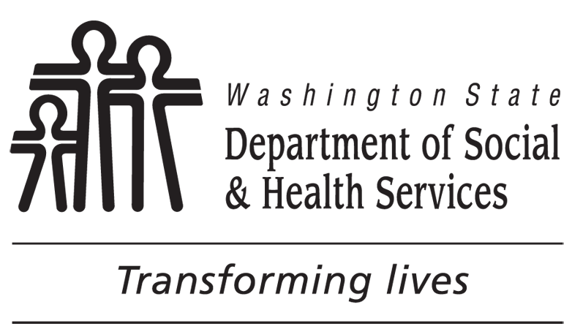 | STATE OF WASHINGTON  DEPARTMENT OF SOCIAL AND HEALTH SERVICES  DIVISION OF CHILD SUPPORT (DCS)
Permission to Share Documents for Reimbursement of Health Care Expenses
TO: |  | RE:  CASE NUMBER:  CHILDREN’S NAMES:
You requested that the Division of Child Support (DCS) help you get reimbursed for uninsured health care expenses you paid for the children named above. Please send the following items to: DIVISION OF CHILD SUPPORT
PO BOX 11520
TACOMA WA 98411-5520
1. Completed, dated, and signed Detail Sheet-Uninsured Health Care Expenses form.
2. Completed, dated, and signed Permission to Share Documents for Reimbursement of Health Care Expenses form.
3. Readable and numbered photocopies of your detailed expense records.
4. Readable and numbered photocopies of your payment records.
If your claim meets all of our requirements, DCS will serve a Notice of Support Owed - Medical Support on the obligated parent. Copies of the Detail Sheet – Uninsured Health Care Expenses and forms, bills and receipts you provide to DCS to support your claim for reimbursement will be sent to the obligated parent with the Notice. The copies also will be provided to the Administrative Law Judge (ALJ) if a hearing is requested.
Health care expense documents may contain confidential personal information that you do not want the other party to see. If you do not have concerns about releasing personal information to the other party, you may want to consider disclosing it so the other party and the ALJ can understand the documents better. This generally helps to speed up the process.
Make two copies of the original documents.
- DO NOT make any marks on one copy. DCS needs one clean copy for its records.
- On the second copy, black out (redact) any information you do not want shared. Keep the original unredacted documents for your records. If you have concerns about sharing particular information with the other party, you may want to redact the following types of information:
  - Your address and telephone number.
  - Doctor, clinic, or pharmacy names, addresses, phone numbers, and web addresses.
  - Prescription numbers, authorization numbers, and the physician’s NPI number on pharmacy receipts.
  - Diagnoses or procedures that state the charge is for mental health, drug or alcohol services, HIV / AIDS or other STDs, birth control, or abortions.
  - Social security numbers, account numbers, or banking information shown on your receipts.
3. If you don't mind sharing your information, you can authorize DCS to send out the documents the way you submitted them. DCS will not make any further redactions to your documents.

Please check the applicable box below, sign and date this form, and then return it to DCS with the Detail Sheet – Uninsured Health Care Expenses, bills, and receipts to support your claim.
I authorize DCS to provide copies of my forms and the bills, receipts, and other documentation I submit to DCS to the other party to my child support order and the Office of Administrative Hearings along with the Notice of Support Owed - Medical Support.
I consent to share with the other party and the ALJ the forms and supporting documentation in the following manner (check ONLY ONE of the following):
As they are - I redacted all the information I do not want the other party to see. I understand these documents will be shared with the other party with no further redactions. This permission applies only to this reimbursement request.
Or,
Only after DCS redacts my confidential information (my address and telephone number; doctor, clinic, or pharmacy names, addresses, phone numbers, and web addresses; prescription numbers, authorization numbers, and the physician’s NPI number on pharmacy receipts; diagnoses or procedures that state the charge is for mental health, drug or alcohol services, HIV/AIDS or other STDs, birth control, or abortions; social security numbers, account numbers, or banking information shown on my receipts).
NOTE: If any of the diagnoses or procedures show they are for mental health, drug or alcohol services, HIV / AIDS or other STDs, birth control, or abortion, DCS may contact you for further consent.
DATE MY PRINTED NAME

( )
MY TELEPHONE NUMBER (INCLUDE AREA CODE) MY SIGNATURE
NOTICE: This form applies only for the purposes of serving a Notice of Support Owed - Medical Support and getting a final administrative order based on that Notice. If you make another request for reimbursement in the future, DCS will ask you to sign another permission form. This form does not authorize DCS to share unredacted documents for any other purpose.
No person, because of race, color, national origin, creed, religion, sex, age, or disability, shall be discriminated against in employment, services, or any aspect of the program's activities. This form is available in alternative formats upon request.

