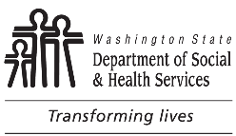 | Asset Verification  Authorization |  | Client’s Name
 |  |  | ACES ID Number
I understand the following:
- Information provided to apply for or renew medical assistance is subject to verification by federal and state officials to determine if it is correct.
- The Health Care Authority (HCA) and the Department of Social and Health Services (DSHS) may investigate and contact any financial institution as part of the asset verification process.
- This authorization ends when:
  - A final adverse decision is made on my application, or
  - My benefits end, or
  - I revoke the authorization, at any time, by providing HCA or DSHS written notice.
If I revoke or refuse to provide authorization, I understand that I won’t be eligible for any Washington Apple Health aged, blind or disabled SSI-related Medicaid programs. This doesn’t affect my ability to apply for cash, food, and/or childcare.
I authorize HCA and DSHS to conduct asset verification to determine eligibility and to verify the accuracy of financial institution information.

Sign acknowledgement below as appropriate and provide printed name.
Signature of Client Date |  | Printed Name
Signature of Spouse Date |  | Printed Name
Signature of Parent for Minor Child Client Date |  | Printed Name
Signature of Authorized Representative Date |  | Printed Name

