7.01 TRIBAL PLANS
APRIL 1, 2016-ARRIL 2017
Compiled by Linda Gil, DDA Tribal Liaison to OIP

Washington Tribes Washington State Tribal Map

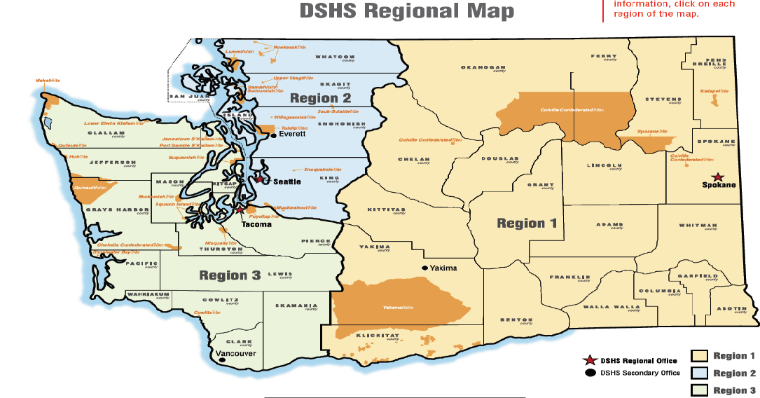

- Tribal Chairs
- Recognized American Indian Organization Directors

Federally Recognized Tribes Washington
- Chehalis  - Colville  - Cowlitz  - Hoh  - Jamestown  - Kalispel  - Lower Elwha  - Lummi | - Makah  - Muckleshoot  - Nisqually  - Nooksack  - Port Gamble  - Puyallup  - Quileute | - Quinault  - Samish  - Sauk-Suiattle  - Shoalwater  - Skokomish  - Snoqualmie  - Spokane | - Squaxin Island  - Stillaguamish  - Suquamish  - Swinomish  - Tulalip  - Upper Skagit  - Yakama

DDA REGION 1 N

REGION 1 S
TRIBE: Yakama
COUNTIES: Asotin, Benton, Columbia, Franklin, Garfield, Kittitas, Klickitat, Walla Walla, Yakima

DDA REGION 2 S
Tribes: Lummi, Nooksack, Upper Skagit, Sauk-Suiattle, Samish, Stillaguamish, Tulalip and Swinomish
Muckleshoot, Snoqualmie

TRIBES: Hoh, Jamestown S’Klallam, Lower Elwha Klallam, Makah, Quileute, Port Gamble S’Klallam, Suquamish
COUNTIES: Clallam, Jefferson, Kitsap

DDA REGION 3 N

DDA REGION 3 S
TRIBES & RAIOs: Chehalis, Cowlitz, Nisqually, Puyallup, Quinault, Skokomish, Shoalwater Bay, Squaxin Island, South Puget Intertribal Planning Agency, Small Tribes of Western Washington
COUNTIES: Clark, Cowlitz, Grays Harbor, Lewis, Mason, Pacific, Pierce, Skamania, Thurston, Wahkiakum

